KUTUMBA

C2-W2 — Older Teacher Pack
  - Grades 4–5 run sheet and activities
C2-W2 • Free Will and Responsibility: The Next Choice Matters
V13 • Families Growing in Krishna Consciousness
Program Director: Swapnil Patil
Internal founding-cohort teaching material — human/temple review EXTERNAL_OPEN
KUTUMBA | Families Growing in Krishna Consciousness

Locked Saturday Schedule
Time | Block
1:50–2:00 | Arrival
2:00–2:10 | Opening mantras + welcome
2:10–2:30 | All-family launch/orientation
2:30–3:10 | Parallel tracks
3:10–3:30 | Reunification + bhakti laboratory
3:30–3:40 | Snack + water
3:40–3:55 | Saṅkalpa + project + home practice
3:55–4:00 | Close

TIME CUE | Track handoff is at 2:30; all groups reunite at 3:10.

Primary verse: BG 18.63
Source URL: https://vedabase.io/en/library/bg/18/63/

Older Teacher Run Sheet
Canonical source: 11-weekly-program-library/first-six-months/c2-w2-free-will-and-responsibility-the-next-choice-matters/teacher/OLDER-TEACHER-GUIDE-V13.md • SHA-256: 839c1b883d6625c5ae8a78d1b2322b6e2be97255e5daba5c759caecc36a6c755
KUTUMBA · Families Growing in Krishna Consciousness Program Director: Swapnil Patil Week: Free Will and Responsibility: The Next Choice Matters · Date: 2026-11-14 Track window: Saturday 2:30–3:10 (Grades 4–5) Reunite: 3:10 for bhakti laboratory Primary: BG 18.63 — https://vedabase.io/en/library/bg/18/63/ Primary mechanic: Decision tree Status: Internal founding-cohort teaching material — human/temple review EXTERNAL_OPEN

Essential question
What is my next responsible choice?

Materials (print before Saturday)
From activities/v13-older/: O01–O06 Also pens/crayons; verse card; privacy reminder.

Locked Saturday context
- 1:50–2:00 Arrival · 2:00–2:10 Mantras · 2:10–2:30 All-family launch
- 2:30–3:10 This track · 3:10–3:30 Reunify · 3:30–3:40 Snack/water · 3:40–3:55 Saṅkalpa · 3:55–4:00 Close
Parents remain onsite. No public ranking. No forced disclosure.

Source layer (use mid-track)
Primary: BG 18.63 — https://vedabase.io/en/library/bg/18/63/
Devanāgarī: इति ते ज्ञानमाख्यातं गुह्याद्गुह्यतरं मया । विमृश्यैतदशेषेण यथेच्छसि तथा कुरु ॥ ६३ ॥
IAST: iti te jñānam ākhyātaṁ guhyād guhyataraṁ mayā / vimṛśyaitad aśeṣeṇa yathecchasi tathā kuru
KUTUMBA teaching meaning (not a BBT translation): The Lord has explained confidential knowledge; now deliberate fully and then act as you choose — responsibility remains with the living being.

Memory line
The next choice matters.

V13 printable wiring (Decision tree)

V13 printable block 0–6 — BG 18.63 observation
Printable: activities/v13-older/O01-BG-18-63-OBSERVATION.md (O01-BG-18-63-OBSERVATION)
Observe deliberation + choice language.
Keep primary mechanic (Decision tree). Block: Choice means do whatever you feel; OR the soul has no agency / “I had no choice.”

V13 printable block 6–14 — Next-choice decision tree
Printable: activities/v13-older/O02-NEXT-CHOICE-DECISION-TREE.md (O02-NEXT-CHOICE-DECISION-TREE)
Build a 3-level tree for a real low-risk fork.
Keep primary mechanic (Decision tree). Block: Choice means do whatever you feel; OR the soul has no agency / “I had no choice.”

V13 printable block 14–22 — Agency vs control sort
Printable: activities/v13-older/O03-AGENCY-VS-CONTROL-SORT.md (O03-AGENCY-VS-CONTROL-SORT)
Sort what I can choose / influence / not control.
Keep primary mechanic (Decision tree). Block: Choice means do whatever you feel; OR the soul has no agency / “I had no choice.”

V13 printable block 22–30 — Responsibility scenarios
Printable: activities/v13-older/O04-RESPONSIBILITY-SCENARIOS.md (O04-RESPONSIBILITY-SCENARIOS)
Three cases: blame, freeze, responsible next step.
Keep primary mechanic (Decision tree). Block: Choice means do whatever you feel; OR the soul has no agency / “I had no choice.”

V13 printable block 30–36 — Deliberation worksheet
Printable: activities/v13-older/O05-DELIBERATION-WORKSHEET.md (O05-DELIBERATION-WORKSHEET)
vimṛśya practice: facts, options, values, choose.
Keep primary mechanic (Decision tree). Block: Choice means do whatever you feel; OR the soul has no agency / “I had no choice.”

V13 printable block 36–40 — Exit ticket
Printable: activities/v13-older/O06-EXIT-TICKET.md (O06-EXIT-TICKET)
My next responsible choice tomorrow.
Keep primary mechanic (Decision tree). Block: Choice means do whatever you feel; OR the soul has no agency / “I had no choice.”

Close of track (handoff)
Bring one sentence or artifact to reunification. Do not start next week’s topic. Care boundary: Do not blame children for events beyond their control; distinguish agency from total control.

Inherited classroom depth (from V12 OLDER-TEACHER-GUIDE.md)
Keep story scripts, movement steps, and wonder questions below. Wire printables to the V13 codes above; do not replace this depth with “see research.”
Week: Free Will and Responsibility: The Next Choice Matters Primary: BG 18.63 — https://vedabase.io/en/library/bg/18/63/ Session length: ~40 minutes (parallel track ~2:30–3:10) Parents: Remain onsite; reunite at 3:10 Status: Internal founding-cohort teaching material — human/temple review EXTERNAL_OPEN

Objective
Students observe BG 18.63, explain that deliberation and choice go together with responsibility, map a trigger chain, and contribute one project sentence answering: What is my next responsible choice?

Exact memory phrase
After giving knowledge, Kṛṣṇa tells Arjuna to deliberate fully and then act as he chooses.
Short echo: The next choice matters.

Teacher background
- KUTUMBA teaching meaning: The Lord has explained confidential knowledge; now deliberate fully and then act as you choose — responsibility remains with the living being. (Label as KUTUMBA teaching meaning — not as BBT translation.)
- Supporting frames (one sentence each): BG 18.61 machine-of-nature limits; BG 3.34 sense attachment/aversion; BG 2.7 seeking guidance; BG 18.73 willing alignment after clarity.
- Block: “Choice = do whatever I feel” and “I have no agency.”
- Scope: Do not teach reincarnation ontology (C2-W3) tonight.

Materials
- Printed verse strip: Devanāgarī + IAST + KUTUMBA teaching meaning
- Worksheet copies from activities/OLDER-ACTIVITY-PACK.md
- Scenario cards (sibling anger; homework vs game; parent snap/repair — fictional)
- Choice-map diagram sheet (event → sensation → thought → urge → choice → consequence)
- Pencils; timer; answer key activities/OLDER-ANSWER-KEY.md for teacher only
- Project contribution half-sheets

Minute-by-minute plan

0–5 min — Settle and hook
1. Welcome; feet on floor.
2. Hook: “Which sentence is more true — ‘I had no choice’ or ‘I can do whatever I feel’?” Let two volunteers answer; hold both as incomplete.
3. State essential question: What is my next responsible choice?

5–14 min — Primary text observation (BG 18.63)
1. Display verse; read IAST aloud together once; teacher reads Devanāgarī slowly or plays authorized audio if available.
2. Students underline three idea-words in the teaching meaning: deliberate, choose, responsibility.
3. Observation prompts (write short answers):
- What has already been given? (knowledge explained)
- What must Arjuna do before acting? (deliberate fully)
- Who remains responsible for action? (the living being / Arjuna as representative learner)
1. Add one-sentence bridges:
- BG 2.7 — seeking guidance is a responsible move when confused.
- BG 18.73 — clarity can lead to acting according to the Lord’s instruction.
1. Paraphrase only; no invented dialogue.

14–22 min — Worksheet questions
Students complete Section A of the older activity pack:
1. Restate KUTUMBA teaching meaning in their own words (one sentence).
2. Name two things a person might not control in a hard moment.
3. Name one thing a person can still choose.
4. Why is “do whatever you feel” not the meaning of this verse?
5. Why is “I had no choice” incomplete?
Teacher circulates; use OLDER-ANSWER-KEY.md for expected directions (not for grading ranks).

22–28 min — Scenario cards (small groups)
Each group gets one fictional card:
Card A — Sibling anger: Urge to shout/snatch. Mistaken line: “Anger made me do it.” Card B — Homework vs game: Urge to skip work. Mistaken line: “Easy feeling = right choice.” Card C — Repair after a snap: Adult or older child spoke harshly; now what?
For each card, group writes:
1. What is not fully controlled?
2. What is the Pause–Remember–Choose path?
3. What should we not say (shame, ranking, public exposure)?
Share one insight per group (60 seconds).

28–33 min — Puzzle / game: Responsible Fork
1. Teacher reads a short fork aloud (two endings).
2. Teams hold up R (responsible next step) or M (mistaken conclusion).
3. Three rounds, then students explain one “R” choice using the words deliberate or responsibility.
4. Keep energy respectful; no mocking wrong holds.

33–37 min — Diagram task
On the choice-map sheet, students fill one low-risk example (lost pencil, long line, noisy sibling — not forced trauma disclosure):
Event → Body sensation → Thought → Urge → Choice → Consequence
Circle the Choice box and write the memory short echo inside it.

37–40 min — Project contribution + reflection + handoff
1. Complete project half-sheet: “This week my next responsible choice at _________ is _________.”
2. Reflection (one sentence): How does BG 18.63 challenge both license and fatalism?
3. Cleanup; bring sheets to reunification.
4. Parent handoff line: Home practice is Pause–Remember–Choose once daily on the family trigger.

Extension (if group finishes early)
Compare BG 3.34 (sense attachment/aversion) with the traffic-light pause: feelings arise; we need not obey every urge. Still no reincarnation teaching.

Answer key pointer
Teacher-facing expected answers: activities/OLDER-ANSWER-KEY.md. Do not distribute the key to students during the first attempt.

Behavior and privacy
- Redirect side talk: “Return to your map — choice box only.”
- No forced confession of real family conflict details.
- No ranking scores aloud.
- Parents onsite; snack/water belongs to main schedule, not track rewards framed as a meal.

O01 — BG 18.63 observation
Observe deliberation + choice language.

VERSE CARD • BG 18.63
इति ते ज्ञानमाख्यातं गुह्याद्गुह्यतरं मया । विमृश्यैतदशेषेण यथेच्छसि तथा कुरु ॥ ६३ ॥
iti te jñānam ākhyātaṁ guhyād guhyataraṁ mayā / vimṛśyaitad aśeṣeṇa yathecchasi tathā kuru
KUTUMBA teaching meaning: The Lord has explained confidential knowledge; now deliberate fully and then act as you choose — responsibility remains with the living being.
Source: https://vedabase.io/en/library/bg/18/63/
Rights/status: Scripture display/source: VedaBase; teaching meaning: KUTUMBA-original (not labeled as BBT translation).

What does the verse teach in my words?
________________________________________________________________
________________________________________________________________
What misconception does this week block?
________________________________________________________________
________________________________________________________________
One question for the facilitator:
________________________________________________________________
________________________________________________________________

O02 — Next-choice decision tree
Build a 3-level tree for a real low-risk fork.
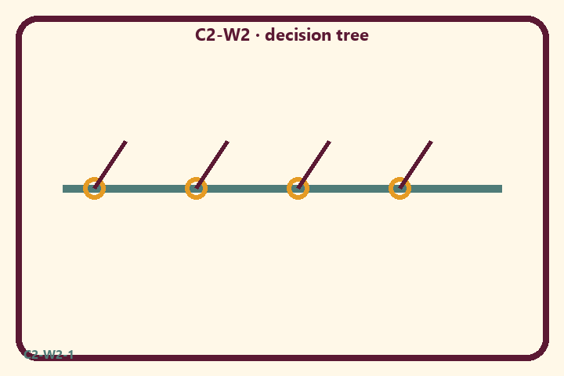
Prompt | My notes
Next-choice decision tree | ________________
Limit / care | ________________

Application:
________________________________________________________________
________________________________________________________________
What not to say:
________________________________________________________________
________________________________________________________________
KEY IDEA | Knowledge invites deliberation; the living being still chooses; the next choice matters.

O03 — Agency vs control sort
Sort what I can choose / influence / not control.
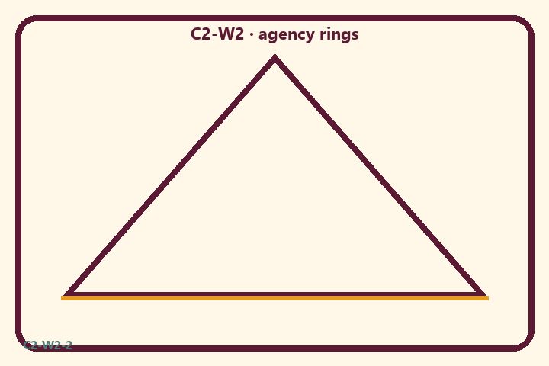
Prompt | My notes
Agency vs control sort | ________________
Limit / care | ________________

Application:
________________________________________________________________
________________________________________________________________
What not to say:
________________________________________________________________
________________________________________________________________
KEY IDEA | Knowledge invites deliberation; the living being still chooses; the next choice matters.

O04 — Responsibility scenarios
Three cases: blame, freeze, responsible next step.
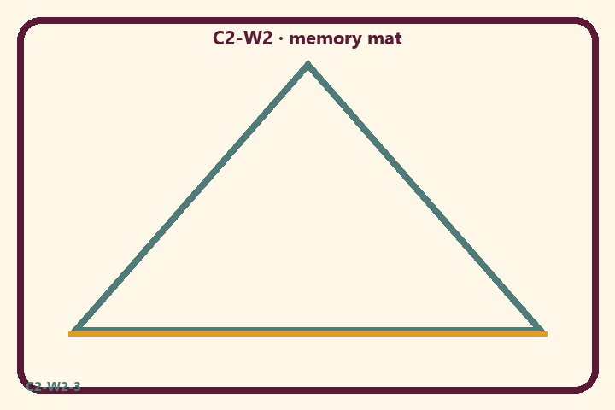
Prompt | My notes
Responsibility scenarios | ________________
Limit / care | ________________

Application:
________________________________________________________________
________________________________________________________________
What not to say:
________________________________________________________________
________________________________________________________________
KEY IDEA | Knowledge invites deliberation; the living being still chooses; the next choice matters.

O05 — Deliberation worksheet
vimṛśya practice: facts, options, values, choose.
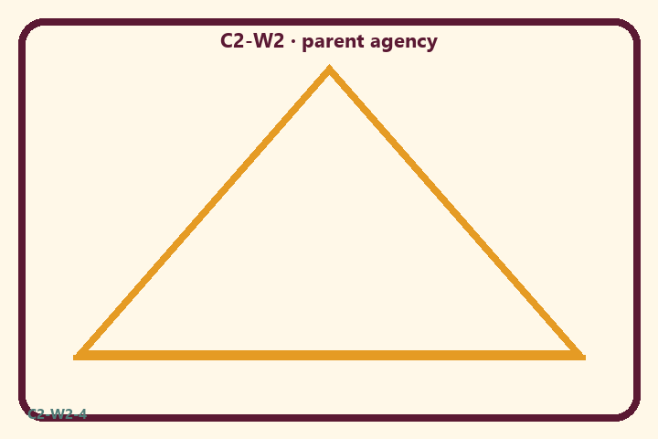
Prompt | My notes
Deliberation worksheet | ________________
Limit / care | ________________

Application:
________________________________________________________________
________________________________________________________________
What not to say:
________________________________________________________________
________________________________________________________________
KEY IDEA | Knowledge invites deliberation; the living being still chooses; the next choice matters.

O06 — Exit ticket
My next responsible choice tomorrow.
Primary in one sentence:
________________________________________________________________
________________________________________________________________
One analogy or mechanic and its limit:
________________________________________________________________
________________________________________________________________
One home action:
________________________________________________________________
________________________________________________________________
One question I still have:
________________________________________________________________
________________________________________________________________
RIGHTS NOTE | KUTUMBA-original framing; cited third-party material retains its own rights. Human/temple review remains EXTERNAL_OPEN.

