KUTUMBA

C2-W2 — Parent Track
  - Facilitator guide and parent printables
C2-W2 • Free Will and Responsibility: The Next Choice Matters
V13 • Families Growing in Krishna Consciousness
Program Director: Swapnil Patil
Internal founding-cohort teaching material — human/temple review EXTERNAL_OPEN
KUTUMBA | Families Growing in Krishna Consciousness

Locked Saturday Schedule
Time | Block
1:50–2:00 | Arrival
2:00–2:10 | Opening mantras + welcome
2:10–2:30 | All-family launch/orientation
2:30–3:10 | Parallel tracks
3:10–3:30 | Reunification + bhakti laboratory
3:30–3:40 | Snack + water
3:40–3:55 | Saṅkalpa + project + home practice
3:55–4:00 | Close

TIME CUE | Track handoff is at 2:30; all groups reunite at 3:10.

Primary verse: BG 18.63
Source URL: https://vedabase.io/en/library/bg/18/63/

Parent Facilitator Run Sheet
Canonical source: 11-weekly-program-library/first-six-months/c2-w2-free-will-and-responsibility-the-next-choice-matters/teacher/PARENT-GUIDE-V13.md • SHA-256: 5dc9598f8415882c6fa50468399851697851fb1c7a1cc193e1c3361f53536210
KUTUMBA · Families Growing in Krishna Consciousness Program Director: Swapnil Patil Week: Free Will and Responsibility: The Next Choice Matters · Date: 2026-11-14 Track window: Saturday 2:30–3:10 (parents) Reunite: 3:10 for bhakti laboratory Primary: BG 18.63 — https://vedabase.io/en/library/bg/18/63/ Primary mechanic: Decision tree Status: Internal founding-cohort teaching material — human/temple review EXTERNAL_OPEN

Essential question
What is my next responsible choice?

Materials (print before Saturday)
From activities/v13-parent/: P01–P05 Also pens/crayons; verse card; privacy reminder.

Locked Saturday context
- 1:50–2:00 Arrival · 2:00–2:10 Mantras · 2:10–2:30 All-family launch
- 2:30–3:10 This track · 3:10–3:30 Reunify · 3:30–3:40 Snack/water · 3:40–3:55 Saṅkalpa · 3:55–4:00 Close
Parents remain onsite. No public ranking. No forced disclosure.

Source layer (use mid-track)
Primary: BG 18.63 — https://vedabase.io/en/library/bg/18/63/
Devanāgarī: इति ते ज्ञानमाख्यातं गुह्याद्गुह्यतरं मया । विमृश्यैतदशेषेण यथेच्छसि तथा कुरु ॥ ६३ ॥
IAST: iti te jñānam ākhyātaṁ guhyād guhyataraṁ mayā / vimṛśyaitad aśeṣeṇa yathecchasi tathā kuru
KUTUMBA teaching meaning (not a BBT translation): The Lord has explained confidential knowledge; now deliberate fully and then act as you choose — responsibility remains with the living being.

Memory line
The next choice matters.

V13 printable wiring (Decision tree)

V13 printable block 0–5 — Private reflection — agency vs control
Printable: activities/v13-parent/P01-PRIVATE-REFLECTION.md (P01-PRIVATE-REFLECTION)
Where do we confuse control with responsibility?
Keep primary mechanic (Decision tree). Block: Choice means do whatever you feel; OR the soul has no agency / “I had no choice.”

V13 printable block 5–12 — Agency vs control card sort
Printable: activities/v13-parent/P02-AGENCY-CONTROL-CARD-SORT.md (P02-AGENCY-CONTROL-CARD-SORT)
Sort CAN CHOOSE / CAN INFLUENCE / CANNOT CONTROL.
Keep primary mechanic (Decision tree). Block: Choice means do whatever you feel; OR the soul has no agency / “I had no choice.”

V13 printable block 12–22 — Substantial family case
Printable: activities/v13-parent/P03-SUBSTANTIAL-FAMILY-CASE.md (P03-SUBSTANTIAL-FAMILY-CASE)
Teen freezes after a grade drop; parent says “you had no choice but to fail.”
Keep primary mechanic (Decision tree). Block: Choice means do whatever you feel; OR the soul has no agency / “I had no choice.”

V13 printable block 22–32 — Household operating application
Printable: activities/v13-parent/P04-HOUSEHOLD-OPERATING-APPLICATION.md (P04-HOUSEHOLD-OPERATING-APPLICATION)
One nightly deliberation cue for seven days.
Keep primary mechanic (Decision tree). Block: Choice means do whatever you feel; OR the soul has no agency / “I had no choice.”

V13 printable block 32–38 — Private next-step saṅkalpa
Printable: activities/v13-parent/P05-PRIVATE-NEXT-STEP-SANKALPA.md (P05-PRIVATE-NEXT-STEP-SANKALPA)
Specific next choice + trigger + minimum version.
Keep primary mechanic (Decision tree). Block: Choice means do whatever you feel; OR the soul has no agency / “I had no choice.”

Close of track (handoff)
Bring one sentence or artifact to reunification. Do not start next week’s topic. Care boundary: Do not blame children for events beyond their control; distinguish agency from total control.

Inherited classroom depth (from V12 parent-lesson / constructed V13 flow)
Keep story scripts, movement steps, and wonder questions below. Wire printables to the V13 codes above; do not replace this depth with “see research.”

Essential question
What is my next responsible choice?

Source
BG 18.63 — teaching meaning: The Lord has explained confidential knowledge; now deliberate fully and then act as you choose — responsibility remains with the living being.

Discussion
One realistic household tension; no compelled confession.

Application
5–15 minute cue; minimum version counts.

Privacy
No public scoring of sādhana.

P01 — Private reflection — agency vs control
Where do we confuse control with responsibility?

SAFETY & PRIVACY | Write privately. Sharing is optional. Do not collect or place completed sheets in Git.

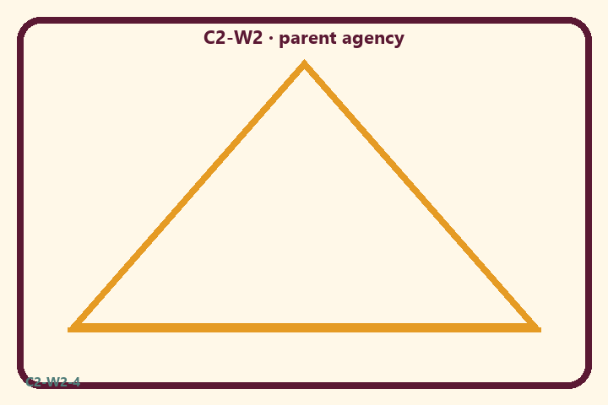
Where do we confuse control with responsibility?
Private notes:
________________________________________________________________
________________________________________________________________
________________________________________________________________
________________________________________________________________
Habit to watch this week:
________________________________________________________________
________________________________________________________________
________________________________________________________________
________________________________________________________________

P02 — Agency vs control card sort
Sort CAN CHOOSE / CAN INFLUENCE / CANNOT CONTROL.
HELPFUL | MISTAKEN

L1  My tone in an argument | L2  Traffic delay
L3  Sibling’s mood | L4  Whether I apologize
L5  Weather | L6  My homework start time
TEACHER NOTE | Choice means do whatever you feel; OR the soul has no agency / “I had no choice.”

P03 — Substantial family case
Teen freezes after a grade drop; parent says “you had no choice but to fail.”
SAFETY & PRIVACY | Fictional case. No compelled confession of real events.

A teen freezes after a grade drop. One parent says “you had no choice but to fail.” Another lectures for twenty minutes without naming a next step.
Tempting mistaken conclusion:
________________________________________________________________
________________________________________________________________
________________________________________________________________
Principle from primary:
________________________________________________________________
________________________________________________________________
________________________________________________________________
Compassionate response:
________________________________________________________________
________________________________________________________________
________________________________________________________________
One seven-day household action:
________________________________________________________________
________________________________________________________________
________________________________________________________________
What we should not say:
________________________________________________________________
________________________________________________________________
________________________________________________________________
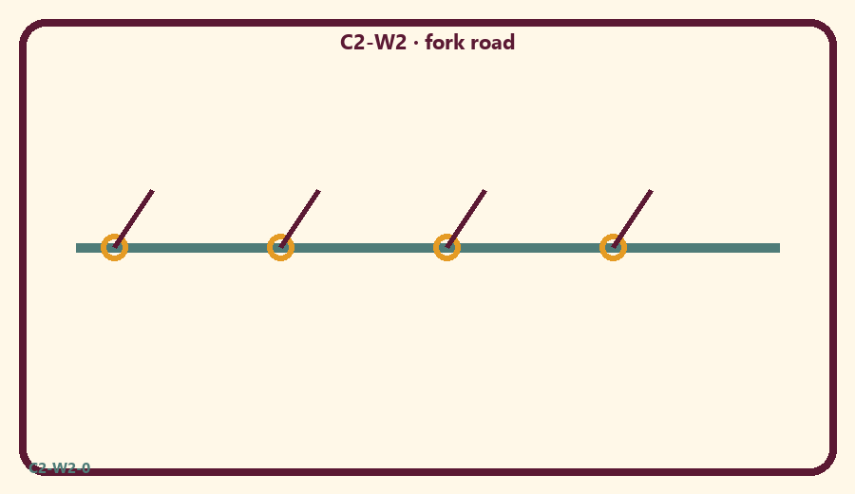

P04 — Household operating application
One nightly deliberation cue for seven days.
SAFETY & PRIVACY | No ranking and no public reading required.

One household action for seven days:
________________________________________________________________
________________________________________________________________
________________________________________________________________
Trigger (when/where):
________________________________________________________________
________________________________________________________________
________________________________________________________________
Who starts if others are tired:
________________________________________________________________
________________________________________________________________
________________________________________________________________
Minimum version on a hard day:
________________________________________________________________
________________________________________________________________
________________________________________________________________

Memory phrase
The next choice matters.

P05 — Private next-step saṅkalpa
Specific next choice + trigger + minimum version.
KEY IDEA | specific action + frequency + trigger + minimum version

Specific action:
________________________________________________________________
________________________________________________________________
Frequency:
________________________________________________________________
________________________________________________________________
Trigger (when and where):
________________________________________________________________
________________________________________________________________
Minimum version for a hard day:
________________________________________________________________
________________________________________________________________
Where we will place the reminder:
________________________________________________________________
________________________________________________________________
No ranking. The minimum version counts as success.
RIGHTS NOTE | KUTUMBA-original framing; cited third-party material retains its own rights. Human/temple review remains EXTERNAL_OPEN.

