KUTUMBA

C2-W3 — Older Teacher Pack
  - Grades 4–5 run sheet and activities
C2-W3 • Birth, Death and Reincarnation
V13 • Families Growing in Krishna Consciousness
Program Director: Swapnil Patil
Internal founding-cohort teaching material — human/temple review EXTERNAL_OPEN
KUTUMBA | Families Growing in Krishna Consciousness

Locked Saturday Schedule
Time | Block
1:50–2:00 | Arrival
2:00–2:10 | Opening mantras + welcome
2:10–2:30 | All-family launch/orientation
2:30–3:10 | Parallel tracks
3:10–3:30 | Reunification + bhakti laboratory
3:30–3:40 | Snack + water
3:40–3:55 | Saṅkalpa + project + home practice
3:55–4:00 | Close

TIME CUE | Track handoff is at 2:30; all groups reunite at 3:10.

Primary verse: BG 2.22
Source URL: https://vedabase.io/en/library/bg/2/22/

Older Teacher Run Sheet
Canonical source: 11-weekly-program-library/first-six-months/c2-w3-birth-death-and-reincarnation/teacher/OLDER-TEACHER-GUIDE-V13.md • SHA-256: ea671c79c751f9aed5407e02b884dbdec348f81df3767e04e1849372b2cba5cf
KUTUMBA · Families Growing in Krishna Consciousness Program Director: Swapnil Patil Week: Birth, Death and Reincarnation · Date: 2026-11-21 Track window: Saturday 2:30–3:10 (Grades 4–5) Reunite: 3:10 for bhakti laboratory Primary: BG 2.22 — https://vedabase.io/en/library/bg/2/22/ Primary mechanic: Analogy with limits Status: Internal founding-cohort teaching material — human/temple review EXTERNAL_OPEN

Essential question
How do we speak calmly about birth and death?

Materials (print before Saturday)
From activities/v13-older/: O01–O06 Also pens/crayons; verse card; privacy reminder.

Locked Saturday context
- 1:50–2:00 Arrival · 2:00–2:10 Mantras · 2:10–2:30 All-family launch
- 2:30–3:10 This track · 3:10–3:30 Reunify · 3:30–3:40 Snack/water · 3:40–3:55 Saṅkalpa · 3:55–4:00 Close
Parents remain onsite. No public ranking. No forced disclosure.

Source layer (use mid-track)
Primary: BG 2.22 — https://vedabase.io/en/library/bg/2/22/
Devanāgarī: वासांसि जीर्णानि यथा विहाय नवानि गृह्णाति नरोऽपराणि । तथा शरीराणि विहाय जीर्णान्यन्यानि संयाति नवानि देही ॥ २२ ॥
IAST: vāsāṁsi jīrṇāni yathā vihāya navāni gṛhṇāti naro ’parāṇi / tathā śarīrāṇi vihāya jīrṇāny anyāni saṁyāti navāni dehī
KUTUMBA teaching meaning (not a BBT translation): As a person puts on new garments, giving up old ones, the embodied self similarly accepts new bodies, giving up old ones — taught calmly, without fear tactics for children.

Memory line
Birth and death are changes of dress for the eternal self.

V13 printable wiring (Analogy with limits)

V13 printable block 0–6 — BG 2.22 observation
Printable: activities/v13-older/O01-BG-2-22-OBSERVATION.md (O01-BG-2-22-OBSERVATION)
Observe analogy language and its classroom limits.
Keep primary mechanic (Analogy with limits). Block: Scare pedagogy; diagnosing destinations; ghost speculation; closet-shopping for bodies.

V13 printable block 6–14 — Analogy + limits worksheet
Printable: activities/v13-older/O02-ANALOGY-LIMITS-WORKSHEET.md (O02-ANALOGY-LIMITS-WORKSHEET)
Map garment analogy; write where it breaks.
Keep primary mechanic (Analogy with limits). Block: Scare pedagogy; diagnosing destinations; ghost speculation; closet-shopping for bodies.

V13 printable block 14–22 — Calm vs scare speech sort
Printable: activities/v13-older/O03-CALM-VS-SCARE-SORT.md (O03-CALM-VS-SCARE-SORT)
Sort respectful teaching vs fear tactics.
Keep primary mechanic (Analogy with limits). Block: Scare pedagogy; diagnosing destinations; ghost speculation; closet-shopping for bodies.

V13 printable block 22–30 — Age-sensitive scenarios
Printable: activities/v13-older/O04-AGE-SENSITIVE-SCENARIOS.md (O04-AGE-SENSITIVE-SCENARIOS)
Three family talk scenarios with boundaries.
Keep primary mechanic (Analogy with limits). Block: Scare pedagogy; diagnosing destinations; ghost speculation; closet-shopping for bodies.

V13 printable block 30–36 — Continuity + care diagram
Printable: activities/v13-older/O05-CONTINUITY-CARE-DIAGRAM.md (O05-CONTINUITY-CARE-DIAGRAM)
Self continues; body deserves care.
Keep primary mechanic (Analogy with limits). Block: Scare pedagogy; diagnosing destinations; ghost speculation; closet-shopping for bodies.

V13 printable block 36–40 — Exit ticket
Printable: activities/v13-older/O06-EXIT-TICKET.md (O06-EXIT-TICKET)
One analogy + one limit + one calm sentence.
Keep primary mechanic (Analogy with limits). Block: Scare pedagogy; diagnosing destinations; ghost speculation; closet-shopping for bodies.

Close of track (handoff)
Bring one sentence or artifact to reunification. Do not start next week’s topic. Care boundary: Age-sensitive death talk; no frightening imagery; no unsupported past-life anecdotes.

Inherited classroom depth (from V12 OLDER-TEACHER-GUIDE.md)
Keep story scripts, movement steps, and wonder questions below. Wire printables to the V13 codes above; do not replace this depth with “see research.”
KUTUMBA • Families Growing in Krishna Consciousness Program Director: Swapnil Patil Track window: approximately 2:30–3:10 (40 minutes) · parents onsite · snack/water only after reunification Status: INTERNAL founding-cohort teaching material — human/temple review EXTERNAL_OPEN

Objective
Students explain, calmly and without scare tactics: Birth and death are changes of dress for the eternal self, anchored in BG 2.22 (https://vedabase.io/en/library/bg/2/22/), and reject the fatalism that “nothing matters if we reincarnate.”

Essential question
How do we speak calmly about birth and death?

Teacher background (2 minutes private prep)
- Primary: BG 2.22 — garment analogy for transmigration.
- Supports (recognition, not new lectures): BG 2.13, 2.20, 2.27; BG 8.5–8.6 for remembrance direction; BG 14.14–15 recognition only (modes arrive C2-W4).
- KUTUMBA teaching meaning (not a BBT translation label): As a person puts on new garments, giving up old ones, the embodied self similarly accepts new bodies, giving up old ones — taught calmly, without fear tactics for children.
- Block: scare pedagogy; diagnosing a deceased person’s destination; ghost speculation; “closet shopping” for the next body; reincarnation used to excuse present duty.
- Privacy: no forced disclosure of personal grief; anonymous questions only.

Minute-by-minute
Minutes | Block | What you do
0–5 | Hook | Read essential question; students write a one-line first answer privately
5–15 | Text observation | Open BG 2.22 on VedaBase; complete observation task below
15–22 | Diagram | Label garment → body continuity map; fill the **limit** box
22–30 | Scenario cards | Pairs work Cases 1–3 (bedtime / funeral language / teen fatalism)
30–36 | Worksheet + matching puzzle | Complete sections A–B of `activities/OLDER-ACTIVITY-PACK.md`
36–40 | Reflection + reunification line | One calm sentence for the 3:10 family share

Primary text observation (10 min)
Open https://vedabase.io/en/library/bg/2/22/. Students write on the observation half-sheet:
1. Who is teaching whom in Bhagavad-gītā Chapter 2 (keep non-graphic)?
2. Which comparison (garments) does the verse use?
3. One phrase that signals continuity of the embodied self.
4. One-sentence paraphrase in their own words (not a long dump).
5. One thing this verse does not say (examples: does not say we shop for bodies; does not say frighten children; does not assign destinations).
Target paraphrase to check against: As a person puts on new garments, giving up old ones, the embodied self similarly accepts new bodies, giving up old ones — taught calmly, without fear tactics for children.
Optional skim only if a student finishes early: https://vedabase.io/en/library/bg/2/13/ and https://vedabase.io/en/library/bg/8/6/ — note continuity and remembrance direction without expanding into modes.

Worksheet questions (align with activity pack)
1. State this week’s conclusion in one sentence.
2. Write the primary scripture reference.
3. Paraphrase BG 2.22 in your words.
4. Name one misconception to avoid.
5. Write one family action for the next seven days that includes bedtime remembrance.
6. Answer the essential question in two or three calm sentences.
Grade with activities/OLDER-ANSWER-KEY.md.

Scenario cards (use these prompts; full fields live in MAIN + research/CASE-STUDIES.md)
Card A — Bedtime question. A younger sibling asks, “What happens when someone dies?” while lights are out. Mistaken path: either silence from fear or a graphic lecture. Better path: two calm sentences + offer to sit with a parent for remembrance.
Card B — Funeral language. At a gathering, an adult says the deceased “must have had bad karma.” Mistaken path: diagnose destination. Better path: dignity, grief respect, no private karmic verdicts.
Card C — Teen fatalism. “If we just get another body, nothing we do matters.” Mistaken path: excuse duty. Better path: continuity raises the stakes of consciousness and choice; connect lightly to next week’s modes only if asked, then defer.
Pairs: name mistaken conclusion → compassionate response → one action → what not to say.

Matching puzzle / game (real steps)
1. Print activities/OLDER-ACTIVITY-PACK.md section B as two cut columns (Term / Meaning).
2. Shuffle meaning cards.
3. Students match in pairs within four minutes.
4. Check against answer key together once — no ranking of speed.
5. If time remains, complete scramble section C as a silent desk check.
Terms: dehī; garment analogy; remembrance; analogy limit.

Diagram task
On board or printed frame:
- Worn garment → set aside
- New garment → accepted
- Embodied self (dehī) → continues
- Limit box: Not choosing from a closet / not ghost speculation / not destination diagnosis
Draw one arrow showing the week’s conclusion: the self continues; teach calmly.

Project contribution
Advance project/CYCLE-CONTRIBUTION.md for C2-W3: produce one “calm speech card” or bedtime-cue poster that families may use at home. No competitive scoring.

Reflection (2 min)
“Where might someone confuse the clothes analogy with ‘picking a next body,’ and how do we correct that kindly?”

Extension
If a student finishes early: write a two-sentence answer to “Why should present choices matter if the soul continues?” using BG 2.22 continuity + responsibility (without importing C2-W4 modes as tonight’s main lesson).

Answer key pointer
Use activities/OLDER-ANSWER-KEY.md for worksheet, matching, scramble, and scenario grading criteria.

Boundaries and handoff
- No gore, no ghost entertainment as doctrine, no forced grief stories.
- BG 14.14–15: recognition only — full modes next week (C2-W4).
- Science may inform calm speech pedagogy only — never prove transmigration.
- At 3:10, bring students to reunification with one calm sentence; parents receive the bedtime-remembrance home cue (three nights minimum).

O01 — BG 2.22 observation
Observe analogy language and its classroom limits.

VERSE CARD • BG 2.22
वासांसि जीर्णानि यथा विहाय नवानि गृह्णाति नरोऽपराणि । तथा शरीराणि विहाय जीर्णान्यन्यानि संयाति नवानि देही ॥ २२ ॥
vāsāṁsi jīrṇāni yathā vihāya navāni gṛhṇāti naro ’parāṇi / tathā śarīrāṇi vihāya jīrṇāny anyāni saṁyāti navāni dehī
KUTUMBA teaching meaning: As a person puts on new garments, giving up old ones, the embodied self similarly accepts new bodies, giving up old ones — taught calmly, without fear tactics for children.
Source: https://vedabase.io/en/library/bg/2/22/
Rights/status: Scripture display/source: VedaBase; teaching meaning: KUTUMBA-original (not labeled as BBT translation).

What does the verse teach in my words?
________________________________________________________________
________________________________________________________________
What misconception does this week block?
________________________________________________________________
________________________________________________________________
One question for the facilitator:
________________________________________________________________
________________________________________________________________

O02 — Analogy + limits worksheet
Map garment analogy; write where it breaks.
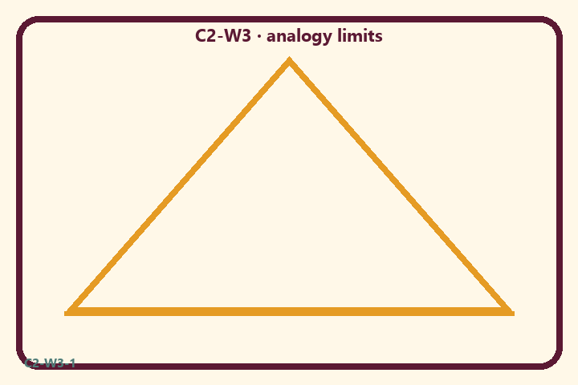
Prompt | My notes
Analogy + limits worksheet | ________________
Limit / care | ________________

Application:
________________________________________________________________
________________________________________________________________
What not to say:
________________________________________________________________
________________________________________________________________
KEY IDEA | The clothing analogy teaches continuity with limits; families speak with calm dignity, not fear.

O03 — Calm vs scare speech sort
Sort respectful teaching vs fear tactics.
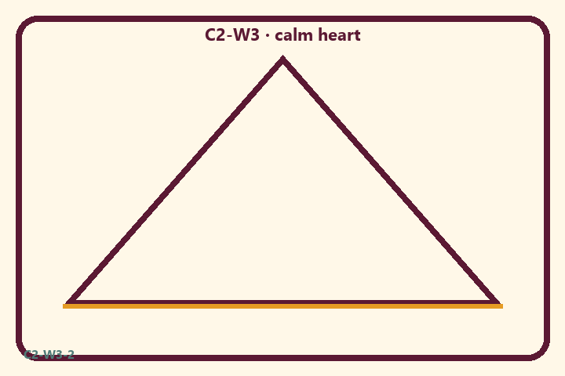
Prompt | My notes
Calm vs scare speech sort | ________________
Limit / care | ________________

Application:
________________________________________________________________
________________________________________________________________
What not to say:
________________________________________________________________
________________________________________________________________
KEY IDEA | The clothing analogy teaches continuity with limits; families speak with calm dignity, not fear.

O04 — Age-sensitive scenarios
Three family talk scenarios with boundaries.
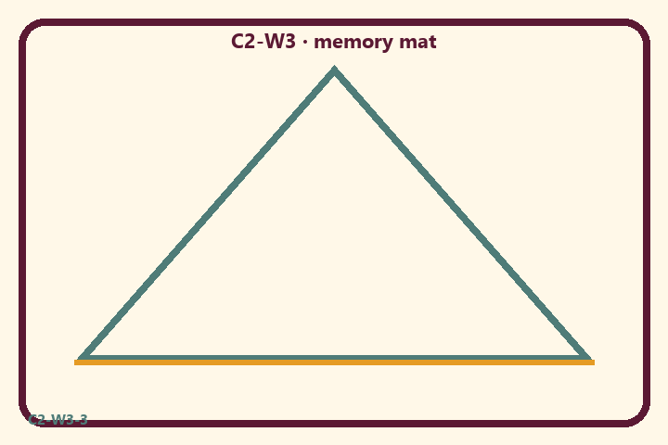
Prompt | My notes
Age-sensitive scenarios | ________________
Limit / care | ________________

Application:
________________________________________________________________
________________________________________________________________
What not to say:
________________________________________________________________
________________________________________________________________
KEY IDEA | The clothing analogy teaches continuity with limits; families speak with calm dignity, not fear.

O05 — Continuity + care diagram
Self continues; body deserves care.
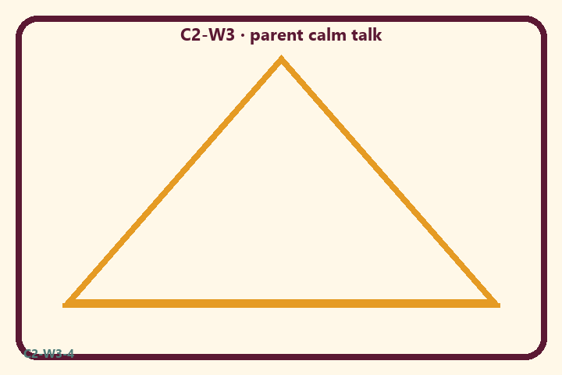
Prompt | My notes
Continuity + care diagram | ________________
Limit / care | ________________

Application:
________________________________________________________________
________________________________________________________________
What not to say:
________________________________________________________________
________________________________________________________________
KEY IDEA | The clothing analogy teaches continuity with limits; families speak with calm dignity, not fear.

O06 — Exit ticket
One analogy + one limit + one calm sentence.
Primary in one sentence:
________________________________________________________________
________________________________________________________________
One analogy or mechanic and its limit:
________________________________________________________________
________________________________________________________________
One home action:
________________________________________________________________
________________________________________________________________
One question I still have:
________________________________________________________________
________________________________________________________________
RIGHTS NOTE | KUTUMBA-original framing; cited third-party material retains its own rights. Human/temple review remains EXTERNAL_OPEN.

