KUTUMBA

C2-W3 — Parent Track
  - Facilitator guide and parent printables
C2-W3 • Birth, Death and Reincarnation
V13 • Families Growing in Krishna Consciousness
Program Director: Swapnil Patil
Internal founding-cohort teaching material — human/temple review EXTERNAL_OPEN
KUTUMBA | Families Growing in Krishna Consciousness

Locked Saturday Schedule
Time | Block
1:50–2:00 | Arrival
2:00–2:10 | Opening mantras + welcome
2:10–2:30 | All-family launch/orientation
2:30–3:10 | Parallel tracks
3:10–3:30 | Reunification + bhakti laboratory
3:30–3:40 | Snack + water
3:40–3:55 | Saṅkalpa + project + home practice
3:55–4:00 | Close

TIME CUE | Track handoff is at 2:30; all groups reunite at 3:10.

Primary verse: BG 2.22
Source URL: https://vedabase.io/en/library/bg/2/22/

Parent Facilitator Run Sheet
Canonical source: 11-weekly-program-library/first-six-months/c2-w3-birth-death-and-reincarnation/teacher/PARENT-GUIDE-V13.md • SHA-256: 0d61aca234dafdd66647bd11a7648f0b29f199a9cb57ec9acec7dc950b8eb2ca
KUTUMBA · Families Growing in Krishna Consciousness Program Director: Swapnil Patil Week: Birth, Death and Reincarnation · Date: 2026-11-21 Track window: Saturday 2:30–3:10 (parents) Reunite: 3:10 for bhakti laboratory Primary: BG 2.22 — https://vedabase.io/en/library/bg/2/22/ Primary mechanic: Analogy with limits Status: Internal founding-cohort teaching material — human/temple review EXTERNAL_OPEN

Essential question
How do we speak calmly about birth and death?

Materials (print before Saturday)
From activities/v13-parent/: P01–P05 Also pens/crayons; verse card; privacy reminder.

Locked Saturday context
- 1:50–2:00 Arrival · 2:00–2:10 Mantras · 2:10–2:30 All-family launch
- 2:30–3:10 This track · 3:10–3:30 Reunify · 3:30–3:40 Snack/water · 3:40–3:55 Saṅkalpa · 3:55–4:00 Close
Parents remain onsite. No public ranking. No forced disclosure.

Source layer (use mid-track)
Primary: BG 2.22 — https://vedabase.io/en/library/bg/2/22/
Devanāgarī: वासांसि जीर्णानि यथा विहाय नवानि गृह्णाति नरोऽपराणि । तथा शरीराणि विहाय जीर्णान्यन्यानि संयाति नवानि देही ॥ २२ ॥
IAST: vāsāṁsi jīrṇāni yathā vihāya navāni gṛhṇāti naro ’parāṇi / tathā śarīrāṇi vihāya jīrṇāny anyāni saṁyāti navāni dehī
KUTUMBA teaching meaning (not a BBT translation): As a person puts on new garments, giving up old ones, the embodied self similarly accepts new bodies, giving up old ones — taught calmly, without fear tactics for children.

Memory line
Birth and death are changes of dress for the eternal self.

V13 printable wiring (Analogy with limits)

V13 printable block 0–5 — Private reflection — how we talk about death
Printable: activities/v13-parent/P01-PRIVATE-REFLECTION.md (P01-PRIVATE-REFLECTION)
What scare or silence patterns do we use?
Keep primary mechanic (Analogy with limits). Block: Scare pedagogy; diagnosing destinations; ghost speculation; closet-shopping for bodies.

V13 printable block 5–12 — Calm speech card sort
Printable: activities/v13-parent/P02-CALM-SPEECH-CARD-SORT.md (P02-CALM-SPEECH-CARD-SORT)
Sort CALM / SCARE / SPECULATION.
Keep primary mechanic (Analogy with limits). Block: Scare pedagogy; diagnosing destinations; ghost speculation; closet-shopping for bodies.

V13 printable block 12–22 — Substantial family case
Printable: activities/v13-parent/P03-SUBSTANTIAL-FAMILY-CASE.md (P03-SUBSTANTIAL-FAMILY-CASE)
Child asks about a grandparent’s death at dinner.
Keep primary mechanic (Analogy with limits). Block: Scare pedagogy; diagnosing destinations; ghost speculation; closet-shopping for bodies.

V13 printable block 22–32 — Household operating application
Printable: activities/v13-parent/P04-HOUSEHOLD-OPERATING-APPLICATION.md (P04-HOUSEHOLD-OPERATING-APPLICATION)
One calm-response line + who speaks first.
Keep primary mechanic (Analogy with limits). Block: Scare pedagogy; diagnosing destinations; ghost speculation; closet-shopping for bodies.

V13 printable block 32–38 — Private next-step saṅkalpa
Printable: activities/v13-parent/P05-PRIVATE-NEXT-STEP-SANKALPA.md (P05-PRIVATE-NEXT-STEP-SANKALPA)
Practice one calm conversation cue.
Keep primary mechanic (Analogy with limits). Block: Scare pedagogy; diagnosing destinations; ghost speculation; closet-shopping for bodies.

Close of track (handoff)
Bring one sentence or artifact to reunification. Do not start next week’s topic. Care boundary: Age-sensitive death talk; no frightening imagery; no unsupported past-life anecdotes.

Inherited classroom depth (from V12 parent-lesson / constructed V13 flow)
Keep story scripts, movement steps, and wonder questions below. Wire printables to the V13 codes above; do not replace this depth with “see research.”

Essential question
How do we speak calmly about birth and death?

Source
BG 2.22 — teaching meaning: As a person puts on new garments, giving up old ones, the embodied self similarly accepts new bodies, giving up old ones — taught calmly, without fear tactics for children.

Discussion
One realistic household tension; no compelled confession.

Application
5–15 minute cue; minimum version counts.

Privacy
No public scoring of sādhana.

P01 — Private reflection — how we talk about death
What scare or silence patterns do we use?

SAFETY & PRIVACY | Write privately. Sharing is optional. Do not collect or place completed sheets in Git.

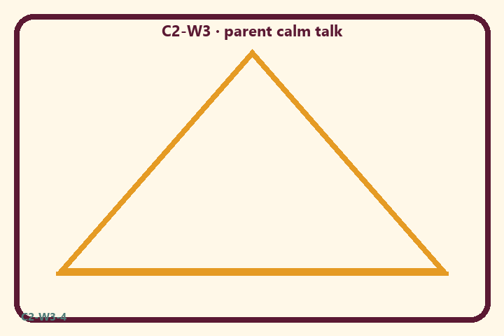
What scare or silence patterns do we use?
Private notes:
________________________________________________________________
________________________________________________________________
________________________________________________________________
________________________________________________________________
Habit to watch this week:
________________________________________________________________
________________________________________________________________
________________________________________________________________
________________________________________________________________

P02 — Calm speech card sort
Sort CALM / SCARE / SPECULATION.
HELPFUL | MISTAKEN

L1  Bodies change like clothes (with limits) | L2  Frighten kids into belief
L3  We care for elders | L4  Diagnose someone’s destination
L5  Photos prove reincarnation | L6  Speak gently about loss
TEACHER NOTE | Scare pedagogy; diagnosing destinations; ghost speculation; closet-shopping for bodies.

P03 — Substantial family case
Child asks about a grandparent’s death at dinner.
SAFETY & PRIVACY | Fictional case. No compelled confession of real events.

At dinner a child asks where a grandparent “went.” One adult freezes. Another launches into graphic afterlife details and a destination diagnosis.
Tempting mistaken conclusion:
________________________________________________________________
________________________________________________________________
________________________________________________________________
Principle from primary:
________________________________________________________________
________________________________________________________________
________________________________________________________________
Compassionate response:
________________________________________________________________
________________________________________________________________
________________________________________________________________
One seven-day household action:
________________________________________________________________
________________________________________________________________
________________________________________________________________
What we should not say:
________________________________________________________________
________________________________________________________________
________________________________________________________________
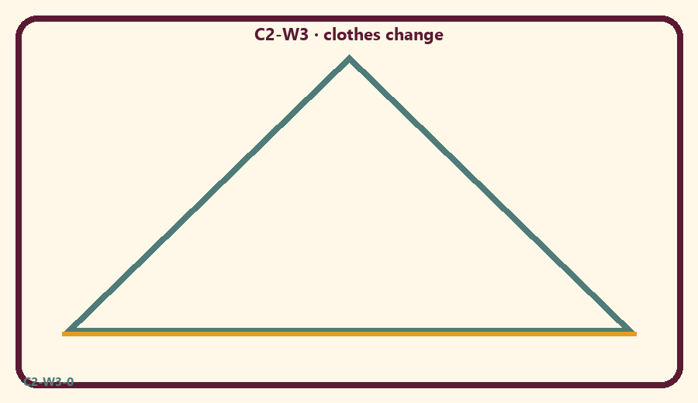

P04 — Household operating application
One calm-response line + who speaks first.
SAFETY & PRIVACY | No ranking and no public reading required.

One household action for seven days:
________________________________________________________________
________________________________________________________________
________________________________________________________________
Trigger (when/where):
________________________________________________________________
________________________________________________________________
________________________________________________________________
Who starts if others are tired:
________________________________________________________________
________________________________________________________________
________________________________________________________________
Minimum version on a hard day:
________________________________________________________________
________________________________________________________________
________________________________________________________________

Memory phrase
Birth and death are changes of dress for the eternal self.

P05 — Private next-step saṅkalpa
Practice one calm conversation cue.
KEY IDEA | specific action + frequency + trigger + minimum version

Specific action:
________________________________________________________________
________________________________________________________________
Frequency:
________________________________________________________________
________________________________________________________________
Trigger (when and where):
________________________________________________________________
________________________________________________________________
Minimum version for a hard day:
________________________________________________________________
________________________________________________________________
Where we will place the reminder:
________________________________________________________________
________________________________________________________________
No ranking. The minimum version counts as success.
RIGHTS NOTE | KUTUMBA-original framing; cited third-party material retains its own rights. Human/temple review remains EXTERNAL_OPEN.

