KUTUMBA

C2-W3 — Younger Teacher Pack
  - K–2 run sheet and activities
C2-W3 • Birth, Death and Reincarnation
V13 • Families Growing in Krishna Consciousness
Program Director: Swapnil Patil
Internal founding-cohort teaching material — human/temple review EXTERNAL_OPEN
KUTUMBA | Families Growing in Krishna Consciousness

Locked Saturday Schedule
Time | Block
1:50–2:00 | Arrival
2:00–2:10 | Opening mantras + welcome
2:10–2:30 | All-family launch/orientation
2:30–3:10 | Parallel tracks
3:10–3:30 | Reunification + bhakti laboratory
3:30–3:40 | Snack + water
3:40–3:55 | Saṅkalpa + project + home practice
3:55–4:00 | Close

TIME CUE | Track handoff is at 2:30; all groups reunite at 3:10.

Primary verse: BG 2.22
Source URL: https://vedabase.io/en/library/bg/2/22/

Younger Teacher Run Sheet
Canonical source: 11-weekly-program-library/first-six-months/c2-w3-birth-death-and-reincarnation/teacher/YOUNGER-TEACHER-GUIDE-V13.md • SHA-256: be3f9dd6b7d682c840cbb44dcfc153c00fa4d3046a07990f5133c9030cdb083c
KUTUMBA · Families Growing in Krishna Consciousness Program Director: Swapnil Patil Week: Birth, Death and Reincarnation · Date: 2026-11-21 Track window: Saturday 2:30–3:10 (K–2) Reunite: 3:10 for bhakti laboratory Primary: BG 2.22 — https://vedabase.io/en/library/bg/2/22/ Primary mechanic: Analogy with limits Status: Internal founding-cohort teaching material — human/temple review EXTERNAL_OPEN

Essential question
How do we speak calmly about birth and death?

Materials (print before Saturday)
From activities/v13-younger/: Y01–Y05 Also pens/crayons; verse card; privacy reminder.

Locked Saturday context
- 1:50–2:00 Arrival · 2:00–2:10 Mantras · 2:10–2:30 All-family launch
- 2:30–3:10 This track · 3:10–3:30 Reunify · 3:30–3:40 Snack/water · 3:40–3:55 Saṅkalpa · 3:55–4:00 Close
Parents remain onsite. No public ranking. No forced disclosure.

Source layer (use mid-track)
Primary: BG 2.22 — https://vedabase.io/en/library/bg/2/22/
Devanāgarī: वासांसि जीर्णानि यथा विहाय नवानि गृह्णाति नरोऽपराणि । तथा शरीराणि विहाय जीर्णान्यन्यानि संयाति नवानि देही ॥ २२ ॥
IAST: vāsāṁsi jīrṇāni yathā vihāya navāni gṛhṇāti naro ’parāṇi / tathā śarīrāṇi vihāya jīrṇāny anyāni saṁyāti navāni dehī
KUTUMBA teaching meaning (not a BBT translation): As a person puts on new garments, giving up old ones, the embodied self similarly accepts new bodies, giving up old ones — taught calmly, without fear tactics for children.

Memory line
Birth and death are changes of dress for the eternal self.

V13 printable wiring (Analogy with limits)

V13 printable block 0–6 — Gentle clothes-change sequence
Printable: activities/v13-younger/Y01-GENTLE-CLOTHES-CHANGE.md (Y01-GENTLE-CLOTHES-CHANGE)
Order worn shirt → folded shirt → new shirt; say the limit.
Keep primary mechanic (Analogy with limits). Block: Scare pedagogy; diagnosing destinations; ghost speculation; closet-shopping for bodies.

V13 printable block 6–14 — Same-friend care matching
Printable: activities/v13-younger/Y02-SAME-FRIEND-CARE-MATCHING.md (Y02-SAME-FRIEND-CARE-MATCHING)
Match care acts that honor a person who changes.
Keep primary mechanic (Analogy with limits). Block: Scare pedagogy; diagnosing destinations; ghost speculation; closet-shopping for bodies.

V13 printable block 14–24 — Calm-heart craft
Printable: activities/v13-younger/Y03-CALM-HEART-CRAFT.md (Y03-CALM-HEART-CRAFT)
Draw a calm heart for kind words about change.
Keep primary mechanic (Analogy with limits). Block: Scare pedagogy; diagnosing destinations; ghost speculation; closet-shopping for bodies.

V13 printable block 24–32 — Gentle words cards
Printable: activities/v13-younger/Y04-GENTLE-WORDS-CARDS.md (Y04-GENTLE-WORDS-CARDS)
Redirect scare talk to gentle cards.
Keep primary mechanic (Analogy with limits). Block: Scare pedagogy; diagnosing destinations; ghost speculation; closet-shopping for bodies.

V13 printable block 32–38 — Memory phrase mat
Printable: activities/v13-younger/Y05-MEMORY-PHRASE-MAT.md (Y05-MEMORY-PHRASE-MAT)
Echo the dress-change memory line gently.
Keep primary mechanic (Analogy with limits). Block: Scare pedagogy; diagnosing destinations; ghost speculation; closet-shopping for bodies.

Close of track (handoff)
Bring one sentence or artifact to reunification. Do not start next week’s topic. Care boundary: Age-sensitive death talk; no frightening imagery; no unsupported past-life anecdotes.

Inherited classroom depth (from V12 YOUNGER-TEACHER-GUIDE.md)
Keep story scripts, movement steps, and wonder questions below. Wire printables to the V13 codes above; do not replace this depth with “see research.”
Track window: approx. 2:30–3:10 (40 minutes). Parents onsite elsewhere; reunite at 3:10.

Objective
Children can say and show: Birth and death are changes of dress for the eternal self — gently, without fear.

Exact memory phrase
Birth and death are changes of dress for the eternal self.

Teacher background (2 minutes, before children arrive)
- Primary: BG 2.22 — As a person puts on new garments, giving up old ones, the embodied self similarly accepts new bodies, giving up old ones — taught calmly, without fear tactics for children. (https://vedabase.io/en/library/bg/2/22/)
- Block: scare pedagogy; ghost talk; funeral role-play; scary pictures; “choosing bodies from a closet.”
- Do not teach adult debates, destinations of deceased relatives, or graphic death.
- If a child mentions a recent death, acknowledge kindly (“That is sad. We can remember them with love.”) and return to the gentle lesson. Do not diagnose.
- Snack later with whole group only; water okay if needed.

Minute-by-minute lesson
Minutes | Block | What you do
0–3 | Welcome + seated circle | Soft voice; “kind words only”; show calm clothes/doll visual — no scary images
3–8 | Memory phrase echo | You say half; they finish; two joyful rounds max
8–16 | Story script | Read/tell the gentle story below; ask one wonder question
16–23 | Movement game | Soft Clothes Walk (rules below)
23–33 | Hands-on + craft | Doll/clothes object lesson + take-home card
33–37 | Coloring | `visuals/V12/line-art-younger.svg` (calm scene only)
37–40 | Cleanup + door handoff | Tell parent the memory phrase + three-night bedtime cue

Age-appropriate story script (5–8 min) — gentle; no gore
Once there was a soft doll who wore a yellow shirt. The doll was still the same doll when the yellow shirt was folded away and a blue shirt was put on. The doll did not disappear. The clothes changed.
Kṛṣṇa teaches something kind: we are not only our clothes-of-the-body. When a body grows from little to bigger — like baby clothes to bigger clothes — we are still us. Someday bodies finish their work, the way worn clothes are set aside. The person Kṛṣṇa knows continues. We do not need to be afraid in this room. Tonight we practice kind words and remembering Kṛṣṇa with a calm heart.
Rules: no invented deity dialogue; no frightening detail; no funerals, hospitals, blood, ghosts, or “dying games.” Stop at the moral: bodies change like clothes; we speak calmly; we remember Kṛṣṇa gently.

Three wonder questions
1. What stayed the same when the doll’s clothes changed?
2. Whom can we remember with kindness this week?
3. When could our family remember Kṛṣṇa for one minute before sleep?

Movement game (5–7 min) — Soft Clothes Walk — C2-W3
1. Children walk gently in a circle holding (or pretending to hold) a soft scarf “shirt.”
2. When you say “Change!”, they pause and fold the scarf to their heart (no throwing).
3. You say the first half of the memory phrase; they finish it.
4. Two rounds only; then sit. Redirect: “Feet on the floor. Kind words only. Soft bodies.”

Hands-on object lesson (8–10 min) — Doll / clothes
Object: One classroom doll (or paper doll) + two simple outfits or colored paper shirts. Steps:
1. Teacher shows doll in outfit A: “This is the same friend.”
2. Change to outfit B slowly: “Clothes changed. Friend is still here.”
3. Children say: “The doll stays. The clothes change.”
4. Secure ending: “Our bodies change too. We speak kindly. We remember Kṛṣṇa.”
Never: “Now the doll dies.” Never closet-shopping for “next life animals.”

Craft (8–10 min)
Clothes-card: Fold a card. Outside: draw a simple shirt. Inside: write or sticker the memory phrase. Optional: glue a tiny fabric scrap. Children take it home to look at before bedtime remembrance.

Coloring / line-art
Color ../visuals/V12/line-art-younger.svg. Title the page with C2-W3. If the art is unclear, children draw a calm shirt and a smiling child praying — no graves, no ghosts.

Sanskrit exposure (optional, 1 min)
Softly invite hearing one word from the verse: dehī (the embodied self) — or simply Kṛṣṇa / Hare. Never forced volume.

Behavior redirects
- “Feet on the floor.”
- “Kind words only.”
- “That toy rests for now.”
- “We use soft voices about bodies.”
- Quiet reset in visible space if needed (parents onsite).

Backup low-prep (if craft or doll fails)
Sit in a circle; pass a soft scarf; each child says one kind word; end with memory phrase echo twice.

Extension
Helper role: hand out crayons / collect papers / hold the “calm scarf.”

Materials
Printed line art; crayons; memory cards; soft scarf; doll or paper doll + two outfits/paper shirts; card stock; tape; fabric scrap optional.

Cleanup / handoff
3 minutes cleanup. At door: tell parent the memory phrase and: “Please try one-minute bedtime remembrance on three nights.”

Home-practice explanation to parents
“Please say the memory phrase once and do one calm minute of remembrance before bed on three nights. Soft language only — no scare stories.”

Child House Rules
Canonical source: launch/CHILD-HOUSE-RULES.md • SHA-256: 6a525f3dd1da740db86e246622696c7b08e28c1f1475227567d639a5bd54ce47
Parents remain onsite. Facilitators guide the session. Host property rules also apply.

Shared rules (all ages)
1. Keep your body safe — feet on the floor; hands gentle.
2. Use respectful speech — no teasing, yelling, or mean labels.
3. Follow the facilitator safety cue immediately (pause / freeze / come here).
4. No jumping on furniture.
5. No indoor throwing.
6. No writing on walls, books, or furniture that are not activity materials.
7. Ask before entering private rooms.
8. Respect belongings — ask before touching what is not yours.
9. Devices away unless the lesson specifically needs them.
10. Snack only in the allowed area; water anytime with permission.
11. Help clean up before leaving.

Correction ladder (no public shame)
1. Calm reminder
2. Redirect / offer a choice
3. Brief quiet reset in a visible space
4. Parent involvement
5. Sit out a specific activity
6. Private parent/program conversation for repeated patterns
Never: public shame, yelling, sarcasm, corporal punishment, forced chanting, or comparing children.

Younger (K–2) emphasis
- Soft voices indoors
- Stay with the group
- Hands to yourself
- Ask before leaving the room

Older (Grades 4–5) emphasis
- Model respectful speech for younger children
- Devices fully away unless assigned
- Help clean-up leadership
- Honest questions welcome; speculation wait for source check
Printable versions: W1 launch-pack CHILD-RULES-YOUNGER.md and CHILD-RULES-OLDER.md.

Y01 — Gentle clothes-change sequence
Order worn shirt → folded shirt → new shirt; say the limit.
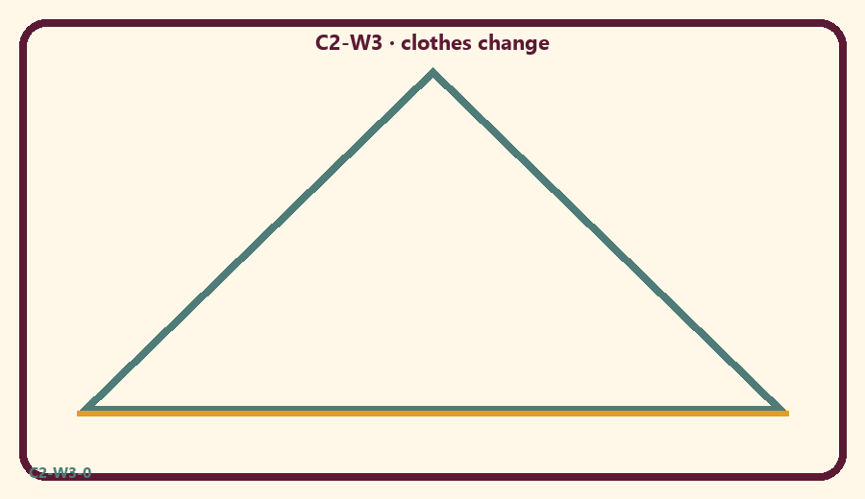
CARD 1  Fold old shirt | CARD 2  Put on fresh shirt
CARD 3  Say a kind thank-you | CARD 4  Scare story
CARD 5  Hug a friend | CARD 6  Guess a ghost tale

Memory phrase
Birth and death are changes of dress for the eternal self.
Cut on the dashed borders. Keep each card intact.
TEACHER NOTE | Age-sensitive death talk; no frightening imagery; no unsupported past-life anecdotes.

Y02 — Same-friend care matching
Match care acts that honor a person who changes.
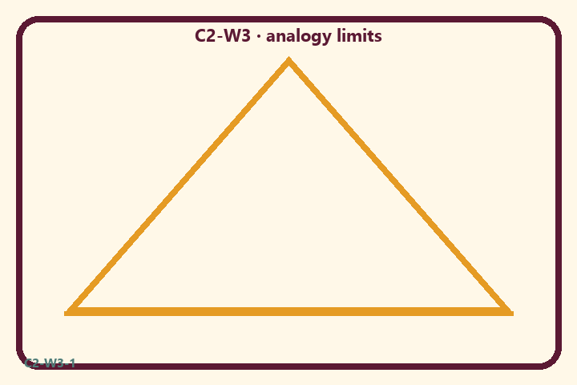
CARD 1  Fold old shirt | CARD 2  Put on fresh shirt
CARD 3  Say a kind thank-you | CARD 4  Scare story
CARD 5  Hug a friend | CARD 6  Guess a ghost tale

Memory phrase
Birth and death are changes of dress for the eternal self.
Cut on the dashed borders. Keep each card intact.
TEACHER NOTE | Age-sensitive death talk; no frightening imagery; no unsupported past-life anecdotes.

Y03 — Calm-heart craft
Draw a calm heart for kind words about change.
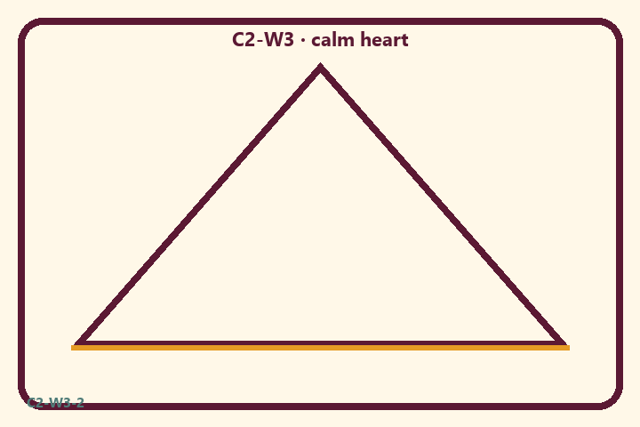
CARD 1  Fold old shirt | CARD 2  Put on fresh shirt
CARD 3  Say a kind thank-you | CARD 4  Scare story
CARD 5  Hug a friend | CARD 6  Guess a ghost tale

Memory phrase
Birth and death are changes of dress for the eternal self.
Cut on the dashed borders. Keep each card intact.
TEACHER NOTE | Age-sensitive death talk; no frightening imagery; no unsupported past-life anecdotes.

Y04 — Gentle words cards
Redirect scare talk to gentle cards.
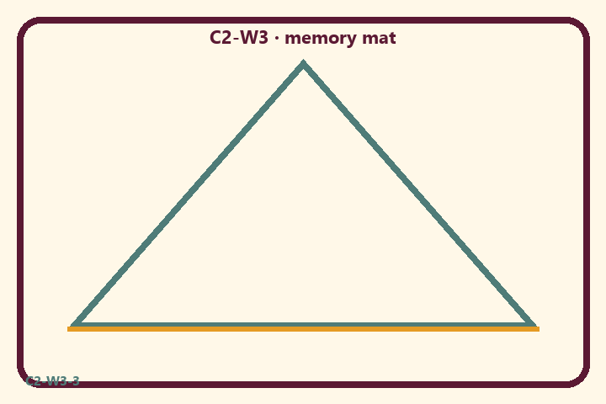
CARD 1  Fold old shirt | CARD 2  Put on fresh shirt
CARD 3  Say a kind thank-you | CARD 4  Scare story
CARD 5  Hug a friend | CARD 6  Guess a ghost tale

Memory phrase
Birth and death are changes of dress for the eternal self.
Cut on the dashed borders. Keep each card intact.
TEACHER NOTE | Age-sensitive death talk; no frightening imagery; no unsupported past-life anecdotes.

Y05 — Memory phrase mat
Echo the dress-change memory line gently.

Memory phrase
Birth and death are changes of dress for the eternal self.
BG 2.22 · family week
RIGHTS NOTE | KUTUMBA-original framing; cited third-party material retains its own rights. Human/temple review remains EXTERNAL_OPEN.

