KUTUMBA

C2-W4 — Older Teacher Pack
  - Grades 4–5 run sheet and activities
C2-W4 • The Three Modes of Material Nature
V13 • Families Growing in Krishna Consciousness
Program Director: Swapnil Patil
Internal founding-cohort teaching material — human/temple review EXTERNAL_OPEN
KUTUMBA | Families Growing in Krishna Consciousness

Locked Saturday Schedule
Time | Block
1:50–2:00 | Arrival
2:00–2:10 | Opening mantras + welcome
2:10–2:30 | All-family launch/orientation
2:30–3:10 | Parallel tracks
3:10–3:30 | Reunification + bhakti laboratory
3:30–3:40 | Snack + water
3:40–3:55 | Saṅkalpa + project + home practice
3:55–4:00 | Close

TIME CUE | Track handoff is at 2:30; all groups reunite at 3:10.

Primary verse: BG 14.5
Source URL: https://vedabase.io/en/library/bg/14/5/

Older Teacher Run Sheet
Canonical source: 11-weekly-program-library/first-six-months/c2-w4-the-three-modes-of-material-nature/teacher/OLDER-TEACHER-GUIDE-V13.md • SHA-256: 1d854974939e1a82f299e514af71a8571c21f8c76b2a5bbfd8e1abd82d16c89e
KUTUMBA · Families Growing in Krishna Consciousness Program Director: Swapnil Patil Week: The Three Modes of Material Nature · Date: 2026-11-28 Track window: Saturday 2:30–3:10 (Grades 4–5) Reunite: 3:10 for bhakti laboratory Primary: BG 14.5 — https://vedabase.io/en/library/bg/14/5/ Primary mechanic: Scenario sorting Status: Internal founding-cohort teaching material — human/temple review EXTERNAL_OPEN

Essential question
Which mode is shaping this moment?

Materials (print before Saturday)
From activities/v13-older/: O01–O06 Also pens/crayons; verse card; privacy reminder.

Locked Saturday context
- 1:50–2:00 Arrival · 2:00–2:10 Mantras · 2:10–2:30 All-family launch
- 2:30–3:10 This track · 3:10–3:30 Reunify · 3:30–3:40 Snack/water · 3:40–3:55 Saṅkalpa · 3:55–4:00 Close
Parents remain onsite. No public ranking. No forced disclosure.

Source layer (use mid-track)
Primary: BG 14.5 — https://vedabase.io/en/library/bg/14/5/
Devanāgarī: सत्त्वं रजस्तम इति गुणा: प्रकृतिसम्भवा: । निबध्नन्ति महाबाहो देहे देहिनमव्ययम् ॥ ५ ॥
IAST: sattvaṁ rajas tama iti guṇāḥ prakṛti-sambhavāḥ / nibadhnanti mahā-bāho dehe dehinam avyayam
KUTUMBA teaching meaning (not a BBT translation): Goodness, passion, and ignorance — born of material nature — bind the eternal embodied self within the body.

Memory line
Calm helps me hear Kṛṣṇa.

V13 printable wiring (Scenario sorting)

V13 printable block 0–6 — BG 14.5 observation
Printable: activities/v13-older/O01-BG-14-5-OBSERVATION.md (O01-BG-14-5-OBSERVATION)
Name three modes; what they do; what they are not.
Keep primary mechanic (Scenario sorting). Block: Labeling people/families as a mode; food policing as spiritual superiority.

V13 printable block 6–14 — Mode scenario board
Printable: activities/v13-older/O02-MODE-SCENARIO-BOARD.md (O02-MODE-SCENARIO-BOARD)
Sort scenarios into moment influences.
Keep primary mechanic (Scenario sorting). Block: Labeling people/families as a mode; food policing as spiritual superiority.

V13 printable block 14–22 — Support vs label sort
Printable: activities/v13-older/O03-SUPPORT-VS-LABEL-SORT.md (O03-SUPPORT-VS-LABEL-SORT)
Helpful environment support vs person-labeling.
Keep primary mechanic (Scenario sorting). Block: Labeling people/families as a mode; food policing as spiritual superiority.

V13 printable block 22–30 — Habit/environment scenarios
Printable: activities/v13-older/O04-HABIT-ENVIRONMENT-SCENARIOS.md (O04-HABIT-ENVIRONMENT-SCENARIOS)
Three household chaos/clarity cases.
Keep primary mechanic (Scenario sorting). Block: Labeling people/families as a mode; food policing as spiritual superiority.

V13 printable block 30–36 — Clarity-before-chanting diagram
Printable: activities/v13-older/O05-CLARITY-BEFORE-CHANTING-DIAGRAM.md (O05-CLARITY-BEFORE-CHANTING-DIAGRAM)
Reset → practice → review.
Keep primary mechanic (Scenario sorting). Block: Labeling people/families as a mode; food policing as spiritual superiority.

V13 printable block 36–40 — Exit ticket
Printable: activities/v13-older/O06-EXIT-TICKET.md (O06-EXIT-TICKET)
One moment notice + one support + no person label.
Keep primary mechanic (Scenario sorting). Block: Labeling people/families as a mode; food policing as spiritual superiority.

Close of track (handoff)
Bring one sentence or artifact to reunification. Do not start next week’s topic. Care boundary: Never label persons. Avoid food policing. Environment supports practice; devotion is the goal.

Inherited classroom depth (from V12 OLDER-TEACHER-GUIDE.md)
Keep story scripts, movement steps, and wonder questions below. Wire printables to the V13 codes above; do not replace this depth with “see research.”
Essential question: Which mode is shaping this moment? Primary: BG 14.5 — https://vedabase.io/en/library/bg/14/5/ Conclusion students should state: Modes are changing influences that bind the embodied self; we describe conditions, not people; clarity serves bhakti, not pride.

Objective
Students will (1) observe BG 14.5 on VedaBase and paraphrase the KUTUMBA teaching meaning, (2) sort scenario cards into sattva/rajas/tamas tendencies without labeling persons, (3) complete a diagram and worksheet, and (4) write one reunification sentence plus a project contribution idea.

Teacher background
- Teaching meaning: Goodness, passion, and ignorance — born of material nature — bind the eternal embodied self within the body.
- Supports: BG 14.6–14.9 (tendencies + goodness trap), 14.17 (fruits), 14.26 (bhakti transcends), 17.8–10 only as non-policing food-tendency footnote if asked.
- Misconception to interrupt immediately: using modes to shame siblings/classmates/other families.

Materials
- Devices or printed screenshot of https://vedabase.io/en/library/bg/14/5/ (teacher-controlled)
- activities/OLDER-ACTIVITY-PACK.md printables / mode-sort cards
- activities/OLDER-ANSWER-KEY.md (teacher only)
- Concept diagram (visuals/V12/concept-diagram.svg or board copy)
- Pencils; timer; scenario card deck (6 cards minimum)

Minute-by-minute

0–5 — Hook
Show three evening captions (calm ordered / multi-screen rush / neglected dull). Ask: “Same family—what changed?” Collect condition words only. Post essential question.

5–12 — Primary text observation
Students open or view BG 14.5 and complete four lines in notebooks:
1. Setting: Kṛṣṇa teaching Arjuna in the Gītā (Chapter 14).
2. Key Sanskrit/IAST phrase they notice (e.g., guṇāḥ prakṛti-sambhavāḥ or nibadhnanti).
3. Paraphrase (KUTUMBA teaching meaning): Goodness, passion, and ignorance — born of material nature — bind the eternal embodied self within the body.
4. **What it does not say:** That we should nickname people as modes.
Teacher checks paraphrases against answer key; corrects invented verse numbers.

12–18 — Worksheet questions (from activity pack)
Students answer:
- One tendency of each mode (from BG 14.6–9 / 14.17 sense).
- Why goodness can still bind (BG 14.6).
- How BG 14.26 redirects pride.

18–26 — Scenario cards + mode_sort puzzle
In pairs, sort six short scenarios into three columns: clarifying / restless-craving / dull-covering. Rule card on table: “Sort the situation, not the person.” Teacher circulates; flips any “Rahul is tamas” talk back to condition language. One group shares a sort aloud; class may challenge kindly with evidence from tendencies.

26–32 — Diagram task
On the concept diagram, label:
- Three modes
- “Bind the embodied self”
- Arrow to “bhakti transcends (BG 14.26)”
- Red “X” on “label people”

32–36 — Project contribution + reflection
- Write one evening redesign: remove / add / move earlier / simplify.
- Reflection sentence: “An analogy helps me picture modes, but scripture is the authority because…”
- Extension (fast finishers): How would food-tendency talk stay kind under BG 17.8–10 without policing allergies/budgets?

36–40 — Reunification sentence + cleanup
Each student drafts one sentence to share upstairs, e.g.: “Modes change; we reset the room so we can hear, without calling people names.” Stack materials; teacher keeps answer key private.

Answer key pointer
Use activities/OLDER-ANSWER-KEY.md for paraphrase targets and reject lists. Do not distribute the key to students.

Behavior / speech ethics
- Interrupt mode-labeling of peers in one calm sentence.
- No confession pressure about home mess.
- Privacy: no ranking families’ “scores.”

Backup if tech fails
Teacher reads IAST aloud from verse card; students write paraphrase from dictation; card sort continues offline.

O01 — BG 14.5 observation
Name three modes; what they do; what they are not.

VERSE CARD • BG 14.5
सत्त्वं रजस्तम इति गुणा: प्रकृतिसम्भवा: । निबध्नन्ति महाबाहो देहे देहिनमव्ययम् ॥ ५ ॥
sattvaṁ rajas tama iti guṇāḥ prakṛti-sambhavāḥ / nibadhnanti mahā-bāho dehe dehinam avyayam
KUTUMBA teaching meaning: Goodness, passion, and ignorance — born of material nature — bind the eternal embodied self within the body.
Source: https://vedabase.io/en/library/bg/14/5/
Rights/status: Scripture display/source: VedaBase; teaching meaning: KUTUMBA-original (not labeled as BBT translation).

What does the verse teach in my words?
________________________________________________________________
________________________________________________________________
What misconception does this week block?
________________________________________________________________
________________________________________________________________
One question for the facilitator:
________________________________________________________________
________________________________________________________________

O02 — Mode scenario board
Sort scenarios into moment influences.
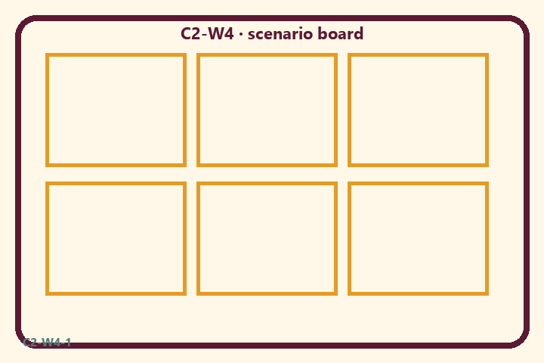
Prompt | My notes
Mode scenario board | ________________
Limit / care | ________________

Application:
________________________________________________________________
________________________________________________________________
What not to say:
________________________________________________________________
________________________________________________________________
KEY IDEA | Sattva, rajas, and tamas condition the embodied self; notice the moment; design supports; never label persons.

O03 — Support vs label sort
Helpful environment support vs person-labeling.
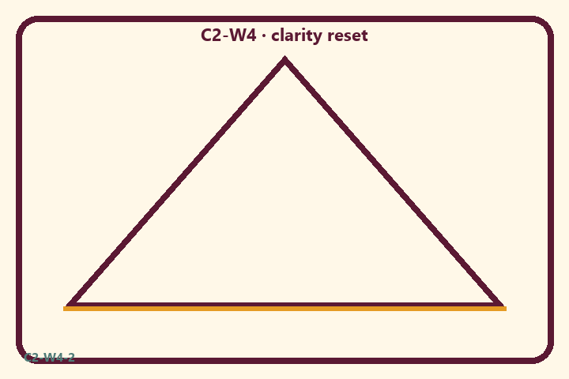
Prompt | My notes
Support vs label sort | ________________
Limit / care | ________________

Application:
________________________________________________________________
________________________________________________________________
What not to say:
________________________________________________________________
________________________________________________________________
KEY IDEA | Sattva, rajas, and tamas condition the embodied self; notice the moment; design supports; never label persons.

O04 — Habit/environment scenarios
Three household chaos/clarity cases.
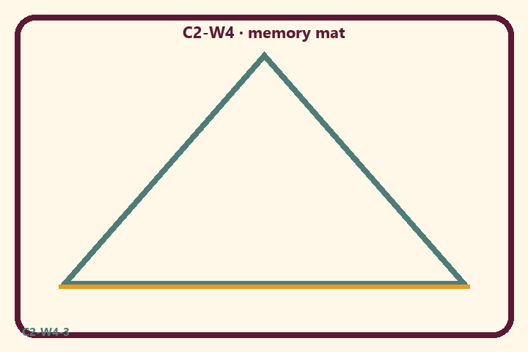
Prompt | My notes
Habit/environment scenarios | ________________
Limit / care | ________________

Application:
________________________________________________________________
________________________________________________________________
What not to say:
________________________________________________________________
________________________________________________________________
KEY IDEA | Sattva, rajas, and tamas condition the embodied self; notice the moment; design supports; never label persons.

O05 — Clarity-before-chanting diagram
Reset → practice → review.
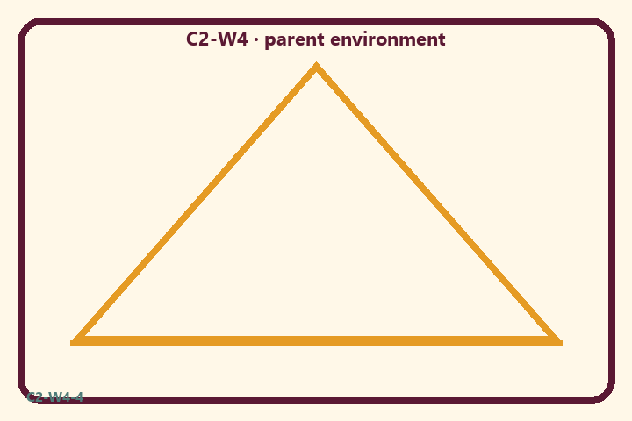
Prompt | My notes
Clarity-before-chanting diagram | ________________
Limit / care | ________________

Application:
________________________________________________________________
________________________________________________________________
What not to say:
________________________________________________________________
________________________________________________________________
KEY IDEA | Sattva, rajas, and tamas condition the embodied self; notice the moment; design supports; never label persons.

O06 — Exit ticket
One moment notice + one support + no person label.
Primary in one sentence:
________________________________________________________________
________________________________________________________________
One analogy or mechanic and its limit:
________________________________________________________________
________________________________________________________________
One home action:
________________________________________________________________
________________________________________________________________
One question I still have:
________________________________________________________________
________________________________________________________________
RIGHTS NOTE | KUTUMBA-original framing; cited third-party material retains its own rights. Human/temple review remains EXTERNAL_OPEN.

