KUTUMBA

C2-W4 — Parent Track
  - Facilitator guide and parent printables
C2-W4 • The Three Modes of Material Nature
V13 • Families Growing in Krishna Consciousness
Program Director: Swapnil Patil
Internal founding-cohort teaching material — human/temple review EXTERNAL_OPEN
KUTUMBA | Families Growing in Krishna Consciousness

Locked Saturday Schedule
Time | Block
1:50–2:00 | Arrival
2:00–2:10 | Opening mantras + welcome
2:10–2:30 | All-family launch/orientation
2:30–3:10 | Parallel tracks
3:10–3:30 | Reunification + bhakti laboratory
3:30–3:40 | Snack + water
3:40–3:55 | Saṅkalpa + project + home practice
3:55–4:00 | Close

TIME CUE | Track handoff is at 2:30; all groups reunite at 3:10.

Primary verse: BG 14.5
Source URL: https://vedabase.io/en/library/bg/14/5/

Parent Facilitator Run Sheet
Canonical source: 11-weekly-program-library/first-six-months/c2-w4-the-three-modes-of-material-nature/teacher/PARENT-GUIDE-V13.md • SHA-256: a06a163c0497ec57a71f2aefce08210e51b65c7bb394289eb12cbe85949d1ca6
KUTUMBA · Families Growing in Krishna Consciousness Program Director: Swapnil Patil Week: The Three Modes of Material Nature · Date: 2026-11-28 Track window: Saturday 2:30–3:10 (parents) Reunite: 3:10 for bhakti laboratory Primary: BG 14.5 — https://vedabase.io/en/library/bg/14/5/ Primary mechanic: Scenario sorting Status: Internal founding-cohort teaching material — human/temple review EXTERNAL_OPEN

Essential question
Which mode is shaping this moment?

Materials (print before Saturday)
From activities/v13-parent/: P01–P05 Also pens/crayons; verse card; privacy reminder.

Locked Saturday context
- 1:50–2:00 Arrival · 2:00–2:10 Mantras · 2:10–2:30 All-family launch
- 2:30–3:10 This track · 3:10–3:30 Reunify · 3:30–3:40 Snack/water · 3:40–3:55 Saṅkalpa · 3:55–4:00 Close
Parents remain onsite. No public ranking. No forced disclosure.

Source layer (use mid-track)
Primary: BG 14.5 — https://vedabase.io/en/library/bg/14/5/
Devanāgarī: सत्त्वं रजस्तम इति गुणा: प्रकृतिसम्भवा: । निबध्नन्ति महाबाहो देहे देहिनमव्ययम् ॥ ५ ॥
IAST: sattvaṁ rajas tama iti guṇāḥ prakṛti-sambhavāḥ / nibadhnanti mahā-bāho dehe dehinam avyayam
KUTUMBA teaching meaning (not a BBT translation): Goodness, passion, and ignorance — born of material nature — bind the eternal embodied self within the body.

Memory line
Calm helps me hear Kṛṣṇa.

V13 printable wiring (Scenario sorting)

V13 printable block 0–5 — Private reflection — habit environment
Printable: activities/v13-parent/P01-PRIVATE-REFLECTION.md (P01-PRIVATE-REFLECTION)
Which room cues push restless or dull moments?
Keep primary mechanic (Scenario sorting). Block: Labeling people/families as a mode; food policing as spiritual superiority.

V13 printable block 5–12 — Support vs label card sort
Printable: activities/v13-parent/P02-SUPPORT-VS-LABEL-CARD-SORT.md (P02-SUPPORT-VS-LABEL-CARD-SORT)
Sort SUPPORT / LABELING / FOOD POLICING.
Keep primary mechanic (Scenario sorting). Block: Labeling people/families as a mode; food policing as spiritual superiority.

V13 printable block 12–22 — Substantial family case
Printable: activities/v13-parent/P03-SUBSTANTIAL-FAMILY-CASE.md (P03-SUBSTANTIAL-FAMILY-CASE)
Parent calls a child “tamasic” after late screens.
Keep primary mechanic (Scenario sorting). Block: Labeling people/families as a mode; food policing as spiritual superiority.

V13 printable block 22–32 — Household operating application
Printable: activities/v13-parent/P04-HOUSEHOLD-OPERATING-APPLICATION.md (P04-HOUSEHOLD-OPERATING-APPLICATION)
One five-minute reset ritual for seven days.
Keep primary mechanic (Scenario sorting). Block: Labeling people/families as a mode; food policing as spiritual superiority.

V13 printable block 32–38 — Private next-step saṅkalpa
Printable: activities/v13-parent/P05-PRIVATE-NEXT-STEP-SANKALPA.md (P05-PRIVATE-NEXT-STEP-SANKALPA)
Environment support + minimum version.
Keep primary mechanic (Scenario sorting). Block: Labeling people/families as a mode; food policing as spiritual superiority.

Close of track (handoff)
Bring one sentence or artifact to reunification. Do not start next week’s topic. Care boundary: Never label persons. Avoid food policing. Environment supports practice; devotion is the goal.

Inherited classroom depth (from V12 parent-lesson / constructed V13 flow)
Keep story scripts, movement steps, and wonder questions below. Wire printables to the V13 codes above; do not replace this depth with “see research.”

Essential question
Which mode is shaping this moment?

Source
BG 14.5 — teaching meaning: Goodness, passion, and ignorance — born of material nature — bind the eternal embodied self within the body.

Discussion
One realistic household tension; no compelled confession.

Application
5–15 minute cue; minimum version counts.

Privacy
No public scoring of sādhana.

P01 — Private reflection — habit environment
Which room cues push restless or dull moments?

SAFETY & PRIVACY | Write privately. Sharing is optional. Do not collect or place completed sheets in Git.

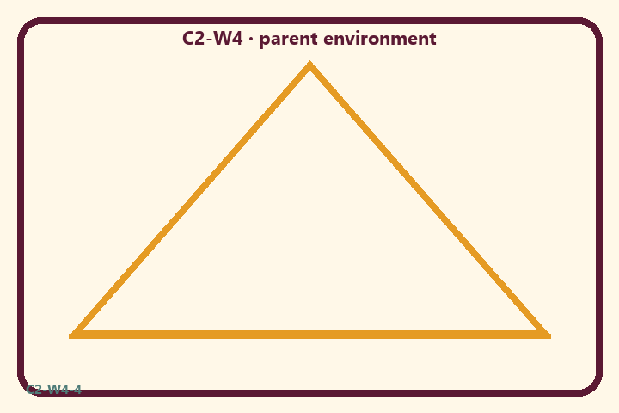
Which room cues push restless or dull moments?
Private notes:
________________________________________________________________
________________________________________________________________
________________________________________________________________
________________________________________________________________
Habit to watch this week:
________________________________________________________________
________________________________________________________________
________________________________________________________________
________________________________________________________________

P02 — Support vs label card sort
Sort SUPPORT / LABELING / FOOD POLICING.
HELPFUL | MISTAKEN

L1  Clear the table before reading | L2  You are tamasic
L3  Dim lights for bedtime | L4  Our family is rajasic
L5  Phone basket at door | L6  Food police lecture
TEACHER NOTE | Labeling people/families as a mode; food policing as spiritual superiority.

P03 — Substantial family case
Parent calls a child “tamasic” after late screens.
SAFETY & PRIVACY | Fictional case. No compelled confession of real events.

After late screens, a parent announces “you’re being tamasic again” in front of siblings. The child shuts down; another parent starts food policing as spiritual ranking.
Tempting mistaken conclusion:
________________________________________________________________
________________________________________________________________
________________________________________________________________
Principle from primary:
________________________________________________________________
________________________________________________________________
________________________________________________________________
Compassionate response:
________________________________________________________________
________________________________________________________________
________________________________________________________________
One seven-day household action:
________________________________________________________________
________________________________________________________________
________________________________________________________________
What we should not say:
________________________________________________________________
________________________________________________________________
________________________________________________________________
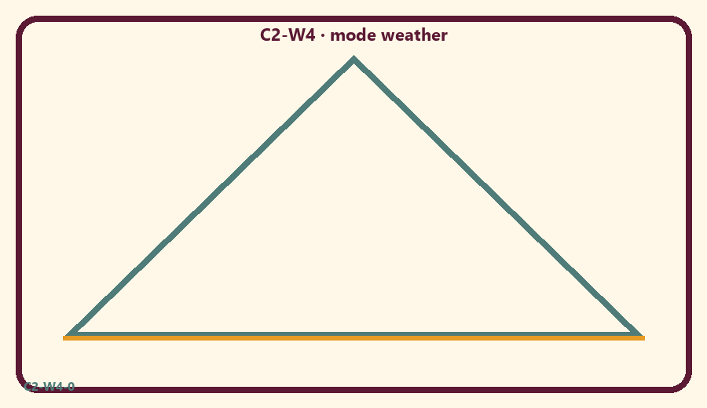

P04 — Household operating application
One five-minute reset ritual for seven days.
SAFETY & PRIVACY | No ranking and no public reading required.

One household action for seven days:
________________________________________________________________
________________________________________________________________
________________________________________________________________
Trigger (when/where):
________________________________________________________________
________________________________________________________________
________________________________________________________________
Who starts if others are tired:
________________________________________________________________
________________________________________________________________
________________________________________________________________
Minimum version on a hard day:
________________________________________________________________
________________________________________________________________
________________________________________________________________

Memory phrase
Calm helps me hear Kṛṣṇa.

P05 — Private next-step saṅkalpa
Environment support + minimum version.
KEY IDEA | specific action + frequency + trigger + minimum version

Specific action:
________________________________________________________________
________________________________________________________________
Frequency:
________________________________________________________________
________________________________________________________________
Trigger (when and where):
________________________________________________________________
________________________________________________________________
Minimum version for a hard day:
________________________________________________________________
________________________________________________________________
Where we will place the reminder:
________________________________________________________________
________________________________________________________________
No ranking. The minimum version counts as success.
RIGHTS NOTE | KUTUMBA-original framing; cited third-party material retains its own rights. Human/temple review remains EXTERNAL_OPEN.

