KUTUMBA

C2-W4 — Younger Teacher Pack
  - K–2 run sheet and activities
C2-W4 • The Three Modes of Material Nature
V13 • Families Growing in Krishna Consciousness
Program Director: Swapnil Patil
Internal founding-cohort teaching material — human/temple review EXTERNAL_OPEN
KUTUMBA | Families Growing in Krishna Consciousness

Locked Saturday Schedule
Time | Block
1:50–2:00 | Arrival
2:00–2:10 | Opening mantras + welcome
2:10–2:30 | All-family launch/orientation
2:30–3:10 | Parallel tracks
3:10–3:30 | Reunification + bhakti laboratory
3:30–3:40 | Snack + water
3:40–3:55 | Saṅkalpa + project + home practice
3:55–4:00 | Close

TIME CUE | Track handoff is at 2:30; all groups reunite at 3:10.

Primary verse: BG 14.5
Source URL: https://vedabase.io/en/library/bg/14/5/

Younger Teacher Run Sheet
Canonical source: 11-weekly-program-library/first-six-months/c2-w4-the-three-modes-of-material-nature/teacher/YOUNGER-TEACHER-GUIDE-V13.md • SHA-256: 93029d25b38834ca1f9db0457bd84d379bf46c67d00480336bd450c7567d91ab
KUTUMBA · Families Growing in Krishna Consciousness Program Director: Swapnil Patil Week: The Three Modes of Material Nature · Date: 2026-11-28 Track window: Saturday 2:30–3:10 (K–2) Reunite: 3:10 for bhakti laboratory Primary: BG 14.5 — https://vedabase.io/en/library/bg/14/5/ Primary mechanic: Scenario sorting Status: Internal founding-cohort teaching material — human/temple review EXTERNAL_OPEN

Essential question
Which mode is shaping this moment?

Materials (print before Saturday)
From activities/v13-younger/: Y01–Y05 Also pens/crayons; verse card; privacy reminder.

Locked Saturday context
- 1:50–2:00 Arrival · 2:00–2:10 Mantras · 2:10–2:30 All-family launch
- 2:30–3:10 This track · 3:10–3:30 Reunify · 3:30–3:40 Snack/water · 3:40–3:55 Saṅkalpa · 3:55–4:00 Close
Parents remain onsite. No public ranking. No forced disclosure.

Source layer (use mid-track)
Primary: BG 14.5 — https://vedabase.io/en/library/bg/14/5/
Devanāgarī: सत्त्वं रजस्तम इति गुणा: प्रकृतिसम्भवा: । निबध्नन्ति महाबाहो देहे देहिनमव्ययम् ॥ ५ ॥
IAST: sattvaṁ rajas tama iti guṇāḥ prakṛti-sambhavāḥ / nibadhnanti mahā-bāho dehe dehinam avyayam
KUTUMBA teaching meaning (not a BBT translation): Goodness, passion, and ignorance — born of material nature — bind the eternal embodied self within the body.

Memory line
Calm helps me hear Kṛṣṇa.

V13 printable wiring (Scenario sorting)

V13 printable block 0–6 — Mode weather corners
Printable: activities/v13-younger/Y01-MODE-WEATHER-CORNERS.md (Y01-MODE-WEATHER-CORNERS)
Sunny/windy/foggy corners for calm/busy/sleepy moments — not people.
Keep primary mechanic (Scenario sorting). Block: Labeling people/families as a mode; food policing as spiritual superiority.

V13 printable block 6–14 — Moment matching
Printable: activities/v13-younger/Y02-MOMENT-MATCHING.md (Y02-MOMENT-MATCHING)
Match scenes to weather icons.
Keep primary mechanic (Scenario sorting). Block: Labeling people/families as a mode; food policing as spiritual superiority.

V13 printable block 14–24 — Reset-corner craft
Printable: activities/v13-younger/Y03-RESET-CORNER-CRAFT.md (Y03-RESET-CORNER-CRAFT)
Make a calm-corner card for home.
Keep primary mechanic (Scenario sorting). Block: Labeling people/families as a mode; food policing as spiritual superiority.

V13 printable block 24–32 — Kind reset cards
Printable: activities/v13-younger/Y04-KIND-RESET-CARDS.md (Y04-KIND-RESET-CARDS)
Words for resetting a chaotic room.
Keep primary mechanic (Scenario sorting). Block: Labeling people/families as a mode; food policing as spiritual superiority.

V13 printable block 32–38 — Memory phrase mat
Printable: activities/v13-younger/Y05-MEMORY-PHRASE-MAT.md (Y05-MEMORY-PHRASE-MAT)
Echo: Calm helps me hear Kṛṣṇa.
Keep primary mechanic (Scenario sorting). Block: Labeling people/families as a mode; food policing as spiritual superiority.

Close of track (handoff)
Bring one sentence or artifact to reunification. Do not start next week’s topic. Care boundary: Never label persons. Avoid food policing. Environment supports practice; devotion is the goal.

Inherited classroom depth (from V12 YOUNGER-TEACHER-GUIDE.md)
Keep story scripts, movement steps, and wonder questions below. Wire printables to the V13 codes above; do not replace this depth with “see research.”
Theme: Modes are like weather in a room—changing influences that help or hinder hearing. Primary: BG 14.5 — https://vedabase.io/en/library/bg/14/5/ Hard block: Never call a child “sattva / rajas / tamas.” Describe the room or the choice.

Objective
By the end of the track, each child can (1) name three simple “weather” feelings—clear, windy, foggy—as room helpers/hinderers, (2) join a five-step room-reset game, and (3) say the memory phrase without labeling friends.

Exact memory phrase
Calm helps me hear Kṛṣṇa.
(Adult memory line differs; children use this actionable phrase.)

Teacher background (2 minutes private prep)
- BG 14.5 teaches that goodness, passion, and ignorance—born of material nature—bind the eternal embodied self in the body.
- For K–2, translate to: rooms and habits can feel clear, rushed, or sleepy-confused; we practice habits that help us hear the holy name.
- Block: mode-shaming, food policing, and comparing families.
- Story must paraphrase only; no invented Kṛṣṇa–child dialogue; no scary destiny talk from BG 14.18.

Materials
- Three weather-face cards (clear sun, windy cloud, fog)
- Soft toss object (beanbag)
- Basket for “tidy three”
- Printed visuals/V12/line-art-younger.svg (US Letter) + crayons
- Take-home card stock (memory phrase inside)
- Optional: teacher-held colored cellophane scrap (no small choking pieces unsupervised)
- Timer; tissues; water

Minute-by-minute run of show

0–5 — Opening / recall
1. Circle sit; feet on floor.
2. Ask: “Who remembers last week’s kind habit?” (one or two shares).
3. Show three weather faces. Children echo: clear / windy / foggy.
4. Say: “Today we learn that rooms can feel different—and we can help our room get ready to hear Kṛṣṇa.”

5–13 — Story script (paraphrase; ~5–8 minutes spoken)
Title: Three Weather Days in One House
Teacher narrates (no invented deity dialogue):
In one house lived a family who loved to chant Kṛṣṇa’s names. On a clear day, toys found their basket, voices were soft, and sitting for a short chant felt easy. On a windy day, screens talked loudly, everyone hurried, and ears felt too busy to listen. On a foggy day, the floor stayed messy, bodies felt heavy, and starting anything seemed hard. The same children lived in that house on all three days. The weather of the room changed. A helper adult said: “We don’t call people weather words. We change three things, wash hands, and try a short chant.” They put three toys away, lowered the noise, sat, and softly answered the holy name. Hearing felt clearer. Remember: calm helps us hear Kṛṣṇa—and we speak kindly about others.
Pause once mid-story for children to hold up which weather face they hear.

13–16 — Three wonder questions
1. What was new in the story about clear, windy, and foggy days?
2. Whom can we serve when the room feels windy or foggy?
3. When can our family practice five quiet minutes before chanting?
Accept short answers; redirect labels (“My brother is fog”) to “The room feels foggy—what can we tidy?”

16–24 — Movement game: Room-Reset Relay (steps)
1. Place three soft “mess” items in the center.
2. On “Clear sky,” children freeze in a calm seated pose.
3. On “Windy,” children do ten quiet tip-toe steps in place (no crashing).
4. On “Foggy,” children move slowly to pick one item into the basket (teacher models gentle pace).
5. Repeat two rounds; end with whole group seated, hands washed or wiped, soft echo of memory phrase.
6. Teacher states: “We changed the room. We did not call anyone a weather name.”

24–32 — Craft / printable task (steps)
1. Give each child the younger line-art page.
2. Children color three zones lightly: sunny edge, wind lines, soft fog dots—or simply color the calm listening scene if the SVG is a single scene.
3. Fold card stock; child (or teacher scribe) writes/copies: Calm helps me hear Kṛṣṇa.
4. On the back, draw one tidy basket or one quiet device.
5. If time: pass soft object; each child says one kind word, then the memory phrase.

32–35 — Verse / recall
- Teacher holds verse card and says slowly: “Śāstra teaches there are three modes—like helpers and hinderers in nature. We practice calm so we can hear.”
- Children repeat memory phrase twice.
- Optional echo of shortened adult idea: “Modes change. We can choose helpful habits.”

35–40 — Cleanup and parent handoff
1. Crayons away; papers named; floor check.
2. Behavior redirects if needed: feet on floor · kind words · toy rests · quiet reset corner (30 seconds), then rejoin.
3. Parent handoff script:
Today’s phrase: “Calm helps me hear Kṛṣṇa.” Home cue: before chanting, tidy three things and silence devices for five minutes. Please don’t call children mode names.

Behavior redirects
Signal | Redirect
Rough bodies | “Feet on floor; hands soft.”
Name-calling with weather/mode words | “We name the room, not the friend.”
Food shaming at snack talk | “We don’t police food here.”
Overwhelm | Quiet reset: sit with teacher, three breaths, rejoin.

Backup (if craft fails / time collapses)
Pass soft object around the circle. Each child: (1) one kind word, (2) echo memory phrase. End with three-item tidy of the teaching rug.

What success looks like
- Children can point to clear/windy/foggy without labeling peers.
- Most children join tidy-three and seated chant echo.
- No child is publicly ranked.

Child House Rules
Canonical source: launch/CHILD-HOUSE-RULES.md • SHA-256: 6a525f3dd1da740db86e246622696c7b08e28c1f1475227567d639a5bd54ce47
Parents remain onsite. Facilitators guide the session. Host property rules also apply.

Shared rules (all ages)
1. Keep your body safe — feet on the floor; hands gentle.
2. Use respectful speech — no teasing, yelling, or mean labels.
3. Follow the facilitator safety cue immediately (pause / freeze / come here).
4. No jumping on furniture.
5. No indoor throwing.
6. No writing on walls, books, or furniture that are not activity materials.
7. Ask before entering private rooms.
8. Respect belongings — ask before touching what is not yours.
9. Devices away unless the lesson specifically needs them.
10. Snack only in the allowed area; water anytime with permission.
11. Help clean up before leaving.

Correction ladder (no public shame)
1. Calm reminder
2. Redirect / offer a choice
3. Brief quiet reset in a visible space
4. Parent involvement
5. Sit out a specific activity
6. Private parent/program conversation for repeated patterns
Never: public shame, yelling, sarcasm, corporal punishment, forced chanting, or comparing children.

Younger (K–2) emphasis
- Soft voices indoors
- Stay with the group
- Hands to yourself
- Ask before leaving the room

Older (Grades 4–5) emphasis
- Model respectful speech for younger children
- Devices fully away unless assigned
- Help clean-up leadership
- Honest questions welcome; speculation wait for source check
Printable versions: W1 launch-pack CHILD-RULES-YOUNGER.md and CHILD-RULES-OLDER.md.

Y01 — Mode weather corners
Sunny/windy/foggy corners for calm/busy/sleepy moments — not people.
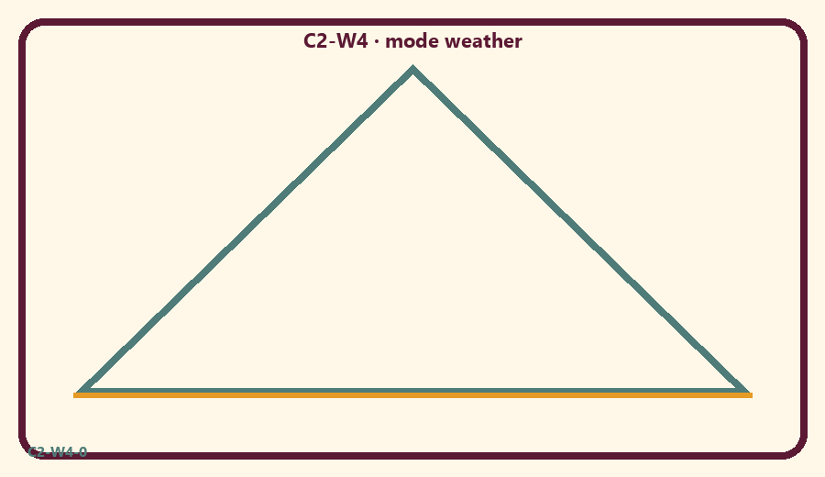
CARD 1  Sunny calm | CARD 2  Windy rush
CARD 3  Foggy sleepy | CARD 4  Reset corner
CARD 5  Quiet voice | CARD 6  Call someone a mode

Memory phrase
Calm helps me hear Kṛṣṇa.
Cut on the dashed borders. Keep each card intact.
TEACHER NOTE | Never label persons. Avoid food policing. Environment supports practice; devotion is the goal.

Y02 — Moment matching
Match scenes to weather icons.
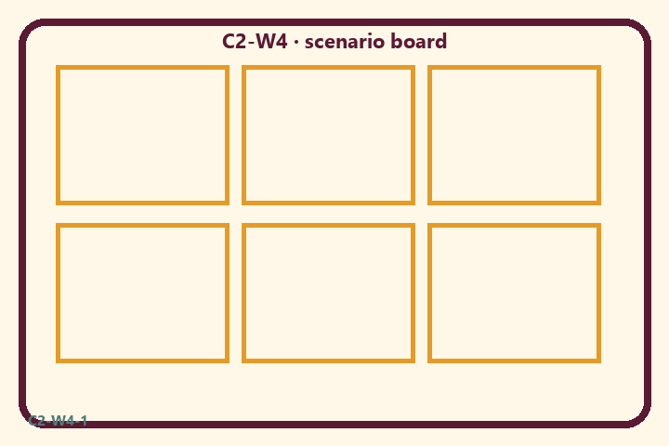
CARD 1  Sunny calm | CARD 2  Windy rush
CARD 3  Foggy sleepy | CARD 4  Reset corner
CARD 5  Quiet voice | CARD 6  Call someone a mode

Memory phrase
Calm helps me hear Kṛṣṇa.
Cut on the dashed borders. Keep each card intact.
TEACHER NOTE | Never label persons. Avoid food policing. Environment supports practice; devotion is the goal.

Y03 — Reset-corner craft
Make a calm-corner card for home.
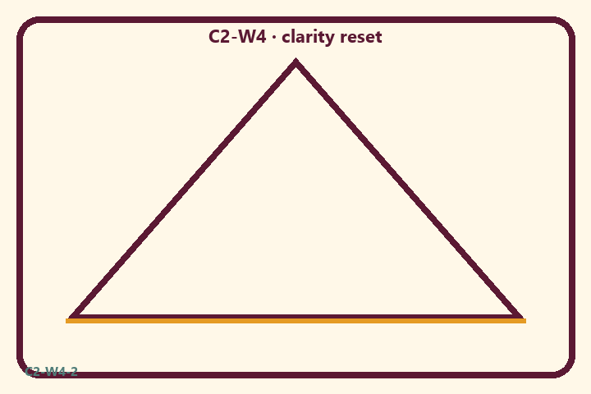
CARD 1  Sunny calm | CARD 2  Windy rush
CARD 3  Foggy sleepy | CARD 4  Reset corner
CARD 5  Quiet voice | CARD 6  Call someone a mode

Memory phrase
Calm helps me hear Kṛṣṇa.
Cut on the dashed borders. Keep each card intact.
TEACHER NOTE | Never label persons. Avoid food policing. Environment supports practice; devotion is the goal.

Y04 — Kind reset cards
Words for resetting a chaotic room.
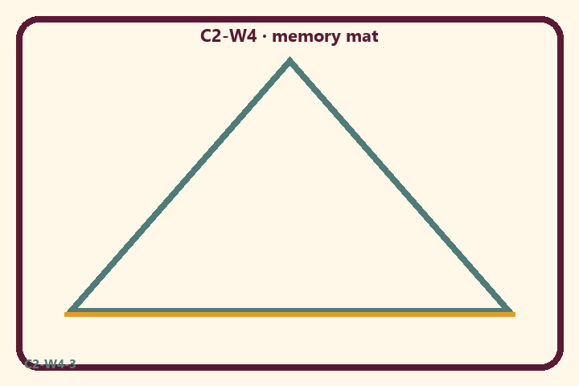
CARD 1  Sunny calm | CARD 2  Windy rush
CARD 3  Foggy sleepy | CARD 4  Reset corner
CARD 5  Quiet voice | CARD 6  Call someone a mode

Memory phrase
Calm helps me hear Kṛṣṇa.
Cut on the dashed borders. Keep each card intact.
TEACHER NOTE | Never label persons. Avoid food policing. Environment supports practice; devotion is the goal.

Y05 — Memory phrase mat
Echo: Calm helps me hear Kṛṣṇa.

Memory phrase
Calm helps me hear Kṛṣṇa.
BG 14.5 · family week
RIGHTS NOTE | KUTUMBA-original framing; cited third-party material retains its own rights. Human/temple review remains EXTERNAL_OPEN.

