KUTUMBA

C2-W5 — Older Teacher Pack
  - Grades 4–5 run sheet and activities
C2-W5 • Māyā: Decorating the Prison Cell
V13 • Families Growing in Krishna Consciousness
Program Director: Swapnil Patil
Internal founding-cohort teaching material — human/temple review EXTERNAL_OPEN
KUTUMBA | Families Growing in Krishna Consciousness

Locked Saturday Schedule
Time | Block
1:50–2:00 | Arrival
2:00–2:10 | Opening mantras + welcome
2:10–2:30 | All-family launch/orientation
2:30–3:10 | Parallel tracks
3:10–3:30 | Reunification + bhakti laboratory
3:30–3:40 | Snack + water
3:40–3:55 | Saṅkalpa + project + home practice
3:55–4:00 | Close

TIME CUE | Track handoff is at 2:30; all groups reunite at 3:10.

Primary verse: BG 7.14
Source URL: https://vedabase.io/en/library/bg/7/14/

Older Teacher Run Sheet
Canonical source: 11-weekly-program-library/first-six-months/c2-w5-māyā-decorating-the-prison-cell/teacher/OLDER-TEACHER-GUIDE-V13.md • SHA-256: 94afdc8b609b05a911b9196c286f30964a16e86a851153df7e27f56ad70b4f23
KUTUMBA · Families Growing in Krishna Consciousness Program Director: Swapnil Patil Week: Māyā: Decorating the Prison Cell · Date: 2026-12-05 Track window: Saturday 2:30–3:10 (Grades 4–5) Reunite: 3:10 for bhakti laboratory Primary: BG 7.14 — https://vedabase.io/en/library/bg/7/14/ Primary mechanic: Attention trap cases Status: Internal founding-cohort teaching material — human/temple review EXTERNAL_OPEN

Essential question
Where are we decorating bondage?

Materials (print before Saturday)
From activities/v13-older/: O01–O06 Also pens/crayons; verse card; privacy reminder.

Locked Saturday context
- 1:50–2:00 Arrival · 2:00–2:10 Mantras · 2:10–2:30 All-family launch
- 2:30–3:10 This track · 3:10–3:30 Reunify · 3:30–3:40 Snack/water · 3:40–3:55 Saṅkalpa · 3:55–4:00 Close
Parents remain onsite. No public ranking. No forced disclosure.

Source layer (use mid-track)
Primary: BG 7.14 — https://vedabase.io/en/library/bg/7/14/
Devanāgarī: दैवी ह्येषा गुणमयी मम माया दुरत्यया । मामेव ये प्रपद्यन्ते मायामेतां तरन्ति ते ॥ १४ ॥
IAST: daivī hy eṣā guṇa-mayī mama māyā duratyayā / mām eva ye prapadyante māyām etāṁ taranti te
KUTUMBA teaching meaning (not a BBT translation): This divine illusory energy of the Lord, made of the modes, is difficult to overcome — but those who surrender unto Him cross beyond it.

Memory line
Surrender crosses māyā.

V13 printable wiring (Attention trap cases)

V13 printable block 0–6 — BG 7.14 observation
Printable: activities/v13-older/O01-BG-7-14-OBSERVATION.md (O01-BG-7-14-OBSERVATION)
Observe difficulty + surrender crossing.
Keep primary mechanic (Attention trap cases). Block: Hate all material duty / “women are māyā”; willpower alone conquers māyā without surrender.

V13 printable block 6–14 — Advertising illusion board
Printable: activities/v13-older/O02-ADVERTISING-ILLUSION-BOARD.md (O02-ADVERTISING-ILLUSION-BOARD)
Map attention traps and better aims.
Keep primary mechanic (Attention trap cases). Block: Hate all material duty / “women are māyā”; willpower alone conquers māyā without surrender.

V13 printable block 14–22 — Trap vs escape sort
Printable: activities/v13-older/O03-TRAP-VS-ESCAPE-SORT.md (O03-TRAP-VS-ESCAPE-SORT)
Sort decorating-bondage vs crossing helps.
Keep primary mechanic (Attention trap cases). Block: Hate all material duty / “women are māyā”; willpower alone conquers māyā without surrender.

V13 printable block 22–30 — Attention trap scenarios
Printable: activities/v13-older/O04-ATTENTION-TRAP-SCENARIOS.md (O04-ATTENTION-TRAP-SCENARIOS)
Three low-risk family attention cases.
Keep primary mechanic (Attention trap cases). Block: Hate all material duty / “women are māyā”; willpower alone conquers māyā without surrender.

V13 printable block 30–36 — Escape-map diagram
Printable: activities/v13-older/O05-ESCAPE-MAP-DIAGRAM.md (O05-ESCAPE-MAP-DIAGRAM)
Notice → turn → shelter in Kṛṣṇa practice.
Keep primary mechanic (Attention trap cases). Block: Hate all material duty / “women are māyā”; willpower alone conquers māyā without surrender.

V13 printable block 36–40 — Exit ticket
Printable: activities/v13-older/O06-EXIT-TICKET.md (O06-EXIT-TICKET)
One trap I notice + one surrender practice.
Keep primary mechanic (Attention trap cases). Block: Hate all material duty / “women are māyā”; willpower alone conquers māyā without surrender.

Close of track (handoff)
Bring one sentence or artifact to reunification. Do not start next week’s topic. Care boundary: Age-sensitive; no fear/paranoia; decorating-prison analogy with limits.

Inherited classroom depth (from V12 OLDER-TEACHER-GUIDE.md)
Keep story scripts, movement steps, and wonder questions below. Wire printables to the V13 codes above; do not replace this depth with “see research.”
Week: Māyā: Decorating the Prison Cell Primary: BG 7.14 — https://vedabase.io/en/library/bg/7/14/ Session length: ~40 minutes (parallel track ~2:30–3:10) Parents: Remain onsite; reunite at 3:10 Status: Internal founding-cohort teaching material — human/temple review EXTERNAL_OPEN

Objective
Students observe BG 7.14, explain that māyā is hard to overcome and crossed by surrender, map one attention chain, and contribute one project sentence answering: Where are we decorating bondage?

Exact memory phrase
Kṛṣṇa’s material energy is difficult to overcome, but those who surrender to Him can cross beyond it.
Short echo: Surrender crosses māyā.

Teacher background
- KUTUMBA teaching meaning: This divine illusory energy of the Lord, made of the modes, is difficult to overcome — but those who surrender unto Him cross beyond it. (Label as KUTUMBA teaching meaning — not as BBT translation.)
- Supporting frames (one sentence each): BG 2.62–63 attention chain; BG 9.10 nature under the Lord; prison-cell pedagogy with limits.
- Block: Hate all material duty / “women are māyā.”; Willpower alone conquers māyā without surrender and shelter.
- Scope: Do not teach Cycle 3 God-identity lectures tonight; keep C2-W6 five-lens method for next week.

Materials
- Printed verse strip: Devanāgarī + IAST + KUTUMBA teaching meaning
- Worksheet copies from activities/OLDER-ACTIVITY-PACK.md
- Scenario cards (notification; shopping polish; people≠māyā)
- Attention-chain diagram sheet
- Pencils; timer; OLDER-ANSWER-KEY.md for teacher only
- Project contribution half-sheets

Minute-by-minute plan

0–5 min — Settle and hook
1. Welcome; feet on floor.
2. Hook: “Is upgrading your room always freedom?” Let two volunteers answer; hold the prison-cell image gently.
3. State essential question: Where are we decorating bondage?

5–14 min — Primary text observation
1. Display BG 7.14; read IAST aloud together once.
2. Students underline: difficult / surrender / cross.
3. Observation prompts: Whose energy? What is it made of? How is it crossed?
4. Add one-sentence bridges to BG 2.62–63 and BG 9.10.
5. Paraphrase only; no invented dialogue.

14–22 min — Worksheet questions
Students complete Section A of the older activity pack. Teacher circulates; use OLDER-ANSWER-KEY.md for expected directions (not for grading ranks).

22–28 min — Scenario cards (small groups)
Each group gets one fictional card: Card A — Notification spiral Card B — Shopping as identity polish Card C — Mislabeling a person as māyā For each: mistaken conclusion, boundary, shelter, what not to say.
Share one insight per group (60 seconds).

28–33 min — Puzzle / game: False Promise / True Crossing
1. Teacher reads a short claim.
2. Teams hold F (false promise / misconception) or T (true to BG 7.14).
3. Three rounds; explain one T using surrender or cross.
4. Keep respectful; no mocking.

33–37 min — Diagram / map task
On the attention-chain sheet, fill one low-risk example: Notice → Want → Act → Fog Then add a side path: Surrender cue → Boundary → Shelter. Circle the surrender cue; write the short echo.

37–40 min — Project sentence + handoff
Complete Section E project sentence. Hand to parent at 3:10 reunification. No public ranking.

Boundaries
- No ranking or public scores.
- No invented dialogue.
- Parents onsite; snack/water only at 3:30 in the main schedule.
- Defer off-scope topics: Deep initiation debates; diagnosing demoniac nature; Cycle 3 extended theology.

O01 — BG 7.14 observation
Observe difficulty + surrender crossing.

VERSE CARD • BG 7.14
दैवी ह्येषा गुणमयी मम माया दुरत्यया । मामेव ये प्रपद्यन्ते मायामेतां तरन्ति ते ॥ १४ ॥
daivī hy eṣā guṇa-mayī mama māyā duratyayā / mām eva ye prapadyante māyām etāṁ taranti te
KUTUMBA teaching meaning: This divine illusory energy of the Lord, made of the modes, is difficult to overcome — but those who surrender unto Him cross beyond it.
Source: https://vedabase.io/en/library/bg/7/14/
Rights/status: Scripture display/source: VedaBase; teaching meaning: KUTUMBA-original (not labeled as BBT translation).

What does the verse teach in my words?
________________________________________________________________
________________________________________________________________
What misconception does this week block?
________________________________________________________________
________________________________________________________________
One question for the facilitator:
________________________________________________________________
________________________________________________________________

O02 — Advertising illusion board
Map attention traps and better aims.
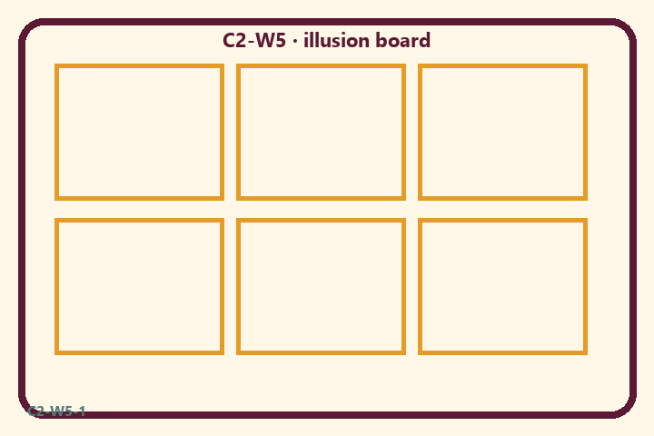
Prompt | My notes
Advertising illusion board | ________________
Limit / care | ________________

Application:
________________________________________________________________
________________________________________________________________
What not to say:
________________________________________________________________
________________________________________________________________
KEY IDEA | Illusory energy is hard to cross; surrender and Kṛṣṇa-centered practice open the path — without fear pedagogy.

O03 — Trap vs escape sort
Sort decorating-bondage vs crossing helps.
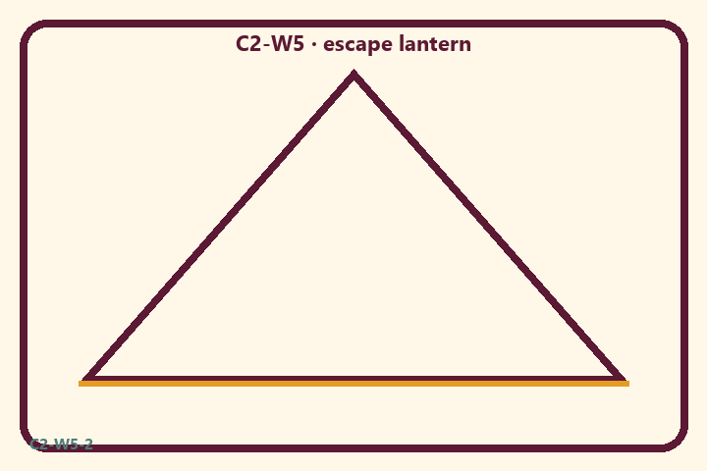
Prompt | My notes
Trap vs escape sort | ________________
Limit / care | ________________

Application:
________________________________________________________________
________________________________________________________________
What not to say:
________________________________________________________________
________________________________________________________________
KEY IDEA | Illusory energy is hard to cross; surrender and Kṛṣṇa-centered practice open the path — without fear pedagogy.

O04 — Attention trap scenarios
Three low-risk family attention cases.
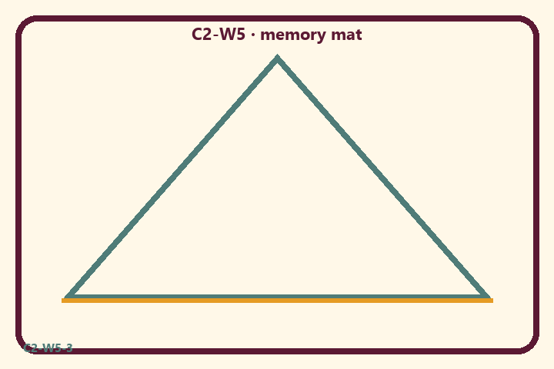
Prompt | My notes
Attention trap scenarios | ________________
Limit / care | ________________

Application:
________________________________________________________________
________________________________________________________________
What not to say:
________________________________________________________________
________________________________________________________________
KEY IDEA | Illusory energy is hard to cross; surrender and Kṛṣṇa-centered practice open the path — without fear pedagogy.

O05 — Escape-map diagram
Notice → turn → shelter in Kṛṣṇa practice.
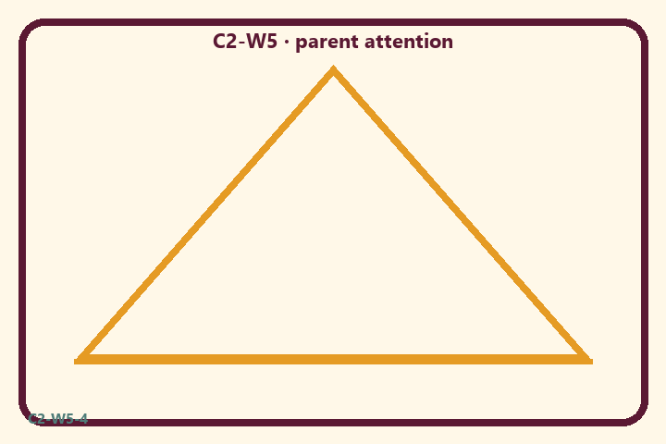
Prompt | My notes
Escape-map diagram | ________________
Limit / care | ________________

Application:
________________________________________________________________
________________________________________________________________
What not to say:
________________________________________________________________
________________________________________________________________
KEY IDEA | Illusory energy is hard to cross; surrender and Kṛṣṇa-centered practice open the path — without fear pedagogy.

O06 — Exit ticket
One trap I notice + one surrender practice.
Primary in one sentence:
________________________________________________________________
________________________________________________________________
One analogy or mechanic and its limit:
________________________________________________________________
________________________________________________________________
One home action:
________________________________________________________________
________________________________________________________________
One question I still have:
________________________________________________________________
________________________________________________________________
RIGHTS NOTE | KUTUMBA-original framing; cited third-party material retains its own rights. Human/temple review remains EXTERNAL_OPEN.

