KUTUMBA

C2-W5 — Parent Track
  - Facilitator guide and parent printables
C2-W5 • Māyā: Decorating the Prison Cell
V13 • Families Growing in Krishna Consciousness
Program Director: Swapnil Patil
Internal founding-cohort teaching material — human/temple review EXTERNAL_OPEN
KUTUMBA | Families Growing in Krishna Consciousness

Locked Saturday Schedule
Time | Block
1:50–2:00 | Arrival
2:00–2:10 | Opening mantras + welcome
2:10–2:30 | All-family launch/orientation
2:30–3:10 | Parallel tracks
3:10–3:30 | Reunification + bhakti laboratory
3:30–3:40 | Snack + water
3:40–3:55 | Saṅkalpa + project + home practice
3:55–4:00 | Close

TIME CUE | Track handoff is at 2:30; all groups reunite at 3:10.

Primary verse: BG 7.14
Source URL: https://vedabase.io/en/library/bg/7/14/

Parent Facilitator Run Sheet
Canonical source: 11-weekly-program-library/first-six-months/c2-w5-māyā-decorating-the-prison-cell/teacher/PARENT-GUIDE-V13.md • SHA-256: afb7d02fddd1188d17873b7c2461bad889922433894d5b6edd651161b188f05b
KUTUMBA · Families Growing in Krishna Consciousness Program Director: Swapnil Patil Week: Māyā: Decorating the Prison Cell · Date: 2026-12-05 Track window: Saturday 2:30–3:10 (parents) Reunite: 3:10 for bhakti laboratory Primary: BG 7.14 — https://vedabase.io/en/library/bg/7/14/ Primary mechanic: Attention trap cases Status: Internal founding-cohort teaching material — human/temple review EXTERNAL_OPEN

Essential question
Where are we decorating bondage?

Materials (print before Saturday)
From activities/v13-parent/: P01–P05 Also pens/crayons; verse card; privacy reminder.

Locked Saturday context
- 1:50–2:00 Arrival · 2:00–2:10 Mantras · 2:10–2:30 All-family launch
- 2:30–3:10 This track · 3:10–3:30 Reunify · 3:30–3:40 Snack/water · 3:40–3:55 Saṅkalpa · 3:55–4:00 Close
Parents remain onsite. No public ranking. No forced disclosure.

Source layer (use mid-track)
Primary: BG 7.14 — https://vedabase.io/en/library/bg/7/14/
Devanāgarī: दैवी ह्येषा गुणमयी मम माया दुरत्यया । मामेव ये प्रपद्यन्ते मायामेतां तरन्ति ते ॥ १४ ॥
IAST: daivī hy eṣā guṇa-mayī mama māyā duratyayā / mām eva ye prapadyante māyām etāṁ taranti te
KUTUMBA teaching meaning (not a BBT translation): This divine illusory energy of the Lord, made of the modes, is difficult to overcome — but those who surrender unto Him cross beyond it.

Memory line
Surrender crosses māyā.

V13 printable wiring (Attention trap cases)

V13 printable block 0–5 — Private reflection — attention audit
Printable: activities/v13-parent/P01-PRIVATE-REFLECTION.md (P01-PRIVATE-REFLECTION)
Where do we decorate comfort while neglecting devotion?
Keep primary mechanic (Attention trap cases). Block: Hate all material duty / “women are māyā”; willpower alone conquers māyā without surrender.

V13 printable block 5–12 — Attention audit card sort
Printable: activities/v13-parent/P02-ATTENTION-AUDIT-CARD-SORT.md (P02-ATTENTION-AUDIT-CARD-SORT)
Sort TRAP / CROSSING HELP / HARMFUL FRAMING.
Keep primary mechanic (Attention trap cases). Block: Hate all material duty / “women are māyā”; willpower alone conquers māyā without surrender.

V13 printable block 12–22 — Substantial family case
Printable: activities/v13-parent/P03-SUBSTANTIAL-FAMILY-CASE.md (P03-SUBSTANTIAL-FAMILY-CASE)
Family upgrades gadgets weekly while skipping shared chanting.
Keep primary mechanic (Attention trap cases). Block: Hate all material duty / “women are māyā”; willpower alone conquers māyā without surrender.

V13 printable block 22–32 — Household operating application
Printable: activities/v13-parent/P04-HOUSEHOLD-OPERATING-APPLICATION.md (P04-HOUSEHOLD-OPERATING-APPLICATION)
One attention-audit cue + one chanting shelter.
Keep primary mechanic (Attention trap cases). Block: Hate all material duty / “women are māyā”; willpower alone conquers māyā without surrender.

V13 printable block 32–38 — Private next-step saṅkalpa
Printable: activities/v13-parent/P05-PRIVATE-NEXT-STEP-SANKALPA.md (P05-PRIVATE-NEXT-STEP-SANKALPA)
Surrender practice + minimum version.
Keep primary mechanic (Attention trap cases). Block: Hate all material duty / “women are māyā”; willpower alone conquers māyā without surrender.

Close of track (handoff)
Bring one sentence or artifact to reunification. Do not start next week’s topic. Care boundary: Age-sensitive; no fear/paranoia; decorating-prison analogy with limits.

Inherited classroom depth (from V12 parent-lesson / constructed V13 flow)
Keep story scripts, movement steps, and wonder questions below. Wire printables to the V13 codes above; do not replace this depth with “see research.”

Essential question
Where are we decorating bondage?

Source
BG 7.14 — teaching meaning: This divine illusory energy made of the modes is hard to overcome — but those who surrender to the Lord cross beyond it.

Discussion
One realistic household tension; no compelled confession.

Application
5–15 minute cue; minimum version counts.

Privacy
No public scoring of sādhana.

P01 — Private reflection — attention audit
Where do we decorate comfort while neglecting devotion?

SAFETY & PRIVACY | Write privately. Sharing is optional. Do not collect or place completed sheets in Git.

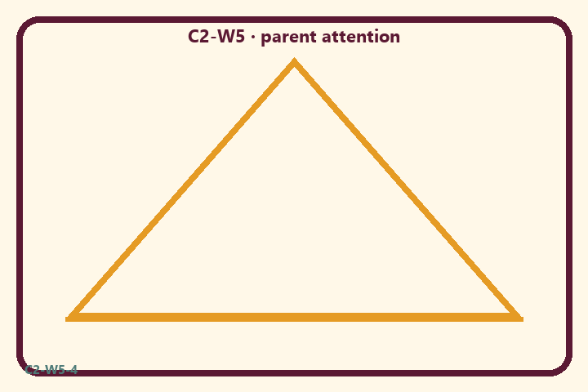
Where do we decorate comfort while neglecting devotion?
Private notes:
________________________________________________________________
________________________________________________________________
________________________________________________________________
________________________________________________________________
Habit to watch this week:
________________________________________________________________
________________________________________________________________
________________________________________________________________
________________________________________________________________

P02 — Attention audit card sort
Sort TRAP / CROSSING HELP / HARMFUL FRAMING.
HELPFUL | MISTAKEN

L1  Endless upgrade chase | L2  Short holy name
L3  Women are māyā | L4  Willpower alone
L5  Serve quietly | L6  Paranoia about all matter
TEACHER NOTE | Hate all material duty / “women are māyā”; willpower alone conquers māyā without surrender.

P03 — Substantial family case
Family upgrades gadgets weekly while skipping shared chanting.
SAFETY & PRIVACY | Fictional case. No compelled confession of real events.

A family keeps upgrading gadgets and rearranging décor while shared chanting disappears. One adult jokes “we’re just making the prison nicer.” Another says “all duty is māyā — quit your job.”
Tempting mistaken conclusion:
________________________________________________________________
________________________________________________________________
________________________________________________________________
Principle from primary:
________________________________________________________________
________________________________________________________________
________________________________________________________________
Compassionate response:
________________________________________________________________
________________________________________________________________
________________________________________________________________
One seven-day household action:
________________________________________________________________
________________________________________________________________
________________________________________________________________
What we should not say:
________________________________________________________________
________________________________________________________________
________________________________________________________________
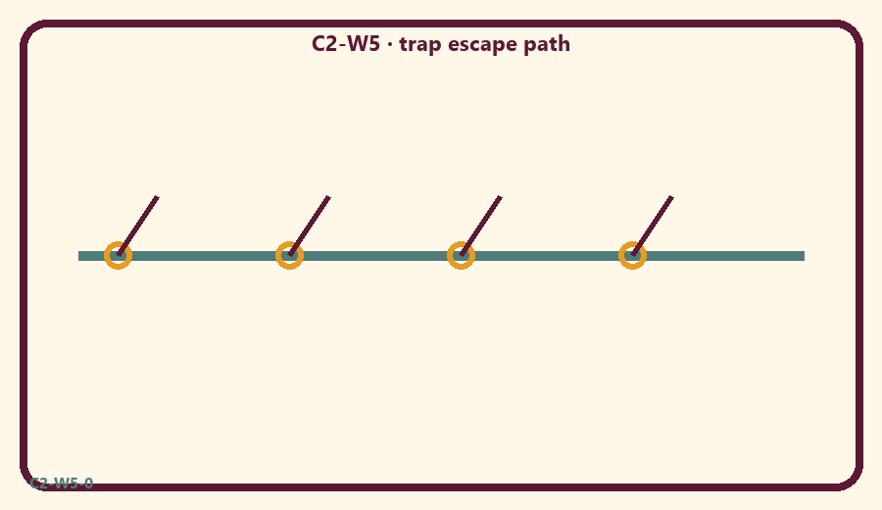

P04 — Household operating application
One attention-audit cue + one chanting shelter.
SAFETY & PRIVACY | No ranking and no public reading required.

One household action for seven days:
________________________________________________________________
________________________________________________________________
________________________________________________________________
Trigger (when/where):
________________________________________________________________
________________________________________________________________
________________________________________________________________
Who starts if others are tired:
________________________________________________________________
________________________________________________________________
________________________________________________________________
Minimum version on a hard day:
________________________________________________________________
________________________________________________________________
________________________________________________________________

Memory phrase
Surrender crosses māyā.

P05 — Private next-step saṅkalpa
Surrender practice + minimum version.
KEY IDEA | specific action + frequency + trigger + minimum version

Specific action:
________________________________________________________________
________________________________________________________________
Frequency:
________________________________________________________________
________________________________________________________________
Trigger (when and where):
________________________________________________________________
________________________________________________________________
Minimum version for a hard day:
________________________________________________________________
________________________________________________________________
Where we will place the reminder:
________________________________________________________________
________________________________________________________________
No ranking. The minimum version counts as success.
RIGHTS NOTE | KUTUMBA-original framing; cited third-party material retains its own rights. Human/temple review remains EXTERNAL_OPEN.

