KUTUMBA

C2-W5 — Younger Teacher Pack
  - K–2 run sheet and activities
C2-W5 • Māyā: Decorating the Prison Cell
V13 • Families Growing in Krishna Consciousness
Program Director: Swapnil Patil
Internal founding-cohort teaching material — human/temple review EXTERNAL_OPEN
KUTUMBA | Families Growing in Krishna Consciousness

Locked Saturday Schedule
Time | Block
1:50–2:00 | Arrival
2:00–2:10 | Opening mantras + welcome
2:10–2:30 | All-family launch/orientation
2:30–3:10 | Parallel tracks
3:10–3:30 | Reunification + bhakti laboratory
3:30–3:40 | Snack + water
3:40–3:55 | Saṅkalpa + project + home practice
3:55–4:00 | Close

TIME CUE | Track handoff is at 2:30; all groups reunite at 3:10.

Primary verse: BG 7.14
Source URL: https://vedabase.io/en/library/bg/7/14/

Younger Teacher Run Sheet
Canonical source: 11-weekly-program-library/first-six-months/c2-w5-māyā-decorating-the-prison-cell/teacher/YOUNGER-TEACHER-GUIDE-V13.md • SHA-256: 919f92a610757901d6e2c5d89667ade858a88ddc56c1fd12a1b563ff9d040f70
KUTUMBA · Families Growing in Krishna Consciousness Program Director: Swapnil Patil Week: Māyā: Decorating the Prison Cell · Date: 2026-12-05 Track window: Saturday 2:30–3:10 (K–2) Reunite: 3:10 for bhakti laboratory Primary: BG 7.14 — https://vedabase.io/en/library/bg/7/14/ Primary mechanic: Attention trap cases Status: Internal founding-cohort teaching material — human/temple review EXTERNAL_OPEN

Essential question
Where are we decorating bondage?

Materials (print before Saturday)
From activities/v13-younger/: Y01–Y05 Also pens/crayons; verse card; privacy reminder.

Locked Saturday context
- 1:50–2:00 Arrival · 2:00–2:10 Mantras · 2:10–2:30 All-family launch
- 2:30–3:10 This track · 3:10–3:30 Reunify · 3:30–3:40 Snack/water · 3:40–3:55 Saṅkalpa · 3:55–4:00 Close
Parents remain onsite. No public ranking. No forced disclosure.

Source layer (use mid-track)
Primary: BG 7.14 — https://vedabase.io/en/library/bg/7/14/
Devanāgarī: दैवी ह्येषा गुणमयी मम माया दुरत्यया । मामेव ये प्रपद्यन्ते मायामेतां तरन्ति ते ॥ १४ ॥
IAST: daivī hy eṣā guṇa-mayī mama māyā duratyayā / mām eva ye prapadyante māyām etāṁ taranti te
KUTUMBA teaching meaning (not a BBT translation): This divine illusory energy of the Lord, made of the modes, is difficult to overcome — but those who surrender unto Him cross beyond it.

Memory line
Surrender crosses māyā.

V13 printable wiring (Attention trap cases)

V13 printable block 0–6 — Simple trap/escape path
Printable: activities/v13-younger/Y01-TRAP-ESCAPE-PATH.md (Y01-TRAP-ESCAPE-PATH)
Follow path: shiny trap → pause → call Kṛṣṇa / kind help.
Keep primary mechanic (Attention trap cases). Block: Hate all material duty / “women are māyā”; willpower alone conquers māyā without surrender.

V13 printable block 6–14 — Shiny vs real matching
Printable: activities/v13-younger/Y02-SHINY-VS-REAL-MATCHING.md (Y02-SHINY-VS-REAL-MATCHING)
Match ads/toys to “looks big” vs “helps love.”
Keep primary mechanic (Attention trap cases). Block: Hate all material duty / “women are māyā”; willpower alone conquers māyā without surrender.

V13 printable block 14–24 — Escape lantern craft
Printable: activities/v13-younger/Y03-ESCAPE-LANTERN-CRAFT.md (Y03-ESCAPE-LANTERN-CRAFT)
Craft a lantern card for holy name / help.
Keep primary mechanic (Attention trap cases). Block: Hate all material duty / “women are māyā”; willpower alone conquers māyā without surrender.

V13 printable block 24–32 — Pause cards
Printable: activities/v13-younger/Y04-PAUSE-CARDS.md (Y04-PAUSE-CARDS)
When stuck, point to Pause / Ask / Chant.
Keep primary mechanic (Attention trap cases). Block: Hate all material duty / “women are māyā”; willpower alone conquers māyā without surrender.

V13 printable block 32–38 — Memory phrase mat
Printable: activities/v13-younger/Y05-MEMORY-PHRASE-MAT.md (Y05-MEMORY-PHRASE-MAT)
Echo: Surrender crosses māyā.
Keep primary mechanic (Attention trap cases). Block: Hate all material duty / “women are māyā”; willpower alone conquers māyā without surrender.

Close of track (handoff)
Bring one sentence or artifact to reunification. Do not start next week’s topic. Care boundary: Age-sensitive; no fear/paranoia; decorating-prison analogy with limits.

Inherited classroom depth (from V12 YOUNGER-TEACHER-GUIDE.md)
Keep story scripts, movement steps, and wonder questions below. Wire printables to the V13 codes above; do not replace this depth with “see research.”
Week: Māyā: Decorating the Prison Cell Primary: BG 7.14 — https://vedabase.io/en/library/bg/7/14/ Session length: 40 minutes (parallel track ~2:30–3:10) Parents: Remain onsite; reunite at 3:10 Status: Internal founding-cohort teaching material — human/temple review EXTERNAL_OPEN

Objective
Children learn that shiny things can pull attention away from what matters, practice stop-and-choose, and clearly say people are not māyā. They take home a decorated-cage craft with the memory phrase.

Exact memory phrase
Surrender crosses māyā.

Teacher background (2 minutes to review)
- KUTUMBA teaching meaning (adult wording): This divine illusory energy of the Lord, made of the modes, is difficult to overcome — but those who surrender unto Him cross beyond it.
- Child-facing paraphrase: Kṛṣṇa’s energy can make forgetfulness look shiny. We ask Kṛṣṇa for help and choose good next steps. People are not māyā.
- Block misconceptions (child words):
- “People (or girls/boys) are māyā.”
- “I can grab every shiny thing.”
- Do not: invent deity dialogue; force confession; rank children; use scare tactics; claim temple certification stickers.

Materials
- Shiny toy or foil card vs helping-hands picture
- Soft puppet
- Card stock cages / boxes for craft
- Stickers, crayons, glue sticks
- Printed memory phrase stickers if available
- Soft toss object for backup
- Calm-corner chair

Room setup
Circle on the floor; materials table behind you; calm corner with one chair for quiet reset. Keep aisles clear for movement.

Minute-by-minute executable plan

0–5 min — Opening and recall
1. Welcome by name; feet on floor.
2. Echo memory phrase three times: Surrender / crosses / māyā.
3. Show shiny card and helping card.
4. Practice the correction sentence once: “People are not māyā.”

5–13 min — Story script (paraphrase only; ~8 minutes)
Say exactly this spine (do not invent deity dialogue):
Sometimes something shiny makes us forget what we were doing to help. Kṛṣṇa teaches that His material energy is hard to cross by ourselves. When we take shelter of Kṛṣṇa, we can cross. A pretty cage is still a cage if we forget Kṛṣṇa. Making the cage pretty is not the same as being free. People are not māyā. Māyā is the energy that makes us forget. We can stop, remember Kṛṣṇa, and choose a helping step.
Story boundaries: Paraphrase BG 7.14 themes only. No invented deity quotes. No scary prison talk. No blaming a child as “māyā.”

13–16 min — Three wonder questions
1. What should we do when something shiny pulls us?
2. Who helps us cross when forgetting feels strong? (Kṛṣṇa)
3. Are people māyā? (No.)
Accept one- or two-word answers. Affirm effort.

16–24 min — Movement game: Shiny Freeze and Help (steps)
1. Spread children in a safe open space.
2. Teacher shows shiny card — children freeze (stop).
3. Teacher says “Remember Kṛṣṇa” — hand on heart + memory phrase.
4. Teacher shows helping card — children take three gentle steps to the kindness mat and sit.
5. Play three rounds. On round three, children point to helping card on the green choice.
6. End seated; say together: “People are not māyā.”

24–32 min — Craft: Decorated cage reminder card (steps)
1. Give each child a folded card with a simple cage outline.
2. Let them add 2–3 “pretty” stickers (decorations).
3. Inside, helper writes: Surrender crosses māyā.
4. On the back, child draws one helping choice.
5. Practice: touch decorations, then open card and say the memory phrase — beauty is not the whole story.
Full printable steps also live in activities/YOUNGER-ACTIVITY-PACK.md (use together; this guide remains executable if the pack is missing).

32–35 min — Printable / coloring task
If time remains, color the younger line-art sheet if available. If short on time, keep the craft as the take-home.

35–38 min — Behavior redirects and quiet reset
Use calm, specific redirects:
- Feet on floor — “Feet visit the mat.”
- Kind hands — “Toys rest; hands help.”
- Loud shout — “Soft voice, please.”
- Quiet reset — “Calm corner with helping card for 60 seconds.”

38–40 min — Cleanup and parent handoff
1. Materials away; craft in hand.
2. At reunification, tell parent in one sentence:
Memory phrase: “Surrender crosses māyā..” Home cue: Use one media or consumption boundary for three days.
1. Do not report private behavior struggles in front of other families.

Behavior redirects (quick reference)
Signal | Teacher line | Child action
Running | Freeze bodies — shiny pause. | Freeze, then walk
Snatching | Helping hands. | Hands to lap
Calling someone māyā | People are not māyā. | Repeat correction
Shutdown | Quiet reset is okay. | Calm corner 60 sec

Backup low-prep (if craft fails or energy crashes)
1. Sit in a circle with soft toss object.
2. Child catches, says “People are not māyā” or one helping choice, tosses to next.
3. End with three echoes of the memory phrase.

What success looks like
- Child can echo: Surrender crosses māyā.
- Child can say: People are not māyā.
- Child can name one helping choice when shiny pulls.

Boundaries
- Snack/water only happens in main schedule (3:30), not as a track bribe.
- No weekly meal language.
- No fabricated approval stickers implying temple certification.
- Privacy: no forced confession.

Child House Rules
Canonical source: launch/CHILD-HOUSE-RULES.md • SHA-256: 6a525f3dd1da740db86e246622696c7b08e28c1f1475227567d639a5bd54ce47
Parents remain onsite. Facilitators guide the session. Host property rules also apply.

Shared rules (all ages)
1. Keep your body safe — feet on the floor; hands gentle.
2. Use respectful speech — no teasing, yelling, or mean labels.
3. Follow the facilitator safety cue immediately (pause / freeze / come here).
4. No jumping on furniture.
5. No indoor throwing.
6. No writing on walls, books, or furniture that are not activity materials.
7. Ask before entering private rooms.
8. Respect belongings — ask before touching what is not yours.
9. Devices away unless the lesson specifically needs them.
10. Snack only in the allowed area; water anytime with permission.
11. Help clean up before leaving.

Correction ladder (no public shame)
1. Calm reminder
2. Redirect / offer a choice
3. Brief quiet reset in a visible space
4. Parent involvement
5. Sit out a specific activity
6. Private parent/program conversation for repeated patterns
Never: public shame, yelling, sarcasm, corporal punishment, forced chanting, or comparing children.

Younger (K–2) emphasis
- Soft voices indoors
- Stay with the group
- Hands to yourself
- Ask before leaving the room

Older (Grades 4–5) emphasis
- Model respectful speech for younger children
- Devices fully away unless assigned
- Help clean-up leadership
- Honest questions welcome; speculation wait for source check
Printable versions: W1 launch-pack CHILD-RULES-YOUNGER.md and CHILD-RULES-OLDER.md.

Y01 — Simple trap/escape path
Follow path: shiny trap → pause → call Kṛṣṇa / kind help.
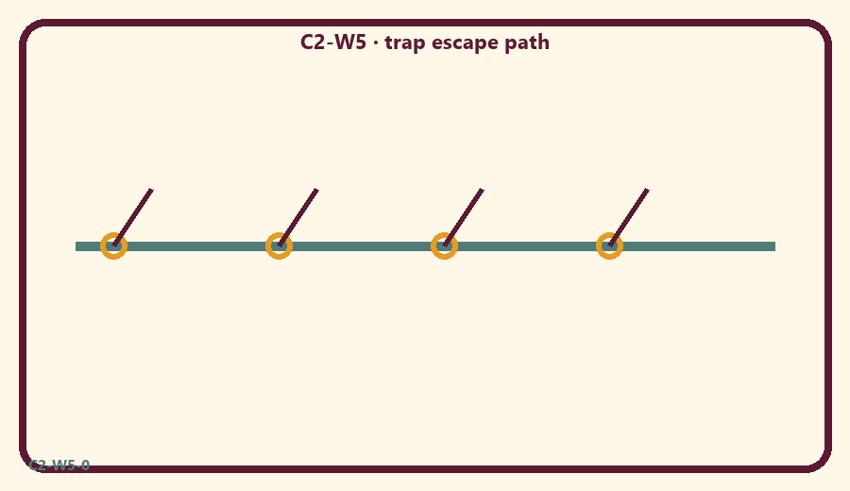
CARD 1  Shiny toy shout | CARD 2  Pause
CARD 3  Ask for help | CARD 4  Holy name
CARD 5  Scare story | CARD 6  Kind share

Memory phrase
Surrender crosses māyā.
Cut on the dashed borders. Keep each card intact.
TEACHER NOTE | Age-sensitive; no fear/paranoia; decorating-prison analogy with limits.

Y02 — Shiny vs real matching
Match ads/toys to “looks big” vs “helps love.”
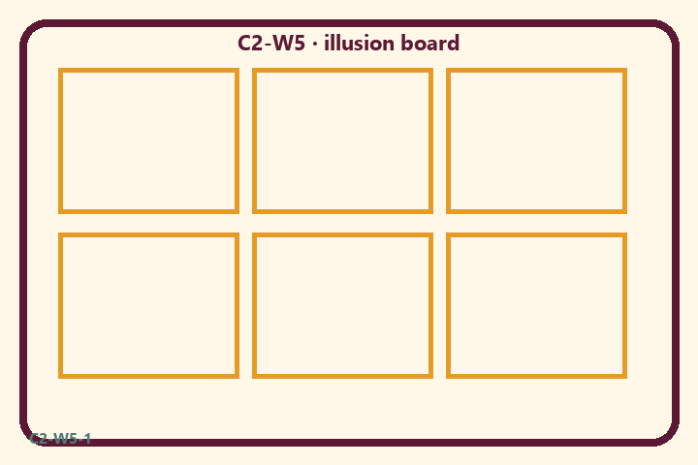
CARD 1  Shiny toy shout | CARD 2  Pause
CARD 3  Ask for help | CARD 4  Holy name
CARD 5  Scare story | CARD 6  Kind share

Memory phrase
Surrender crosses māyā.
Cut on the dashed borders. Keep each card intact.
TEACHER NOTE | Age-sensitive; no fear/paranoia; decorating-prison analogy with limits.

Y03 — Escape lantern craft
Craft a lantern card for holy name / help.
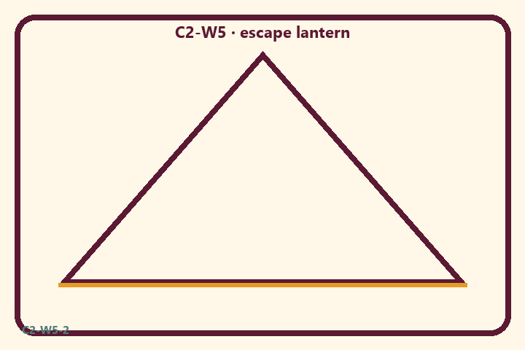
CARD 1  Shiny toy shout | CARD 2  Pause
CARD 3  Ask for help | CARD 4  Holy name
CARD 5  Scare story | CARD 6  Kind share

Memory phrase
Surrender crosses māyā.
Cut on the dashed borders. Keep each card intact.
TEACHER NOTE | Age-sensitive; no fear/paranoia; decorating-prison analogy with limits.

Y04 — Pause cards
When stuck, point to Pause / Ask / Chant.
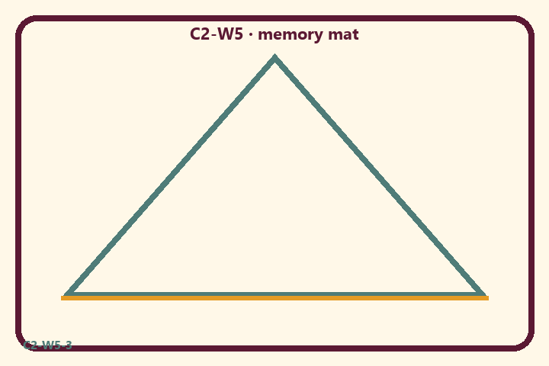
CARD 1  Shiny toy shout | CARD 2  Pause
CARD 3  Ask for help | CARD 4  Holy name
CARD 5  Scare story | CARD 6  Kind share

Memory phrase
Surrender crosses māyā.
Cut on the dashed borders. Keep each card intact.
TEACHER NOTE | Age-sensitive; no fear/paranoia; decorating-prison analogy with limits.

Y05 — Memory phrase mat
Echo: Surrender crosses māyā.

Memory phrase
Surrender crosses māyā.
BG 7.14 · family week
RIGHTS NOTE | KUTUMBA-original framing; cited third-party material retains its own rights. Human/temple review remains EXTERNAL_OPEN.

