KUTUMBA

C2-W6 — Older Teacher Pack
  - Grades 4–5 run sheet and activities
C2-W6 • Integration Night: Choice, Consequence and the Modes
V13 • Families Growing in Krishna Consciousness
Program Director: Swapnil Patil
Internal founding-cohort teaching material — human/temple review EXTERNAL_OPEN
KUTUMBA | Families Growing in Krishna Consciousness

Locked Saturday Schedule
Time | Block
1:50–2:00 | Arrival
2:00–2:10 | Opening mantras + welcome
2:10–2:30 | All-family launch/orientation
2:30–3:10 | Parallel tracks
3:10–3:30 | Reunification + bhakti laboratory
3:30–3:40 | Snack + water
3:40–3:55 | Saṅkalpa + project + home practice
3:55–4:00 | Close

TIME CUE | Integration planning date 2026-12-12. Use 2:30 / 3:10 cues when parallel tracks run; local tithi remains EXTERNAL_OPEN.

Primary verse: Cycle 2 review (BG 18.63 center)
Source URL: https://vedabase.io/en/library/bg/18/63/

Older Teacher Run Sheet
Canonical source: 11-weekly-program-library/first-six-months/c2-w6-integration-night-choice-consequence-and-the-modes/teacher/OLDER-TEACHER-GUIDE-V13.md • SHA-256: 1d34f338facaa6c104eb5701ae821c9ef29290f154a2544a9ea2647fa9731920
KUTUMBA · Families Growing in Krishna Consciousness Program Director: Swapnil Patil Week: Integration Night: Choice, Consequence and the Modes · Date: 2026-12-12 Track window: Saturday 2:30–3:10 (Grades 4–5) Reunite: 3:10 for bhakti laboratory Primary: Cycle 2 review (BG 18.63 center) — https://vedabase.io/en/library/bg/18/63/ Primary mechanic: Scenario board teach-back Status: Internal founding-cohort teaching material — human/temple review EXTERNAL_OPEN

Essential question
Can we synthesize choice and modes?

Materials (print before Saturday)
From activities/v13-older/: O01–O06 Also pens/crayons; verse card; privacy reminder.

Locked Saturday context
- 1:50–2:00 Arrival · 2:00–2:10 Mantras · 2:10–2:30 All-family launch
- 2:30–3:10 This track · 3:10–3:30 Reunify · 3:30–3:40 Snack/water · 3:40–3:55 Saṅkalpa · 3:55–4:00 Close
Parents remain onsite. No public ranking. No forced disclosure.

Source layer (use mid-track)
Primary: Cycle 2 review (BG 18.63 center) — https://vedabase.io/en/library/bg/18/63/
Devanāgarī: इति ते ज्ञानमाख्यातं गुह्याद्गुह्यतरं मया । विमृश्यैतदशेषेण यथेच्छसि तथा कुरु ॥ ६३ ॥
IAST: iti te jñānam ākhyātaṁ guhyād guhyataraṁ mayā / vimṛśyaitad aśeṣeṇa yathecchasi tathā kuru
KUTUMBA teaching meaning (not a BBT translation): Choice, consequence, and the modes must form one coherent family practice — synthesis, not new doctrine overload. (BG 18.63 center for review.)

Memory line
Choose with all five lenses.

V13 printable wiring (Scenario board teach-back)

V13 printable block 0–6 — Cycle 2 retrieval quiz
Printable: activities/v13-older/O01-CYCLE2-RETRIEVAL.md (O01-CYCLE2-RETRIEVAL)
Retrieve BG 3.9 / 18.63 / 2.22 / 14.5 / 7.14 themes.
Keep primary mechanic (Scenario board teach-back). Block: Integration means new advanced doctrine; ranking families by presentation polish.

V13 printable block 6–14 — Choice + modes board
Printable: activities/v13-older/O02-CHOICE-MODES-BOARD.md (O02-CHOICE-MODES-BOARD)
Place scenarios on choice/consequence/mode board.
Keep primary mechanic (Scenario board teach-back). Block: Integration means new advanced doctrine; ranking families by presentation polish.

V13 printable block 14–22 — Misconception clinic
Printable: activities/v13-older/O03-MISCONCEPTION-CLINIC.md (O03-MISCONCEPTION-CLINIC)
Correct fatalism, labeling, scare talk, paranoia.
Keep primary mechanic (Scenario board teach-back). Block: Integration means new advanced doctrine; ranking families by presentation polish.

V13 printable block 22–30 — Teach-back scenarios
Printable: activities/v13-older/O04-TEACH-BACK-SCENARIOS.md (O04-TEACH-BACK-SCENARIOS)
Coach a 2-minute family teach-back.
Keep primary mechanic (Scenario board teach-back). Block: Integration means new advanced doctrine; ranking families by presentation polish.

V13 printable block 30–36 — Integration diagram
Printable: activities/v13-older/O05-INTEGRATION-DIAGRAM.md (O05-INTEGRATION-DIAGRAM)
Five lenses → one household practice.
Keep primary mechanic (Scenario board teach-back). Block: Integration means new advanced doctrine; ranking families by presentation polish.

V13 printable block 36–40 — Exit ticket
Printable: activities/v13-older/O06-EXIT-TICKET.md (O06-EXIT-TICKET)
One synthesis sentence + one home cue.
Keep primary mechanic (Scenario board teach-back). Block: Integration means new advanced doctrine; ranking families by presentation polish.

Close of track (handoff)
Bring one sentence or artifact to reunification. Do not start next week’s topic. Care boundary: Retrieval/presentation focus; no major new doctrine; noncompetitive teach-back.

Inherited classroom depth (from V12 OLDER-TEACHER-GUIDE.md)
Keep story scripts, movement steps, and wonder questions below. Wire printables to the V13 codes above; do not replace this depth with “see research.”
Week: Integration Night: Choice, Consequence and the Modes Primary: Cycle 2 review (BG 3.9 · 18.63 · 2.22 · 14.5 · 7.14) — https://vedabase.io/en/library/bg/18/63/ Session length: ~40 minutes (parallel track ~2:30–3:10) Parents: Remain onsite; reunite at 3:10 Status: Internal founding-cohort teaching material — human/temple review EXTERNAL_OPEN

Objective
Students map five Cycle 2 verses to five lenses, analyze a fictional case without fatalism or ranking, and select one continuing method plus one environmental change.

Exact memory phrase
Knowledge should lead to thoughtful, responsible choice under Kṛṣṇa's guidance.
Short echo: Choose with all five lenses.

Teacher background
- KUTUMBA teaching meaning: Choice, consequence, and the modes must form one coherent family practice — synthesis, not new doctrine overload. (Label as KUTUMBA teaching meaning — not as BBT translation.)
- Supporting frames (one sentence each): BG 3.9 action; BG 18.63 choice; BG 2.22 consequence; BG 14.5 modes; BG 7.14 shelter.
- Block: Ranking families on “who applied Cycle 2 better.”; New doctrine overload / fatalism that denies responsible choice.
- Scope: No Cycle 3 God-identity teaching beyond title preview; no initiation debates.

Materials
- Verse-lens matching strips
- Worksheets
- Scenario cards
- Five-lens diagram sheet
- Pencils; timer; answer key
- Project half-sheets

Minute-by-minute plan

0–5 min — Settle and hook
1. Welcome; feet on floor.
2. Hook: “If someone says ‘it’s karma, nothing can change,’ which verse pushes back — and how?”
3. Essential question: Can we synthesize choice and modes?

5–14 min — Primary text observation
1. Display review_iast_line; read once.
2. Students match each BG reference to a lens.
3. Underline vimṛśya / yathecchasi / tathā kuru on BG 18.63 strip.
4. Paraphrase only; no invented dialogue.

14–22 min — Worksheet questions
Students complete Section A of the older activity pack. Teacher circulates; use OLDER-ANSWER-KEY.md for expected directions (not for grading ranks).

22–28 min — Scenario cards (small groups)
Card A — Friday rush/fatalism Card B — Mode insult Card C — Boundary without shelter For each: missing lens, corrected response, what not to say.
Share one insight per group (60 seconds).

28–33 min — Puzzle / game: Lens or Leak
1. Teacher reads a claim.
2. Teams show L (uses a true lens) or K (leak: fatalism/rank/insult/willpower-only).
3. Three rounds; explain one L with a verse.
4. No mocking.

33–37 min — Diagram / map task
Complete five-lens diagram for one fictional case. Circle the shelter cue. Write short echo.

37–40 min — Project sentence + handoff
Section E: method + environment change. Hand to parent at 3:10. No ranking.

Boundaries
- No ranking or public scores.
- No invented dialogue.
- Parents onsite; snack/water only at 3:30 in the main schedule.
- Defer off-scope topics: Cycle 3 ontology; initiation; past-life readings.

O01 — Cycle 2 retrieval quiz
Retrieve BG 3.9 / 18.63 / 2.22 / 14.5 / 7.14 themes.

VERSE CARD • Cycle 2 review (BG 18.63 center)
इति ते ज्ञानमाख्यातं गुह्याद्गुह्यतरं मया । विमृश्यैतदशेषेण यथेच्छसि तथा कुरु ॥ ६३ ॥
iti te jñānam ākhyātaṁ guhyād guhyataraṁ mayā / vimṛśyaitad aśeṣeṇa yathecchasi tathā kuru
KUTUMBA teaching meaning: Choice, consequence, and the modes must form one coherent family practice — synthesis, not new doctrine overload. (BG 18.63 center for review.)
Source: https://vedabase.io/en/library/bg/18/63/
Rights/status: Scripture display/source: VedaBase; teaching meaning: KUTUMBA-original (not labeled as BBT translation).

What does the verse teach in my words?
________________________________________________________________
________________________________________________________________
What misconception does this week block?
________________________________________________________________
________________________________________________________________
One question for the facilitator:
________________________________________________________________
________________________________________________________________

O02 — Choice + modes board
Place scenarios on choice/consequence/mode board.
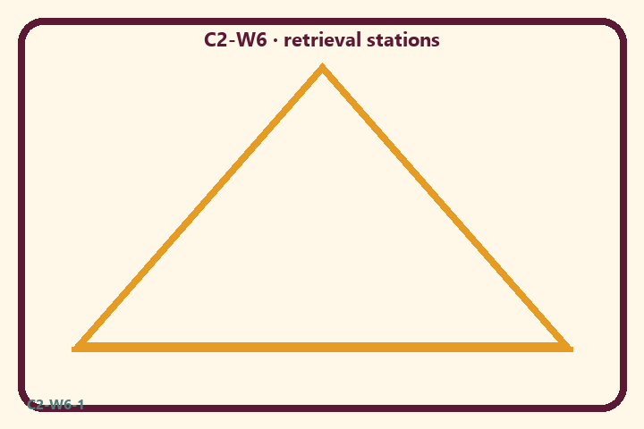
Prompt | My notes
Choice + modes board | ________________
Limit / care | ________________

Application:
________________________________________________________________
________________________________________________________________
What not to say:
________________________________________________________________
________________________________________________________________
KEY IDEA | Cycle 2 becomes one family practice: responsible choice, consequence awareness, mode supports — taught back without ranking.

O03 — Misconception clinic
Correct fatalism, labeling, scare talk, paranoia.
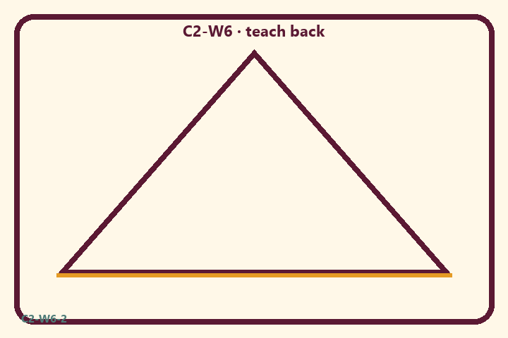
Prompt | My notes
Misconception clinic | ________________
Limit / care | ________________

Application:
________________________________________________________________
________________________________________________________________
What not to say:
________________________________________________________________
________________________________________________________________
KEY IDEA | Cycle 2 becomes one family practice: responsible choice, consequence awareness, mode supports — taught back without ranking.

O04 — Teach-back scenarios
Coach a 2-minute family teach-back.
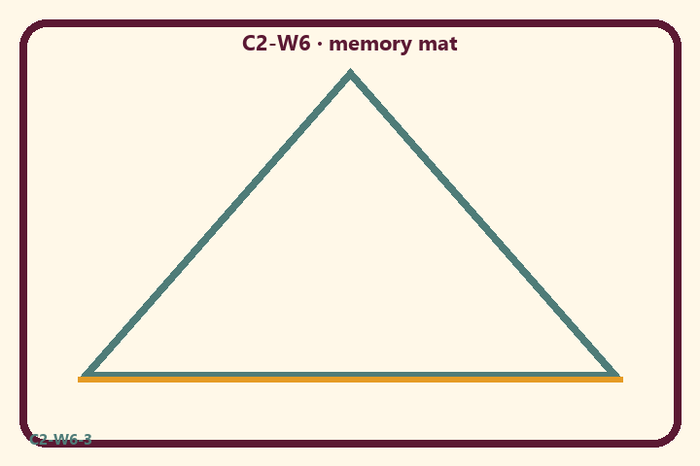
Prompt | My notes
Teach-back scenarios | ________________
Limit / care | ________________

Application:
________________________________________________________________
________________________________________________________________
What not to say:
________________________________________________________________
________________________________________________________________
KEY IDEA | Cycle 2 becomes one family practice: responsible choice, consequence awareness, mode supports — taught back without ranking.

O05 — Integration diagram
Five lenses → one household practice.
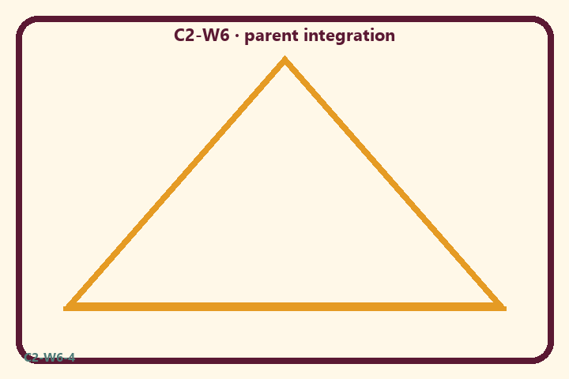
Prompt | My notes
Integration diagram | ________________
Limit / care | ________________

Application:
________________________________________________________________
________________________________________________________________
What not to say:
________________________________________________________________
________________________________________________________________
KEY IDEA | Cycle 2 becomes one family practice: responsible choice, consequence awareness, mode supports — taught back without ranking.

O06 — Exit ticket
One synthesis sentence + one home cue.
Primary in one sentence:
________________________________________________________________
________________________________________________________________
One analogy or mechanic and its limit:
________________________________________________________________
________________________________________________________________
One home action:
________________________________________________________________
________________________________________________________________
One question I still have:
________________________________________________________________
________________________________________________________________
RIGHTS NOTE | KUTUMBA-original framing; cited third-party material retains its own rights. Human/temple review remains EXTERNAL_OPEN.

