KUTUMBA

C2-W6 — Younger Teacher Pack
  - K–2 run sheet and activities
C2-W6 • Integration Night: Choice, Consequence and the Modes
V13 • Families Growing in Krishna Consciousness
Program Director: Swapnil Patil
Internal founding-cohort teaching material — human/temple review EXTERNAL_OPEN
KUTUMBA | Families Growing in Krishna Consciousness

Locked Saturday Schedule
Time | Block
1:50–2:00 | Arrival
2:00–2:10 | Opening mantras + welcome
2:10–2:30 | All-family launch/orientation
2:30–3:10 | Parallel tracks
3:10–3:30 | Reunification + bhakti laboratory
3:30–3:40 | Snack + water
3:40–3:55 | Saṅkalpa + project + home practice
3:55–4:00 | Close

TIME CUE | Integration planning date 2026-12-12. Use 2:30 / 3:10 cues when parallel tracks run; local tithi remains EXTERNAL_OPEN.

Primary verse: Cycle 2 review (BG 18.63 center)
Source URL: https://vedabase.io/en/library/bg/18/63/

Younger Teacher Run Sheet
Canonical source: 11-weekly-program-library/first-six-months/c2-w6-integration-night-choice-consequence-and-the-modes/teacher/YOUNGER-TEACHER-GUIDE-V13.md • SHA-256: 54330da1e97e6afe1f2c37f53563df69339e4abb531a06c963520e887f2ce455
KUTUMBA · Families Growing in Krishna Consciousness Program Director: Swapnil Patil Week: Integration Night: Choice, Consequence and the Modes · Date: 2026-12-12 Track window: Saturday 2:30–3:10 (K–2) Reunite: 3:10 for bhakti laboratory Primary: Cycle 2 review (BG 18.63 center) — https://vedabase.io/en/library/bg/18/63/ Primary mechanic: Scenario board teach-back Status: Internal founding-cohort teaching material — human/temple review EXTERNAL_OPEN

Essential question
Can we synthesize choice and modes?

Materials (print before Saturday)
From activities/v13-younger/: Y01–Y05 Also pens/crayons; verse card; privacy reminder.

Locked Saturday context
- 1:50–2:00 Arrival · 2:00–2:10 Mantras · 2:10–2:30 All-family launch
- 2:30–3:10 This track · 3:10–3:30 Reunify · 3:30–3:40 Snack/water · 3:40–3:55 Saṅkalpa · 3:55–4:00 Close
Parents remain onsite. No public ranking. No forced disclosure.

Source layer (use mid-track)
Primary: Cycle 2 review (BG 18.63 center) — https://vedabase.io/en/library/bg/18/63/
Devanāgarī: इति ते ज्ञानमाख्यातं गुह्याद्गुह्यतरं मया । विमृश्यैतदशेषेण यथेच्छसि तथा कुरु ॥ ६३ ॥
IAST: iti te jñānam ākhyātaṁ guhyād guhyataraṁ mayā / vimṛśyaitad aśeṣeṇa yathecchasi tathā kuru
KUTUMBA teaching meaning (not a BBT translation): Choice, consequence, and the modes must form one coherent family practice — synthesis, not new doctrine overload. (BG 18.63 center for review.)

Memory line
Choose with all five lenses.

V13 printable wiring (Scenario board teach-back)

V13 printable block 0–6 — Review game stations
Printable: activities/v13-younger/Y01-REVIEW-GAME-STATIONS.md (Y01-REVIEW-GAME-STATIONS)
Visit karma / choice / dress / weather / escape stations.
Keep primary mechanic (Scenario board teach-back). Block: Integration means new advanced doctrine; ranking families by presentation polish.

V13 printable block 6–14 — Five-lens matching
Printable: activities/v13-younger/Y02-LENS-MATCHING.md (Y02-LENS-MATCHING)
Match icons to Cycle 2 themes.
Keep primary mechanic (Scenario board teach-back). Block: Integration means new advanced doctrine; ranking families by presentation polish.

V13 printable block 14–24 — Teach-back craft
Printable: activities/v13-younger/Y03-TEACH-BACK-CRAFT.md (Y03-TEACH-BACK-CRAFT)
One sentence our family can teach.
Keep primary mechanic (Scenario board teach-back). Block: Integration means new advanced doctrine; ranking families by presentation polish.

V13 printable block 24–32 — Cheer cards
Printable: activities/v13-younger/Y04-CHEER-CARDS.md (Y04-CHEER-CARDS)
Encourage other families without ranking.
Keep primary mechanic (Scenario board teach-back). Block: Integration means new advanced doctrine; ranking families by presentation polish.

V13 printable block 32–38 — Memory phrase mat
Printable: activities/v13-younger/Y05-MEMORY-PHRASE-MAT.md (Y05-MEMORY-PHRASE-MAT)
Echo: Choose with all five lenses.
Keep primary mechanic (Scenario board teach-back). Block: Integration means new advanced doctrine; ranking families by presentation polish.

Close of track (handoff)
Bring one sentence or artifact to reunification. Do not start next week’s topic. Care boundary: Retrieval/presentation focus; no major new doctrine; noncompetitive teach-back.

Inherited classroom depth (from V12 YOUNGER-TEACHER-GUIDE.md)
Keep story scripts, movement steps, and wonder questions below. Wire printables to the V13 codes above; do not replace this depth with “see research.”
Week: Integration Night: Choice, Consequence and the Modes Primary: Cycle 2 review (BG 3.9 · 18.63 · 2.22 · 14.5 · 7.14) — https://vedabase.io/en/library/bg/18/63/ Session length: 40 minutes (parallel track ~2:30–3:10) Parents: Remain onsite; reunite at 3:10 Status: Internal founding-cohort teaching material — human/temple review EXTERNAL_OPEN

Objective
Children practice a choice pause on a puppet rush problem, meet five simple lens pictures, and take home one tool card with the memory phrase.

Exact memory phrase
Choose with all five lenses.

Teacher background (2 minutes to review)
- KUTUMBA teaching meaning (adult wording): Choice, consequence, and the modes must form one coherent family practice — synthesis, not new doctrine overload.
- Child-facing paraphrase: When things feel rushed, we pause, remember Kṛṣṇa, and choose a helping next step. We use all five picture lenses.
- Block misconceptions (child words):
- “Nothing can ever change.”
- “We rank who is best.”
- Do not: invent deity dialogue; force confession; rank children; use scare tactics; claim temple certification stickers.

Materials
- Puppet
- Five lens picture cards
- Traffic-light pause cards
- Tool cards
- Crayons
- Soft toss object
- Calm-corner chair

Room setup
Circle on the floor; materials table behind you; calm corner with one chair for quiet reset. Keep aisles clear for movement.

Minute-by-minute executable plan

0–5 min — Opening and recall
1. Welcome by name; feet on floor.
2. Echo three times: Choose / with / all five lenses.
3. Show traffic-light: red pause, yellow remember, green help.
4. Say once: “We do not rank friends.”

5–13 min — Story script (paraphrase only; ~8 minutes)
Say exactly this spine (do not invent deity dialogue):
Sometimes a family feels rushed and grumpy before singing for Kṛṣṇa. Kṛṣṇa teaches us to think carefully and then choose a good next step. We can look with five helper pictures: what we did, what we can choose, what mood-weather we feel, what trick the mind tells, and how we take shelter of Kṛṣṇa. We do not say “nothing can change.” We pause and choose with Kṛṣṇa’s help.
Story boundaries: Paraphrase review themes only. No invented deity quotes. No scary karma talk. No ranking children.

13–16 min — Three wonder questions
1. What do we do at the red light? (Pause)
2. Who helps us choose? (Kṛṣṇa)
3. Do we rank friends? (No)
Accept one- or two-word answers. Affirm effort.

16–24 min — Movement game: Traffic-Light Five Lenses (steps)
1. Spread in open space.
2. Red card — freeze (pause).
3. Yellow — hand on heart + memory phrase.
4. Green — walk to helping mat.
5. Teacher flashes one lens card; children point to it.
6. Three rounds; end seated with phrase echo.

24–32 min — Craft: Five-lens tool wheel (steps)
1. Give a paper circle divided into five slices (pre-drawn).
2. Child colors each slice lightly.
3. Helper writes memory phrase in the center: Choose with all five lenses.
4. Attach one tool-card tab the child picks for home.
5. Practice pointing to each slice once.
Full printable steps also live in activities/YOUNGER-ACTIVITY-PACK.md (use together; this guide remains executable if the pack is missing).

32–35 min — Printable / coloring task
If time remains, color the younger line-art sheet if available. If short on time, keep the craft as the take-home.

35–38 min — Behavior redirects and quiet reset
Use calm, specific redirects:
- Feet on floor — “Feet visit the mat.”
- Kind hands — “Hands help; toys rest.”
- Loud shout — “Soft voice, please.”
- Quiet reset — “Calm corner for sixty seconds.”

38–40 min — Cleanup and parent handoff
1. Materials away; craft in hand.
2. At reunification, tell parent in one sentence:
Memory phrase: “Choose with all five lenses..” Home cue: Continue one selected Cycle 2 method during the off week.
1. Do not report private behavior struggles in front of other families.

Behavior redirects (quick reference)
Signal | Teacher line | Child action
Running | Walking feet. | Walk to mat
Snatching | Kind hands. | Hands to lap
Interrupt shout | Soft voice. | Whisper retry
Shutdown | Quiet reset is okay. | Calm corner 60 sec

Backup low-prep (if craft fails or energy crashes)
1. Soft toss circle.
2. Catch, say “Pause” or “Choose with Kṛṣṇa,” toss on.
3. End with three memory-phrase echoes.

What success looks like
- Echoes memory phrase
- Can pause at red card
- Says we do not rank friends

Boundaries
- Snack/water only happens in main schedule (3:30), not as a track bribe.
- No weekly meal language.
- No fabricated approval stickers implying temple certification.
- Privacy: no forced confession.

Child House Rules
Canonical source: launch/CHILD-HOUSE-RULES.md • SHA-256: 6a525f3dd1da740db86e246622696c7b08e28c1f1475227567d639a5bd54ce47
Parents remain onsite. Facilitators guide the session. Host property rules also apply.

Shared rules (all ages)
1. Keep your body safe — feet on the floor; hands gentle.
2. Use respectful speech — no teasing, yelling, or mean labels.
3. Follow the facilitator safety cue immediately (pause / freeze / come here).
4. No jumping on furniture.
5. No indoor throwing.
6. No writing on walls, books, or furniture that are not activity materials.
7. Ask before entering private rooms.
8. Respect belongings — ask before touching what is not yours.
9. Devices away unless the lesson specifically needs them.
10. Snack only in the allowed area; water anytime with permission.
11. Help clean up before leaving.

Correction ladder (no public shame)
1. Calm reminder
2. Redirect / offer a choice
3. Brief quiet reset in a visible space
4. Parent involvement
5. Sit out a specific activity
6. Private parent/program conversation for repeated patterns
Never: public shame, yelling, sarcasm, corporal punishment, forced chanting, or comparing children.

Younger (K–2) emphasis
- Soft voices indoors
- Stay with the group
- Hands to yourself
- Ask before leaving the room

Older (Grades 4–5) emphasis
- Model respectful speech for younger children
- Devices fully away unless assigned
- Help clean-up leadership
- Honest questions welcome; speculation wait for source check
Printable versions: W1 launch-pack CHILD-RULES-YOUNGER.md and CHILD-RULES-OLDER.md.

Y01 — Review game stations
Visit karma / choice / dress / weather / escape stations.
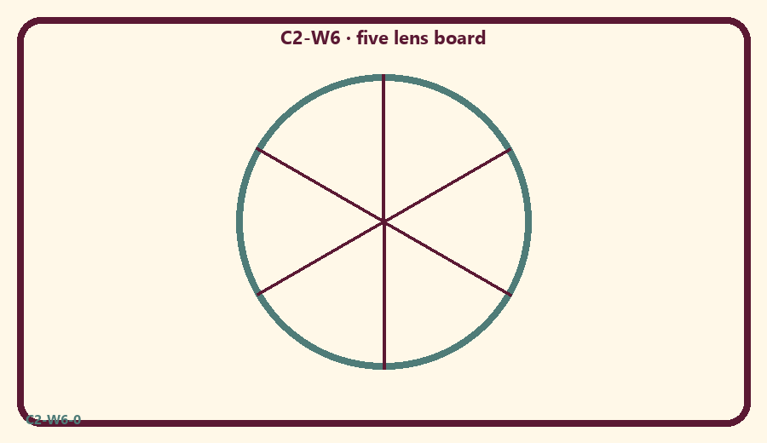
CARD 1  Karma seed | CARD 2  Next choice
CARD 3  Dress change | CARD 4  Mode weather
CARD 5  Escape path | CARD 6  Trophy ranking

Memory phrase
Choose with all five lenses.
Cut on the dashed borders. Keep each card intact.
TEACHER NOTE | Retrieval/presentation focus; no major new doctrine; noncompetitive teach-back.

Y02 — Five-lens matching
Match icons to Cycle 2 themes.
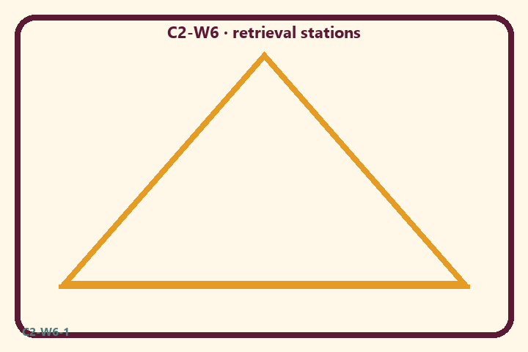
CARD 1  Karma seed | CARD 2  Next choice
CARD 3  Dress change | CARD 4  Mode weather
CARD 5  Escape path | CARD 6  Trophy ranking

Memory phrase
Choose with all five lenses.
Cut on the dashed borders. Keep each card intact.
TEACHER NOTE | Retrieval/presentation focus; no major new doctrine; noncompetitive teach-back.

Y03 — Teach-back craft
One sentence our family can teach.
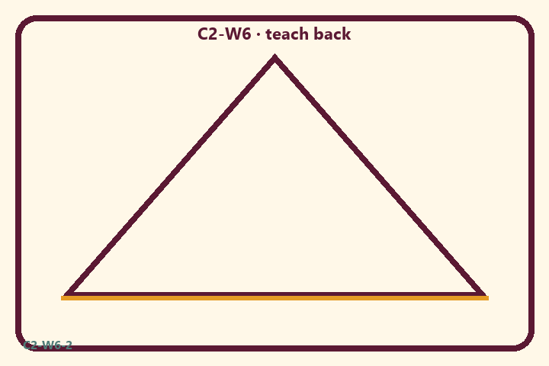
CARD 1  Karma seed | CARD 2  Next choice
CARD 3  Dress change | CARD 4  Mode weather
CARD 5  Escape path | CARD 6  Trophy ranking

Memory phrase
Choose with all five lenses.
Cut on the dashed borders. Keep each card intact.
TEACHER NOTE | Retrieval/presentation focus; no major new doctrine; noncompetitive teach-back.

Y04 — Cheer cards
Encourage other families without ranking.
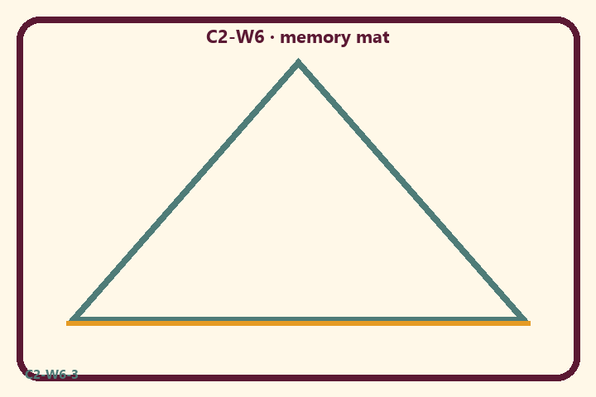
CARD 1  Karma seed | CARD 2  Next choice
CARD 3  Dress change | CARD 4  Mode weather
CARD 5  Escape path | CARD 6  Trophy ranking

Memory phrase
Choose with all five lenses.
Cut on the dashed borders. Keep each card intact.
TEACHER NOTE | Retrieval/presentation focus; no major new doctrine; noncompetitive teach-back.

Y05 — Memory phrase mat
Echo: Choose with all five lenses.

Memory phrase
Choose with all five lenses.
Cycle 2 review (BG 18.63 center) · family week
RIGHTS NOTE | KUTUMBA-original framing; cited third-party material retains its own rights. Human/temple review remains EXTERNAL_OPEN.

