KUTUMBA

C3-U3 — Older Teacher Pack
  - Grades 4–5 run sheet and activities
C3-U3 • Nityānanda Trayodaśī Family Utsava
V13 • Families Growing in Krishna Consciousness
Program Director: Swapnil Patil
Internal founding-cohort teaching material — human/temple review EXTERNAL_OPEN
KUTUMBA | Families Growing in Krishna Consciousness

Locked Saturday Schedule
Time | Block
1:50–2:00 | Arrival
2:00–2:10 | Opening mantras + welcome
2:10–2:30 | All-family launch/orientation
2:30–3:10 | Parallel tracks
3:10–3:30 | Reunification + bhakti laboratory
3:30–3:40 | Snack + water
3:40–3:55 | Saṅkalpa + project + home practice
3:55–4:00 | Close

TIME CUE | Utsava planning date 2027-02-20. Use 2:30 / 3:10 cues when parallel tracks run; local tithi remains EXTERNAL_OPEN.

Primary verse: CC Ādi 5.208
Source URL: https://vedabase.io/en/library/cc/adi/5/208/

Older Teacher Run Sheet
Canonical source: 11-weekly-program-library/first-six-months/c3-u3-nityananda-trayodasi-family-utsava/teacher/OLDER-TEACHER-GUIDE-V13.md • SHA-256: 22a9c44f8009c05795bcde24697bb7f650d8624b40b9b5ad4c60d4e1700ca7a8
Use with printable stations. Operator completeness pack.

Main Facilitator Guide — C3-U3
Nityānanda Trayodaśī Family Utsava · Saturday 2027-02-20 (planning); published example 2027-02-19 Status: EXTERNAL_OPEN local tithi/human/temple Entry: V13-UTSAVA-START-HERE.md

Exact primary
- Reference: CC Ādi 5.208
- URL: https://vedabase.io/en/library/cc/adi/5/208/
- Bengali: প্রেমে মত্ত নিত্যানন্দ কৃপা–অবতার । উত্তম, অধম, কিছু না করে বিচার ॥ ২০৮ ॥
- IAST: preme matta nityānanda kṛpā-avatāra / uttama, adhama, kichu nā kare vicāra
- KUTUMBA teaching meaning: Nityānanda, intoxicated by ecstatic love and an incarnation of mercy, does not distinguish between the good and the bad.
- Supporting: CC Madhya 1.25 — https://vedabase.io/en/library/cc/madhya/1/25/ — by nature inspired in Kṛṣṇa-prema, and by the Lord’s order He distributes loving service everywhere.
- Rights: Bengali display + KUTUMBA meaning; no full purport.

10–20 minute speaking script
Welcome to our Nityānanda Trayodaśī Family Utsava planning Saturday — 2027-02-20.
Calendar honesty: published example often lists 2027-02-19. Tonight is a family observance candidate, not a settled exact local tithi claim (EXTERNAL_OPEN).
Essential question: How should mercy, service, and saṅkīrtana shape our family’s next kind action?
Primary: CC Ādi 5.208 — https://vedabase.io/en/library/cc/adi/5/208/
KUTUMBA teaching meaning: “Nityānanda, intoxicated by ecstatic love and an incarnation of mercy, does not distinguish between the good and the bad.”
We teach mercy and service. If Jagāi-Mādhāi is mentioned, keep it age-sensitive: people far from kindness are invited toward the holy name and service. No graphic violence. No speculative miracle embellishment.
Analogy one — mercy chain: one kind invitation leads to another. Limit: not every person responds immediately; do not force.
Analogy two — service challenge cards: small helps train the heart. Limit: service is not a scoreboard.
Analogy three — saṅkīrtana as invitation: listening counts. Limit: not a volume contest.
Household case: Older child wants to dramatize a violent scene “for realism.” Redirect to mercy and helping. Principle: age-sensitive storytelling.
Memory line: Nityānanda is an incarnation of mercy.

O01 — CC Ādi 5.208 Observation

VERSE CARD • CC Ādi 5.208

KUTUMBA teaching meaning: Nityānanda is an incarnation of mercy and does not distinguish good and bad.
Source: https://vedabase.io/en/library/cc/adi/5/208/
Rights/status: Sanskrit/Bengali display + KUTUMBA teaching meaning; no full purport

What is mercy here?
________________________________________________________________
________________________________________________________________
________________________________________________________________
What must we not dramatize?
________________________________________________________________
________________________________________________________________
________________________________________________________________

O02 — Mercy vs Judgment Sort
CARD 1  Invite kindly | CARD 2  Mock the fallen
CARD 3  Serve quietly | CARD 4  Public shame
CARD 5  Listen in kīrtana | CARD 6  Scoreboard seva

O03 — Age-Sensitive Boundaries
Rewrite without graphic violence.
Harsh line (do not perform):
________________________________________________________________
________________________________________________________________
________________________________________________________________
Mercy-focused rewrite:
________________________________________________________________
________________________________________________________________
________________________________________________________________
Why the rewrite is better:
________________________________________________________________
________________________________________________________________
________________________________________________________________
TEACHER NOTE | No graphic Jagāi-Mādhāi violence in materials.

O04 — Service Plan
Who can we serve?
Person/place:
________________________________________________________________
________________________________________________________________
Help act:
________________________________________________________________
________________________________________________________________
When:
________________________________________________________________
________________________________________________________________
Minimum version:
________________________________________________________________
________________________________________________________________

O05 — Saṅkīrtana Invitation Map
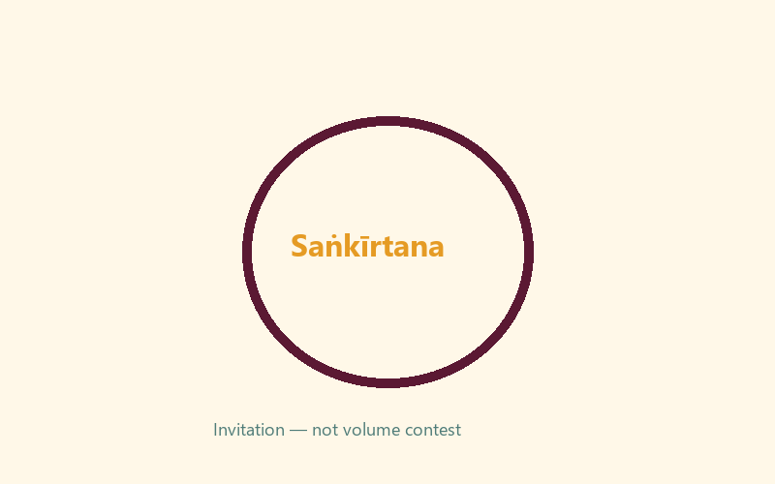
Invitation line:
________________________________________________________________
________________________________________________________________
Listening counts because:
________________________________________________________________
________________________________________________________________

O06 — Exit Ticket
Memory line:
________________________________________________________________
________________________________________________________________
One mercy act:
________________________________________________________________
________________________________________________________________
One person to serve:
________________________________________________________________
________________________________________________________________
RIGHTS NOTE | KUTUMBA-original framing; cited third-party material retains its own rights. Human/temple review remains EXTERNAL_OPEN.

