KUTUMBA

C3-U3 — Saturday Print Packet
  - Complete ordered participant and teacher packet
C3-U3 • Nityānanda Trayodaśī Family Utsava
V13 • Families Growing in Krishna Consciousness
Program Director: Swapnil Patil
Internal founding-cohort teaching material — human/temple review EXTERNAL_OPEN
KUTUMBA | Families Growing in Krishna Consciousness

Quick Schedule
Time | Block
1:50–2:00 | Arrival
2:00–2:10 | Opening mantras + welcome
2:10–2:30 | All-family launch/orientation
2:30–3:10 | Parallel tracks
3:10–3:30 | Reunification + bhakti laboratory
3:30–3:40 | Snack + water
3:40–3:55 | Saṅkalpa + project + home practice
3:55–4:00 | Close

TIME CUE | Utsava planning date 2027-02-20. Use 2:30 / 3:10 cues when parallel tracks run; local tithi remains EXTERNAL_OPEN.

Primary verse: CC Ādi 5.208
Source URL: https://vedabase.io/en/library/cc/adi/5/208/

Opening Mantras
Canonical source: launch/OPENING-MANTRAS-HANDOUT.md • SHA-256: e9487fa3eef1f08c79b8a191932fc70aae9766d2ad3b52a5c47815e3d50e6cb6
KUTUMBA · Families Growing in Krishna Consciousness Program Director: Swapnil Patil

1. Śrīla Prabhupāda Praṇāma
nama oṁ viṣṇu-pādāya kṛṣṇa-preṣṭhāya bhū-tale śrīmate bhaktivedānta-svāmin iti nāmine namas te sārasvate deve gaura-vāṇī-pracāriṇe nirviśeṣa-śūnyavādi-pāścātya-deśa-tāriṇe
Direct sources (verify chanting sheet locally):
- https://vedabase.io/en/library/transcripts/690110in-los-angeles/
- https://vedabase.io/en/library/transcripts/690413sb-new-york/
KUTUMBA plain meaning: We offer respects to Śrīla Prabhupāda, dear to Kṛṣṇa, who carries Lord Caitanya's message.

2. Pañca-tattva Mantra
(jaya) śrī-kṛṣṇa-caitanya prabhu-nityānanda śrī-advaita gadādhara śrīvāsādi-gaura-bhakta-vṛnda
Source: https://vedabase.io/en/library/cc/adi/7/4/ Also see transcript context: https://vedabase.io/en/library/transcripts/710328bg-bombay/

3. Hare Kṛṣṇa Mahā-mantra
Hare Kṛṣṇa Hare Kṛṣṇa Kṛṣṇa Kṛṣṇa Hare Hare Hare Rāma Hare Rāma Rāma Rāma Hare Hare
Direct sources (complete sixteen-word mahā-mantra stated / teaching context):
- Lecture on the Mahā-mantra: https://vedabase.io/en/library/transcripts/660909le-new-york/
- Śrī Caitanya-caritāmṛta Ādi 7.83 (nature of the mahā-mantra): https://vedabase.io/en/library/cc/adi/7/83/
Invitation only — never forced volume or punishment.
RIGHTS NOTE | do not invent extra prayers; temple sheet is exact-text control where required.

Parent Track Run Sheet
Canonical source: 11-weekly-program-library/first-six-months/c3-u3-nityananda-trayodasi-family-utsava/teacher/PARENT-GUIDE-V13.md • SHA-256: 2476f36f615ba83a854605e0011e9903c4e294d571420b6c07837624001ebef1
Use with printable stations. Operator completeness pack.

Main Facilitator Guide — C3-U3
Nityānanda Trayodaśī Family Utsava · Saturday 2027-02-20 (planning); published example 2027-02-19 Status: EXTERNAL_OPEN local tithi/human/temple Entry: V13-UTSAVA-START-HERE.md

Exact primary
- Reference: CC Ādi 5.208
- URL: https://vedabase.io/en/library/cc/adi/5/208/
- Bengali: প্রেমে মত্ত নিত্যানন্দ কৃপা–অবতার । উত্তম, অধম, কিছু না করে বিচার ॥ ২০৮ ॥
- IAST: preme matta nityānanda kṛpā-avatāra / uttama, adhama, kichu nā kare vicāra
- KUTUMBA teaching meaning: Nityānanda, intoxicated by ecstatic love and an incarnation of mercy, does not distinguish between the good and the bad.
- Supporting: CC Madhya 1.25 — https://vedabase.io/en/library/cc/madhya/1/25/ — by nature inspired in Kṛṣṇa-prema, and by the Lord’s order He distributes loving service everywhere.
- Rights: Bengali display + KUTUMBA meaning; no full purport.

10–20 minute speaking script
Welcome to our Nityānanda Trayodaśī Family Utsava planning Saturday — 2027-02-20.
Calendar honesty: published example often lists 2027-02-19. Tonight is a family observance candidate, not a settled exact local tithi claim (EXTERNAL_OPEN).
Essential question: How should mercy, service, and saṅkīrtana shape our family’s next kind action?
Primary: CC Ādi 5.208 — https://vedabase.io/en/library/cc/adi/5/208/
KUTUMBA teaching meaning: “Nityānanda, intoxicated by ecstatic love and an incarnation of mercy, does not distinguish between the good and the bad.”
We teach mercy and service. If Jagāi-Mādhāi is mentioned, keep it age-sensitive: people far from kindness are invited toward the holy name and service. No graphic violence. No speculative miracle embellishment.
Analogy one — mercy chain: one kind invitation leads to another. Limit: not every person responds immediately; do not force.
Analogy two — service challenge cards: small helps train the heart. Limit: service is not a scoreboard.
Analogy three — saṅkīrtana as invitation: listening counts. Limit: not a volume contest.
Household case: Older child wants to dramatize a violent scene “for realism.” Redirect to mercy and helping. Principle: age-sensitive storytelling.
Memory line: Nityānanda is an incarnation of mercy.

P01 — Private Reflection

Where judgment blocks mercy:
________________________________________________________________
________________________________________________________________
________________________________________________________________
One softer response:
________________________________________________________________
________________________________________________________________
________________________________________________________________
SAFETY & PRIVACY | Private optional share.

P02 — Source Observation

VERSE CARD • CC Ādi 5.208

KUTUMBA teaching meaning: Incarnation of mercy.
Source: https://vedabase.io/en/library/cc/adi/5/208/
Rights/status: Sanskrit/Bengali display + KUTUMBA teaching meaning; no full purport

Takeaway:
________________________________________________________________
________________________________________________________________
________________________________________________________________
Calendar honesty:
________________________________________________________________
________________________________________________________________
________________________________________________________________

P03 — Age-Sensitive Case
Violent dramatization request
Mistaken goal:
________________________________________________________________
________________________________________________________________
________________________________________________________________
Principle:
________________________________________________________________
________________________________________________________________
________________________________________________________________
Redirect:
________________________________________________________________
________________________________________________________________
________________________________________________________________
DO NOT SPECULATE | No graphic violence; no miracle embellishment.

P04 — Who Can We Serve?
Household:
________________________________________________________________
________________________________________________________________
Community:
________________________________________________________________
________________________________________________________________
Temple/service space:
________________________________________________________________
________________________________________________________________
Minimum version:
________________________________________________________________
________________________________________________________________
FAMILY APPLICATION | One real act beats many slogans.

P05 — Private Saṅkalpa
KEY IDEA | specific action + frequency + trigger + minimum version

Specific action:
________________________________________________________________
________________________________________________________________
Frequency:
________________________________________________________________
________________________________________________________________
Trigger:
________________________________________________________________
________________________________________________________________
Minimum version:
________________________________________________________________
________________________________________________________________

Younger Child Rules
Canonical source: launch/CHILD-HOUSE-RULES.md • SHA-256: 6a525f3dd1da740db86e246622696c7b08e28c1f1475227567d639a5bd54ce47
Parents remain onsite. Facilitators guide the session. Host property rules also apply.

Shared rules (all ages)
1. Keep your body safe — feet on the floor; hands gentle.
2. Use respectful speech — no teasing, yelling, or mean labels.
3. Follow the facilitator safety cue immediately (pause / freeze / come here).
4. No jumping on furniture.
5. No indoor throwing.
6. No writing on walls, books, or furniture that are not activity materials.
7. Ask before entering private rooms.
8. Respect belongings — ask before touching what is not yours.
9. Devices away unless the lesson specifically needs them.
10. Snack only in the allowed area; water anytime with permission.
11. Help clean up before leaving.

Correction ladder (no public shame)
1. Calm reminder
2. Redirect / offer a choice
3. Brief quiet reset in a visible space
4. Parent involvement
5. Sit out a specific activity
6. Private parent/program conversation for repeated patterns
Never: public shame, yelling, sarcasm, corporal punishment, forced chanting, or comparing children.

Younger (K–2) emphasis
- Soft voices indoors
- Stay with the group
- Hands to yourself
- Ask before leaving the room

Older (Grades 4–5) emphasis
- Model respectful speech for younger children
- Devices fully away unless assigned
- Help clean-up leadership
- Honest questions welcome; speculation wait for source check
Printable versions: W1 launch-pack CHILD-RULES-YOUNGER.md and CHILD-RULES-OLDER.md.

Y01 — Mercy Chain
Hear → mercy → serve → invite
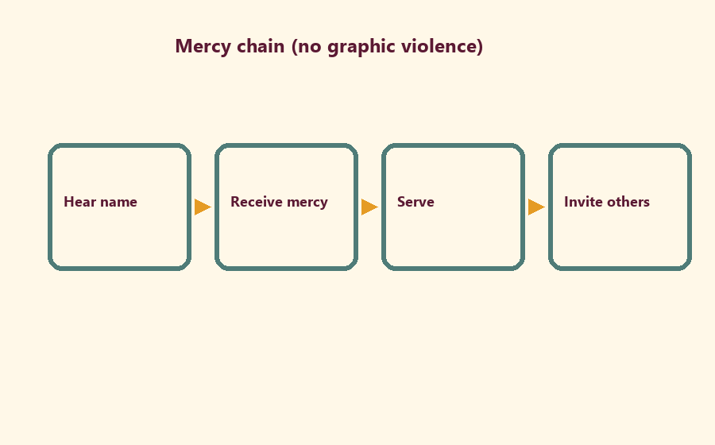

Memory phrase
Nityānanda is an incarnation of mercy.
CHILD ACTIVITY | No scary or violent pictures.

Y02 — Service Challenge Cards
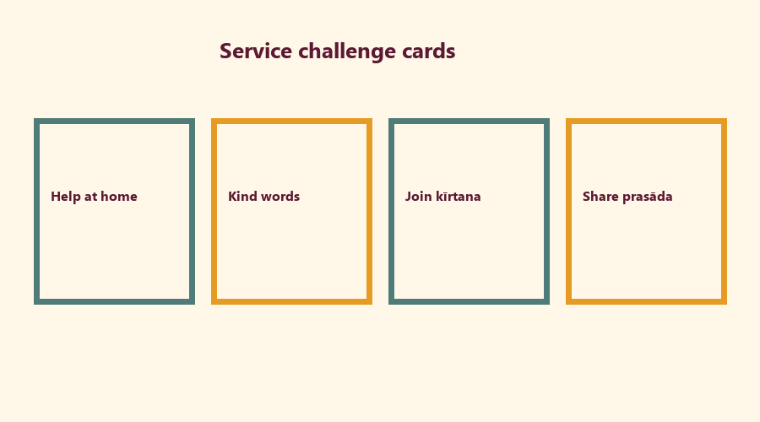
Cut on the dashed borders. Keep each card intact.

Y03 — Help-Hands Craft
Trace and write one help.
My helping hand will:
________________________________________________________________
________________________________________________________________
For whom:
________________________________________________________________
________________________________________________________________

Y04 — Kind Invitation Cards
CARD 1  Please sing with us | CARD 2  Listening is welcome
CARD 3  We can help together | CARD 4  Come share kindness

Y05 — Memory Phrase Mat
Nityānanda is an incarnation of mercy.

Memory phrase
Nityānanda is an incarnation of mercy.

Older Child Rules
Canonical source: launch/CHILD-HOUSE-RULES.md • SHA-256: 6a525f3dd1da740db86e246622696c7b08e28c1f1475227567d639a5bd54ce47
Parents remain onsite. Facilitators guide the session. Host property rules also apply.

Shared rules (all ages)
1. Keep your body safe — feet on the floor; hands gentle.
2. Use respectful speech — no teasing, yelling, or mean labels.
3. Follow the facilitator safety cue immediately (pause / freeze / come here).
4. No jumping on furniture.
5. No indoor throwing.
6. No writing on walls, books, or furniture that are not activity materials.
7. Ask before entering private rooms.
8. Respect belongings — ask before touching what is not yours.
9. Devices away unless the lesson specifically needs them.
10. Snack only in the allowed area; water anytime with permission.
11. Help clean up before leaving.

Correction ladder (no public shame)
1. Calm reminder
2. Redirect / offer a choice
3. Brief quiet reset in a visible space
4. Parent involvement
5. Sit out a specific activity
6. Private parent/program conversation for repeated patterns
Never: public shame, yelling, sarcasm, corporal punishment, forced chanting, or comparing children.

Younger (K–2) emphasis
- Soft voices indoors
- Stay with the group
- Hands to yourself
- Ask before leaving the room

Older (Grades 4–5) emphasis
- Model respectful speech for younger children
- Devices fully away unless assigned
- Help clean-up leadership
- Honest questions welcome; speculation wait for source check
Printable versions: W1 launch-pack CHILD-RULES-YOUNGER.md and CHILD-RULES-OLDER.md.

O01 — CC Ādi 5.208 Observation

VERSE CARD • CC Ādi 5.208

KUTUMBA teaching meaning: Nityānanda is an incarnation of mercy and does not distinguish good and bad.
Source: https://vedabase.io/en/library/cc/adi/5/208/
Rights/status: Sanskrit/Bengali display + KUTUMBA teaching meaning; no full purport

What is mercy here?
________________________________________________________________
________________________________________________________________
________________________________________________________________
What must we not dramatize?
________________________________________________________________
________________________________________________________________
________________________________________________________________

O02 — Mercy vs Judgment Sort
CARD 1  Invite kindly | CARD 2  Mock the fallen
CARD 3  Serve quietly | CARD 4  Public shame
CARD 5  Listen in kīrtana | CARD 6  Scoreboard seva

O03 — Age-Sensitive Boundaries
Rewrite without graphic violence.
Harsh line (do not perform):
________________________________________________________________
________________________________________________________________
________________________________________________________________
Mercy-focused rewrite:
________________________________________________________________
________________________________________________________________
________________________________________________________________
Why the rewrite is better:
________________________________________________________________
________________________________________________________________
________________________________________________________________
TEACHER NOTE | No graphic Jagāi-Mādhāi violence in materials.

O04 — Service Plan
Who can we serve?
Person/place:
________________________________________________________________
________________________________________________________________
Help act:
________________________________________________________________
________________________________________________________________
When:
________________________________________________________________
________________________________________________________________
Minimum version:
________________________________________________________________
________________________________________________________________

O05 — Saṅkīrtana Invitation Map
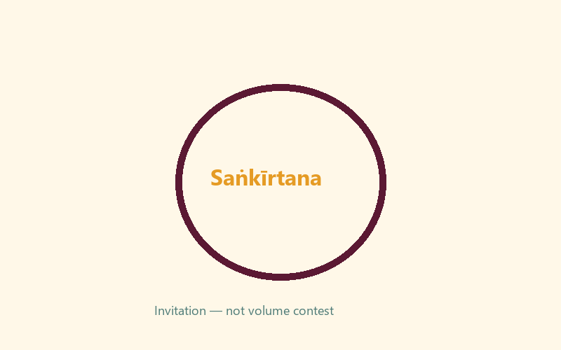
Invitation line:
________________________________________________________________
________________________________________________________________
Listening counts because:
________________________________________________________________
________________________________________________________________

O06 — Exit Ticket
Memory line:
________________________________________________________________
________________________________________________________________
One mercy act:
________________________________________________________________
________________________________________________________________
One person to serve:
________________________________________________________________
________________________________________________________________

Module Project
Canonical source: 11-weekly-program-library/first-six-months/c3-u3-nityananda-trayodasi-family-utsava/project/V13-MODULE-PROJECT-BRIEF.md • SHA-256: 950da6b94fd23d96b8fad01f6c815c9d8c585bc91f11c6b4c2161790175313de
“Who can we serve?” family card for Mela exhibition (noncompetitive).

Week Home Practice
Memory: Nityānanda is an incarnation of mercy. Minimum: memory line + one mercy/service act. Optional soft kīrtana listening.

TEACHER-ONLY
Remove teacher-only pages before distributing participant copies.

Younger Teacher Run Sheet
Canonical source: 11-weekly-program-library/first-six-months/c3-u3-nityananda-trayodasi-family-utsava/teacher/YOUNGER-TEACHER-GUIDE-V13.md • SHA-256: a2d59e25b982888ddba35549f77e2058dbf1c22331f36fe15ebcf373b92d248e
Use with printable stations. Operator completeness pack.

Main Facilitator Guide — C3-U3
Nityānanda Trayodaśī Family Utsava · Saturday 2027-02-20 (planning); published example 2027-02-19 Status: EXTERNAL_OPEN local tithi/human/temple Entry: V13-UTSAVA-START-HERE.md

Exact primary
- Reference: CC Ādi 5.208
- URL: https://vedabase.io/en/library/cc/adi/5/208/
- Bengali: প্রেমে মত্ত নিত্যানন্দ কৃপা–অবতার । উত্তম, অধম, কিছু না করে বিচার ॥ ২০৮ ॥
- IAST: preme matta nityānanda kṛpā-avatāra / uttama, adhama, kichu nā kare vicāra
- KUTUMBA teaching meaning: Nityānanda, intoxicated by ecstatic love and an incarnation of mercy, does not distinguish between the good and the bad.
- Supporting: CC Madhya 1.25 — https://vedabase.io/en/library/cc/madhya/1/25/ — by nature inspired in Kṛṣṇa-prema, and by the Lord’s order He distributes loving service everywhere.
- Rights: Bengali display + KUTUMBA meaning; no full purport.

10–20 minute speaking script
Welcome to our Nityānanda Trayodaśī Family Utsava planning Saturday — 2027-02-20.
Calendar honesty: published example often lists 2027-02-19. Tonight is a family observance candidate, not a settled exact local tithi claim (EXTERNAL_OPEN).
Essential question: How should mercy, service, and saṅkīrtana shape our family’s next kind action?
Primary: CC Ādi 5.208 — https://vedabase.io/en/library/cc/adi/5/208/
KUTUMBA teaching meaning: “Nityānanda, intoxicated by ecstatic love and an incarnation of mercy, does not distinguish between the good and the bad.”
We teach mercy and service. If Jagāi-Mādhāi is mentioned, keep it age-sensitive: people far from kindness are invited toward the holy name and service. No graphic violence. No speculative miracle embellishment.
Analogy one — mercy chain: one kind invitation leads to another. Limit: not every person responds immediately; do not force.
Analogy two — service challenge cards: small helps train the heart. Limit: service is not a scoreboard.
Analogy three — saṅkīrtana as invitation: listening counts. Limit: not a volume contest.
Household case: Older child wants to dramatize a violent scene “for realism.” Redirect to mercy and helping. Principle: age-sensitive storytelling.
Memory line: Nityānanda is an incarnation of mercy.

Older Teacher Run Sheet
Canonical source: 11-weekly-program-library/first-six-months/c3-u3-nityananda-trayodasi-family-utsava/teacher/OLDER-TEACHER-GUIDE-V13.md • SHA-256: 22a9c44f8009c05795bcde24697bb7f650d8624b40b9b5ad4c60d4e1700ca7a8
Use with printable stations. Operator completeness pack.

Main Facilitator Guide — C3-U3
Nityānanda Trayodaśī Family Utsava · Saturday 2027-02-20 (planning); published example 2027-02-19 Status: EXTERNAL_OPEN local tithi/human/temple Entry: V13-UTSAVA-START-HERE.md

Exact primary
- Reference: CC Ādi 5.208
- URL: https://vedabase.io/en/library/cc/adi/5/208/
- Bengali: প্রেমে মত্ত নিত্যানন্দ কৃপা–অবতার । উত্তম, অধম, কিছু না করে বিচার ॥ ২০৮ ॥
- IAST: preme matta nityānanda kṛpā-avatāra / uttama, adhama, kichu nā kare vicāra
- KUTUMBA teaching meaning: Nityānanda, intoxicated by ecstatic love and an incarnation of mercy, does not distinguish between the good and the bad.
- Supporting: CC Madhya 1.25 — https://vedabase.io/en/library/cc/madhya/1/25/ — by nature inspired in Kṛṣṇa-prema, and by the Lord’s order He distributes loving service everywhere.
- Rights: Bengali display + KUTUMBA meaning; no full purport.

10–20 minute speaking script
Welcome to our Nityānanda Trayodaśī Family Utsava planning Saturday — 2027-02-20.
Calendar honesty: published example often lists 2027-02-19. Tonight is a family observance candidate, not a settled exact local tithi claim (EXTERNAL_OPEN).
Essential question: How should mercy, service, and saṅkīrtana shape our family’s next kind action?
Primary: CC Ādi 5.208 — https://vedabase.io/en/library/cc/adi/5/208/
KUTUMBA teaching meaning: “Nityānanda, intoxicated by ecstatic love and an incarnation of mercy, does not distinguish between the good and the bad.”
We teach mercy and service. If Jagāi-Mādhāi is mentioned, keep it age-sensitive: people far from kindness are invited toward the holy name and service. No graphic violence. No speculative miracle embellishment.
Analogy one — mercy chain: one kind invitation leads to another. Limit: not every person responds immediately; do not force.
Analogy two — service challenge cards: small helps train the heart. Limit: service is not a scoreboard.
Analogy three — saṅkīrtana as invitation: listening counts. Limit: not a volume contest.
Household case: Older child wants to dramatize a violent scene “for realism.” Redirect to mercy and helping. Principle: age-sensitive storytelling.
Memory line: Nityānanda is an incarnation of mercy.

Main Facilitator Speaking Map
Canonical source: 11-weekly-program-library/first-six-months/c3-u3-nityananda-trayodasi-family-utsava/teacher/MAIN-FACILITATOR-GUIDE-V13.md • SHA-256: 223234abf270c16751166b4a6c54bc10c62b5301e5317b908d46a9a4167b6d7b
Nityānanda Trayodaśī Family Utsava · Saturday 2027-02-20 (planning); published example 2027-02-19 Status: EXTERNAL_OPEN local tithi/human/temple Entry: V13-UTSAVA-START-HERE.md

Exact primary
- Reference: CC Ādi 5.208
- URL: https://vedabase.io/en/library/cc/adi/5/208/
- Bengali: প্রেমে মত্ত নিত্যানন্দ কৃপা–অবতার । উত্তম, অধম, কিছু না করে বিচার ॥ ২০৮ ॥
- IAST: preme matta nityānanda kṛpā-avatāra / uttama, adhama, kichu nā kare vicāra
- KUTUMBA teaching meaning: Nityānanda, intoxicated by ecstatic love and an incarnation of mercy, does not distinguish between the good and the bad.
- Supporting: CC Madhya 1.25 — https://vedabase.io/en/library/cc/madhya/1/25/ — by nature inspired in Kṛṣṇa-prema, and by the Lord’s order He distributes loving service everywhere.
- Rights: Bengali display + KUTUMBA meaning; no full purport.

10–20 minute speaking script
Welcome to our Nityānanda Trayodaśī Family Utsava planning Saturday — 2027-02-20.
Calendar honesty: published example often lists 2027-02-19. Tonight is a family observance candidate, not a settled exact local tithi claim (EXTERNAL_OPEN).
Essential question: How should mercy, service, and saṅkīrtana shape our family’s next kind action?
Primary: CC Ādi 5.208 — https://vedabase.io/en/library/cc/adi/5/208/
KUTUMBA teaching meaning: “Nityānanda, intoxicated by ecstatic love and an incarnation of mercy, does not distinguish between the good and the bad.”
We teach mercy and service. If Jagāi-Mādhāi is mentioned, keep it age-sensitive: people far from kindness are invited toward the holy name and service. No graphic violence. No speculative miracle embellishment.
Analogy one — mercy chain: one kind invitation leads to another. Limit: not every person responds immediately; do not force.
Analogy two — service challenge cards: small helps train the heart. Limit: service is not a scoreboard.
Analogy three — saṅkīrtana as invitation: listening counts. Limit: not a volume contest.
Household case: Older child wants to dramatize a violent scene “for realism.” Redirect to mercy and helping. Principle: age-sensitive storytelling.
Memory line: Nityānanda is an incarnation of mercy.

Room / Material / Snack / Cleanup Checklist
Done | Area | Check
☐ | Room | Parent circle, younger floor zone, older table zone, clear aisles
☐ | Materials | Labeled track folders, pencils, crayons, tape, timer
☐ | Privacy | Completed forms remain private and never enter Git
☐ | Snack | Snack and water staged for 3:30; allergy plan confirmed
☐ | Safety | Calm corner visible; private rooms closed; exits clear
☐ | Cleanup | Tables wiped and host home reset assigned

RIGHTS NOTE | KUTUMBA-original framing; cited third-party material retains its own rights. Human/temple review remains EXTERNAL_OPEN.

