KUTUMBA

C3-U3 — Younger Teacher Pack
  - K–2 run sheet and activities
C3-U3 • Nityānanda Trayodaśī Family Utsava
V13 • Families Growing in Krishna Consciousness
Program Director: Swapnil Patil
Internal founding-cohort teaching material — human/temple review EXTERNAL_OPEN
KUTUMBA | Families Growing in Krishna Consciousness

Locked Saturday Schedule
Time | Block
1:50–2:00 | Arrival
2:00–2:10 | Opening mantras + welcome
2:10–2:30 | All-family launch/orientation
2:30–3:10 | Parallel tracks
3:10–3:30 | Reunification + bhakti laboratory
3:30–3:40 | Snack + water
3:40–3:55 | Saṅkalpa + project + home practice
3:55–4:00 | Close

TIME CUE | Utsava planning date 2027-02-20. Use 2:30 / 3:10 cues when parallel tracks run; local tithi remains EXTERNAL_OPEN.

Primary verse: CC Ādi 5.208
Source URL: https://vedabase.io/en/library/cc/adi/5/208/

Younger Teacher Run Sheet
Canonical source: 11-weekly-program-library/first-six-months/c3-u3-nityananda-trayodasi-family-utsava/teacher/YOUNGER-TEACHER-GUIDE-V13.md • SHA-256: a2d59e25b982888ddba35549f77e2058dbf1c22331f36fe15ebcf373b92d248e
Use with printable stations. Operator completeness pack.

Main Facilitator Guide — C3-U3
Nityānanda Trayodaśī Family Utsava · Saturday 2027-02-20 (planning); published example 2027-02-19 Status: EXTERNAL_OPEN local tithi/human/temple Entry: V13-UTSAVA-START-HERE.md

Exact primary
- Reference: CC Ādi 5.208
- URL: https://vedabase.io/en/library/cc/adi/5/208/
- Bengali: প্রেমে মত্ত নিত্যানন্দ কৃপা–অবতার । উত্তম, অধম, কিছু না করে বিচার ॥ ২০৮ ॥
- IAST: preme matta nityānanda kṛpā-avatāra / uttama, adhama, kichu nā kare vicāra
- KUTUMBA teaching meaning: Nityānanda, intoxicated by ecstatic love and an incarnation of mercy, does not distinguish between the good and the bad.
- Supporting: CC Madhya 1.25 — https://vedabase.io/en/library/cc/madhya/1/25/ — by nature inspired in Kṛṣṇa-prema, and by the Lord’s order He distributes loving service everywhere.
- Rights: Bengali display + KUTUMBA meaning; no full purport.

10–20 minute speaking script
Welcome to our Nityānanda Trayodaśī Family Utsava planning Saturday — 2027-02-20.
Calendar honesty: published example often lists 2027-02-19. Tonight is a family observance candidate, not a settled exact local tithi claim (EXTERNAL_OPEN).
Essential question: How should mercy, service, and saṅkīrtana shape our family’s next kind action?
Primary: CC Ādi 5.208 — https://vedabase.io/en/library/cc/adi/5/208/
KUTUMBA teaching meaning: “Nityānanda, intoxicated by ecstatic love and an incarnation of mercy, does not distinguish between the good and the bad.”
We teach mercy and service. If Jagāi-Mādhāi is mentioned, keep it age-sensitive: people far from kindness are invited toward the holy name and service. No graphic violence. No speculative miracle embellishment.
Analogy one — mercy chain: one kind invitation leads to another. Limit: not every person responds immediately; do not force.
Analogy two — service challenge cards: small helps train the heart. Limit: service is not a scoreboard.
Analogy three — saṅkīrtana as invitation: listening counts. Limit: not a volume contest.
Household case: Older child wants to dramatize a violent scene “for realism.” Redirect to mercy and helping. Principle: age-sensitive storytelling.
Memory line: Nityānanda is an incarnation of mercy.

Child House Rules
Canonical source: launch/CHILD-HOUSE-RULES.md • SHA-256: 6a525f3dd1da740db86e246622696c7b08e28c1f1475227567d639a5bd54ce47
Parents remain onsite. Facilitators guide the session. Host property rules also apply.

Shared rules (all ages)
1. Keep your body safe — feet on the floor; hands gentle.
2. Use respectful speech — no teasing, yelling, or mean labels.
3. Follow the facilitator safety cue immediately (pause / freeze / come here).
4. No jumping on furniture.
5. No indoor throwing.
6. No writing on walls, books, or furniture that are not activity materials.
7. Ask before entering private rooms.
8. Respect belongings — ask before touching what is not yours.
9. Devices away unless the lesson specifically needs them.
10. Snack only in the allowed area; water anytime with permission.
11. Help clean up before leaving.

Correction ladder (no public shame)
1. Calm reminder
2. Redirect / offer a choice
3. Brief quiet reset in a visible space
4. Parent involvement
5. Sit out a specific activity
6. Private parent/program conversation for repeated patterns
Never: public shame, yelling, sarcasm, corporal punishment, forced chanting, or comparing children.

Younger (K–2) emphasis
- Soft voices indoors
- Stay with the group
- Hands to yourself
- Ask before leaving the room

Older (Grades 4–5) emphasis
- Model respectful speech for younger children
- Devices fully away unless assigned
- Help clean-up leadership
- Honest questions welcome; speculation wait for source check
Printable versions: W1 launch-pack CHILD-RULES-YOUNGER.md and CHILD-RULES-OLDER.md.

Y01 — Mercy Chain
Hear → mercy → serve → invite
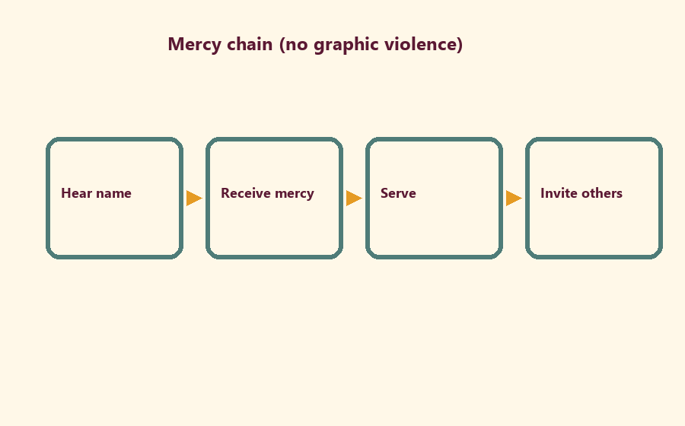

Memory phrase
Nityānanda is an incarnation of mercy.
CHILD ACTIVITY | No scary or violent pictures.

Y02 — Service Challenge Cards
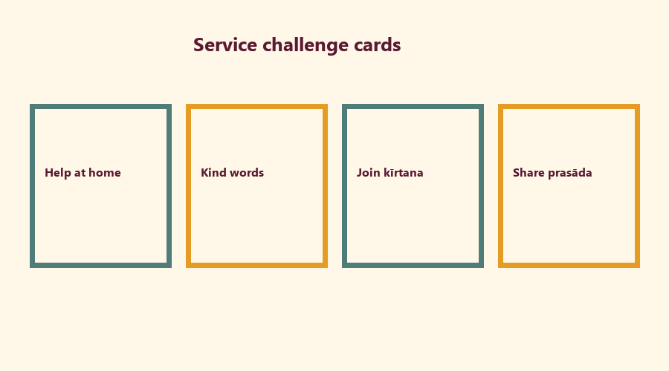
Cut on the dashed borders. Keep each card intact.

Y03 — Help-Hands Craft
Trace and write one help.
My helping hand will:
________________________________________________________________
________________________________________________________________
For whom:
________________________________________________________________
________________________________________________________________

Y04 — Kind Invitation Cards
CARD 1  Please sing with us | CARD 2  Listening is welcome
CARD 3  We can help together | CARD 4  Come share kindness

Y05 — Memory Phrase Mat
Nityānanda is an incarnation of mercy.

Memory phrase
Nityānanda is an incarnation of mercy.
RIGHTS NOTE | KUTUMBA-original framing; cited third-party material retains its own rights. Human/temple review remains EXTERNAL_OPEN.

