KUTUMBA

C3-W1 — Older Teacher Pack
  - Grades 4–5 run sheet and activities
C3-W1 • Who Is God? The Supreme Enjoyer, Proprietor and Friend
V13 • Families Growing in Krishna Consciousness
Program Director: Swapnil Patil
Internal founding-cohort teaching material — human/temple review EXTERNAL_OPEN
KUTUMBA | Families Growing in Krishna Consciousness

Locked Saturday Schedule
Time | Block
1:50–2:00 | Arrival
2:00–2:10 | Opening mantras + welcome
2:10–2:30 | All-family launch/orientation
2:30–3:10 | Parallel tracks
3:10–3:30 | Reunification + bhakti laboratory
3:30–3:40 | Snack + water
3:40–3:55 | Saṅkalpa + project + home practice
3:55–4:00 | Close

TIME CUE | Track handoff is at 2:30; all groups reunite at 3:10.

Primary verse: BG 5.29
Source URL: https://vedabase.io/en/library/bg/5/29/

Older Teacher Run Sheet
Canonical source: 11-weekly-program-library/first-six-months/c3-w1-who-is-god-the-supreme-enjoyer-proprietor-and-friend/teacher/OLDER-TEACHER-GUIDE-V13.md • SHA-256: 0067774fbdc124881612ee8101f8a6afe93d723f838a7b7df1dced055c6fbcd9
KUTUMBA · Families Growing in Krishna Consciousness Program Director: Swapnil Patil Week: Who Is God? The Supreme Enjoyer, Proprietor and Friend · Date: 2027-01-09 Track window: Saturday 2:30–3:10 (Grades 4–5) Reunite: 3:10 for bhakti laboratory Primary: BG 5.29 — https://vedabase.io/en/library/bg/5/29/ Primary mechanic: Triple-lens map Status: Internal founding-cohort teaching material — human/temple review EXTERNAL_OPEN

Essential question
Who is God — and how does knowing Him bring peace?

Materials (print before Saturday)
From activities/v13-older/: O01–O06 Also pens/crayons; verse card; privacy reminder.

Locked Saturday context
- 1:50–2:00 Arrival · 2:00–2:10 Mantras · 2:10–2:30 All-family launch
- 2:30–3:10 This track · 3:10–3:30 Reunify · 3:30–3:40 Snack/water · 3:40–3:55 Saṅkalpa · 3:55–4:00 Close
Parents remain onsite. No public ranking. No forced disclosure.

Source layer (use mid-track)
Primary: BG 5.29 — https://vedabase.io/en/library/bg/5/29/
Devanāgarī: भोक्तारं यज्ञतपसां सर्वलोकमहेश्वरम् । सुहृदं सर्वभूतानां ज्ञात्वा मां शान्तिमृच्छति ॥ २९ ॥
IAST: bhoktāraṁ yajña-tapasāṁ sarva-loka-maheśvaram / suhṛdaṁ sarva-bhūtānāṁ jñātvā māṁ śāntim ṛcchati
KUTUMBA teaching meaning (not a BBT translation): Knowing Kṛṣṇa as the supreme enjoyer of sacrifice and austerity, the Lord of all worlds, and the friend of all beings, one attains peace.

Memory line
Kṛṣṇa owns, enjoys, befriends.

V13 printable wiring (Triple-lens map)

V13 printable block 0–6 — BG 5.29 observation
Printable: activities/v13-older/O01-BG-5-29-OBSERVATION.md (O01-BG-5-29-OBSERVATION)
Three titles → peace.
Keep primary mechanic (Triple-lens map). Block: God as remote force only; ownership means domination without friendship/service.

V13 printable block 6–14 — Three-lens worksheet
Printable: activities/v13-older/O02-THREE-LENS-WORKSHEET.md (O02-THREE-LENS-WORKSHEET)
Map enjoyer / proprietor / friend applications.
Keep primary mechanic (Triple-lens map). Block: God as remote force only; ownership means domination without friendship/service.

V13 printable block 14–22 — Ownership/service sort
Printable: activities/v13-older/O03-OWNERSHIP-SERVICE-SORT.md (O03-OWNERSHIP-SERVICE-SORT)
Sort domination vs stewardship.
Keep primary mechanic (Triple-lens map). Block: God as remote force only; ownership means domination without friendship/service.

V13 printable block 22–30 — Peace application scenarios
Printable: activities/v13-older/O04-PEACE-APPLICATION-SCENARIOS.md (O04-PEACE-APPLICATION-SCENARIOS)
Three ownership conflict cases.
Keep primary mechanic (Triple-lens map). Block: God as remote force only; ownership means domination without friendship/service.

V13 printable block 30–36 — Triple-lens diagram
Printable: activities/v13-older/O05-TRIPLE-LENS-DIAGRAM.md (O05-TRIPLE-LENS-DIAGRAM)
One Lord; three lenses; peace.
Keep primary mechanic (Triple-lens map). Block: God as remote force only; ownership means domination without friendship/service.

V13 printable block 36–40 — Exit ticket
Printable: activities/v13-older/O06-EXIT-TICKET.md (O06-EXIT-TICKET)
One lens to practice at home.
Keep primary mechanic (Triple-lens map). Block: God as remote force only; ownership means domination without friendship/service.

Close of track (handoff)
Bring one sentence or artifact to reunification. Do not start next week’s topic. Care boundary: Age-appropriate ownership/friendship/service; no speculative iconography.

Inherited classroom depth (from V12 OLDER-TEACHER-GUIDE.md)
Keep story scripts, movement steps, and wonder questions below. Wire printables to the V13 codes above; do not replace this depth with “see research.”
Week: Who Is God? The Supreme Enjoyer, Proprietor and Friend Primary: BG 5.29 — https://vedabase.io/en/library/bg/5/29/ Session length: ~40 minutes (parallel track ~2:30–3:10) Parents: Remain onsite; reunite at 3:10 Status: Internal founding-cohort teaching material — human/temple review EXTERNAL_OPEN

Objective
Students observe BG 5.29, explain the three peace-giving features, apply stewardship vs neglect, and write one duty remembrance.

Exact memory phrase
Peace comes from knowing Kṛṣṇa as the supreme enjoyer, proprietor of everything and friend of all living beings.
Short echo: Kṛṣṇa owns, enjoys, befriends.

Teacher background
- KUTUMBA teaching meaning: Knowing Kṛṣṇa as the supreme enjoyer of sacrifice and austerity, the Lord of all worlds, and the friend of all beings, one attains peace. (Label as KUTUMBA teaching meaning — not as BBT translation.)
- Supporting frames (one sentence each): Īśo 1 stewardship; BG 9.26 offering; BG 9.10 supervision.
- Block: “I am the ultimate owner/enjoyer.”; Neglect of stewardship (careless misuse because “Kṛṣṇa owns it”).
- Scope: No initiation track; no invented rituals; defer deep Supersoul debates.

Materials
- Verse strips
- Worksheets
- Scenario cards
- Peace-triangle sheets
- Pencils; answer key
- Project half-sheets

Minute-by-minute plan

0–5 min — Settle and hook
1. Welcome.
2. Hook: “Can knowing who God is change a fight about credit?”
3. Essential question aloud.

5–14 min — Primary text observation
1. Read IAST together.
2. Underline bhoktāram / maheśvaram / suhṛdam / śāntim.
3. Observation: What result follows knowing?
4. One-sentence bridges to Īśo 1 and BG 9.26.

14–22 min — Worksheet questions
Students complete Section A of the older activity pack. Teacher circulates; use OLDER-ANSWER-KEY.md for expected directions (not for grading ranks).

22–28 min — Scenario cards (small groups)
A Credit fight B Grab C Careless slogan — mistaken, response, what not to say.
Share one insight per group (60 seconds).

28–33 min — Puzzle / game: Owner or Steward
Claims sorted O (ultimate-owner error) vs S (stewardship true to 5.29). Three rounds.

33–37 min — Diagram / map task
Peace triangle: label corners; write one conflict reframed.

37–40 min — Project sentence + handoff
Duty + three-line remembrance to parent at 3:10.

Boundaries
- No ranking or public scores.
- No invented dialogue.
- Parents onsite; snack/water only at 3:30 in the main schedule.
- Defer off-scope topics: Initiation; confidential pastimes; full īśvara-tattva dump.

O01 — BG 5.29 observation
Three titles → peace.

VERSE CARD • BG 5.29
भोक्तारं यज्ञतपसां सर्वलोकमहेश्वरम् । सुहृदं सर्वभूतानां ज्ञात्वा मां शान्तिमृच्छति ॥ २९ ॥
bhoktāraṁ yajña-tapasāṁ sarva-loka-maheśvaram / suhṛdaṁ sarva-bhūtānāṁ jñātvā māṁ śāntim ṛcchati
KUTUMBA teaching meaning: Knowing Kṛṣṇa as the supreme enjoyer of sacrifice and austerity, the Lord of all worlds, and the friend of all beings, one attains peace.
Source: https://vedabase.io/en/library/bg/5/29/
Rights/status: Scripture display/source: VedaBase; teaching meaning: KUTUMBA-original (not labeled as BBT translation).

What does the verse teach in my words?
________________________________________________________________
________________________________________________________________
What misconception does this week block?
________________________________________________________________
________________________________________________________________
One question for the facilitator:
________________________________________________________________
________________________________________________________________

O02 — Three-lens worksheet
Map enjoyer / proprietor / friend applications.
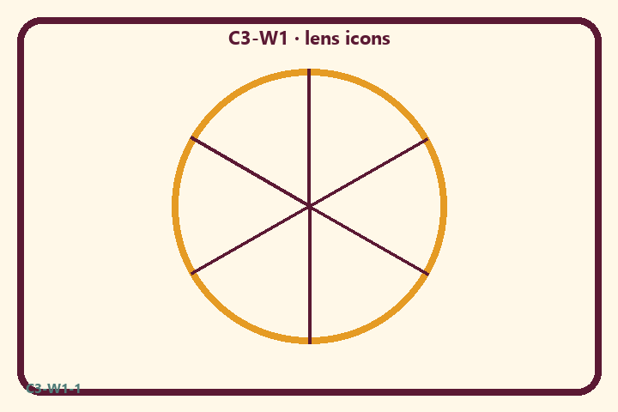
Prompt | My notes
Three-lens worksheet | ________________
Limit / care | ________________

Application:
________________________________________________________________
________________________________________________________________
What not to say:
________________________________________________________________
________________________________________________________________
KEY IDEA | Kṛṣṇa is supreme enjoyer, proprietor of all worlds, and friend of all beings — knowing this brings peace.

O03 — Ownership/service sort
Sort domination vs stewardship.
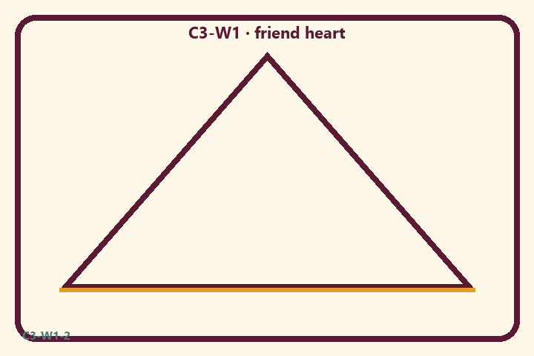
Prompt | My notes
Ownership/service sort | ________________
Limit / care | ________________

Application:
________________________________________________________________
________________________________________________________________
What not to say:
________________________________________________________________
________________________________________________________________
KEY IDEA | Kṛṣṇa is supreme enjoyer, proprietor of all worlds, and friend of all beings — knowing this brings peace.

O04 — Peace application scenarios
Three ownership conflict cases.
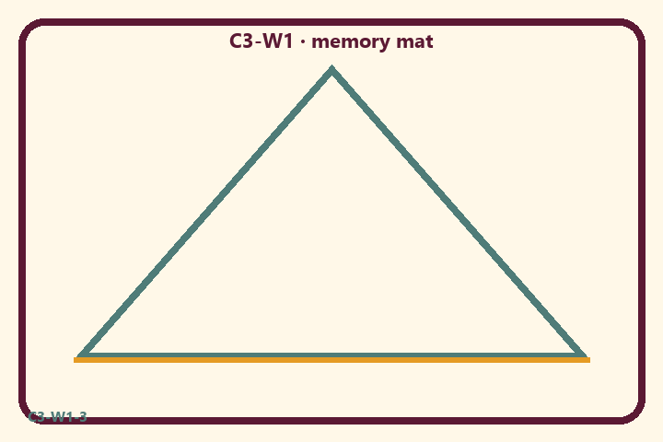
Prompt | My notes
Peace application scenarios | ________________
Limit / care | ________________

Application:
________________________________________________________________
________________________________________________________________
What not to say:
________________________________________________________________
________________________________________________________________
KEY IDEA | Kṛṣṇa is supreme enjoyer, proprietor of all worlds, and friend of all beings — knowing this brings peace.

O05 — Triple-lens diagram
One Lord; three lenses; peace.
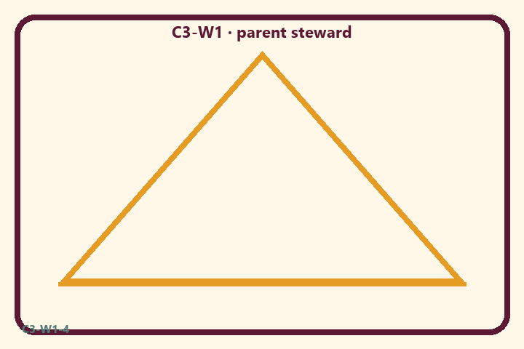
Prompt | My notes
Triple-lens diagram | ________________
Limit / care | ________________

Application:
________________________________________________________________
________________________________________________________________
What not to say:
________________________________________________________________
________________________________________________________________
KEY IDEA | Kṛṣṇa is supreme enjoyer, proprietor of all worlds, and friend of all beings — knowing this brings peace.

O06 — Exit ticket
One lens to practice at home.
Primary in one sentence:
________________________________________________________________
________________________________________________________________
One analogy or mechanic and its limit:
________________________________________________________________
________________________________________________________________
One home action:
________________________________________________________________
________________________________________________________________
One question I still have:
________________________________________________________________
________________________________________________________________
RIGHTS NOTE | KUTUMBA-original framing; cited third-party material retains its own rights. Human/temple review remains EXTERNAL_OPEN.

