KUTUMBA

C3-W1 — Parent Track
  - Facilitator guide and parent printables
C3-W1 • Who Is God? The Supreme Enjoyer, Proprietor and Friend
V13 • Families Growing in Krishna Consciousness
Program Director: Swapnil Patil
Internal founding-cohort teaching material — human/temple review EXTERNAL_OPEN
KUTUMBA | Families Growing in Krishna Consciousness

Locked Saturday Schedule
Time | Block
1:50–2:00 | Arrival
2:00–2:10 | Opening mantras + welcome
2:10–2:30 | All-family launch/orientation
2:30–3:10 | Parallel tracks
3:10–3:30 | Reunification + bhakti laboratory
3:30–3:40 | Snack + water
3:40–3:55 | Saṅkalpa + project + home practice
3:55–4:00 | Close

TIME CUE | Track handoff is at 2:30; all groups reunite at 3:10.

Primary verse: BG 5.29
Source URL: https://vedabase.io/en/library/bg/5/29/

Parent Facilitator Run Sheet
Canonical source: 11-weekly-program-library/first-six-months/c3-w1-who-is-god-the-supreme-enjoyer-proprietor-and-friend/teacher/PARENT-GUIDE-V13.md • SHA-256: 07ff5980dc4c0534953e4d89dcade62287af9e55a4af4c9af6f7edce5f17b835
KUTUMBA · Families Growing in Krishna Consciousness Program Director: Swapnil Patil Week: Who Is God? The Supreme Enjoyer, Proprietor and Friend · Date: 2027-01-09 Track window: Saturday 2:30–3:10 (parents) Reunite: 3:10 for bhakti laboratory Primary: BG 5.29 — https://vedabase.io/en/library/bg/5/29/ Primary mechanic: Triple-lens map Status: Internal founding-cohort teaching material — human/temple review EXTERNAL_OPEN

Essential question
Who is God — and how does knowing Him bring peace?

Materials (print before Saturday)
From activities/v13-parent/: P01–P05 Also pens/crayons; verse card; privacy reminder.

Locked Saturday context
- 1:50–2:00 Arrival · 2:00–2:10 Mantras · 2:10–2:30 All-family launch
- 2:30–3:10 This track · 3:10–3:30 Reunify · 3:30–3:40 Snack/water · 3:40–3:55 Saṅkalpa · 3:55–4:00 Close
Parents remain onsite. No public ranking. No forced disclosure.

Source layer (use mid-track)
Primary: BG 5.29 — https://vedabase.io/en/library/bg/5/29/
Devanāgarī: भोक्तारं यज्ञतपसां सर्वलोकमहेश्वरम् । सुहृदं सर्वभूतानां ज्ञात्वा मां शान्तिमृच्छति ॥ २९ ॥
IAST: bhoktāraṁ yajña-tapasāṁ sarva-loka-maheśvaram / suhṛdaṁ sarva-bhūtānāṁ jñātvā māṁ śāntim ṛcchati
KUTUMBA teaching meaning (not a BBT translation): Knowing Kṛṣṇa as the supreme enjoyer of sacrifice and austerity, the Lord of all worlds, and the friend of all beings, one attains peace.

Memory line
Kṛṣṇa owns, enjoys, befriends.

V13 printable wiring (Triple-lens map)

V13 printable block 0–5 — Private reflection — ownership tone
Printable: activities/v13-parent/P01-PRIVATE-REFLECTION.md (P01-PRIVATE-REFLECTION)
Where does our home clutch rather than steward?
Keep primary mechanic (Triple-lens map). Block: God as remote force only; ownership means domination without friendship/service.

V13 printable block 5–12 — Ownership/service card sort
Printable: activities/v13-parent/P02-OWNERSHIP-SERVICE-CARD-SORT.md (P02-OWNERSHIP-SERVICE-CARD-SORT)
Sort STEWARD / CLUTCH / FRIEND.
Keep primary mechanic (Triple-lens map). Block: God as remote force only; ownership means domination without friendship/service.

V13 printable block 12–22 — Substantial family case
Printable: activities/v13-parent/P03-SUBSTANTIAL-FAMILY-CASE.md (P03-SUBSTANTIAL-FAMILY-CASE)
Sibling fight over “my room / my phone.”
Keep primary mechanic (Triple-lens map). Block: God as remote force only; ownership means domination without friendship/service.

V13 printable block 22–32 — Household operating application
Printable: activities/v13-parent/P04-HOUSEHOLD-OPERATING-APPLICATION.md (P04-HOUSEHOLD-OPERATING-APPLICATION)
One stewardship sentence + one friend act.
Keep primary mechanic (Triple-lens map). Block: God as remote force only; ownership means domination without friendship/service.

V13 printable block 32–38 — Private next-step saṅkalpa
Printable: activities/v13-parent/P05-PRIVATE-NEXT-STEP-SANKALPA.md (P05-PRIVATE-NEXT-STEP-SANKALPA)
Practice one lens daily.
Keep primary mechanic (Triple-lens map). Block: God as remote force only; ownership means domination without friendship/service.

Close of track (handoff)
Bring one sentence or artifact to reunification. Do not start next week’s topic. Care boundary: Age-appropriate ownership/friendship/service; no speculative iconography.

Inherited classroom depth (from V12 parent-lesson / constructed V13 flow)
Keep story scripts, movement steps, and wonder questions below. Wire printables to the V13 codes above; do not replace this depth with “see research.”

Essential question
Who is God to our family?

Source
BG 5.29 — teaching meaning: Knowing the Lord as the enjoyer of sacrifice and austerity, the proprietor of all worlds, and the friend of all beings — one attains peace.

Discussion
One realistic household tension; no compelled confession.

Application
5–15 minute cue; minimum version counts.

Privacy
No public scoring of sādhana.

P01 — Private reflection — ownership tone
Where does our home clutch rather than steward?

SAFETY & PRIVACY | Write privately. Sharing is optional. Do not collect or place completed sheets in Git.

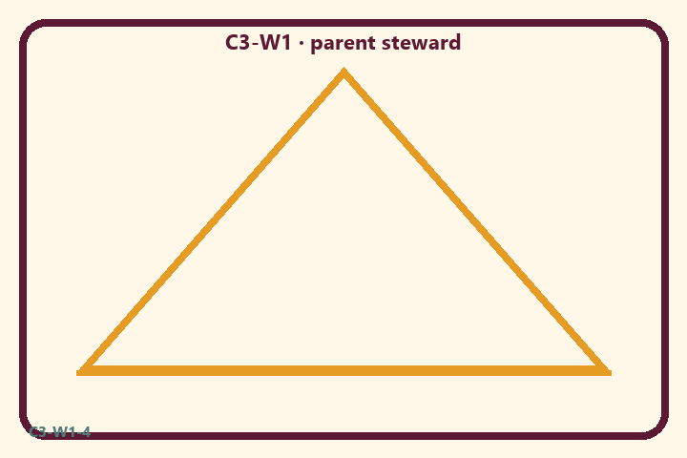
Where does our home clutch rather than steward?
Private notes:
________________________________________________________________
________________________________________________________________
________________________________________________________________
________________________________________________________________
Habit to watch this week:
________________________________________________________________
________________________________________________________________
________________________________________________________________
________________________________________________________________

P02 — Ownership/service card sort
Sort STEWARD / CLUTCH / FRIEND.
HELPFUL | MISTAKEN

L1  Offer first | L2  Dominate siblings
L3  Steward shared space | L4  Kṛṣṇa is only a force
L5  Befriend with service | L6  Clutch the remote
TEACHER NOTE | God as remote force only; ownership means domination without friendship/service.

P03 — Substantial family case
Sibling fight over “my room / my phone.”
SAFETY & PRIVACY | Fictional case. No compelled confession of real events.

Siblings fight over “my room” and “my phone.” Parents escalate ownership lectures without naming Kṛṣṇa as proprietor or modeling friendship.
Tempting mistaken conclusion:
________________________________________________________________
________________________________________________________________
________________________________________________________________
Principle from primary:
________________________________________________________________
________________________________________________________________
________________________________________________________________
Compassionate response:
________________________________________________________________
________________________________________________________________
________________________________________________________________
One seven-day household action:
________________________________________________________________
________________________________________________________________
________________________________________________________________
What we should not say:
________________________________________________________________
________________________________________________________________
________________________________________________________________
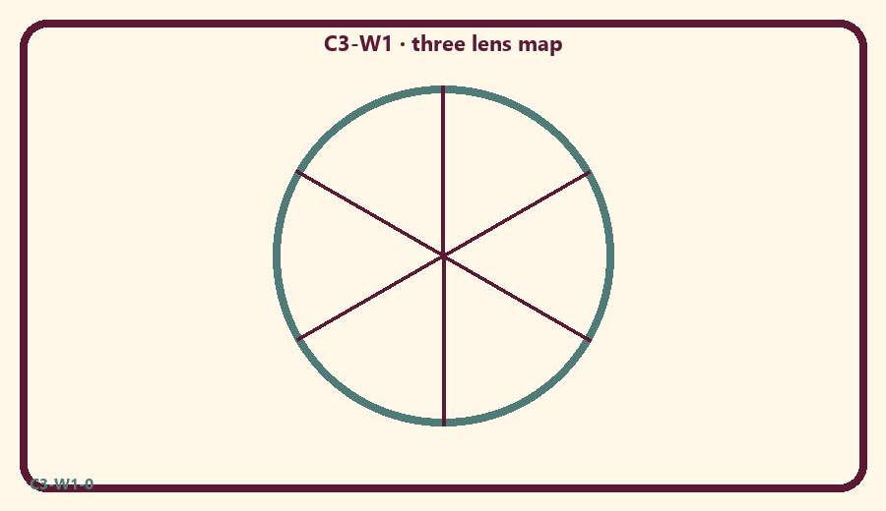

P04 — Household operating application
One stewardship sentence + one friend act.
SAFETY & PRIVACY | No ranking and no public reading required.

One household action for seven days:
________________________________________________________________
________________________________________________________________
________________________________________________________________
Trigger (when/where):
________________________________________________________________
________________________________________________________________
________________________________________________________________
Who starts if others are tired:
________________________________________________________________
________________________________________________________________
________________________________________________________________
Minimum version on a hard day:
________________________________________________________________
________________________________________________________________
________________________________________________________________

Memory phrase
Kṛṣṇa owns, enjoys, befriends.

P05 — Private next-step saṅkalpa
Practice one lens daily.
KEY IDEA | specific action + frequency + trigger + minimum version

Specific action:
________________________________________________________________
________________________________________________________________
Frequency:
________________________________________________________________
________________________________________________________________
Trigger (when and where):
________________________________________________________________
________________________________________________________________
Minimum version for a hard day:
________________________________________________________________
________________________________________________________________
Where we will place the reminder:
________________________________________________________________
________________________________________________________________
No ranking. The minimum version counts as success.
RIGHTS NOTE | KUTUMBA-original framing; cited third-party material retains its own rights. Human/temple review remains EXTERNAL_OPEN.

