KUTUMBA

C3-W1 — Younger Teacher Pack
  - K–2 run sheet and activities
C3-W1 • Who Is God? The Supreme Enjoyer, Proprietor and Friend
V13 • Families Growing in Krishna Consciousness
Program Director: Swapnil Patil
Internal founding-cohort teaching material — human/temple review EXTERNAL_OPEN
KUTUMBA | Families Growing in Krishna Consciousness

Locked Saturday Schedule
Time | Block
1:50–2:00 | Arrival
2:00–2:10 | Opening mantras + welcome
2:10–2:30 | All-family launch/orientation
2:30–3:10 | Parallel tracks
3:10–3:30 | Reunification + bhakti laboratory
3:30–3:40 | Snack + water
3:40–3:55 | Saṅkalpa + project + home practice
3:55–4:00 | Close

TIME CUE | Track handoff is at 2:30; all groups reunite at 3:10.

Primary verse: BG 5.29
Source URL: https://vedabase.io/en/library/bg/5/29/

Younger Teacher Run Sheet
Canonical source: 11-weekly-program-library/first-six-months/c3-w1-who-is-god-the-supreme-enjoyer-proprietor-and-friend/teacher/YOUNGER-TEACHER-GUIDE-V13.md • SHA-256: 9a17dd55393545f1e6692758aad40277641aff60e12a8c22ea927f8dd912ab9a
KUTUMBA · Families Growing in Krishna Consciousness Program Director: Swapnil Patil Week: Who Is God? The Supreme Enjoyer, Proprietor and Friend · Date: 2027-01-09 Track window: Saturday 2:30–3:10 (K–2) Reunite: 3:10 for bhakti laboratory Primary: BG 5.29 — https://vedabase.io/en/library/bg/5/29/ Primary mechanic: Triple-lens map Status: Internal founding-cohort teaching material — human/temple review EXTERNAL_OPEN

Essential question
Who is God — and how does knowing Him bring peace?

Materials (print before Saturday)
From activities/v13-younger/: Y01–Y05 Also pens/crayons; verse card; privacy reminder.

Locked Saturday context
- 1:50–2:00 Arrival · 2:00–2:10 Mantras · 2:10–2:30 All-family launch
- 2:30–3:10 This track · 3:10–3:30 Reunify · 3:30–3:40 Snack/water · 3:40–3:55 Saṅkalpa · 3:55–4:00 Close
Parents remain onsite. No public ranking. No forced disclosure.

Source layer (use mid-track)
Primary: BG 5.29 — https://vedabase.io/en/library/bg/5/29/
Devanāgarī: भोक्तारं यज्ञतपसां सर्वलोकमहेश्वरम् । सुहृदं सर्वभूतानां ज्ञात्वा मां शान्तिमृच्छति ॥ २९ ॥
IAST: bhoktāraṁ yajña-tapasāṁ sarva-loka-maheśvaram / suhṛdaṁ sarva-bhūtānāṁ jñātvā māṁ śāntim ṛcchati
KUTUMBA teaching meaning (not a BBT translation): Knowing Kṛṣṇa as the supreme enjoyer of sacrifice and austerity, the Lord of all worlds, and the friend of all beings, one attains peace.

Memory line
Kṛṣṇa owns, enjoys, befriends.

V13 printable wiring (Triple-lens map)

V13 printable block 0–6 — Enjoyer/owner/friend icons
Printable: activities/v13-younger/Y01-THREE-LENS-ICONS.md (Y01-THREE-LENS-ICONS)
Place three icon cards; say each lens.
Keep primary mechanic (Triple-lens map). Block: God as remote force only; ownership means domination without friendship/service.

V13 printable block 6–14 — Lens matching
Printable: activities/v13-younger/Y02-LENS-MATCHING.md (Y02-LENS-MATCHING)
Match home scenes to enjoyer/owner/friend.
Keep primary mechanic (Triple-lens map). Block: God as remote force only; ownership means domination without friendship/service.

V13 printable block 14–24 — Friend-of-all craft
Printable: activities/v13-younger/Y03-FRIEND-OF-ALL-CRAFT.md (Y03-FRIEND-OF-ALL-CRAFT)
Craft a friend-heart for kind service.
Keep primary mechanic (Triple-lens map). Block: God as remote force only; ownership means domination without friendship/service.

V13 printable block 24–32 — Steward cards
Printable: activities/v13-younger/Y04-STEWARD-CARDS.md (Y04-STEWARD-CARDS)
We care for things because Kṛṣṇa owns.
Keep primary mechanic (Triple-lens map). Block: God as remote force only; ownership means domination without friendship/service.

V13 printable block 32–38 — Memory phrase mat
Printable: activities/v13-younger/Y05-MEMORY-PHRASE-MAT.md (Y05-MEMORY-PHRASE-MAT)
Echo: Kṛṣṇa owns, enjoys, befriends.
Keep primary mechanic (Triple-lens map). Block: God as remote force only; ownership means domination without friendship/service.

Close of track (handoff)
Bring one sentence or artifact to reunification. Do not start next week’s topic. Care boundary: Age-appropriate ownership/friendship/service; no speculative iconography.

Inherited classroom depth (from V12 YOUNGER-TEACHER-GUIDE.md)
Keep story scripts, movement steps, and wonder questions below. Wire printables to the V13 codes above; do not replace this depth with “see research.”
Week: Who Is God? The Supreme Enjoyer, Proprietor and Friend Primary: BG 5.29 — https://vedabase.io/en/library/bg/5/29/ Session length: 40 minutes (parallel track ~2:30–3:10) Parents: Remain onsite; reunite at 3:10 Status: Internal founding-cohort teaching material — human/temple review EXTERNAL_OPEN

Objective
Children learn Kṛṣṇa owns, enjoys, and befriends; practice shared care of a basket; offer a simple drawing/flower in offering mood.

Exact memory phrase
Kṛṣṇa owns, enjoys, befriends.

Teacher background (2 minutes to review)
- KUTUMBA teaching meaning (adult wording): Knowing Kṛṣṇa as the supreme enjoyer of sacrifice and austerity, the Lord of all worlds, and the friend of all beings, one attains peace.
- Child-facing paraphrase: Kṛṣṇa owns everything. He enjoys loving gifts. He is everyone’s friend. Knowing this brings peace.
- Block misconceptions (child words):
- “It is only mine forever.”
- “If Kṛṣṇa owns it I can be careless.”
- Do not: invent deity dialogue; force confession; rank children; use scare tactics; claim temple certification stickers.

Materials
- Shared basket
- Three picture cards
- Paper flowers / crayons
- Soft puppet
- Memory phrase stickers
- Soft toss object
- Calm-corner chair

Room setup
Circle on the floor; materials table behind you; calm corner with one chair for quiet reset. Keep aisles clear for movement.

Minute-by-minute executable plan

0–5 min — Opening and recall
1. Welcome; feet on floor.
2. Echo: Kṛṣṇa owns, / enjoys, / befriends.
3. Show three pictures once.
4. Practice: “We care because Kṛṣṇa owns.”

5–13 min — Story script (paraphrase only; ~8 minutes)
Say exactly this spine (do not invent deity dialogue):
Sometimes we say “mine!” and feel hot inside. Kṛṣṇa teaches that He is the big Owner, the One who enjoys our loving gifts, and the Friend of every living being. When we remember that, we can share and care — and feel more peaceful. We do not throw things away carelessly. Because Kṛṣṇa owns them, we take care.
Story boundaries: Paraphrase BG 5.29 themes only. No invented deity quotes. No ritual inventions.

13–16 min — Three wonder questions
1. Who owns everything? (Kṛṣṇa)
2. Is Kṛṣṇa our friend? (Yes)
3. If He owns it, do we care more or less? (More)
Accept one- or two-word answers. Affirm effort.

16–24 min — Movement game: Owns–Enjoys–Friend Walk (steps)
1. Three mats labeled with pictures.
2. Children walk gently Owns → Enjoys → Friend while saying the phrase.
3. At Friend mat, hand-to-heart.
4. Return one basket item to the center (stewardship).
5. Two rounds; sit; echo phrase.

24–32 min — Craft: Peace triangle card (steps)
1. Triangle card with three corners pre-marked.
2. Child colors corners; helper writes phrase at center.
3. Back: draw one thing to care for at home.
4. Practice pointing to each corner.
Full printable steps also live in activities/YOUNGER-ACTIVITY-PACK.md (use together; this guide remains executable if the pack is missing).

32–35 min — Printable / coloring task
If time remains, color the younger line-art sheet if available. If short on time, keep the craft as the take-home.

35–38 min — Behavior redirects and quiet reset
Use calm, specific redirects:
- Feet on floor — “Feet visit the mat.”
- Kind hands — “Hands help; toys rest.”
- Loud shout — “Soft voice, please.”
- Quiet reset — “Calm corner for sixty seconds.”

38–40 min — Cleanup and parent handoff
1. Materials away; craft in hand.
2. At reunification, tell parent in one sentence:
Memory phrase: “Kṛṣṇa owns, enjoys, befriends..” Home cue: Before one daily duty, remember: Kṛṣṇa owns, Kṛṣṇa enjoys, Kṛṣṇa is friend.
1. Do not report private behavior struggles in front of other families.

Behavior redirects (quick reference)
Signal | Teacher line | Child action
Running | Walking feet. | Walk to mat
Snatching | Kind hands. | Hands to lap
Interrupt shout | Soft voice. | Whisper retry
Shutdown | Quiet reset is okay. | Calm corner 60 sec

Backup low-prep (if craft fails or energy crashes)
Soft toss: catch and say “Kṛṣṇa owns” or “Kṛṣṇa is friend.”

What success looks like
- Echoes phrase
- Returns one item to basket
- Says we care because Kṛṣṇa owns

Boundaries
- Snack/water only happens in main schedule (3:30), not as a track bribe.
- No weekly meal language.
- No fabricated approval stickers implying temple certification.
- Privacy: no forced confession.

Child House Rules
Canonical source: launch/CHILD-HOUSE-RULES.md • SHA-256: 6a525f3dd1da740db86e246622696c7b08e28c1f1475227567d639a5bd54ce47
Parents remain onsite. Facilitators guide the session. Host property rules also apply.

Shared rules (all ages)
1. Keep your body safe — feet on the floor; hands gentle.
2. Use respectful speech — no teasing, yelling, or mean labels.
3. Follow the facilitator safety cue immediately (pause / freeze / come here).
4. No jumping on furniture.
5. No indoor throwing.
6. No writing on walls, books, or furniture that are not activity materials.
7. Ask before entering private rooms.
8. Respect belongings — ask before touching what is not yours.
9. Devices away unless the lesson specifically needs them.
10. Snack only in the allowed area; water anytime with permission.
11. Help clean up before leaving.

Correction ladder (no public shame)
1. Calm reminder
2. Redirect / offer a choice
3. Brief quiet reset in a visible space
4. Parent involvement
5. Sit out a specific activity
6. Private parent/program conversation for repeated patterns
Never: public shame, yelling, sarcasm, corporal punishment, forced chanting, or comparing children.

Younger (K–2) emphasis
- Soft voices indoors
- Stay with the group
- Hands to yourself
- Ask before leaving the room

Older (Grades 4–5) emphasis
- Model respectful speech for younger children
- Devices fully away unless assigned
- Help clean-up leadership
- Honest questions welcome; speculation wait for source check
Printable versions: W1 launch-pack CHILD-RULES-YOUNGER.md and CHILD-RULES-OLDER.md.

Y01 — Enjoyer/owner/friend icons
Place three icon cards; say each lens.
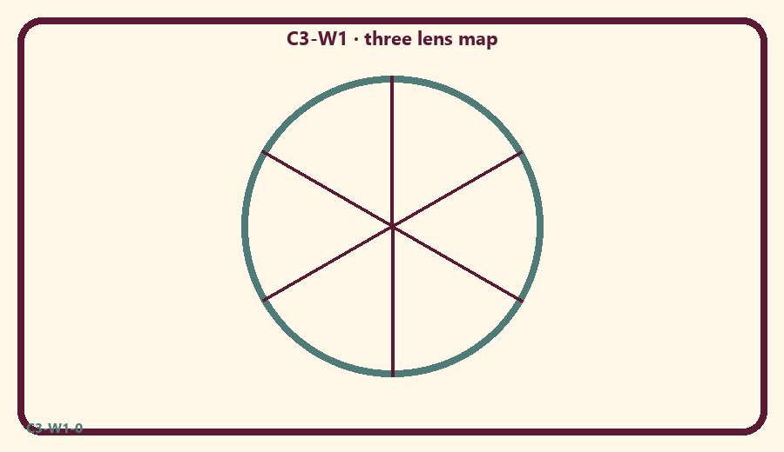
CARD 1  Enjoyer | CARD 2  Owner
CARD 3  Friend | CARD 4  Share kindly
CARD 5  Grab and shout mine | CARD 6  Care for a plant

Memory phrase
Kṛṣṇa owns, enjoys, befriends.
Cut on the dashed borders. Keep each card intact.
TEACHER NOTE | Age-appropriate ownership/friendship/service; no speculative iconography.

Y02 — Lens matching
Match home scenes to enjoyer/owner/friend.
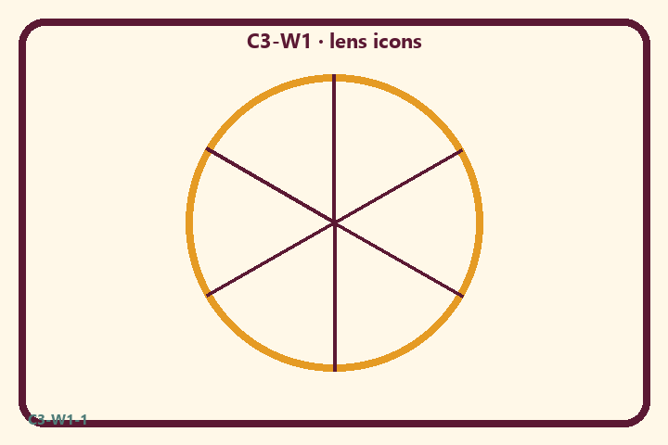
CARD 1  Enjoyer | CARD 2  Owner
CARD 3  Friend | CARD 4  Share kindly
CARD 5  Grab and shout mine | CARD 6  Care for a plant

Memory phrase
Kṛṣṇa owns, enjoys, befriends.
Cut on the dashed borders. Keep each card intact.
TEACHER NOTE | Age-appropriate ownership/friendship/service; no speculative iconography.

Y03 — Friend-of-all craft
Craft a friend-heart for kind service.
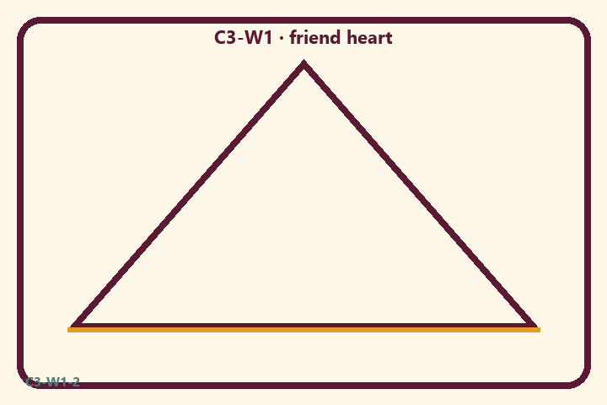
CARD 1  Enjoyer | CARD 2  Owner
CARD 3  Friend | CARD 4  Share kindly
CARD 5  Grab and shout mine | CARD 6  Care for a plant

Memory phrase
Kṛṣṇa owns, enjoys, befriends.
Cut on the dashed borders. Keep each card intact.
TEACHER NOTE | Age-appropriate ownership/friendship/service; no speculative iconography.

Y04 — Steward cards
We care for things because Kṛṣṇa owns.
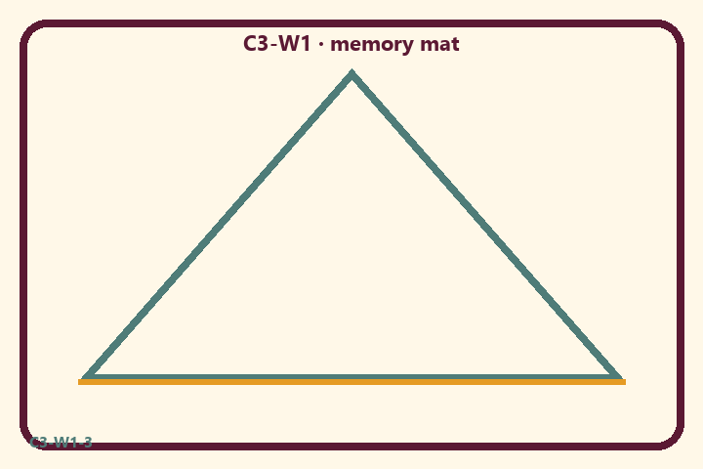
CARD 1  Enjoyer | CARD 2  Owner
CARD 3  Friend | CARD 4  Share kindly
CARD 5  Grab and shout mine | CARD 6  Care for a plant

Memory phrase
Kṛṣṇa owns, enjoys, befriends.
Cut on the dashed borders. Keep each card intact.
TEACHER NOTE | Age-appropriate ownership/friendship/service; no speculative iconography.

Y05 — Memory phrase mat
Echo: Kṛṣṇa owns, enjoys, befriends.

Memory phrase
Kṛṣṇa owns, enjoys, befriends.
BG 5.29 · family week
RIGHTS NOTE | KUTUMBA-original framing; cited third-party material retains its own rights. Human/temple review remains EXTERNAL_OPEN.

