KUTUMBA

C3-W2 — Older Teacher Pack
  - Grades 4–5 run sheet and activities
C3-W2 • Who Is Kṛṣṇa? The Supreme Personality of Godhead
V13 • Families Growing in Krishna Consciousness
Program Director: Swapnil Patil
Internal founding-cohort teaching material — human/temple review EXTERNAL_OPEN
KUTUMBA | Families Growing in Krishna Consciousness

Locked Saturday Schedule
Time | Block
1:50–2:00 | Arrival
2:00–2:10 | Opening mantras + welcome
2:10–2:30 | All-family launch/orientation
2:30–3:10 | Parallel tracks
3:10–3:30 | Reunification + bhakti laboratory
3:30–3:40 | Snack + water
3:40–3:55 | Saṅkalpa + project + home practice
3:55–4:00 | Close

TIME CUE | Track handoff is at 2:30; all groups reunite at 3:10.

Primary verse: BG 7.7
Source URL: https://vedabase.io/en/library/bg/7/7/

Older Teacher Run Sheet
Canonical source: 11-weekly-program-library/first-six-months/c3-w2-who-is-kṛṣṇa-the-supreme-personality-of-godhead/teacher/OLDER-TEACHER-GUIDE-V13.md • SHA-256: c6210b08574ca311db5e1dd52c3f63c525c593453c4e143034b51c95444c14c7
KUTUMBA · Families Growing in Krishna Consciousness Program Director: Swapnil Patil Week: Who Is Kṛṣṇa? The Supreme Personality of Godhead · Date: 2027-01-16 Track window: Saturday 2:30–3:10 (Grades 4–5) Reunite: 3:10 for bhakti laboratory Primary: BG 7.7 — https://vedabase.io/en/library/bg/7/7/ Primary mechanic: Source identity Status: Internal founding-cohort teaching material — human/temple review EXTERNAL_OPEN

Essential question
Why does śāstra present Kṛṣṇa as supreme — and how do we speak that with reverence, not aggression?

Materials (print before Saturday)
From activities/v13-older/: O01–O06 Also pens/crayons; verse card; privacy reminder.

Locked Saturday context
- 1:50–2:00 Arrival · 2:00–2:10 Mantras · 2:10–2:30 All-family launch
- 2:30–3:10 This track · 3:10–3:30 Reunify · 3:30–3:40 Snack/water · 3:40–3:55 Saṅkalpa · 3:55–4:00 Close
Parents remain onsite. No public ranking. No forced disclosure.

Source layer (use mid-track)
Primary: BG 7.7 — https://vedabase.io/en/library/bg/7/7/
Devanāgarī: मत्त: परतरं नान्यत्किञ्चिदस्ति धनञ्जय । मयि सर्वमिदं प्रोतं सूत्रे मणिगणा इव ॥ ७ ॥
IAST: mattaḥ parataraṁ nānyat kiñcid asti dhanañ-jaya / mayi sarvam idaṁ protaṁ sūtre maṇi-gaṇā iva
KUTUMBA teaching meaning (not a BBT translation): There is no truth superior to Kṛṣṇa; everything rests upon Him as pearls are strung on a thread.

Memory line
Nothing is above Kṛṣṇa.

V13 printable wiring (Source identity)

V13 printable block 0–6 — BG 7.7 observation
Printable: activities/v13-older/O01-BG-7-7-OBSERVATION.md (O01-BG-7-7-OBSERVATION)
Source identity of supremacy + thread analogy limits.
Keep primary mechanic (Source identity). Block: Aggressive debate identity; speculative iconography/theology beyond sources.

V13 printable block 6–14 — Source observation worksheet
Printable: activities/v13-older/O02-SOURCE-OBSERVATION-WORKSHEET.md (O02-SOURCE-OBSERVATION-WORKSHEET)
What the verse says / does not say.
Keep primary mechanic (Source identity). Block: Aggressive debate identity; speculative iconography/theology beyond sources.

V13 printable block 14–22 — Reverence vs aggression sort
Printable: activities/v13-older/O03-REVERENCE-VS-AGGRESSION-SORT.md (O03-REVERENCE-VS-AGGRESSION-SORT)
Sort speech postures.
Keep primary mechanic (Source identity). Block: Aggressive debate identity; speculative iconography/theology beyond sources.

V13 printable block 22–30 — Identity application scenarios
Printable: activities/v13-older/O04-IDENTITY-APPLICATION-SCENARIOS.md (O04-IDENTITY-APPLICATION-SCENARIOS)
Three school/home speech cases.
Keep primary mechanic (Source identity). Block: Aggressive debate identity; speculative iconography/theology beyond sources.

V13 printable block 30–36 — Thread analogy diagram
Printable: activities/v13-older/O05-THREAD-ANALOGY-DIAGRAM.md (O05-THREAD-ANALOGY-DIAGRAM)
Pearls on thread + limit box.
Keep primary mechanic (Source identity). Block: Aggressive debate identity; speculative iconography/theology beyond sources.

V13 printable block 36–40 — Exit ticket
Printable: activities/v13-older/O06-EXIT-TICKET.md (O06-EXIT-TICKET)
One source sentence + one reverence rule.
Keep primary mechanic (Source identity). Block: Aggressive debate identity; speculative iconography/theology beyond sources.

Close of track (handoff)
Bring one sentence or artifact to reunification. Do not start next week’s topic. Care boundary: Authorized sources only; no speculative theology; reverence over aggression.

Inherited classroom depth (from V12 OLDER-TEACHER-GUIDE.md)
Keep story scripts, movement steps, and wonder questions below. Wire printables to the V13 codes above; do not replace this depth with “see research.”
Week: Who Is Kṛṣṇa? The Supreme Personality of Godhead Primary: BG 7.7 — https://vedabase.io/en/library/bg/7/7/ Session length: ~40 minutes (parallel track ~2:30–3:10) Parents: Remain onsite; reunite at 3:10 Status: Internal founding-cohort teaching material — human/temple review EXTERNAL_OPEN

Objective
Students observe BG 7.7, connect BG 10.8 and ŚB 1.3.28 paraphrases, practice authorized retelling, and write a respectful supremacy sentence.

Exact memory phrase
There is no truth superior to Kṛṣṇa; everything rests upon Him like pearls on a thread.
Short echo: Nothing is above Kṛṣṇa.

Teacher background
- KUTUMBA teaching meaning: There is no truth superior to Kṛṣṇa; everything rests upon Him as pearls are strung on a thread. (Label as KUTUMBA teaching meaning — not as BBT translation.)
- Supporting frames (one sentence each): BG 10.8 source; ŚB 1.3.28 identity; Govardhana authorized summary.
- Block: Sectarian aggression toward persons.; Invented confidential pastimes or fabricated dialogue.
- Scope: No confidential pastimes; no sectarian attacks; no invented dialogue.

Materials
- Verse strips
- Support cards
- Kathā outlines
- Worksheets
- Answer key
- Project sheets

Minute-by-minute plan

0–5 min — Settle and hook
Hook: preference vs map — what would count as evidence in this class?

5–14 min — Primary text observation
Read 7.7; underline parataram / protaṁ / sūtre. Add 10.8 and 1.3.28 one-liners.

14–22 min — Worksheet questions
Students complete Section A of the older activity pack. Teacher circulates; use OLDER-ANSWER-KEY.md for expected directions (not for grading ranks).

22–28 min — Scenario cards (small groups)
A Insult B Invented dialogue C Preference-only — fix each.
Share one insight per group (60 seconds).

28–33 min — Puzzle / game: Authorized or Invented
A/I cards; explain one Authorized with verse.

33–37 min — Diagram / map task
Pearls diagram: label thread as Kṛṣṇa per teaching meaning.

37–40 min — Project sentence + handoff
Name/quality card to parent.

Boundaries
- No ranking or public scores.
- No invented dialogue.
- Parents onsite; snack/water only at 3:30 in the main schedule.
- Defer off-scope topics: Confidential līlā; initiation; interfaith debate combat.

O01 — BG 7.7 observation
Source identity of supremacy + thread analogy limits.

VERSE CARD • BG 7.7
मत्त: परतरं नान्यत्किञ्चिदस्ति धनञ्जय । मयि सर्वमिदं प्रोतं सूत्रे मणिगणा इव ॥ ७ ॥
mattaḥ parataraṁ nānyat kiñcid asti dhanañ-jaya / mayi sarvam idaṁ protaṁ sūtre maṇi-gaṇā iva
KUTUMBA teaching meaning: There is no truth superior to Kṛṣṇa; everything rests upon Him as pearls are strung on a thread.
Source: https://vedabase.io/en/library/bg/7/7/
Rights/status: Scripture display/source: VedaBase; teaching meaning: KUTUMBA-original (not labeled as BBT translation).

What does the verse teach in my words?
________________________________________________________________
________________________________________________________________
What misconception does this week block?
________________________________________________________________
________________________________________________________________
One question for the facilitator:
________________________________________________________________
________________________________________________________________

O02 — Source observation worksheet
What the verse says / does not say.
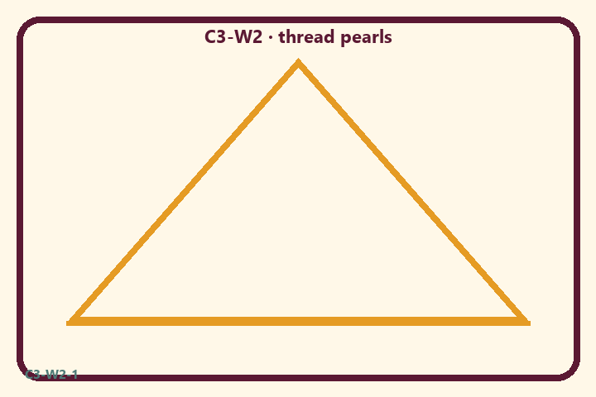
Prompt | My notes
Source observation worksheet | ________________
Limit / care | ________________

Application:
________________________________________________________________
________________________________________________________________
What not to say:
________________________________________________________________
________________________________________________________________
KEY IDEA | There is no truth superior to Kṛṣṇa; everything rests upon Him — taught from sources with reverence.

O03 — Reverence vs aggression sort
Sort speech postures.
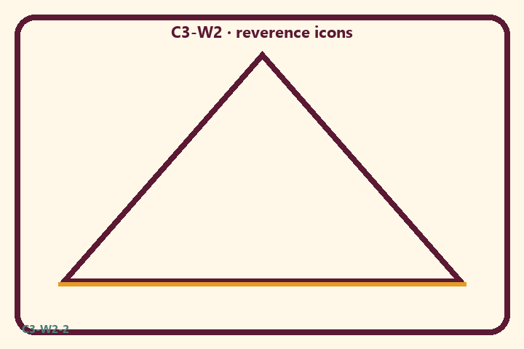
Prompt | My notes
Reverence vs aggression sort | ________________
Limit / care | ________________

Application:
________________________________________________________________
________________________________________________________________
What not to say:
________________________________________________________________
________________________________________________________________
KEY IDEA | There is no truth superior to Kṛṣṇa; everything rests upon Him — taught from sources with reverence.

O04 — Identity application scenarios
Three school/home speech cases.
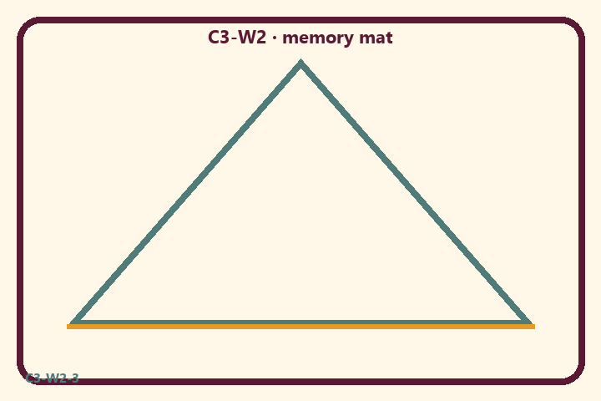
Prompt | My notes
Identity application scenarios | ________________
Limit / care | ________________

Application:
________________________________________________________________
________________________________________________________________
What not to say:
________________________________________________________________
________________________________________________________________
KEY IDEA | There is no truth superior to Kṛṣṇa; everything rests upon Him — taught from sources with reverence.

O05 — Thread analogy diagram
Pearls on thread + limit box.
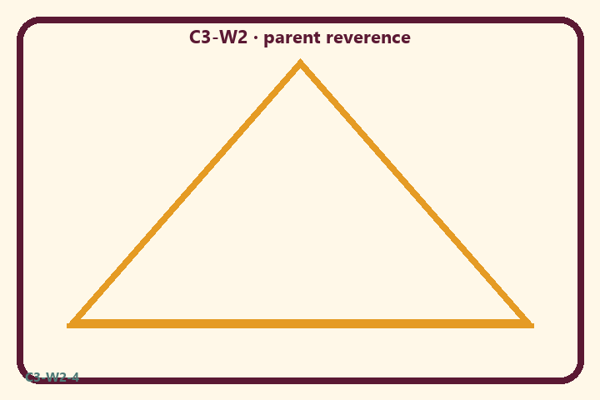
Prompt | My notes
Thread analogy diagram | ________________
Limit / care | ________________

Application:
________________________________________________________________
________________________________________________________________
What not to say:
________________________________________________________________
________________________________________________________________
KEY IDEA | There is no truth superior to Kṛṣṇa; everything rests upon Him — taught from sources with reverence.

O06 — Exit ticket
One source sentence + one reverence rule.
Primary in one sentence:
________________________________________________________________
________________________________________________________________
One analogy or mechanic and its limit:
________________________________________________________________
________________________________________________________________
One home action:
________________________________________________________________
________________________________________________________________
One question I still have:
________________________________________________________________
________________________________________________________________
RIGHTS NOTE | KUTUMBA-original framing; cited third-party material retains its own rights. Human/temple review remains EXTERNAL_OPEN.

