KUTUMBA

C3-W2 — Parent Track
  - Facilitator guide and parent printables
C3-W2 • Who Is Kṛṣṇa? The Supreme Personality of Godhead
V13 • Families Growing in Krishna Consciousness
Program Director: Swapnil Patil
Internal founding-cohort teaching material — human/temple review EXTERNAL_OPEN
KUTUMBA | Families Growing in Krishna Consciousness

Locked Saturday Schedule
Time | Block
1:50–2:00 | Arrival
2:00–2:10 | Opening mantras + welcome
2:10–2:30 | All-family launch/orientation
2:30–3:10 | Parallel tracks
3:10–3:30 | Reunification + bhakti laboratory
3:30–3:40 | Snack + water
3:40–3:55 | Saṅkalpa + project + home practice
3:55–4:00 | Close

TIME CUE | Track handoff is at 2:30; all groups reunite at 3:10.

Primary verse: BG 7.7
Source URL: https://vedabase.io/en/library/bg/7/7/

Parent Facilitator Run Sheet
Canonical source: 11-weekly-program-library/first-six-months/c3-w2-who-is-kṛṣṇa-the-supreme-personality-of-godhead/teacher/PARENT-GUIDE-V13.md • SHA-256: fff1e2d90040b0b61ccaaa18362d731ffe7724beea5052ce12cb85ea44cc264e
KUTUMBA · Families Growing in Krishna Consciousness Program Director: Swapnil Patil Week: Who Is Kṛṣṇa? The Supreme Personality of Godhead · Date: 2027-01-16 Track window: Saturday 2:30–3:10 (parents) Reunite: 3:10 for bhakti laboratory Primary: BG 7.7 — https://vedabase.io/en/library/bg/7/7/ Primary mechanic: Source identity Status: Internal founding-cohort teaching material — human/temple review EXTERNAL_OPEN

Essential question
Why does śāstra present Kṛṣṇa as supreme — and how do we speak that with reverence, not aggression?

Materials (print before Saturday)
From activities/v13-parent/: P01–P05 Also pens/crayons; verse card; privacy reminder.

Locked Saturday context
- 1:50–2:00 Arrival · 2:00–2:10 Mantras · 2:10–2:30 All-family launch
- 2:30–3:10 This track · 3:10–3:30 Reunify · 3:30–3:40 Snack/water · 3:40–3:55 Saṅkalpa · 3:55–4:00 Close
Parents remain onsite. No public ranking. No forced disclosure.

Source layer (use mid-track)
Primary: BG 7.7 — https://vedabase.io/en/library/bg/7/7/
Devanāgarī: मत्त: परतरं नान्यत्किञ्चिदस्ति धनञ्जय । मयि सर्वमिदं प्रोतं सूत्रे मणिगणा इव ॥ ७ ॥
IAST: mattaḥ parataraṁ nānyat kiñcid asti dhanañ-jaya / mayi sarvam idaṁ protaṁ sūtre maṇi-gaṇā iva
KUTUMBA teaching meaning (not a BBT translation): There is no truth superior to Kṛṣṇa; everything rests upon Him as pearls are strung on a thread.

Memory line
Nothing is above Kṛṣṇa.

V13 printable wiring (Source identity)

V13 printable block 0–5 — Private reflection — how we speak of Kṛṣṇa
Printable: activities/v13-parent/P01-PRIVATE-REFLECTION.md (P01-PRIVATE-REFLECTION)
Reverence or argument culture?
Keep primary mechanic (Source identity). Block: Aggressive debate identity; speculative iconography/theology beyond sources.

V13 printable block 5–12 — Reverence card sort
Printable: activities/v13-parent/P02-REVERENCE-CARD-SORT.md (P02-REVERENCE-CARD-SORT)
Sort REVERENT / AGGRESSIVE / SPECULATIVE.
Keep primary mechanic (Source identity). Block: Aggressive debate identity; speculative iconography/theology beyond sources.

V13 printable block 12–22 — Substantial family case
Printable: activities/v13-parent/P03-SUBSTANTIAL-FAMILY-CASE.md (P03-SUBSTANTIAL-FAMILY-CASE)
Teen wants to “win” a religion argument online.
Keep primary mechanic (Source identity). Block: Aggressive debate identity; speculative iconography/theology beyond sources.

V13 printable block 22–32 — Household operating application
Printable: activities/v13-parent/P04-HOUSEHOLD-OPERATING-APPLICATION.md (P04-HOUSEHOLD-OPERATING-APPLICATION)
One reverence speech rule for seven days.
Keep primary mechanic (Source identity). Block: Aggressive debate identity; speculative iconography/theology beyond sources.

V13 printable block 32–38 — Private next-step saṅkalpa
Printable: activities/v13-parent/P05-PRIVATE-NEXT-STEP-SANKALPA.md (P05-PRIVATE-NEXT-STEP-SANKALPA)
Source reading cue + minimum version.
Keep primary mechanic (Source identity). Block: Aggressive debate identity; speculative iconography/theology beyond sources.

Close of track (handoff)
Bring one sentence or artifact to reunification. Do not start next week’s topic. Care boundary: Authorized sources only; no speculative theology; reverence over aggression.

Inherited classroom depth (from V12 parent-lesson / constructed V13 flow)
Keep story scripts, movement steps, and wonder questions below. Wire printables to the V13 codes above; do not replace this depth with “see research.”

Essential question
Who is Kṛṣṇa?

Source
BG 7.7 — teaching meaning: There is no truth superior to Kṛṣṇa; everything rests upon Him as pearls are strung on a thread.

Discussion
One realistic household tension; no compelled confession.

Application
5–15 minute cue; minimum version counts.

Privacy
No public scoring of sādhana.

P01 — Private reflection — how we speak of Kṛṣṇa
Reverence or argument culture?

SAFETY & PRIVACY | Write privately. Sharing is optional. Do not collect or place completed sheets in Git.

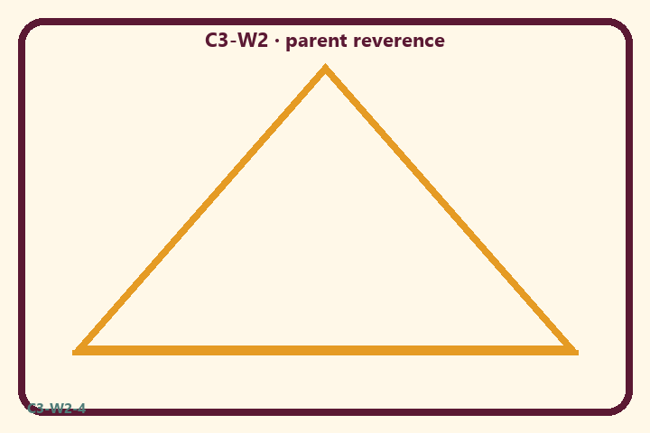
Reverence or argument culture?
Private notes:
________________________________________________________________
________________________________________________________________
________________________________________________________________
________________________________________________________________
Habit to watch this week:
________________________________________________________________
________________________________________________________________
________________________________________________________________
________________________________________________________________

P02 — Reverence card sort
Sort REVERENT / AGGRESSIVE / SPECULATIVE.
HELPFUL | MISTAKEN

L1  Cite BG 7.7 calmly | L2  Win online fight
L3  Speculate freely | L4  Read with family
L5  Mock other faiths | L6  Reverent gratitude
TEACHER NOTE | Aggressive debate identity; speculative iconography/theology beyond sources.

P03 — Substantial family case
Teen wants to “win” a religion argument online.
SAFETY & PRIVACY | Fictional case. No compelled confession of real events.

A teen wants to “destroy” a classmate’s view online. Parents debate whether to coach winning rhetoric or reverent source-based speech.
Tempting mistaken conclusion:
________________________________________________________________
________________________________________________________________
________________________________________________________________
Principle from primary:
________________________________________________________________
________________________________________________________________
________________________________________________________________
Compassionate response:
________________________________________________________________
________________________________________________________________
________________________________________________________________
One seven-day household action:
________________________________________________________________
________________________________________________________________
________________________________________________________________
What we should not say:
________________________________________________________________
________________________________________________________________
________________________________________________________________
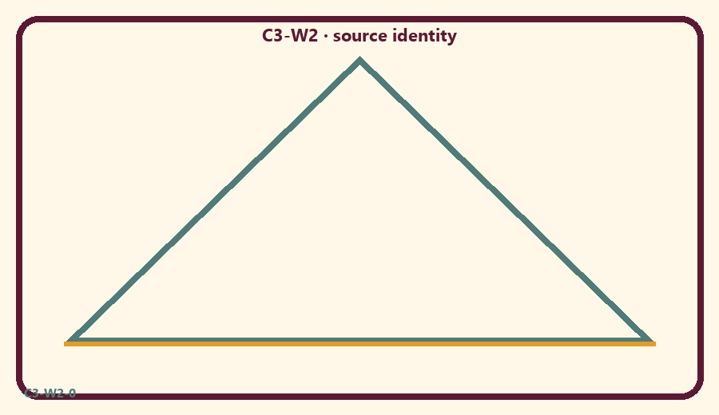

P04 — Household operating application
One reverence speech rule for seven days.
SAFETY & PRIVACY | No ranking and no public reading required.

One household action for seven days:
________________________________________________________________
________________________________________________________________
________________________________________________________________
Trigger (when/where):
________________________________________________________________
________________________________________________________________
________________________________________________________________
Who starts if others are tired:
________________________________________________________________
________________________________________________________________
________________________________________________________________
Minimum version on a hard day:
________________________________________________________________
________________________________________________________________
________________________________________________________________

Memory phrase
Nothing is above Kṛṣṇa.

P05 — Private next-step saṅkalpa
Source reading cue + minimum version.
KEY IDEA | specific action + frequency + trigger + minimum version

Specific action:
________________________________________________________________
________________________________________________________________
Frequency:
________________________________________________________________
________________________________________________________________
Trigger (when and where):
________________________________________________________________
________________________________________________________________
Minimum version for a hard day:
________________________________________________________________
________________________________________________________________
Where we will place the reminder:
________________________________________________________________
________________________________________________________________
No ranking. The minimum version counts as success.
RIGHTS NOTE | KUTUMBA-original framing; cited third-party material retains its own rights. Human/temple review remains EXTERNAL_OPEN.

