KUTUMBA

C3-W2 — Younger Teacher Pack
  - K–2 run sheet and activities
C3-W2 • Who Is Kṛṣṇa? The Supreme Personality of Godhead
V13 • Families Growing in Krishna Consciousness
Program Director: Swapnil Patil
Internal founding-cohort teaching material — human/temple review EXTERNAL_OPEN
KUTUMBA | Families Growing in Krishna Consciousness

Locked Saturday Schedule
Time | Block
1:50–2:00 | Arrival
2:00–2:10 | Opening mantras + welcome
2:10–2:30 | All-family launch/orientation
2:30–3:10 | Parallel tracks
3:10–3:30 | Reunification + bhakti laboratory
3:30–3:40 | Snack + water
3:40–3:55 | Saṅkalpa + project + home practice
3:55–4:00 | Close

TIME CUE | Track handoff is at 2:30; all groups reunite at 3:10.

Primary verse: BG 7.7
Source URL: https://vedabase.io/en/library/bg/7/7/

Younger Teacher Run Sheet
Canonical source: 11-weekly-program-library/first-six-months/c3-w2-who-is-kṛṣṇa-the-supreme-personality-of-godhead/teacher/YOUNGER-TEACHER-GUIDE-V13.md • SHA-256: 0d759baba4f0d51cbfc73362ad6e6fdd3938c2d51d779160c57f5ae596ad0795
KUTUMBA · Families Growing in Krishna Consciousness Program Director: Swapnil Patil Week: Who Is Kṛṣṇa? The Supreme Personality of Godhead · Date: 2027-01-16 Track window: Saturday 2:30–3:10 (K–2) Reunite: 3:10 for bhakti laboratory Primary: BG 7.7 — https://vedabase.io/en/library/bg/7/7/ Primary mechanic: Source identity Status: Internal founding-cohort teaching material — human/temple review EXTERNAL_OPEN

Essential question
Why does śāstra present Kṛṣṇa as supreme — and how do we speak that with reverence, not aggression?

Materials (print before Saturday)
From activities/v13-younger/: Y01–Y05 Also pens/crayons; verse card; privacy reminder.

Locked Saturday context
- 1:50–2:00 Arrival · 2:00–2:10 Mantras · 2:10–2:30 All-family launch
- 2:30–3:10 This track · 3:10–3:30 Reunify · 3:30–3:40 Snack/water · 3:40–3:55 Saṅkalpa · 3:55–4:00 Close
Parents remain onsite. No public ranking. No forced disclosure.

Source layer (use mid-track)
Primary: BG 7.7 — https://vedabase.io/en/library/bg/7/7/
Devanāgarī: मत्त: परतरं नान्यत्किञ्चिदस्ति धनञ्जय । मयि सर्वमिदं प्रोतं सूत्रे मणिगणा इव ॥ ७ ॥
IAST: mattaḥ parataraṁ nānyat kiñcid asti dhanañ-jaya / mayi sarvam idaṁ protaṁ sūtre maṇi-gaṇā iva
KUTUMBA teaching meaning (not a BBT translation): There is no truth superior to Kṛṣṇa; everything rests upon Him as pearls are strung on a thread.

Memory line
Nothing is above Kṛṣṇa.

V13 printable wiring (Source identity)

V13 printable block 0–6 — Who-is-Kṛṣṇa picture cues
Printable: activities/v13-younger/Y01-WHO-IS-KRSNA-CUES.md (Y01-WHO-IS-KRSNA-CUES)
Cue cards: flute/friend/protector — reverence, not jokes.
Keep primary mechanic (Source identity). Block: Aggressive debate identity; speculative iconography/theology beyond sources.

V13 printable block 6–14 — Source matching
Printable: activities/v13-younger/Y02-SOURCE-MATCHING.md (Y02-SOURCE-MATCHING)
Match “we learn from books/teachers” to listening.
Keep primary mechanic (Source identity). Block: Aggressive debate identity; speculative iconography/theology beyond sources.

V13 printable block 14–24 — Thread-and-pearl craft
Printable: activities/v13-younger/Y03-THREAD-PEARL-CRAFT.md (Y03-THREAD-PEARL-CRAFT)
Craft simple thread with beads — analogy with limits.
Keep primary mechanic (Source identity). Block: Aggressive debate identity; speculative iconography/theology beyond sources.

V13 printable block 24–32 — Reverence cards
Printable: activities/v13-younger/Y04-REVERENCE-CARDS.md (Y04-REVERENCE-CARDS)
Speak kindly about Kṛṣṇa; no mockery.
Keep primary mechanic (Source identity). Block: Aggressive debate identity; speculative iconography/theology beyond sources.

V13 printable block 32–38 — Memory phrase mat
Printable: activities/v13-younger/Y05-MEMORY-PHRASE-MAT.md (Y05-MEMORY-PHRASE-MAT)
Echo: Nothing is above Kṛṣṇa.
Keep primary mechanic (Source identity). Block: Aggressive debate identity; speculative iconography/theology beyond sources.

Close of track (handoff)
Bring one sentence or artifact to reunification. Do not start next week’s topic. Care boundary: Authorized sources only; no speculative theology; reverence over aggression.

Inherited classroom depth (from V12 YOUNGER-TEACHER-GUIDE.md)
Keep story scripts, movement steps, and wonder questions below. Wire printables to the V13 codes above; do not replace this depth with “see research.”
Week: Who Is Kṛṣṇa? The Supreme Personality of Godhead Primary: BG 7.7 — https://vedabase.io/en/library/bg/7/7/ Session length: 40 minutes (parallel track ~2:30–3:10) Parents: Remain onsite; reunite at 3:10 Status: Internal founding-cohort teaching material — human/temple review EXTERNAL_OPEN

Objective
Children say nothing is above Kṛṣṇa, string pearls on a thread, and hear an authorized short Govardhana shelter picture without invented quotes.

Exact memory phrase
Nothing is above Kṛṣṇa.

Teacher background (2 minutes to review)
- KUTUMBA teaching meaning (adult wording): There is no truth superior to Kṛṣṇa; everything rests upon Him as pearls are strung on a thread.
- Child-facing paraphrase: Kṛṣṇa is the Supreme. Everything rests on Him like pearls on a string. We speak kindly.
- Block misconceptions (child words):
- “Tease others to prove we are right.”
- “Make up Kṛṣṇa talking lines.”
- Do not: invent deity dialogue; force confession; rank children; use scare tactics; claim temple certification stickers.

Materials
- Paper pearls/string
- Mountain/shelter props
- Outline picture cards
- Crayons
- Soft toss
- Calm corner
- Phrase stickers

Room setup
Circle on the floor; materials table behind you; calm corner with one chair for quiet reset. Keep aisles clear for movement.

Minute-by-minute executable plan

0–5 min — Opening and recall
1. Welcome.
2. Echo: Nothing / is above / Kṛṣṇa.
3. Show pearl string.
4. Practice: “We don’t tease.”

5–13 min — Story script (paraphrase only; ~8 minutes)
Say exactly this spine (do not invent deity dialogue):
Kṛṣṇa says nothing is higher than Him. All things rest on Him like pearls on a thread. When the people of Vraja needed protection, they took shelter of Kṛṣṇa, who held the big hill like a shelter umbrella. We do not invent extra talking lines. We remember Kṛṣṇa’s care and say His name with love.
Story boundaries: Authorized skeleton only. No invented deity dialogue. No scary storm trauma talk.

13–16 min — Three wonder questions
1. Is anyone above Kṛṣṇa? (No)
2. Do we tease to prove a point? (No)
3. Who do we take shelter of? (Kṛṣṇa)
Accept one- or two-word answers. Affirm effort.

16–24 min — Movement game: Pearl Thread and Mountain Shelter (steps)
1. Children hold paper pearl strings and walk a circle saying the phrase.
2. On signal, gather under “mountain” arms/prop.
3. Whisper one Kṛṣṇa name.
4. Two rounds; sit.

24–32 min — Craft: Pearls-on-thread card (steps)
1. Card with drawn thread.
2. Glue 3–5 paper pearls.
3. Helper writes: Nothing is above Kṛṣṇa.
4. Back: draw mountain shelter.
Full printable steps also live in activities/YOUNGER-ACTIVITY-PACK.md (use together; this guide remains executable if the pack is missing).

32–35 min — Printable / coloring task
If time remains, color the younger line-art sheet if available. If short on time, keep the craft as the take-home.

35–38 min — Behavior redirects and quiet reset
Use calm, specific redirects:
- Feet on floor — “Feet visit the mat.”
- Kind hands — “Hands help; toys rest.”
- Loud shout — “Soft voice, please.”
- Quiet reset — “Calm corner for sixty seconds.”

38–40 min — Cleanup and parent handoff
1. Materials away; craft in hand.
2. At reunification, tell parent in one sentence:
Memory phrase: “Nothing is above Kṛṣṇa..” Home cue: Remember one name or quality of Kṛṣṇa once daily.
1. Do not report private behavior struggles in front of other families.

Behavior redirects (quick reference)
Signal | Teacher line | Child action
Running | Walking feet. | Walk to mat
Snatching | Kind hands. | Hands to lap
Interrupt shout | Soft voice. | Whisper retry
Shutdown | Quiet reset is okay. | Calm corner 60 sec

Backup low-prep (if craft fails or energy crashes)
Toss and say a Kṛṣṇa name; end with phrase.

What success looks like
- Echoes phrase
- Refuses teasing line
- Remembers shelter picture

Boundaries
- Snack/water only happens in main schedule (3:30), not as a track bribe.
- No weekly meal language.
- No fabricated approval stickers implying temple certification.
- Privacy: no forced confession.

Child House Rules
Canonical source: launch/CHILD-HOUSE-RULES.md • SHA-256: 6a525f3dd1da740db86e246622696c7b08e28c1f1475227567d639a5bd54ce47
Parents remain onsite. Facilitators guide the session. Host property rules also apply.

Shared rules (all ages)
1. Keep your body safe — feet on the floor; hands gentle.
2. Use respectful speech — no teasing, yelling, or mean labels.
3. Follow the facilitator safety cue immediately (pause / freeze / come here).
4. No jumping on furniture.
5. No indoor throwing.
6. No writing on walls, books, or furniture that are not activity materials.
7. Ask before entering private rooms.
8. Respect belongings — ask before touching what is not yours.
9. Devices away unless the lesson specifically needs them.
10. Snack only in the allowed area; water anytime with permission.
11. Help clean up before leaving.

Correction ladder (no public shame)
1. Calm reminder
2. Redirect / offer a choice
3. Brief quiet reset in a visible space
4. Parent involvement
5. Sit out a specific activity
6. Private parent/program conversation for repeated patterns
Never: public shame, yelling, sarcasm, corporal punishment, forced chanting, or comparing children.

Younger (K–2) emphasis
- Soft voices indoors
- Stay with the group
- Hands to yourself
- Ask before leaving the room

Older (Grades 4–5) emphasis
- Model respectful speech for younger children
- Devices fully away unless assigned
- Help clean-up leadership
- Honest questions welcome; speculation wait for source check
Printable versions: W1 launch-pack CHILD-RULES-YOUNGER.md and CHILD-RULES-OLDER.md.

Y01 — Who-is-Kṛṣṇa picture cues
Cue cards: flute/friend/protector — reverence, not jokes.
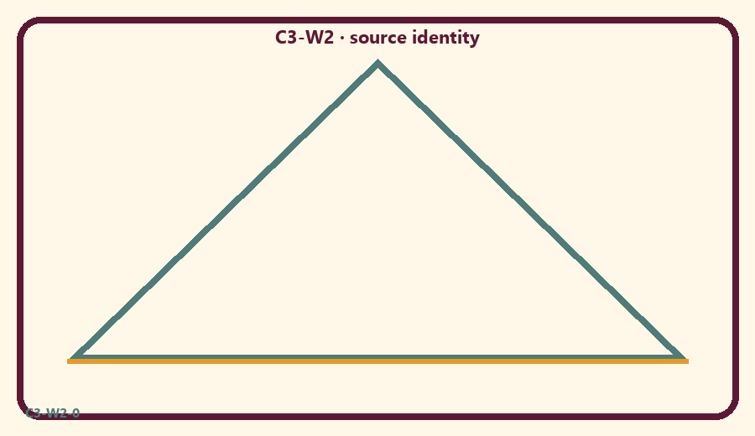
CARD 1  Listen to a verse | CARD 2  Joke about Deity
CARD 3  Thread and pearls | CARD 4  Kind prayer
CARD 5  Yell to win | CARD 6  Ask a teacher

Memory phrase
Nothing is above Kṛṣṇa.
Cut on the dashed borders. Keep each card intact.
TEACHER NOTE | Authorized sources only; no speculative theology; reverence over aggression.

Y02 — Source matching
Match “we learn from books/teachers” to listening.
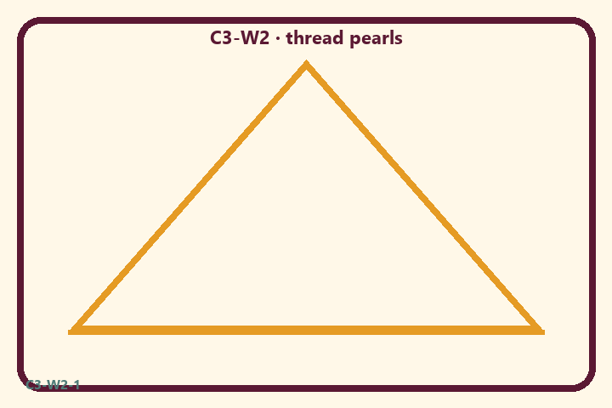
CARD 1  Listen to a verse | CARD 2  Joke about Deity
CARD 3  Thread and pearls | CARD 4  Kind prayer
CARD 5  Yell to win | CARD 6  Ask a teacher

Memory phrase
Nothing is above Kṛṣṇa.
Cut on the dashed borders. Keep each card intact.
TEACHER NOTE | Authorized sources only; no speculative theology; reverence over aggression.

Y03 — Thread-and-pearl craft
Craft simple thread with beads — analogy with limits.
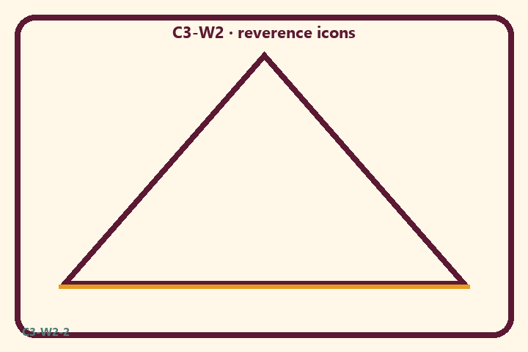
CARD 1  Listen to a verse | CARD 2  Joke about Deity
CARD 3  Thread and pearls | CARD 4  Kind prayer
CARD 5  Yell to win | CARD 6  Ask a teacher

Memory phrase
Nothing is above Kṛṣṇa.
Cut on the dashed borders. Keep each card intact.
TEACHER NOTE | Authorized sources only; no speculative theology; reverence over aggression.

Y04 — Reverence cards
Speak kindly about Kṛṣṇa; no mockery.
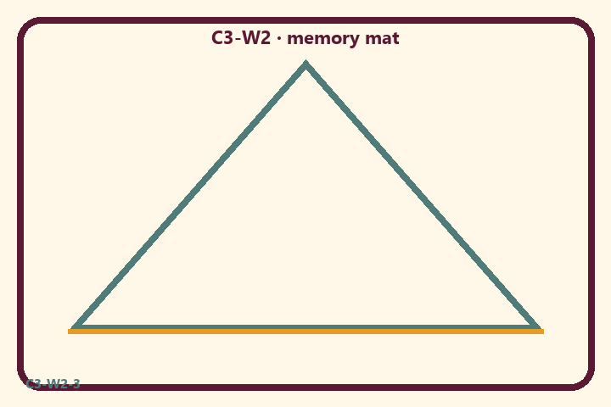
CARD 1  Listen to a verse | CARD 2  Joke about Deity
CARD 3  Thread and pearls | CARD 4  Kind prayer
CARD 5  Yell to win | CARD 6  Ask a teacher

Memory phrase
Nothing is above Kṛṣṇa.
Cut on the dashed borders. Keep each card intact.
TEACHER NOTE | Authorized sources only; no speculative theology; reverence over aggression.

Y05 — Memory phrase mat
Echo: Nothing is above Kṛṣṇa.

Memory phrase
Nothing is above Kṛṣṇa.
BG 7.7 · family week
RIGHTS NOTE | KUTUMBA-original framing; cited third-party material retains its own rights. Human/temple review remains EXTERNAL_OPEN.

