KUTUMBA

C3-W3 — Older Teacher Pack
  - Grades 4–5 run sheet and activities
C3-W3 • Guru, Sādhu and Śāstra: How We Receive Spiritual Knowledge
V13 • Families Growing in Krishna Consciousness
Program Director: Swapnil Patil
Internal founding-cohort teaching material — human/temple review EXTERNAL_OPEN
KUTUMBA | Families Growing in Krishna Consciousness

Locked Saturday Schedule
Time | Block
1:50–2:00 | Arrival
2:00–2:10 | Opening mantras + welcome
2:10–2:30 | All-family launch/orientation
2:30–3:10 | Parallel tracks
3:10–3:30 | Reunification + bhakti laboratory
3:30–3:40 | Snack + water
3:40–3:55 | Saṅkalpa + project + home practice
3:55–4:00 | Close

TIME CUE | Track handoff is at 2:30; all groups reunite at 3:10.

Primary verse: BG 4.34
Source URL: https://vedabase.io/en/library/bg/4/34/

Older Teacher Run Sheet
Canonical source: 11-weekly-program-library/first-six-months/c3-w3-guru-sādhu-and-śāstra-how-we-receive-spiritual-knowledge/teacher/OLDER-TEACHER-GUIDE-V13.md • SHA-256: 098c6e465b831d4c4635ca266b0c0e4635b612973eabaf70158941b2797dacc0
KUTUMBA · Families Growing in Krishna Consciousness Program Director: Swapnil Patil Week: Guru, Sādhu and Śāstra: How We Receive Spiritual Knowledge · Date: 2027-01-23 Track window: Saturday 2:30–3:10 (Grades 4–5) Reunite: 3:10 for bhakti laboratory Primary: BG 4.34 — https://vedabase.io/en/library/bg/4/34/ Primary mechanic: Three-source verify Status: Internal founding-cohort teaching material — human/temple review EXTERNAL_OPEN

Essential question
How do we receive spiritual knowledge safely — and what can KUTUMBA not claim?

Materials (print before Saturday)
From activities/v13-older/: O01–O06 Also pens/crayons; verse card; privacy reminder.

Locked Saturday context
- 1:50–2:00 Arrival · 2:00–2:10 Mantras · 2:10–2:30 All-family launch
- 2:30–3:10 This track · 3:10–3:30 Reunify · 3:30–3:40 Snack/water · 3:40–3:55 Saṅkalpa · 3:55–4:00 Close
Parents remain onsite. No public ranking. No forced disclosure.

Source layer (use mid-track)
Primary: BG 4.34 — https://vedabase.io/en/library/bg/4/34/
Devanāgarī: तद्विद्धि प्रणिपातेन परिप्रश्नेन सेवया । उपदेक्ष्यन्ति ते ज्ञानं ज्ञानिनस्तत्त्वदर्शिनः ॥ ३४ ॥
IAST: tad viddhi praṇipātena paripraśnena sevayā / upadekṣyanti te jñānaṁ jñāninas tattva-darśinaḥ
KUTUMBA teaching meaning (not a BBT translation): Learn the truth by approaching a realized teacher with humility, sincere inquiry, and service — such seers of truth can impart knowledge.

Memory line
Ask, serve, verify.

V13 printable wiring (Three-source verify)

V13 printable block 0–6 — BG 4.34 observation
Printable: activities/v13-older/O01-BG-4-34-OBSERVATION.md (O01-BG-4-34-OBSERVATION)
Humility, inquiry, service triad.
Keep primary mechanic (Three-source verify). Block: Personality-cult framing; KUTUMBA claims of initiating authority; “I feel it so it is true.”

V13 printable block 6–14 — Guru–sādhu–śāstra check
Printable: activities/v13-older/O02-GURU-SADHU-SASTRA-CHECK.md (O02-GURU-SADHU-SASTRA-CHECK)
Verify a claim with three-source map.
Keep primary mechanic (Three-source verify). Block: Personality-cult framing; KUTUMBA claims of initiating authority; “I feel it so it is true.”

V13 printable block 14–22 — Safe vs unsafe authority sort
Printable: activities/v13-older/O03-SAFE-VS-UNSAFE-SORT.md (O03-SAFE-VS-UNSAFE-SORT)
Sort healthy receiving vs cultish traps.
Keep primary mechanic (Three-source verify). Block: Personality-cult framing; KUTUMBA claims of initiating authority; “I feel it so it is true.”

V13 printable block 22–30 — Verify practice scenarios
Printable: activities/v13-older/O04-VERIFY-PRACTICE-SCENARIOS.md (O04-VERIFY-PRACTICE-SCENARIOS)
Three rumor/claim cases.
Keep primary mechanic (Three-source verify). Block: Personality-cult framing; KUTUMBA claims of initiating authority; “I feel it so it is true.”

V13 printable block 30–36 — Receiving-knowledge diagram
Printable: activities/v13-older/O05-RECEIVING-KNOWLEDGE-DIAGRAM.md (O05-RECEIVING-KNOWLEDGE-DIAGRAM)
Approach → inquire → serve → verify.
Keep primary mechanic (Three-source verify). Block: Personality-cult framing; KUTUMBA claims of initiating authority; “I feel it so it is true.”

V13 printable block 36–40 — Exit ticket
Printable: activities/v13-older/O06-EXIT-TICKET.md (O06-EXIT-TICKET)
Deferral line + one verify habit.
Keep primary mechanic (Three-source verify). Block: Personality-cult framing; KUTUMBA claims of initiating authority; “I feel it so it is true.”

Close of track (handoff)
Bring one sentence or artifact to reunification. Do not start next week’s topic. Care boundary: Age-appropriate authority boundaries; no personality cult; “I don’t know; I will verify.”

Inherited classroom depth (from V12 OLDER-TEACHER-GUIDE.md)
Keep story scripts, movement steps, and wonder questions below. Wire printables to the V13 codes above; do not replace this depth with “see research.”
Week: Guru, Sādhu and Śāstra: How We Receive Spiritual Knowledge Primary: BG 4.34 — https://vedabase.io/en/library/bg/4/34/ Session length: ~40 minutes (parallel track ~2:30–3:10) Parents: Remain onsite; reunite at 3:10 Status: Internal founding-cohort teaching material — human/temple review EXTERNAL_OPEN

Objective
Students observe BG 4.34, practice source verification, and state KUTUMBA’s non-initiation boundary clearly.

Exact memory phrase
Approach spiritual truth with humility, sincere inquiry and service; realized teachers can impart knowledge.
Short echo: Ask, serve, verify.

Teacher background
- KUTUMBA teaching meaning: Learn the truth by approaching a realized teacher with humility, sincere inquiry, and service — such seers of truth can impart knowledge. (Label as KUTUMBA teaching meaning — not as BBT translation.)
- Supporting frames (one sentence each): Learner humility; guru-sādhu-śāstra verification principle; program boundary.
- Block: Personality cult / gullibility.; Claiming KUTUMBA confers initiation authority.
- Scope: No recruitment; no declaring who is pure devotee; no dīkṣā roleplay.

Materials
- Verse strips
- Verification worksheets
- Scenario cards
- Boundary slips
- Answer key
- Project sheets

Minute-by-minute plan

0–5 min — Settle and hook
Online rule with no source — what do we do first?

5–14 min — Primary text observation
Underline praṇipātena / paripraśnena / sevayā / tattva-darśinaḥ. Discuss each.

14–22 min — Worksheet questions
Students complete Section A of the older activity pack. Teacher circulates; use OLDER-ANSWER-KEY.md for expected directions (not for grading ranks).

22–28 min — Scenario cards (small groups)
A Initiation confusion B Viral rule C Personality cult
Share one insight per group (60 seconds).

28–33 min — Puzzle / game: Cult or Inquire
C vs I claims; explain with BG 4.34.

33–37 min — Diagram / map task
Three-door diagram with verification arrow to śāstra.

37–40 min — Project sentence + handoff
Question + source card to parent.

Boundaries
- No ranking or public scores.
- No invented dialogue.
- Parents onsite; snack/water only at 3:30 in the main schedule.
- Defer off-scope topics: Personal guru selection pressure; politics of institutions.

O01 — BG 4.34 observation
Humility, inquiry, service triad.

VERSE CARD • BG 4.34
तद्विद्धि प्रणिपातेन परिप्रश्नेन सेवया । उपदेक्ष्यन्ति ते ज्ञानं ज्ञानिनस्तत्त्वदर्शिनः ॥ ३४ ॥
tad viddhi praṇipātena paripraśnena sevayā / upadekṣyanti te jñānaṁ jñāninas tattva-darśinaḥ
KUTUMBA teaching meaning: Learn the truth by approaching a realized teacher with humility, sincere inquiry, and service — such seers of truth can impart knowledge.
Source: https://vedabase.io/en/library/bg/4/34/
Rights/status: Scripture display/source: VedaBase; teaching meaning: KUTUMBA-original (not labeled as BBT translation).

What does the verse teach in my words?
________________________________________________________________
________________________________________________________________
What misconception does this week block?
________________________________________________________________
________________________________________________________________
One question for the facilitator:
________________________________________________________________
________________________________________________________________

O02 — Guru–sādhu–śāstra check
Verify a claim with three-source map.
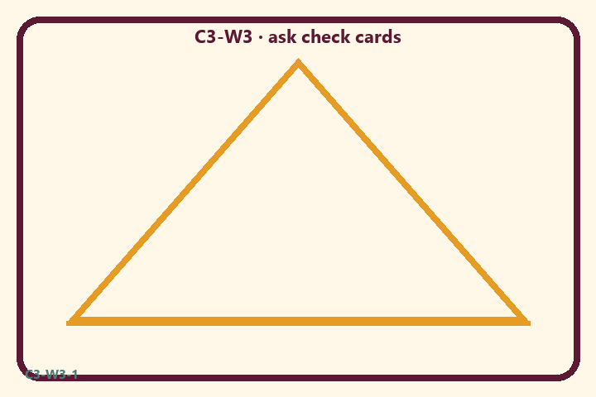
Prompt | My notes
Guru–sādhu–śāstra check | ________________
Limit / care | ________________

Application:
________________________________________________________________
________________________________________________________________
What not to say:
________________________________________________________________
________________________________________________________________
KEY IDEA | Approach realized teachers with humility, inquiry, and service; verify; KUTUMBA is not a initiating guru.

O03 — Safe vs unsafe authority sort
Sort healthy receiving vs cultish traps.
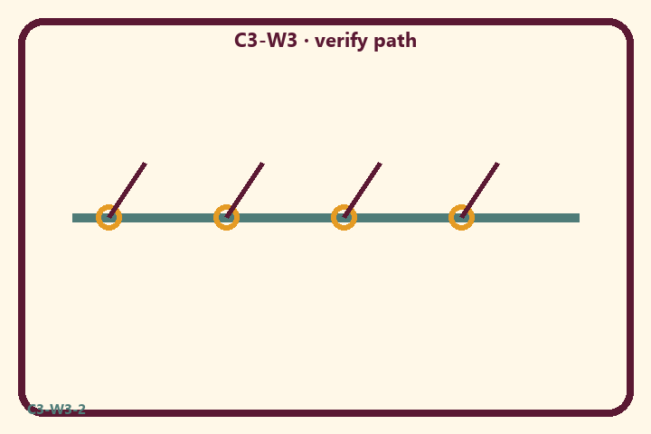
Prompt | My notes
Safe vs unsafe authority sort | ________________
Limit / care | ________________

Application:
________________________________________________________________
________________________________________________________________
What not to say:
________________________________________________________________
________________________________________________________________
KEY IDEA | Approach realized teachers with humility, inquiry, and service; verify; KUTUMBA is not a initiating guru.

O04 — Verify practice scenarios
Three rumor/claim cases.
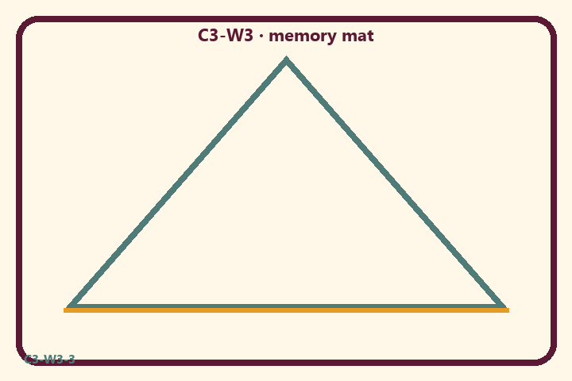
Prompt | My notes
Verify practice scenarios | ________________
Limit / care | ________________

Application:
________________________________________________________________
________________________________________________________________
What not to say:
________________________________________________________________
________________________________________________________________
KEY IDEA | Approach realized teachers with humility, inquiry, and service; verify; KUTUMBA is not a initiating guru.

O05 — Receiving-knowledge diagram
Approach → inquire → serve → verify.
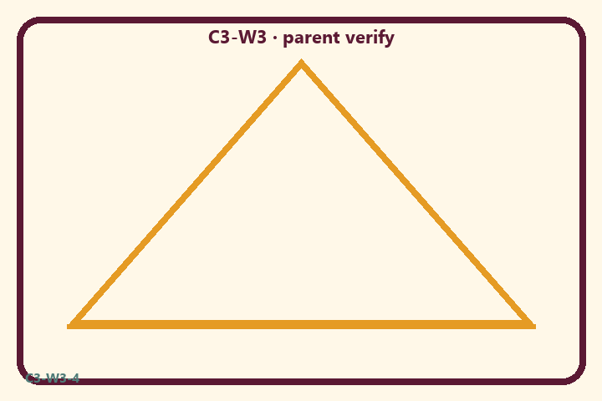
Prompt | My notes
Receiving-knowledge diagram | ________________
Limit / care | ________________

Application:
________________________________________________________________
________________________________________________________________
What not to say:
________________________________________________________________
________________________________________________________________
KEY IDEA | Approach realized teachers with humility, inquiry, and service; verify; KUTUMBA is not a initiating guru.

O06 — Exit ticket
Deferral line + one verify habit.
Primary in one sentence:
________________________________________________________________
________________________________________________________________
One analogy or mechanic and its limit:
________________________________________________________________
________________________________________________________________
One home action:
________________________________________________________________
________________________________________________________________
One question I still have:
________________________________________________________________
________________________________________________________________
RIGHTS NOTE | KUTUMBA-original framing; cited third-party material retains its own rights. Human/temple review remains EXTERNAL_OPEN.

