KUTUMBA

C3-W3 — Parent Track
  - Facilitator guide and parent printables
C3-W3 • Guru, Sādhu and Śāstra: How We Receive Spiritual Knowledge
V13 • Families Growing in Krishna Consciousness
Program Director: Swapnil Patil
Internal founding-cohort teaching material — human/temple review EXTERNAL_OPEN
KUTUMBA | Families Growing in Krishna Consciousness

Locked Saturday Schedule
Time | Block
1:50–2:00 | Arrival
2:00–2:10 | Opening mantras + welcome
2:10–2:30 | All-family launch/orientation
2:30–3:10 | Parallel tracks
3:10–3:30 | Reunification + bhakti laboratory
3:30–3:40 | Snack + water
3:40–3:55 | Saṅkalpa + project + home practice
3:55–4:00 | Close

TIME CUE | Track handoff is at 2:30; all groups reunite at 3:10.

Primary verse: BG 4.34
Source URL: https://vedabase.io/en/library/bg/4/34/

Parent Facilitator Run Sheet
Canonical source: 11-weekly-program-library/first-six-months/c3-w3-guru-sādhu-and-śāstra-how-we-receive-spiritual-knowledge/teacher/PARENT-GUIDE-V13.md • SHA-256: a21473ea304f95559df51bd8ad9017316666f822c61fc655071c02613b3517e9
KUTUMBA · Families Growing in Krishna Consciousness Program Director: Swapnil Patil Week: Guru, Sādhu and Śāstra: How We Receive Spiritual Knowledge · Date: 2027-01-23 Track window: Saturday 2:30–3:10 (parents) Reunite: 3:10 for bhakti laboratory Primary: BG 4.34 — https://vedabase.io/en/library/bg/4/34/ Primary mechanic: Three-source verify Status: Internal founding-cohort teaching material — human/temple review EXTERNAL_OPEN

Essential question
How do we receive spiritual knowledge safely — and what can KUTUMBA not claim?

Materials (print before Saturday)
From activities/v13-parent/: P01–P05 Also pens/crayons; verse card; privacy reminder.

Locked Saturday context
- 1:50–2:00 Arrival · 2:00–2:10 Mantras · 2:10–2:30 All-family launch
- 2:30–3:10 This track · 3:10–3:30 Reunify · 3:30–3:40 Snack/water · 3:40–3:55 Saṅkalpa · 3:55–4:00 Close
Parents remain onsite. No public ranking. No forced disclosure.

Source layer (use mid-track)
Primary: BG 4.34 — https://vedabase.io/en/library/bg/4/34/
Devanāgarī: तद्विद्धि प्रणिपातेन परिप्रश्नेन सेवया । उपदेक्ष्यन्ति ते ज्ञानं ज्ञानिनस्तत्त्वदर्शिनः ॥ ३४ ॥
IAST: tad viddhi praṇipātena paripraśnena sevayā / upadekṣyanti te jñānaṁ jñāninas tattva-darśinaḥ
KUTUMBA teaching meaning (not a BBT translation): Learn the truth by approaching a realized teacher with humility, sincere inquiry, and service — such seers of truth can impart knowledge.

Memory line
Ask, serve, verify.

V13 printable wiring (Three-source verify)

V13 printable block 0–5 — Private reflection — authority boundaries
Printable: activities/v13-parent/P01-PRIVATE-REFLECTION.md (P01-PRIVATE-REFLECTION)
Where do we over-claim or under-verify?
Keep primary mechanic (Three-source verify). Block: Personality-cult framing; KUTUMBA claims of initiating authority; “I feel it so it is true.”

V13 printable block 5–12 — Verify practice card sort
Printable: activities/v13-parent/P02-VERIFY-PRACTICE-CARD-SORT.md (P02-VERIFY-PRACTICE-CARD-SORT)
Sort VERIFY / SPECULATE / OVERCLAIM.
Keep primary mechanic (Three-source verify). Block: Personality-cult framing; KUTUMBA claims of initiating authority; “I feel it so it is true.”

V13 printable block 12–22 — Substantial family case
Printable: activities/v13-parent/P03-SUBSTANTIAL-FAMILY-CASE.md (P03-SUBSTANTIAL-FAMILY-CASE)
Relative forwards a dramatic spiritual rumor as “must share.”
Keep primary mechanic (Three-source verify). Block: Personality-cult framing; KUTUMBA claims of initiating authority; “I feel it so it is true.”

V13 printable block 22–32 — Household operating application
Printable: activities/v13-parent/P04-HOUSEHOLD-OPERATING-APPLICATION.md (P04-HOUSEHOLD-OPERATING-APPLICATION)
Family verify phrase for seven days.
Keep primary mechanic (Three-source verify). Block: Personality-cult framing; KUTUMBA claims of initiating authority; “I feel it so it is true.”

V13 printable block 32–38 — Private next-step saṅkalpa
Printable: activities/v13-parent/P05-PRIVATE-NEXT-STEP-SANKALPA.md (P05-PRIVATE-NEXT-STEP-SANKALPA)
One verify habit + minimum version.
Keep primary mechanic (Three-source verify). Block: Personality-cult framing; KUTUMBA claims of initiating authority; “I feel it so it is true.”

Close of track (handoff)
Bring one sentence or artifact to reunification. Do not start next week’s topic. Care boundary: Age-appropriate authority boundaries; no personality cult; “I don’t know; I will verify.”

Inherited classroom depth (from V12 parent-lesson / constructed V13 flow)
Keep story scripts, movement steps, and wonder questions below. Wire printables to the V13 codes above; do not replace this depth with “see research.”

Essential question
How do we receive spiritual knowledge?

Source
BG 4.34 — teaching meaning: Approach those who have seen the truth — with humility, inquiry, and service — and they will instruct you in knowledge.

Discussion
One realistic household tension; no compelled confession.

Application
5–15 minute cue; minimum version counts.

Privacy
No public scoring of sādhana.

P01 — Private reflection — authority boundaries
Where do we over-claim or under-verify?

SAFETY & PRIVACY | Write privately. Sharing is optional. Do not collect or place completed sheets in Git.

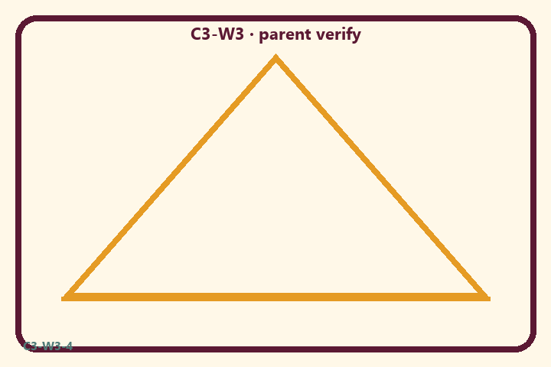
Where do we over-claim or under-verify?
Private notes:
________________________________________________________________
________________________________________________________________
________________________________________________________________
________________________________________________________________
Habit to watch this week:
________________________________________________________________
________________________________________________________________
________________________________________________________________
________________________________________________________________

P02 — Verify practice card sort
Sort VERIFY / SPECULATE / OVERCLAIM.
HELPFUL | MISTAKEN

L1  Check śāstra | L2  Personality cult praise
L3  Ask a teacher | L4  Forward rumor
L5  KUTUMBA is my guru | L6  Defer and verify
TEACHER NOTE | Personality-cult framing; KUTUMBA claims of initiating authority; “I feel it so it is true.”

P03 — Substantial family case
Relative forwards a dramatic spiritual rumor as “must share.”
SAFETY & PRIVACY | Fictional case. No compelled confession of real events.

A relative forwards a dramatic spiritual rumor as “must share tonight.” One parent wants to forward immediately; another wants to verify but feels rude.
Tempting mistaken conclusion:
________________________________________________________________
________________________________________________________________
________________________________________________________________
Principle from primary:
________________________________________________________________
________________________________________________________________
________________________________________________________________
Compassionate response:
________________________________________________________________
________________________________________________________________
________________________________________________________________
One seven-day household action:
________________________________________________________________
________________________________________________________________
________________________________________________________________
What we should not say:
________________________________________________________________
________________________________________________________________
________________________________________________________________
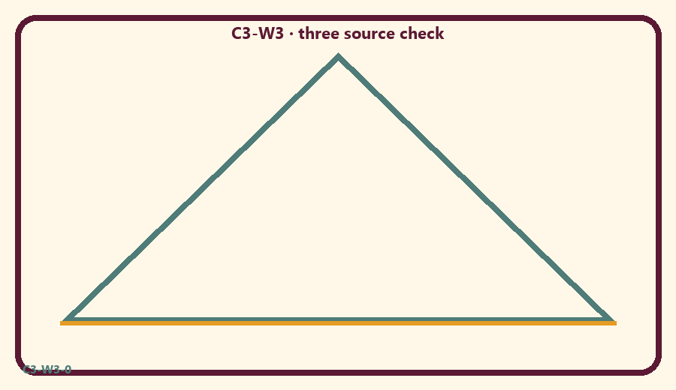

P04 — Household operating application
Family verify phrase for seven days.
SAFETY & PRIVACY | No ranking and no public reading required.

One household action for seven days:
________________________________________________________________
________________________________________________________________
________________________________________________________________
Trigger (when/where):
________________________________________________________________
________________________________________________________________
________________________________________________________________
Who starts if others are tired:
________________________________________________________________
________________________________________________________________
________________________________________________________________
Minimum version on a hard day:
________________________________________________________________
________________________________________________________________
________________________________________________________________

Memory phrase
Ask, serve, verify.

P05 — Private next-step saṅkalpa
One verify habit + minimum version.
KEY IDEA | specific action + frequency + trigger + minimum version

Specific action:
________________________________________________________________
________________________________________________________________
Frequency:
________________________________________________________________
________________________________________________________________
Trigger (when and where):
________________________________________________________________
________________________________________________________________
Minimum version for a hard day:
________________________________________________________________
________________________________________________________________
Where we will place the reminder:
________________________________________________________________
________________________________________________________________
No ranking. The minimum version counts as success.
RIGHTS NOTE | KUTUMBA-original framing; cited third-party material retains its own rights. Human/temple review remains EXTERNAL_OPEN.

