KUTUMBA

C3-W3 — Younger Teacher Pack
  - K–2 run sheet and activities
C3-W3 • Guru, Sādhu and Śāstra: How We Receive Spiritual Knowledge
V13 • Families Growing in Krishna Consciousness
Program Director: Swapnil Patil
Internal founding-cohort teaching material — human/temple review EXTERNAL_OPEN
KUTUMBA | Families Growing in Krishna Consciousness

Locked Saturday Schedule
Time | Block
1:50–2:00 | Arrival
2:00–2:10 | Opening mantras + welcome
2:10–2:30 | All-family launch/orientation
2:30–3:10 | Parallel tracks
3:10–3:30 | Reunification + bhakti laboratory
3:30–3:40 | Snack + water
3:40–3:55 | Saṅkalpa + project + home practice
3:55–4:00 | Close

TIME CUE | Track handoff is at 2:30; all groups reunite at 3:10.

Primary verse: BG 4.34
Source URL: https://vedabase.io/en/library/bg/4/34/

Younger Teacher Run Sheet
Canonical source: 11-weekly-program-library/first-six-months/c3-w3-guru-sādhu-and-śāstra-how-we-receive-spiritual-knowledge/teacher/YOUNGER-TEACHER-GUIDE-V13.md • SHA-256: 60c3592a76350ba485a4c0d700ac15c653ea5b7986b509c265b5d49d591763b9
KUTUMBA · Families Growing in Krishna Consciousness Program Director: Swapnil Patil Week: Guru, Sādhu and Śāstra: How We Receive Spiritual Knowledge · Date: 2027-01-23 Track window: Saturday 2:30–3:10 (K–2) Reunite: 3:10 for bhakti laboratory Primary: BG 4.34 — https://vedabase.io/en/library/bg/4/34/ Primary mechanic: Three-source verify Status: Internal founding-cohort teaching material — human/temple review EXTERNAL_OPEN

Essential question
How do we receive spiritual knowledge safely — and what can KUTUMBA not claim?

Materials (print before Saturday)
From activities/v13-younger/: Y01–Y05 Also pens/crayons; verse card; privacy reminder.

Locked Saturday context
- 1:50–2:00 Arrival · 2:00–2:10 Mantras · 2:10–2:30 All-family launch
- 2:30–3:10 This track · 3:10–3:30 Reunify · 3:30–3:40 Snack/water · 3:40–3:55 Saṅkalpa · 3:55–4:00 Close
Parents remain onsite. No public ranking. No forced disclosure.

Source layer (use mid-track)
Primary: BG 4.34 — https://vedabase.io/en/library/bg/4/34/
Devanāgarī: तद्विद्धि प्रणिपातेन परिप्रश्नेन सेवया । उपदेक्ष्यन्ति ते ज्ञानं ज्ञानिनस्तत्त्वदर्शिनः ॥ ३४ ॥
IAST: tad viddhi praṇipātena paripraśnena sevayā / upadekṣyanti te jñānaṁ jñāninas tattva-darśinaḥ
KUTUMBA teaching meaning (not a BBT translation): Learn the truth by approaching a realized teacher with humility, sincere inquiry, and service — such seers of truth can impart knowledge.

Memory line
Ask, serve, verify.

V13 printable wiring (Three-source verify)

V13 printable block 0–6 — Ask-check cards
Printable: activities/v13-younger/Y01-ASK-CHECK-CARDS.md (Y01-ASK-CHECK-CARDS)
Ask → listen → check with a trusted adult/book.
Keep primary mechanic (Three-source verify). Block: Personality-cult framing; KUTUMBA claims of initiating authority; “I feel it so it is true.”

V13 printable block 6–14 — Humble help matching
Printable: activities/v13-younger/Y02-HUMBLE-HELP-MATCHING.md (Y02-HUMBLE-HELP-MATCHING)
Match asking kindly to learning.
Keep primary mechanic (Three-source verify). Block: Personality-cult framing; KUTUMBA claims of initiating authority; “I feel it so it is true.”

V13 printable block 14–24 — Three-friends craft
Printable: activities/v13-younger/Y03-THREE-FRIENDS-CRAFT.md (Y03-THREE-FRIENDS-CRAFT)
Teacher / holy person example / book icons.
Keep primary mechanic (Three-source verify). Block: Personality-cult framing; KUTUMBA claims of initiating authority; “I feel it so it is true.”

V13 printable block 24–32 — I-will-verify cards
Printable: activities/v13-younger/Y04-I-WILL-VERIFY-CARDS.md (Y04-I-WILL-VERIFY-CARDS)
Practice the deferral sentence.
Keep primary mechanic (Three-source verify). Block: Personality-cult framing; KUTUMBA claims of initiating authority; “I feel it so it is true.”

V13 printable block 32–38 — Memory phrase mat
Printable: activities/v13-younger/Y05-MEMORY-PHRASE-MAT.md (Y05-MEMORY-PHRASE-MAT)
Echo: Ask, serve, verify.
Keep primary mechanic (Three-source verify). Block: Personality-cult framing; KUTUMBA claims of initiating authority; “I feel it so it is true.”

Close of track (handoff)
Bring one sentence or artifact to reunification. Do not start next week’s topic. Care boundary: Age-appropriate authority boundaries; no personality cult; “I don’t know; I will verify.”

Inherited classroom depth (from V12 YOUNGER-TEACHER-GUIDE.md)
Keep story scripts, movement steps, and wonder questions below. Wire printables to the V13 codes above; do not replace this depth with “see research.”
Week: Guru, Sādhu and Śāstra: How We Receive Spiritual Knowledge Primary: BG 4.34 — https://vedabase.io/en/library/bg/4/34/ Session length: 40 minutes (parallel track ~2:30–3:10) Parents: Remain onsite; reunite at 3:10 Status: Internal founding-cohort teaching material — human/temple review EXTERNAL_OPEN

Objective
Children practice asking kindly, helping as service, and “checking the book,” and echo Ask, serve, verify.

Exact memory phrase
Ask, serve, verify.

Teacher background (2 minutes to review)
- KUTUMBA teaching meaning (adult wording): Learn the truth by approaching a realized teacher with humility, sincere inquiry, and service — such seers of truth can impart knowledge.
- Child-facing paraphrase: We learn about Kṛṣṇa by asking politely, helping, and checking trusted books. KUTUMBA helpers teach; they do not give initiation vows.
- Block misconceptions (child words):
- “Believe every video.”
- “Our class helper is my initiating guru.”
- Do not: invent deity dialogue; force confession; rank children; use scare tactics; claim temple certification stickers.

Materials
- Three door cards
- Picture “book check”
- Question puppets
- Crayons
- Soft toss
- Calm corner
- Phrase stickers

Room setup
Circle on the floor; materials table behind you; calm corner with one chair for quiet reset. Keep aisles clear for movement.

Minute-by-minute executable plan

0–5 min — Opening and recall
1. Welcome.
2. Echo: Ask, / serve, / verify.
3. Show three doors.
4. Say: “Helpers teach; big vows are different.”

5–13 min — Story script (paraphrase only; ~8 minutes)
Say exactly this spine (do not invent deity dialogue):
Kṛṣṇa teaches us to learn by bowing our pride, asking sincere questions, and serving. Wise teachers who see the truth can give knowledge. If a video says something scary, we pause and check a trusted book. Our Saturday helpers teach families. They do not give initiation.
Story boundaries: No naming living gurus for recruitment. No fear stories. No invented quotes.

13–16 min — Three wonder questions
1. What are the three words? (Ask, serve, verify)
2. Do we believe every video? (No)
3. Does class give initiation? (No)
Accept one- or two-word answers. Affirm effort.

16–24 min — Movement game: Three-Door Walk (steps)
1. Three mats: Ask, Serve, Verify.
2. Walk each; do a gesture (hand raise; helping hands; open-book hands).
3. Two rounds; sit; phrase.

24–32 min — Craft: Three-door reminder card (steps)
1. Fold card with three doors drawn.
2. Color; write phrase.
3. Back: draw a book check.
Full printable steps also live in activities/YOUNGER-ACTIVITY-PACK.md (use together; this guide remains executable if the pack is missing).

32–35 min — Printable / coloring task
If time remains, color the younger line-art sheet if available. If short on time, keep the craft as the take-home.

35–38 min — Behavior redirects and quiet reset
Use calm, specific redirects:
- Feet on floor — “Feet visit the mat.”
- Kind hands — “Hands help; toys rest.”
- Loud shout — “Soft voice, please.”
- Quiet reset — “Calm corner for sixty seconds.”

38–40 min — Cleanup and parent handoff
1. Materials away; craft in hand.
2. At reunification, tell parent in one sentence:
Memory phrase: “Ask, serve, verify..” Home cue: Write one sincere spiritual question and locate one relevant Śrīla Prabhupāda source.
1. Do not report private behavior struggles in front of other families.

Behavior redirects (quick reference)
Signal | Teacher line | Child action
Running | Walking feet. | Walk to mat
Snatching | Kind hands. | Hands to lap
Interrupt shout | Soft voice. | Whisper retry
Shutdown | Quiet reset is okay. | Calm corner 60 sec

Backup low-prep (if craft fails or energy crashes)
Toss and say Ask or Verify.

What success looks like
- Echoes phrase
- Says class does not initiate
- Practices kind ask

Boundaries
- Snack/water only happens in main schedule (3:30), not as a track bribe.
- No weekly meal language.
- No fabricated approval stickers implying temple certification.
- Privacy: no forced confession.

Child House Rules
Canonical source: launch/CHILD-HOUSE-RULES.md • SHA-256: 6a525f3dd1da740db86e246622696c7b08e28c1f1475227567d639a5bd54ce47
Parents remain onsite. Facilitators guide the session. Host property rules also apply.

Shared rules (all ages)
1. Keep your body safe — feet on the floor; hands gentle.
2. Use respectful speech — no teasing, yelling, or mean labels.
3. Follow the facilitator safety cue immediately (pause / freeze / come here).
4. No jumping on furniture.
5. No indoor throwing.
6. No writing on walls, books, or furniture that are not activity materials.
7. Ask before entering private rooms.
8. Respect belongings — ask before touching what is not yours.
9. Devices away unless the lesson specifically needs them.
10. Snack only in the allowed area; water anytime with permission.
11. Help clean up before leaving.

Correction ladder (no public shame)
1. Calm reminder
2. Redirect / offer a choice
3. Brief quiet reset in a visible space
4. Parent involvement
5. Sit out a specific activity
6. Private parent/program conversation for repeated patterns
Never: public shame, yelling, sarcasm, corporal punishment, forced chanting, or comparing children.

Younger (K–2) emphasis
- Soft voices indoors
- Stay with the group
- Hands to yourself
- Ask before leaving the room

Older (Grades 4–5) emphasis
- Model respectful speech for younger children
- Devices fully away unless assigned
- Help clean-up leadership
- Honest questions welcome; speculation wait for source check
Printable versions: W1 launch-pack CHILD-RULES-YOUNGER.md and CHILD-RULES-OLDER.md.

Y01 — Ask-check cards
Ask → listen → check with a trusted adult/book.
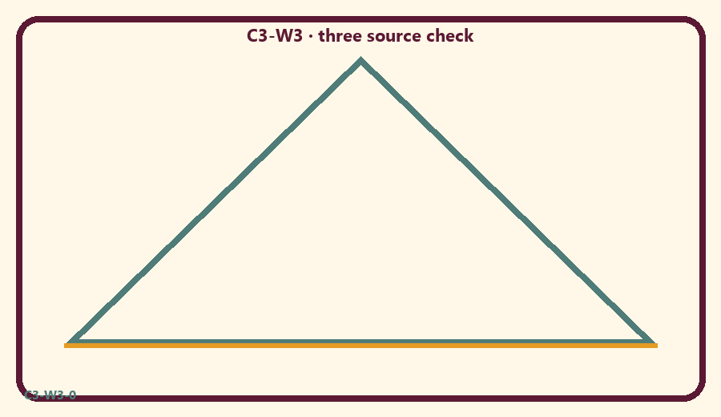
CARD 1  Ask kindly | CARD 2  Guess loudly
CARD 3  Check a book | CARD 4  Serve a little
CARD 5  Believe every video | CARD 6  Say I will verify

Memory phrase
Ask, serve, verify.
Cut on the dashed borders. Keep each card intact.
TEACHER NOTE | Age-appropriate authority boundaries; no personality cult; “I don’t know; I will verify.”

Y02 — Humble help matching
Match asking kindly to learning.
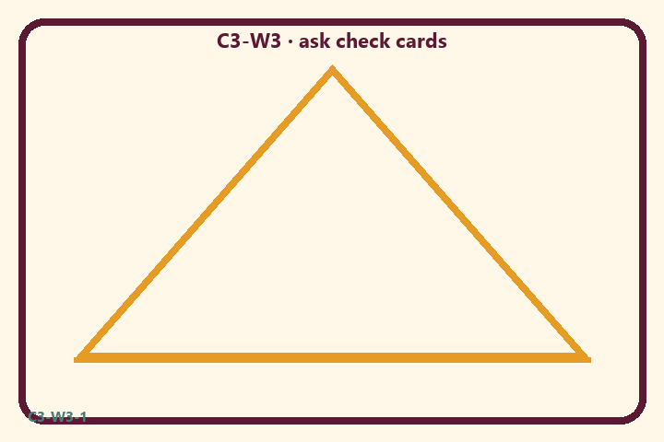
CARD 1  Ask kindly | CARD 2  Guess loudly
CARD 3  Check a book | CARD 4  Serve a little
CARD 5  Believe every video | CARD 6  Say I will verify

Memory phrase
Ask, serve, verify.
Cut on the dashed borders. Keep each card intact.
TEACHER NOTE | Age-appropriate authority boundaries; no personality cult; “I don’t know; I will verify.”

Y03 — Three-friends craft
Teacher / holy person example / book icons.
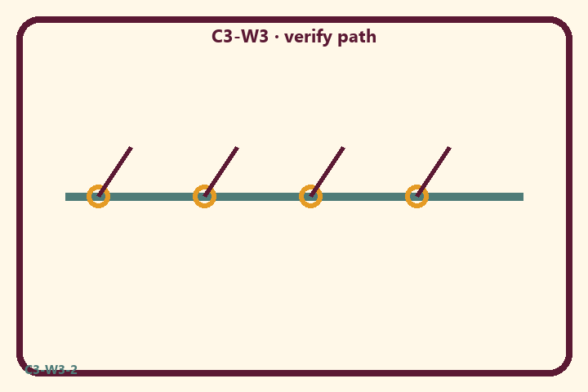
CARD 1  Ask kindly | CARD 2  Guess loudly
CARD 3  Check a book | CARD 4  Serve a little
CARD 5  Believe every video | CARD 6  Say I will verify

Memory phrase
Ask, serve, verify.
Cut on the dashed borders. Keep each card intact.
TEACHER NOTE | Age-appropriate authority boundaries; no personality cult; “I don’t know; I will verify.”

Y04 — I-will-verify cards
Practice the deferral sentence.
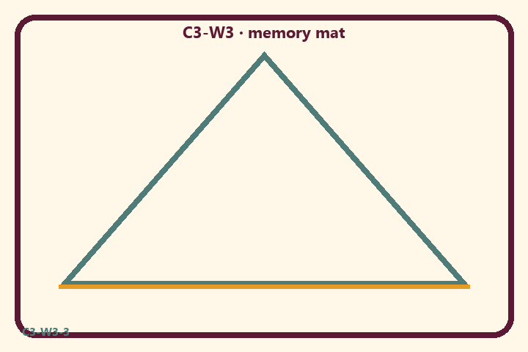
CARD 1  Ask kindly | CARD 2  Guess loudly
CARD 3  Check a book | CARD 4  Serve a little
CARD 5  Believe every video | CARD 6  Say I will verify

Memory phrase
Ask, serve, verify.
Cut on the dashed borders. Keep each card intact.
TEACHER NOTE | Age-appropriate authority boundaries; no personality cult; “I don’t know; I will verify.”

Y05 — Memory phrase mat
Echo: Ask, serve, verify.

Memory phrase
Ask, serve, verify.
BG 4.34 · family week
RIGHTS NOTE | KUTUMBA-original framing; cited third-party material retains its own rights. Human/temple review remains EXTERNAL_OPEN.

