KUTUMBA

C3-W4 — Older Teacher Pack
  - Grades 4–5 run sheet and activities
C3-W4 • Śrī Caitanya Mahāprabhu and the Holy Name
V13 • Families Growing in Krishna Consciousness
Program Director: Swapnil Patil
Internal founding-cohort teaching material — human/temple review EXTERNAL_OPEN
KUTUMBA | Families Growing in Krishna Consciousness

Locked Saturday Schedule
Time | Block
1:50–2:00 | Arrival
2:00–2:10 | Opening mantras + welcome
2:10–2:30 | All-family launch/orientation
2:30–3:10 | Parallel tracks
3:10–3:30 | Reunification + bhakti laboratory
3:30–3:40 | Snack + water
3:40–3:55 | Saṅkalpa + project + home practice
3:55–4:00 | Close

TIME CUE | Track handoff is at 2:30; all groups reunite at 3:10.

Primary verse: CC Antya 20.12
Source URL: https://vedabase.io/en/library/cc/antya/20/12/

Older Teacher Run Sheet
Canonical source: 11-weekly-program-library/first-six-months/c3-w4-śrī-caitanya-mahāprabhu-and-the-holy-name/teacher/OLDER-TEACHER-GUIDE-V13.md • SHA-256: 47e83e56aef9d18e5f8af600cad55f43d462b23bde1eae743885685ac1189b37
KUTUMBA · Families Growing in Krishna Consciousness Program Director: Swapnil Patil Week: Śrī Caitanya Mahāprabhu and the Holy Name · Date: 2027-01-30 Track window: Saturday 2:30–3:10 (Grades 4–5) Reunite: 3:10 for bhakti laboratory Primary: CC Antya 20.12 — https://vedabase.io/en/library/cc/antya/20/12/ Primary mechanic: Kīrtana etiquette Status: Internal founding-cohort teaching material — human/temple review EXTERNAL_OPEN

Essential question
What is śrī-kṛṣṇa-saṅkīrtanam — and how do families practice it with attention, not performance pressure?

Materials (print before Saturday)
From activities/v13-older/: O01–O06 Also pens/crayons; verse card; privacy reminder.

Locked Saturday context
- 1:50–2:00 Arrival · 2:00–2:10 Mantras · 2:10–2:30 All-family launch
- 2:30–3:10 This track · 3:10–3:30 Reunify · 3:30–3:40 Snack/water · 3:40–3:55 Saṅkalpa · 3:55–4:00 Close
Parents remain onsite. No public ranking. No forced disclosure.

Source layer (use mid-track)
Primary: CC Antya 20.12 — https://vedabase.io/en/library/cc/antya/20/12/
Devanāgarī: চেতোদর্পণমার্জনং ভবমহাদাবাগ্নিনির্বাপণং শ্রেয়ঃকৈরবচন্দ্রিকাবিতরণং বিদ্যাবধূজীবনম্ । আনন্দাম্বুধিবর্ধনং প্রতিপদং পূর্ণামৃতাস্বাদনং সর্বাত্মস্নপনং পরং বিজয়তে শ্রীকৃষ্ণসঙ্কীর্তনম্ ॥ ১২ ॥
IAST: ceto-darpaṇa-mārjanaṁ bhava-mahā-dāvāgni-nirvāpaṇaṁ / śreyaḥ-kairava-candrikā-vitaraṇaṁ vidyā-vadhū-jīvanam / ānandāmbudhi-vardhanaṁ prati-padaṁ pūrṇāmṛtāsvādanaṁ / sarvātma-snapanaṁ paraṁ vijayate śrī-kṛṣṇa-saṅkīrtanam
KUTUMBA teaching meaning (not a BBT translation): All victory to śrī-kṛṣṇa-saṅkīrtana — which cleanses the mirror of the heart, extinguishes the forest fire of material existence, spreads the moonlight of good fortune, is the life of knowledge, expands the ocean of bliss, enables tasting full nectar at every step, and bathes the self — supreme.

Memory line
Paraṁ vijayate śrī-kṛṣṇa-saṅkīrtanam.

V13 printable wiring (Kīrtana etiquette)

V13 printable block 0–6 — Śikṣāṣṭaka / CC Antya 20.12 observation
Printable: activities/v13-older/O01-SIKSASTAKA-OBSERVATION.md (O01-SIKSASTAKA-OBSERVATION)
Full source-language layer + teaching meaning.
Keep primary mechanic (Kīrtana etiquette). Block: Volume/performance equals devotion; skipping source-language layer of Śikṣāṣṭaka 1.

V13 printable block 6–14 — Kīrtana etiquette board
Printable: activities/v13-older/O02-KIRTANA-ETIQUETTE-BOARD.md (O02-KIRTANA-ETIQUETTE-BOARD)
Attention practices vs performance traps.
Keep primary mechanic (Kīrtana etiquette). Block: Volume/performance equals devotion; skipping source-language layer of Śikṣāṣṭaka 1.

V13 printable block 14–22 — Attention vs performance sort
Printable: activities/v13-older/O03-ATTENTION-VS-PERFORMANCE-SORT.md (O03-ATTENTION-VS-PERFORMANCE-SORT)
Sort cards carefully.
Keep primary mechanic (Kīrtana etiquette). Block: Volume/performance equals devotion; skipping source-language layer of Śikṣāṣṭaka 1.

V13 printable block 22–30 — Holy name home scenarios
Printable: activities/v13-older/O04-HOLY-NAME-HOME-SCENARIOS.md (O04-HOLY-NAME-HOME-SCENARIOS)
Three family practice cases.
Keep primary mechanic (Kīrtana etiquette). Block: Volume/performance equals devotion; skipping source-language layer of Śikṣāṣṭaka 1.

V13 printable block 30–36 — Heart-mirror diagram
Printable: activities/v13-older/O05-HEART-MIRROR-DIAGRAM.md (O05-HEART-MIRROR-DIAGRAM)
Cleansing metaphor with limits.
Keep primary mechanic (Kīrtana etiquette). Block: Volume/performance equals devotion; skipping source-language layer of Śikṣāṣṭaka 1.

V13 printable block 36–40 — Exit ticket
Printable: activities/v13-older/O06-EXIT-TICKET.md (O06-EXIT-TICKET)
One etiquette rule + one home minute.
Keep primary mechanic (Kīrtana etiquette). Block: Volume/performance equals devotion; skipping source-language layer of Śikṣāṣṭaka 1.

Close of track (handoff)
Bring one sentence or artifact to reunification. Do not start next week’s topic. Care boundary: No ranking by volume; include full Śikṣāṣṭaka verse-1 source-language layer; invitation not contest.

Inherited classroom depth (from V12 OLDER-TEACHER-GUIDE.md)
Keep story scripts, movement steps, and wonder questions below. Wire printables to the V13 codes above; do not replace this depth with “see research.”
Week: Śrī Caitanya Mahāprabhu and the Holy Name Primary: CC Antya 20.12 — https://vedabase.io/en/library/cc/antya/20/12/ Session length: ~40 minutes (parallel track ~2:30–3:10) Parents: Remain onsite; reunite at 3:10 Status: Internal founding-cohort teaching material — human/temple review EXTERNAL_OPEN

Objective
Students observe CC Antya 20.12, explain śrī-kṛṣṇa-saṅkīrtanam benefits in classroom language, and plan three-day attentive practice without ranking.

Exact memory phrase
The congregational chanting of Kṛṣṇa's holy name — śrī-kṛṣṇa-saṅkīrtanam — cleanses the heart and expands spiritual life.
Short echo: Paraṁ vijayate śrī-kṛṣṇa-saṅkīrtanam.

Teacher background
- KUTUMBA teaching meaning: All victory to śrī-kṛṣṇa-saṅkīrtana — which cleanses the mirror of the heart, extinguishes the forest fire of material existence, spreads the moonlight of good fortune, is the life of knowledge, expands the ocean of bliss, and bathes the self in nectar at every step. (Label as KUTUMBA teaching meaning — not as BBT translation.)
- Supporting frames (one sentence each): CC Ādi 17.21 yuga-dharma; ŚB 12.3.51 hope; attention over performance.
- Block: Force chanting as punishment.; Performance ranking of voices/kīrtana skill.
- Scope: No full aparādha prosecution; no advanced ecstasy claims.

Materials
- Verse strips
- Worksheets
- Scenario cards
- Plan sheets
- Answer key
- Soft kīrtana guide

Minute-by-minute plan

0–5 min — Settle and hook
Punishment chanting vs mercy chanting — which matches the verse?

5–14 min — Primary text observation
Read IAST refrain; list benefits in student words; insist on śrī-kṛṣṇa-saṅkīrtanam label.

14–22 min — Worksheet questions
Students complete Section A of the older activity pack. Teacher circulates; use OLDER-ANSWER-KEY.md for expected directions (not for grading ranks).

22–28 min — Scenario cards (small groups)
A Punishment B Volume contest C Generic-only label
Share one insight per group (60 seconds).

28–33 min — Puzzle / game: Hearing or Contest
H vs C claims; explain with verse.

33–37 min — Diagram / map task
Benefit map around the refrain.

37–40 min — Project sentence + handoff
Three-day plan to parent.

Boundaries
- No ranking or public scores.
- No invented dialogue.
- Parents onsite; snack/water only at 3:30 in the main schedule.
- Defer off-scope topics: Deep offense taxonomy; rasa theory.

O01 — Śikṣāṣṭaka / CC Antya 20.12 observation
Full source-language layer + teaching meaning.

VERSE CARD • CC Antya 20.12
চেতোদর্পণমার্জনং ভবমহাদাবাগ্নিনির্বাপণং শ্রেয়ঃকৈরবচন্দ্রিকাবিতরণং বিদ্যাবধূজীবনম্ । আনন্দাম্বুধিবর্ধনং প্রতিপদং পূর্ণামৃতাস্বাদনং সর্বাত্মস্নপনং পরং বিজয়তে শ্রীকৃষ্ণসঙ্কীর্তনম্ ॥ ১২ ॥
ceto-darpaṇa-mārjanaṁ bhava-mahā-dāvāgni-nirvāpaṇaṁ / śreyaḥ-kairava-candrikā-vitaraṇaṁ vidyā-vadhū-jīvanam / ānandāmbudhi-vardhanaṁ prati-padaṁ pūrṇāmṛtāsvādanaṁ / sarvātma-snapanaṁ paraṁ vijayate śrī-kṛṣṇa-saṅkīrtanam
KUTUMBA teaching meaning: All victory to śrī-kṛṣṇa-saṅkīrtana — which cleanses the mirror of the heart, extinguishes the forest fire of material existence, spreads the moonlight of good fortune, is the life of knowledge, expands the ocean of bliss, enables tasting full nectar at every step, and bathes the self — supreme.
Source: https://vedabase.io/en/library/cc/antya/20/12/
Rights/status: Scripture display/source: VedaBase; teaching meaning: KUTUMBA-original (not labeled as BBT translation).

What does the verse teach in my words?
________________________________________________________________
________________________________________________________________
What misconception does this week block?
________________________________________________________________
________________________________________________________________
One question for the facilitator:
________________________________________________________________
________________________________________________________________

O02 — Kīrtana etiquette board
Attention practices vs performance traps.
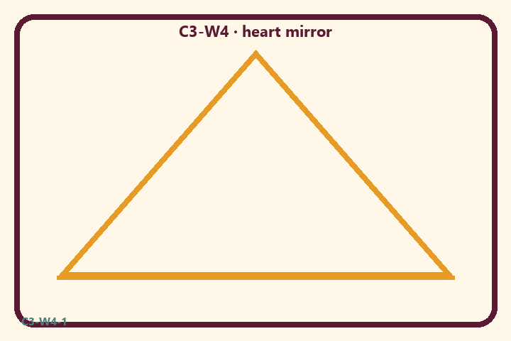
Prompt | My notes
Kīrtana etiquette board | ________________
Limit / care | ________________

Application:
________________________________________________________________
________________________________________________________________
What not to say:
________________________________________________________________
________________________________________________________________
KEY IDEA | All glory to śrī-kṛṣṇa-saṅkīrtana; families practice with attention and etiquette, not performance ranking.

O03 — Attention vs performance sort
Sort cards carefully.
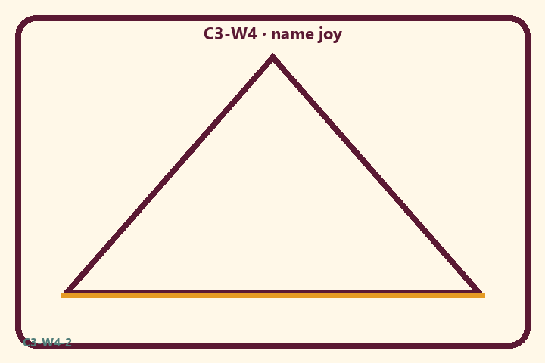
Prompt | My notes
Attention vs performance sort | ________________
Limit / care | ________________

Application:
________________________________________________________________
________________________________________________________________
What not to say:
________________________________________________________________
________________________________________________________________
KEY IDEA | All glory to śrī-kṛṣṇa-saṅkīrtana; families practice with attention and etiquette, not performance ranking.

O04 — Holy name home scenarios
Three family practice cases.
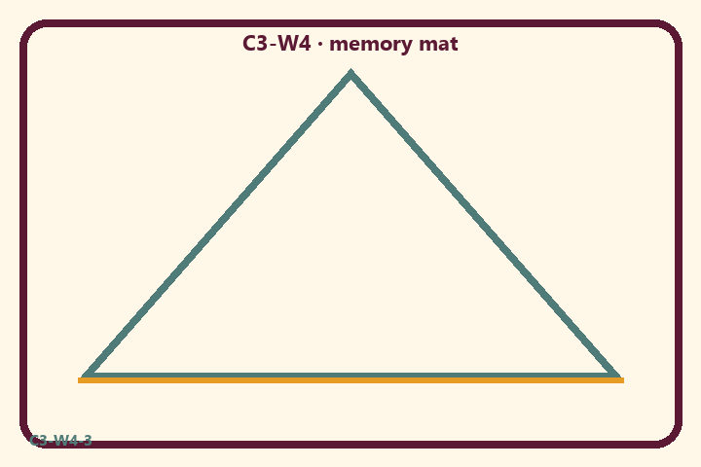
Prompt | My notes
Holy name home scenarios | ________________
Limit / care | ________________

Application:
________________________________________________________________
________________________________________________________________
What not to say:
________________________________________________________________
________________________________________________________________
KEY IDEA | All glory to śrī-kṛṣṇa-saṅkīrtana; families practice with attention and etiquette, not performance ranking.

O05 — Heart-mirror diagram
Cleansing metaphor with limits.
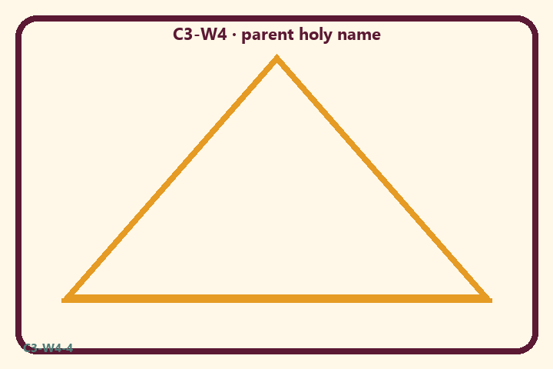
Prompt | My notes
Heart-mirror diagram | ________________
Limit / care | ________________

Application:
________________________________________________________________
________________________________________________________________
What not to say:
________________________________________________________________
________________________________________________________________
KEY IDEA | All glory to śrī-kṛṣṇa-saṅkīrtana; families practice with attention and etiquette, not performance ranking.

O06 — Exit ticket
One etiquette rule + one home minute.
Primary in one sentence:
________________________________________________________________
________________________________________________________________
One analogy or mechanic and its limit:
________________________________________________________________
________________________________________________________________
One home action:
________________________________________________________________
________________________________________________________________
One question I still have:
________________________________________________________________
________________________________________________________________
RIGHTS NOTE | KUTUMBA-original framing; cited third-party material retains its own rights. Human/temple review remains EXTERNAL_OPEN.

