KUTUMBA

C3-W4 — Parent Track
  - Facilitator guide and parent printables
C3-W4 • Śrī Caitanya Mahāprabhu and the Holy Name
V13 • Families Growing in Krishna Consciousness
Program Director: Swapnil Patil
Internal founding-cohort teaching material — human/temple review EXTERNAL_OPEN
KUTUMBA | Families Growing in Krishna Consciousness

Locked Saturday Schedule
Time | Block
1:50–2:00 | Arrival
2:00–2:10 | Opening mantras + welcome
2:10–2:30 | All-family launch/orientation
2:30–3:10 | Parallel tracks
3:10–3:30 | Reunification + bhakti laboratory
3:30–3:40 | Snack + water
3:40–3:55 | Saṅkalpa + project + home practice
3:55–4:00 | Close

TIME CUE | Track handoff is at 2:30; all groups reunite at 3:10.

Primary verse: CC Antya 20.12
Source URL: https://vedabase.io/en/library/cc/antya/20/12/

Parent Facilitator Run Sheet
Canonical source: 11-weekly-program-library/first-six-months/c3-w4-śrī-caitanya-mahāprabhu-and-the-holy-name/teacher/PARENT-GUIDE-V13.md • SHA-256: 4c464d7fab1bd5ed4a11169bf7aad88412928eb1076d4ad8585f56138f5c8bfc
KUTUMBA · Families Growing in Krishna Consciousness Program Director: Swapnil Patil Week: Śrī Caitanya Mahāprabhu and the Holy Name · Date: 2027-01-30 Track window: Saturday 2:30–3:10 (parents) Reunite: 3:10 for bhakti laboratory Primary: CC Antya 20.12 — https://vedabase.io/en/library/cc/antya/20/12/ Primary mechanic: Kīrtana etiquette Status: Internal founding-cohort teaching material — human/temple review EXTERNAL_OPEN

Essential question
What is śrī-kṛṣṇa-saṅkīrtanam — and how do families practice it with attention, not performance pressure?

Materials (print before Saturday)
From activities/v13-parent/: P01–P05 Also pens/crayons; verse card; privacy reminder.

Locked Saturday context
- 1:50–2:00 Arrival · 2:00–2:10 Mantras · 2:10–2:30 All-family launch
- 2:30–3:10 This track · 3:10–3:30 Reunify · 3:30–3:40 Snack/water · 3:40–3:55 Saṅkalpa · 3:55–4:00 Close
Parents remain onsite. No public ranking. No forced disclosure.

Source layer (use mid-track)
Primary: CC Antya 20.12 — https://vedabase.io/en/library/cc/antya/20/12/
Devanāgarī: চেতোদর্পণমার্জনং ভবমহাদাবাগ্নিনির্বাপণং শ্রেয়ঃকৈরবচন্দ্রিকাবিতরণং বিদ্যাবধূজীবনম্ । আনন্দাম্বুধিবর্ধনং প্রতিপদং পূর্ণামৃতাস্বাদনং সর্বাত্মস্নপনং পরং বিজয়তে শ্রীকৃষ্ণসঙ্কীর্তনম্ ॥ ১২ ॥
IAST: ceto-darpaṇa-mārjanaṁ bhava-mahā-dāvāgni-nirvāpaṇaṁ / śreyaḥ-kairava-candrikā-vitaraṇaṁ vidyā-vadhū-jīvanam / ānandāmbudhi-vardhanaṁ prati-padaṁ pūrṇāmṛtāsvādanaṁ / sarvātma-snapanaṁ paraṁ vijayate śrī-kṛṣṇa-saṅkīrtanam
KUTUMBA teaching meaning (not a BBT translation): All victory to śrī-kṛṣṇa-saṅkīrtana — which cleanses the mirror of the heart, extinguishes the forest fire of material existence, spreads the moonlight of good fortune, is the life of knowledge, expands the ocean of bliss, enables tasting full nectar at every step, and bathes the self — supreme.

Memory line
Paraṁ vijayate śrī-kṛṣṇa-saṅkīrtanam.

V13 printable wiring (Kīrtana etiquette)

V13 printable block 0–5 — Private reflection — home name culture
Printable: activities/v13-parent/P01-PRIVATE-REFLECTION.md (P01-PRIVATE-REFLECTION)
Attention or performance pressure?
Keep primary mechanic (Kīrtana etiquette). Block: Volume/performance equals devotion; skipping source-language layer of Śikṣāṣṭaka 1.

V13 printable block 5–12 — Etiquette card sort
Printable: activities/v13-parent/P02-ETIQUETTE-CARD-SORT.md (P02-ETIQUETTE-CARD-SORT)
Sort ATTENTIVE / PERFORMANCE / DISRESPECT.
Keep primary mechanic (Kīrtana etiquette). Block: Volume/performance equals devotion; skipping source-language layer of Śikṣāṣṭaka 1.

V13 printable block 12–22 — Substantial family case
Printable: activities/v13-parent/P03-SUBSTANTIAL-FAMILY-CASE.md (P03-SUBSTANTIAL-FAMILY-CASE)
Child is shamed for soft chanting.
Keep primary mechanic (Kīrtana etiquette). Block: Volume/performance equals devotion; skipping source-language layer of Śikṣāṣṭaka 1.

V13 printable block 22–32 — Household operating application
Printable: activities/v13-parent/P04-HOUSEHOLD-OPERATING-APPLICATION.md (P04-HOUSEHOLD-OPERATING-APPLICATION)
One attentive holy-name slot for seven days.
Keep primary mechanic (Kīrtana etiquette). Block: Volume/performance equals devotion; skipping source-language layer of Śikṣāṣṭaka 1.

V13 printable block 32–38 — Private next-step saṅkalpa
Printable: activities/v13-parent/P05-PRIVATE-NEXT-STEP-SANKALPA.md (P05-PRIVATE-NEXT-STEP-SANKALPA)
Holy name practice + minimum version.
Keep primary mechanic (Kīrtana etiquette). Block: Volume/performance equals devotion; skipping source-language layer of Śikṣāṣṭaka 1.

Close of track (handoff)
Bring one sentence or artifact to reunification. Do not start next week’s topic. Care boundary: No ranking by volume; include full Śikṣāṣṭaka verse-1 source-language layer; invitation not contest.

Inherited classroom depth (from V12 parent-lesson / constructed V13 flow)
Keep story scripts, movement steps, and wonder questions below. Wire printables to the V13 codes above; do not replace this depth with “see research.”

Essential question
Why chant the holy name?

Source
CC Antya 20.12 / Śikṣāṣṭaka 1 context — teaching meaning: Chanting the holy name cleanses the mirror of the heart, extinguishes the forest fire of material existence, and spreads the moonlight of auspiciousness — the life of all knowledge.

Discussion
One realistic household tension; no compelled confession.

Application
5–15 minute cue; minimum version counts.

Privacy
No public scoring of sādhana.

P01 — Private reflection — home name culture
Attention or performance pressure?

SAFETY & PRIVACY | Write privately. Sharing is optional. Do not collect or place completed sheets in Git.

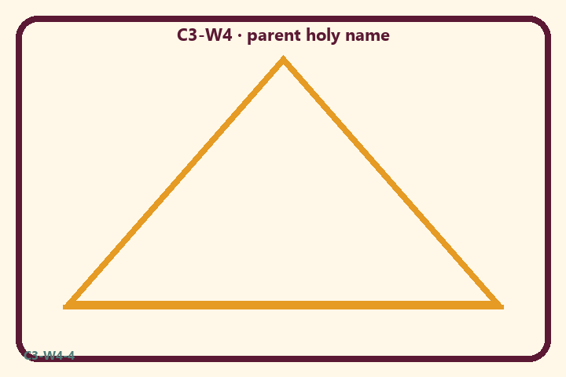
Attention or performance pressure?
Private notes:
________________________________________________________________
________________________________________________________________
________________________________________________________________
________________________________________________________________
Habit to watch this week:
________________________________________________________________
________________________________________________________________
________________________________________________________________
________________________________________________________________

P02 — Etiquette card sort
Sort ATTENTIVE / PERFORMANCE / DISRESPECT.
HELPFUL | MISTAKEN

L1  Attentive listening | L2  Volume contest
L3  Short sincere chant | L4  Shame soft voices
L5  Invite newcomers | L6  Performance ranking
TEACHER NOTE | Volume/performance equals devotion; skipping source-language layer of Śikṣāṣṭaka 1.

P03 — Substantial family case
Child is shamed for soft chanting.
SAFETY & PRIVACY | Fictional case. No compelled confession of real events.

A child chants softly and is shamed: “Louder or you’re not devoted.” Another adult starts a volume contest between siblings.
Tempting mistaken conclusion:
________________________________________________________________
________________________________________________________________
________________________________________________________________
Principle from primary:
________________________________________________________________
________________________________________________________________
________________________________________________________________
Compassionate response:
________________________________________________________________
________________________________________________________________
________________________________________________________________
One seven-day household action:
________________________________________________________________
________________________________________________________________
________________________________________________________________
What we should not say:
________________________________________________________________
________________________________________________________________
________________________________________________________________
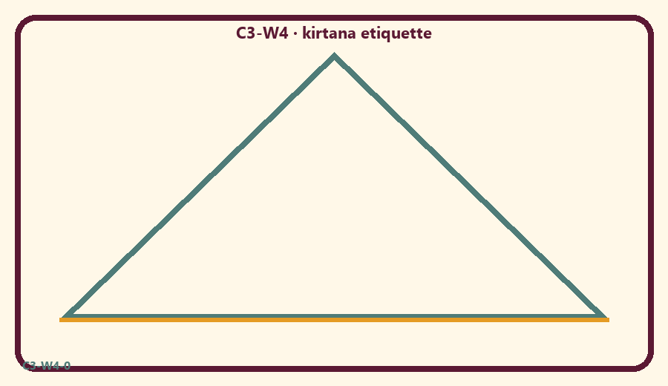

P04 — Household operating application
One attentive holy-name slot for seven days.
SAFETY & PRIVACY | No ranking and no public reading required.

One household action for seven days:
________________________________________________________________
________________________________________________________________
________________________________________________________________
Trigger (when/where):
________________________________________________________________
________________________________________________________________
________________________________________________________________
Who starts if others are tired:
________________________________________________________________
________________________________________________________________
________________________________________________________________
Minimum version on a hard day:
________________________________________________________________
________________________________________________________________
________________________________________________________________

Memory phrase
Paraṁ vijayate śrī-kṛṣṇa-saṅkīrtanam.

P05 — Private next-step saṅkalpa
Holy name practice + minimum version.
KEY IDEA | specific action + frequency + trigger + minimum version

Specific action:
________________________________________________________________
________________________________________________________________
Frequency:
________________________________________________________________
________________________________________________________________
Trigger (when and where):
________________________________________________________________
________________________________________________________________
Minimum version for a hard day:
________________________________________________________________
________________________________________________________________
Where we will place the reminder:
________________________________________________________________
________________________________________________________________
No ranking. The minimum version counts as success.
RIGHTS NOTE | KUTUMBA-original framing; cited third-party material retains its own rights. Human/temple review remains EXTERNAL_OPEN.

