KUTUMBA

C3-W4 — Younger Teacher Pack
  - K–2 run sheet and activities
C3-W4 • Śrī Caitanya Mahāprabhu and the Holy Name
V13 • Families Growing in Krishna Consciousness
Program Director: Swapnil Patil
Internal founding-cohort teaching material — human/temple review EXTERNAL_OPEN
KUTUMBA | Families Growing in Krishna Consciousness

Locked Saturday Schedule
Time | Block
1:50–2:00 | Arrival
2:00–2:10 | Opening mantras + welcome
2:10–2:30 | All-family launch/orientation
2:30–3:10 | Parallel tracks
3:10–3:30 | Reunification + bhakti laboratory
3:30–3:40 | Snack + water
3:40–3:55 | Saṅkalpa + project + home practice
3:55–4:00 | Close

TIME CUE | Track handoff is at 2:30; all groups reunite at 3:10.

Primary verse: CC Antya 20.12
Source URL: https://vedabase.io/en/library/cc/antya/20/12/

Younger Teacher Run Sheet
Canonical source: 11-weekly-program-library/first-six-months/c3-w4-śrī-caitanya-mahāprabhu-and-the-holy-name/teacher/YOUNGER-TEACHER-GUIDE-V13.md • SHA-256: fd2b45d79d49820a36add87e911029fc9a92e1fea78b8b142099239f2d019c21
KUTUMBA · Families Growing in Krishna Consciousness Program Director: Swapnil Patil Week: Śrī Caitanya Mahāprabhu and the Holy Name · Date: 2027-01-30 Track window: Saturday 2:30–3:10 (K–2) Reunite: 3:10 for bhakti laboratory Primary: CC Antya 20.12 — https://vedabase.io/en/library/cc/antya/20/12/ Primary mechanic: Kīrtana etiquette Status: Internal founding-cohort teaching material — human/temple review EXTERNAL_OPEN

Essential question
What is śrī-kṛṣṇa-saṅkīrtanam — and how do families practice it with attention, not performance pressure?

Materials (print before Saturday)
From activities/v13-younger/: Y01–Y05 Also pens/crayons; verse card; privacy reminder.

Locked Saturday context
- 1:50–2:00 Arrival · 2:00–2:10 Mantras · 2:10–2:30 All-family launch
- 2:30–3:10 This track · 3:10–3:30 Reunify · 3:30–3:40 Snack/water · 3:40–3:55 Saṅkalpa · 3:55–4:00 Close
Parents remain onsite. No public ranking. No forced disclosure.

Source layer (use mid-track)
Primary: CC Antya 20.12 — https://vedabase.io/en/library/cc/antya/20/12/
Devanāgarī: চেতোদর্পণমার্জনং ভবমহাদাবাগ্নিনির্বাপণং শ্রেয়ঃকৈরবচন্দ্রিকাবিতরণং বিদ্যাবধূজীবনম্ । আনন্দাম্বুধিবর্ধনং প্রতিপদং পূর্ণামৃতাস্বাদনং সর্বাত্মস্নপনং পরং বিজয়তে শ্রীকৃষ্ণসঙ্কীর্তনম্ ॥ ১২ ॥
IAST: ceto-darpaṇa-mārjanaṁ bhava-mahā-dāvāgni-nirvāpaṇaṁ / śreyaḥ-kairava-candrikā-vitaraṇaṁ vidyā-vadhū-jīvanam / ānandāmbudhi-vardhanaṁ prati-padaṁ pūrṇāmṛtāsvādanaṁ / sarvātma-snapanaṁ paraṁ vijayate śrī-kṛṣṇa-saṅkīrtanam
KUTUMBA teaching meaning (not a BBT translation): All victory to śrī-kṛṣṇa-saṅkīrtana — which cleanses the mirror of the heart, extinguishes the forest fire of material existence, spreads the moonlight of good fortune, is the life of knowledge, expands the ocean of bliss, enables tasting full nectar at every step, and bathes the self — supreme.

Memory line
Paraṁ vijayate śrī-kṛṣṇa-saṅkīrtanam.

V13 printable wiring (Kīrtana etiquette)

V13 printable block 0–6 — Name joy movement
Printable: activities/v13-younger/Y01-NAME-JOY-MOVEMENT.md (Y01-NAME-JOY-MOVEMENT)
Gentle movement while echoing the holy name — soft voices welcome.
Keep primary mechanic (Kīrtana etiquette). Block: Volume/performance equals devotion; skipping source-language layer of Śikṣāṣṭaka 1.

V13 printable block 6–14 — Etiquette matching
Printable: activities/v13-younger/Y02-ETIQUETTE-MATCHING.md (Y02-ETIQUETTE-MATCHING)
Match listen / join / don’t mock.
Keep primary mechanic (Kīrtana etiquette). Block: Volume/performance equals devotion; skipping source-language layer of Śikṣāṣṭaka 1.

V13 printable block 14–24 — Mirror-heart craft
Printable: activities/v13-younger/Y03-MIRROR-HEART-CRAFT.md (Y03-MIRROR-HEART-CRAFT)
Craft “clean the mirror” heart card.
Keep primary mechanic (Kīrtana etiquette). Block: Volume/performance equals devotion; skipping source-language layer of Śikṣāṣṭaka 1.

V13 printable block 24–32 — Attention cards
Printable: activities/v13-younger/Y04-ATTENTION-CARDS.md (Y04-ATTENTION-CARDS)
Eyes soft / voice kind / no contest.
Keep primary mechanic (Kīrtana etiquette). Block: Volume/performance equals devotion; skipping source-language layer of Śikṣāṣṭaka 1.

V13 printable block 32–38 — Memory phrase mat
Printable: activities/v13-younger/Y05-MEMORY-PHRASE-MAT.md (Y05-MEMORY-PHRASE-MAT)
Echo the saṅkīrtana memory line.
Keep primary mechanic (Kīrtana etiquette). Block: Volume/performance equals devotion; skipping source-language layer of Śikṣāṣṭaka 1.

Close of track (handoff)
Bring one sentence or artifact to reunification. Do not start next week’s topic. Care boundary: No ranking by volume; include full Śikṣāṣṭaka verse-1 source-language layer; invitation not contest.

Inherited classroom depth (from V12 YOUNGER-TEACHER-GUIDE.md)
Keep story scripts, movement steps, and wonder questions below. Wire printables to the V13 codes above; do not replace this depth with “see research.”
Week: Śrī Caitanya Mahāprabhu and the Holy Name Primary: CC Antya 20.12 — https://vedabase.io/en/library/cc/antya/20/12/ Session length: 40 minutes (parallel track ~2:30–3:10) Parents: Remain onsite; reunite at 3:10 Status: Internal founding-cohort teaching material — human/temple review EXTERNAL_OPEN

Objective
Children echo Paraṁ vijayate śrī-kṛṣṇa-saṅkīrtanam, practice soft call-and-response, and learn we never punish with chanting.

Exact memory phrase
Paraṁ vijayate śrī-kṛṣṇa-saṅkīrtanam.

Teacher background (2 minutes to review)
- KUTUMBA teaching meaning (adult wording): All victory to śrī-kṛṣṇa-saṅkīrtana — which cleanses the mirror of the heart, extinguishes the forest fire of material existence, spreads the moonlight of good fortune, is the life of knowledge, expands the ocean of bliss, and bathes the self in nectar at every step.
- Child-facing paraphrase: We sing Kṛṣṇa's names together — śrī-kṛṣṇa-saṅkīrtanam. We listen kindly. We do not use singing to punish.
- Block misconceptions (child words):
- “Chant as punishment.”
- “Louder kids win.”
- Do not: invent deity dialogue; force confession; rank children; use scare tactics; claim temple certification stickers.

Materials
- Soft clap guide
- Mirror prop
- Phrase poster
- Crayons
- Soft toss
- Calm corner
- Simple melody cue

Room setup
Circle on the floor; materials table behind you; calm corner with one chair for quiet reset. Keep aisles clear for movement.

Minute-by-minute executable plan

0–5 min — Opening and recall
1. Welcome.
2. Echo phrase slowly in parts.
3. Soft clap once.
4. Say: “We don’t punish with chanting.”

5–13 min — Story script (paraphrase only; ~8 minutes)
Say exactly this spine (do not invent deity dialogue):
Śrī Caitanya Mahāprabhu taught families to chant Kṛṣṇa's holy names together — śrī-kṛṣṇa-saṅkīrtanam. It cleans the heart like wiping a mirror and cools hot worry like water on a fire. We listen carefully. We do not yell to win. We never make someone chant because they are in trouble.
Story boundaries: No invented Lord Caitanya quotes. No fear. No ranking.

13–16 min — Three wonder questions
1. Do we punish with chanting? (No)
2. Do we listen? (Yes)
3. Whose names? (Kṛṣṇa’s)
Accept one- or two-word answers. Affirm effort.

16–24 min — Movement game: Soft Echo Circle (steps)
1. Circle; facilitator sings a short line softly.
2. Children echo softly.
3. Hand-to-ear “I heard it.”
4. Two rounds; sit; full phrase once.

24–32 min — Craft: Heart-mirror card (steps)
1. Card with mirror circle.
2. Color gently; write phrase helper-assisted.
3. Back: draw family singing softly.
Full printable steps also live in activities/YOUNGER-ACTIVITY-PACK.md (use together; this guide remains executable if the pack is missing).

32–35 min — Printable / coloring task
If time remains, color the younger line-art sheet if available. If short on time, keep the craft as the take-home.

35–38 min — Behavior redirects and quiet reset
Use calm, specific redirects:
- Feet on floor — “Feet visit the mat.”
- Kind hands — “Hands help; toys rest.”
- Loud shout — “Soft voice, please.”
- Quiet reset — “Calm corner for sixty seconds.”

38–40 min — Cleanup and parent handoff
1. Materials away; craft in hand.
2. At reunification, tell parent in one sentence:
Memory phrase: “Paraṁ vijayate śrī-kṛṣṇa-saṅkīrtanam..” Home cue: Five-minute family kīrtana or attentive mantra listening on three days.
1. Do not report private behavior struggles in front of other families.

Behavior redirects (quick reference)
Signal | Teacher line | Child action
Running | Walking feet. | Walk to mat
Snatching | Kind hands. | Hands to lap
Interrupt shout | Soft voice. | Whisper retry
Shutdown | Quiet reset is okay. | Calm corner 60 sec

Backup low-prep (if craft fails or energy crashes)
Toss and whisper “Kṛṣṇa”; end with phrase.

What success looks like
- Attempts phrase
- Soft echo once
- Says no punishment chanting

Boundaries
- Snack/water only happens in main schedule (3:30), not as a track bribe.
- No weekly meal language.
- No fabricated approval stickers implying temple certification.
- Privacy: no forced confession.

Child House Rules
Canonical source: launch/CHILD-HOUSE-RULES.md • SHA-256: 6a525f3dd1da740db86e246622696c7b08e28c1f1475227567d639a5bd54ce47
Parents remain onsite. Facilitators guide the session. Host property rules also apply.

Shared rules (all ages)
1. Keep your body safe — feet on the floor; hands gentle.
2. Use respectful speech — no teasing, yelling, or mean labels.
3. Follow the facilitator safety cue immediately (pause / freeze / come here).
4. No jumping on furniture.
5. No indoor throwing.
6. No writing on walls, books, or furniture that are not activity materials.
7. Ask before entering private rooms.
8. Respect belongings — ask before touching what is not yours.
9. Devices away unless the lesson specifically needs them.
10. Snack only in the allowed area; water anytime with permission.
11. Help clean up before leaving.

Correction ladder (no public shame)
1. Calm reminder
2. Redirect / offer a choice
3. Brief quiet reset in a visible space
4. Parent involvement
5. Sit out a specific activity
6. Private parent/program conversation for repeated patterns
Never: public shame, yelling, sarcasm, corporal punishment, forced chanting, or comparing children.

Younger (K–2) emphasis
- Soft voices indoors
- Stay with the group
- Hands to yourself
- Ask before leaving the room

Older (Grades 4–5) emphasis
- Model respectful speech for younger children
- Devices fully away unless assigned
- Help clean-up leadership
- Honest questions welcome; speculation wait for source check
Printable versions: W1 launch-pack CHILD-RULES-YOUNGER.md and CHILD-RULES-OLDER.md.

Y01 — Name joy movement
Gentle movement while echoing the holy name — soft voices welcome.
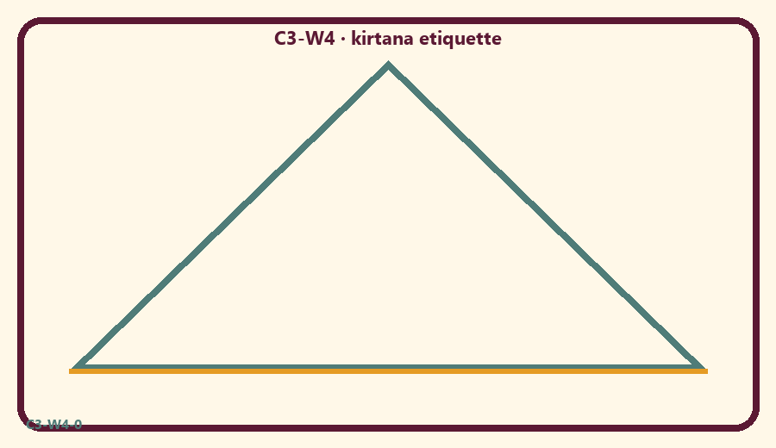
CARD 1  Soft voice welcome | CARD 2  Yell to win
CARD 3  Listen first | CARD 4  Mock a singer
CARD 5  Join kindly | CARD 6  Phone during kīrtana

Memory phrase
Paraṁ vijayate śrī-kṛṣṇa-saṅkīrtanam.
Cut on the dashed borders. Keep each card intact.
TEACHER NOTE | No ranking by volume; include full Śikṣāṣṭaka verse-1 source-language layer; invitation not contest.

Y02 — Etiquette matching
Match listen / join / don’t mock.
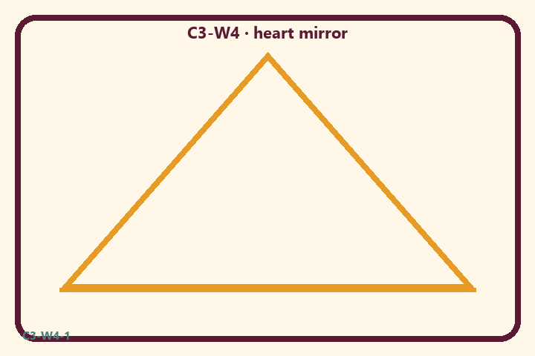
CARD 1  Soft voice welcome | CARD 2  Yell to win
CARD 3  Listen first | CARD 4  Mock a singer
CARD 5  Join kindly | CARD 6  Phone during kīrtana

Memory phrase
Paraṁ vijayate śrī-kṛṣṇa-saṅkīrtanam.
Cut on the dashed borders. Keep each card intact.
TEACHER NOTE | No ranking by volume; include full Śikṣāṣṭaka verse-1 source-language layer; invitation not contest.

Y03 — Mirror-heart craft
Craft “clean the mirror” heart card.
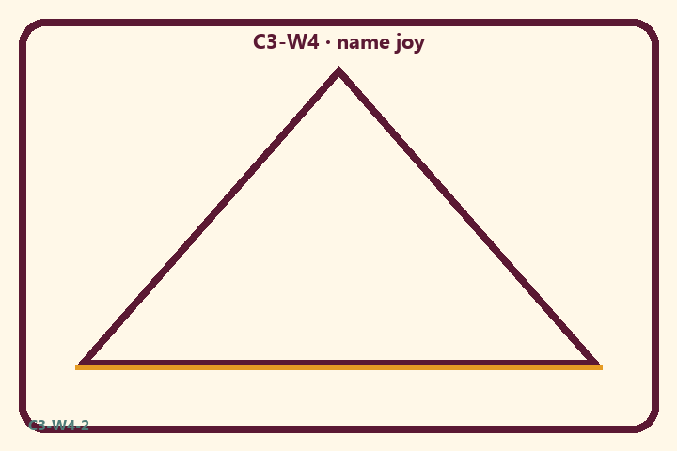
CARD 1  Soft voice welcome | CARD 2  Yell to win
CARD 3  Listen first | CARD 4  Mock a singer
CARD 5  Join kindly | CARD 6  Phone during kīrtana

Memory phrase
Paraṁ vijayate śrī-kṛṣṇa-saṅkīrtanam.
Cut on the dashed borders. Keep each card intact.
TEACHER NOTE | No ranking by volume; include full Śikṣāṣṭaka verse-1 source-language layer; invitation not contest.

Y04 — Attention cards
Eyes soft / voice kind / no contest.
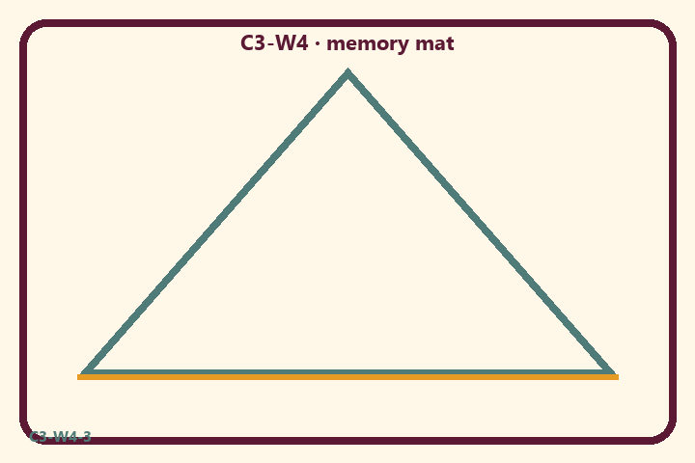
CARD 1  Soft voice welcome | CARD 2  Yell to win
CARD 3  Listen first | CARD 4  Mock a singer
CARD 5  Join kindly | CARD 6  Phone during kīrtana

Memory phrase
Paraṁ vijayate śrī-kṛṣṇa-saṅkīrtanam.
Cut on the dashed borders. Keep each card intact.
TEACHER NOTE | No ranking by volume; include full Śikṣāṣṭaka verse-1 source-language layer; invitation not contest.

Y05 — Memory phrase mat
Echo the saṅkīrtana memory line.

Memory phrase
Paraṁ vijayate śrī-kṛṣṇa-saṅkīrtanam.
CC Antya 20.12 · family week
RIGHTS NOTE | KUTUMBA-original framing; cited third-party material retains its own rights. Human/temple review remains EXTERNAL_OPEN.

