KUTUMBA

C3-W5 — Older Teacher Pack
  - Grades 4–5 run sheet and activities
C3-W5 • The Nine Processes of Bhakti
V13 • Families Growing in Krishna Consciousness
Program Director: Swapnil Patil
Internal founding-cohort teaching material — human/temple review EXTERNAL_OPEN
KUTUMBA | Families Growing in Krishna Consciousness

Locked Saturday Schedule
Time | Block
1:50–2:00 | Arrival
2:00–2:10 | Opening mantras + welcome
2:10–2:30 | All-family launch/orientation
2:30–3:10 | Parallel tracks
3:10–3:30 | Reunification + bhakti laboratory
3:30–3:40 | Snack + water
3:40–3:55 | Saṅkalpa + project + home practice
3:55–4:00 | Close

TIME CUE | Track handoff is at 2:30; all groups reunite at 3:10.

Primary verse: ŚB 7.5.23–24
Source URL: https://vedabase.io/en/library/sb/7/5/23-24/

Older Teacher Run Sheet
Canonical source: 11-weekly-program-library/first-six-months/c3-w5-the-nine-processes-of-bhakti/teacher/OLDER-TEACHER-GUIDE-V13.md • SHA-256: eb543ced09d08da0f9c5fbe9986fa83244db7f7e915c3175c7d7c0f404db36d3
KUTUMBA · Families Growing in Krishna Consciousness Program Director: Swapnil Patil Week: The Nine Processes of Bhakti · Date: 2027-02-06 Track window: Saturday 2:30–3:10 (Grades 4–5) Reunite: 3:10 for bhakti laboratory Primary: ŚB 7.5.23–24 — https://vedabase.io/en/library/sb/7/5/23-24/ Primary mechanic: Nine-process wheel Status: Internal founding-cohort teaching material — human/temple review EXTERNAL_OPEN

Essential question
How do the nine processes map family life — with Viṣṇu/Kṛṣṇa as the object, not generic virtue?

Materials (print before Saturday)
From activities/v13-older/: O01–O06 Also pens/crayons; verse card; privacy reminder.

Locked Saturday context
- 1:50–2:00 Arrival · 2:00–2:10 Mantras · 2:10–2:30 All-family launch
- 2:30–3:10 This track · 3:10–3:30 Reunify · 3:30–3:40 Snack/water · 3:40–3:55 Saṅkalpa · 3:55–4:00 Close
Parents remain onsite. No public ranking. No forced disclosure.

Source layer (use mid-track)
Primary: ŚB 7.5.23–24 — https://vedabase.io/en/library/sb/7/5/23-24/
Devanāgarī: श्रीप्रह्राद उवाच श्रवणं कीर्तनं विष्णो: स्मरणं पादसेवनम् । अर्चनं वन्दनं दास्यं सख्यमात्मनिवेदनम् ॥ २३ ॥ इति पुंसार्पिता विष्णौ भक्तिश्चेन्नवलक्षणा । क्रियेत भगवत्यद्धा तन्मन्येऽधीतमुत्तमम् ॥ २४ ॥
IAST: śravaṇaṁ kīrtanaṁ viṣṇoḥ smaraṇaṁ pāda-sevanam / arcanaṁ vandanaṁ dāsyaṁ sakhyam ātma-nivedanam // iti puṁsārpitā viṣṇau bhaktiś cen nava-lakṣaṇā / kriyeta bhagavaty addhā tan manye 'dhītam uttamam
KUTUMBA teaching meaning (not a BBT translation): Hearing, chanting, remembering, serving the Lord's feet, worship, prayer, servitude, friendship, and full surrender — nine processes of bhakti; when such bhakti is offered to Viṣṇu, that is considered the topmost learning.

Memory line
Nine ways to love Viṣṇu.

V13 printable wiring (Nine-process wheel)

V13 printable block 0–6 — ŚB 7.5.23–24 observation
Printable: activities/v13-older/O01-SB-7-5-23-24-OBSERVATION.md (O01-SB-7-5-23-24-OBSERVATION)
Both verses; nine names; offered to Viṣṇu.
Keep primary mechanic (Nine-process wheel). Block: Ranking processes/families; generic virtue without Viṣṇu as object; citing 7.5.23 without 7.5.24.

V13 printable block 6–14 — Nine-process planning
Printable: activities/v13-older/O02-NINE-PROCESS-PLANNING.md (O02-NINE-PROCESS-PLANNING)
Plan one realistic household practice.
Keep primary mechanic (Nine-process wheel). Block: Ranking processes/families; generic virtue without Viṣṇu as object; citing 7.5.23 without 7.5.24.

V13 printable block 14–22 — Object vs generic sort
Printable: activities/v13-older/O03-OBJECT-VS-GENERIC-SORT.md (O03-OBJECT-VS-GENERIC-SORT)
Viṣṇu-object vs generic virtue.
Keep primary mechanic (Nine-process wheel). Block: Ranking processes/families; generic virtue without Viṣṇu as object; citing 7.5.23 without 7.5.24.

V13 printable block 22–30 — Practice scenarios
Printable: activities/v13-older/O04-PRACTICE-SCENARIOS.md (O04-PRACTICE-SCENARIOS)
Three busy-family practice cases.
Keep primary mechanic (Nine-process wheel). Block: Ranking processes/families; generic virtue without Viṣṇu as object; citing 7.5.23 without 7.5.24.

V13 printable block 30–36 — Nine-process wheel diagram
Printable: activities/v13-older/O05-NINE-PROCESS-WHEEL-DIAGRAM.md (O05-NINE-PROCESS-WHEEL-DIAGRAM)
Wheel with center: offered to Viṣṇu.
Keep primary mechanic (Nine-process wheel). Block: Ranking processes/families; generic virtue without Viṣṇu as object; citing 7.5.23 without 7.5.24.

V13 printable block 36–40 — Exit ticket
Printable: activities/v13-older/O06-EXIT-TICKET.md (O06-EXIT-TICKET)
Our one practice + no ranking pledge.
Keep primary mechanic (Nine-process wheel). Block: Ranking processes/families; generic virtue without Viṣṇu as object; citing 7.5.23 without 7.5.24.

Close of track (handoff)
Bring one sentence or artifact to reunification. Do not start next week’s topic. Care boundary: Must include both 7.5.23 and 7.5.24; no ranking; one realistic practice.

Inherited classroom depth (from V12 OLDER-TEACHER-GUIDE.md)
Keep story scripts, movement steps, and wonder questions below. Wire printables to the V13 codes above; do not replace this depth with “see research.”
Week: The Nine Processes of Bhakti Primary: ŚB 7.5.23–24 — https://vedabase.io/en/library/sb/7/5/23-24/ Session length: ~40 minutes (parallel track ~2:30–3:10) Parents: Remain onsite; reunite at 3:10 Status: Internal founding-cohort teaching material — human/temple review EXTERNAL_OPEN

Objective
Students observe both verses, list nine processes, explain iti puṁsārpitā, and choose core + underused process.

Exact memory phrase
Hearing, chanting, remembering, serving, worshiping, praying, serving as a servant, friendship and full surrender are processes of pure devotional service when offered to Viṣṇu.
Short echo: Nine ways to love Viṣṇu.

Teacher background
- KUTUMBA teaching meaning: Hearing, chanting, remembering, serving the Lord's feet, worship, prayer, servitude, friendship, and full surrender — nine processes of bhakti to Viṣṇu/Kṛṣṇa; when such bhakti is offered to Viṣṇu (iti puṁsārpitā), Prahlāda considers it the topmost learning. (Label as KUTUMBA teaching meaning — not as BBT translation.)
- Supporting frames (one sentence each): BG 9.14 overlap; object clarity; anti-panic pacing.
- Block: Require mastering all nine at once.; Generic virtue without Viṣṇu/Kṛṣṇa as object.
- Scope: No sannyāsa pressure; no ranking portfolios.

Materials
- Dual verse strips
- Station sheets
- Worksheets
- Scenario cards
- Answer key
- Project cards

Minute-by-minute plan

0–5 min — Settle and hook
Checklist panic vs offered bhakti — which matches Prahlāda?

5–14 min — Primary text observation
Read 23 list; read 24 iti puṁsārpitā; underline viṣṇoḥ / viṣṇau.

14–22 min — Worksheet questions
Students complete Section A of the older activity pack. Teacher circulates; use OLDER-ANSWER-KEY.md for expected directions (not for grading ranks).

22–28 min — Scenario cards (small groups)
A All-nine panic B Generic virtue C Surrender scare
Share one insight per group (60 seconds).

28–33 min — Puzzle / game: Object or Generic
O vs G claims.

33–37 min — Diagram / map task
Nine boxes; star core; circle underused.

37–40 min — Project sentence + handoff
Core+underused to parent.

Boundaries
- No ranking or public scores.
- No invented dialogue.
- Parents onsite; snack/water only at 3:30 in the main schedule.
- Defer off-scope topics: Initiation; extreme renunciation debates.

O01 — ŚB 7.5.23–24 observation
Both verses; nine names; offered to Viṣṇu.

VERSE CARD • ŚB 7.5.23–24
श्रीप्रह्राद उवाच श्रवणं कीर्तनं विष्णो: स्मरणं पादसेवनम् । अर्चनं वन्दनं दास्यं सख्यमात्मनिवेदनम् ॥ २३ ॥ इति पुंसार्पिता विष्णौ भक्तिश्चेन्नवलक्षणा । क्रियेत भगवत्यद्धा तन्मन्येऽधीतमुत्तमम् ॥ २४ ॥
śravaṇaṁ kīrtanaṁ viṣṇoḥ smaraṇaṁ pāda-sevanam / arcanaṁ vandanaṁ dāsyaṁ sakhyam ātma-nivedanam // iti puṁsārpitā viṣṇau bhaktiś cen nava-lakṣaṇā / kriyeta bhagavaty addhā tan manye 'dhītam uttamam
KUTUMBA teaching meaning: Hearing, chanting, remembering, serving the Lord's feet, worship, prayer, servitude, friendship, and full surrender — nine processes of bhakti; when such bhakti is offered to Viṣṇu, that is considered the topmost learning.
Source: https://vedabase.io/en/library/sb/7/5/23-24/
Rights/status: Scripture display/source: VedaBase; teaching meaning: KUTUMBA-original (not labeled as BBT translation).

What does the verse teach in my words?
________________________________________________________________
________________________________________________________________
What misconception does this week block?
________________________________________________________________
________________________________________________________________
One question for the facilitator:
________________________________________________________________
________________________________________________________________

O02 — Nine-process planning
Plan one realistic household practice.
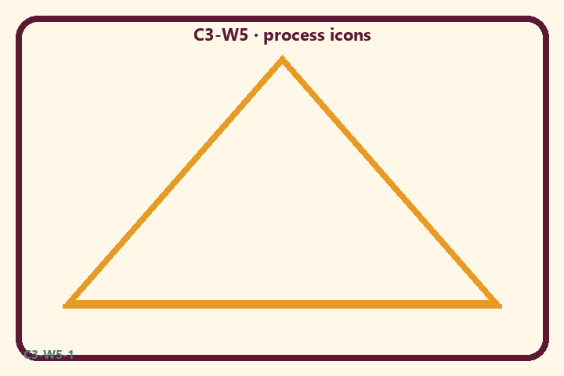
Prompt | My notes
Nine-process planning | ________________
Limit / care | ________________

Application:
________________________________________________________________
________________________________________________________________
What not to say:
________________________________________________________________
________________________________________________________________
KEY IDEA | Nine processes of bhakti to Viṣṇu; families choose one realistic practice; never rank processes or families.

O03 — Object vs generic sort
Viṣṇu-object vs generic virtue.
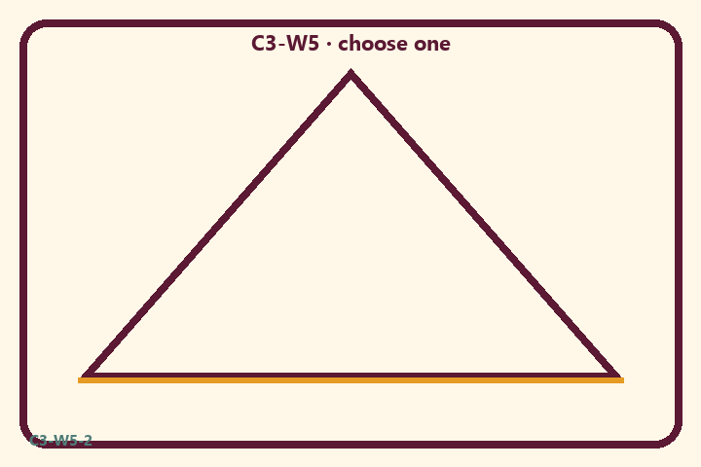
Prompt | My notes
Object vs generic sort | ________________
Limit / care | ________________

Application:
________________________________________________________________
________________________________________________________________
What not to say:
________________________________________________________________
________________________________________________________________
KEY IDEA | Nine processes of bhakti to Viṣṇu; families choose one realistic practice; never rank processes or families.

O04 — Practice scenarios
Three busy-family practice cases.
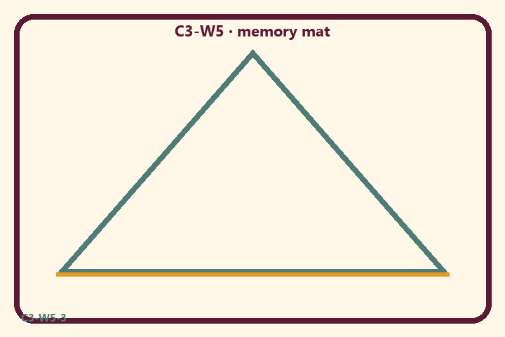
Prompt | My notes
Practice scenarios | ________________
Limit / care | ________________

Application:
________________________________________________________________
________________________________________________________________
What not to say:
________________________________________________________________
________________________________________________________________
KEY IDEA | Nine processes of bhakti to Viṣṇu; families choose one realistic practice; never rank processes or families.

O05 — Nine-process wheel diagram
Wheel with center: offered to Viṣṇu.
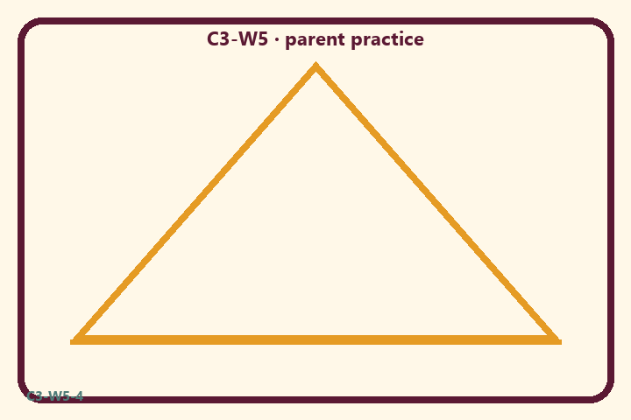
Prompt | My notes
Nine-process wheel diagram | ________________
Limit / care | ________________

Application:
________________________________________________________________
________________________________________________________________
What not to say:
________________________________________________________________
________________________________________________________________
KEY IDEA | Nine processes of bhakti to Viṣṇu; families choose one realistic practice; never rank processes or families.

O06 — Exit ticket
Our one practice + no ranking pledge.
Primary in one sentence:
________________________________________________________________
________________________________________________________________
One analogy or mechanic and its limit:
________________________________________________________________
________________________________________________________________
One home action:
________________________________________________________________
________________________________________________________________
One question I still have:
________________________________________________________________
________________________________________________________________
RIGHTS NOTE | KUTUMBA-original framing; cited third-party material retains its own rights. Human/temple review remains EXTERNAL_OPEN.

