KUTUMBA

C3-W5 — Parent Track
  - Facilitator guide and parent printables
C3-W5 • The Nine Processes of Bhakti
V13 • Families Growing in Krishna Consciousness
Program Director: Swapnil Patil
Internal founding-cohort teaching material — human/temple review EXTERNAL_OPEN
KUTUMBA | Families Growing in Krishna Consciousness

Locked Saturday Schedule
Time | Block
1:50–2:00 | Arrival
2:00–2:10 | Opening mantras + welcome
2:10–2:30 | All-family launch/orientation
2:30–3:10 | Parallel tracks
3:10–3:30 | Reunification + bhakti laboratory
3:30–3:40 | Snack + water
3:40–3:55 | Saṅkalpa + project + home practice
3:55–4:00 | Close

TIME CUE | Track handoff is at 2:30; all groups reunite at 3:10.

Primary verse: ŚB 7.5.23–24
Source URL: https://vedabase.io/en/library/sb/7/5/23-24/

Parent Facilitator Run Sheet
Canonical source: 11-weekly-program-library/first-six-months/c3-w5-the-nine-processes-of-bhakti/teacher/PARENT-GUIDE-V13.md • SHA-256: 3f8ba3a3879fc0cbea8a1652cf85a377528b3bc925f1cc8871dc5748ce20a4f0
KUTUMBA · Families Growing in Krishna Consciousness Program Director: Swapnil Patil Week: The Nine Processes of Bhakti · Date: 2027-02-06 Track window: Saturday 2:30–3:10 (parents) Reunite: 3:10 for bhakti laboratory Primary: ŚB 7.5.23–24 — https://vedabase.io/en/library/sb/7/5/23-24/ Primary mechanic: Nine-process wheel Status: Internal founding-cohort teaching material — human/temple review EXTERNAL_OPEN

Essential question
How do the nine processes map family life — with Viṣṇu/Kṛṣṇa as the object, not generic virtue?

Materials (print before Saturday)
From activities/v13-parent/: P01–P05 Also pens/crayons; verse card; privacy reminder.

Locked Saturday context
- 1:50–2:00 Arrival · 2:00–2:10 Mantras · 2:10–2:30 All-family launch
- 2:30–3:10 This track · 3:10–3:30 Reunify · 3:30–3:40 Snack/water · 3:40–3:55 Saṅkalpa · 3:55–4:00 Close
Parents remain onsite. No public ranking. No forced disclosure.

Source layer (use mid-track)
Primary: ŚB 7.5.23–24 — https://vedabase.io/en/library/sb/7/5/23-24/
Devanāgarī: श्रीप्रह्राद उवाच श्रवणं कीर्तनं विष्णो: स्मरणं पादसेवनम् । अर्चनं वन्दनं दास्यं सख्यमात्मनिवेदनम् ॥ २३ ॥ इति पुंसार्पिता विष्णौ भक्तिश्चेन्नवलक्षणा । क्रियेत भगवत्यद्धा तन्मन्येऽधीतमुत्तमम् ॥ २४ ॥
IAST: śravaṇaṁ kīrtanaṁ viṣṇoḥ smaraṇaṁ pāda-sevanam / arcanaṁ vandanaṁ dāsyaṁ sakhyam ātma-nivedanam // iti puṁsārpitā viṣṇau bhaktiś cen nava-lakṣaṇā / kriyeta bhagavaty addhā tan manye 'dhītam uttamam
KUTUMBA teaching meaning (not a BBT translation): Hearing, chanting, remembering, serving the Lord's feet, worship, prayer, servitude, friendship, and full surrender — nine processes of bhakti; when such bhakti is offered to Viṣṇu, that is considered the topmost learning.

Memory line
Nine ways to love Viṣṇu.

V13 printable wiring (Nine-process wheel)

V13 printable block 0–5 — Private reflection — realistic practice
Printable: activities/v13-parent/P01-PRIVATE-REFLECTION.md (P01-PRIVATE-REFLECTION)
Which process fits our season of life?
Keep primary mechanic (Nine-process wheel). Block: Ranking processes/families; generic virtue without Viṣṇu as object; citing 7.5.23 without 7.5.24.

V13 printable block 5–12 — Choose-one card sort
Printable: activities/v13-parent/P02-CHOOSE-ONE-CARD-SORT.md (P02-CHOOSE-ONE-CARD-SORT)
Sort REALISTIC / OVERLOAD / RANKING.
Keep primary mechanic (Nine-process wheel). Block: Ranking processes/families; generic virtue without Viṣṇu as object; citing 7.5.23 without 7.5.24.

V13 printable block 12–22 — Substantial family case
Printable: activities/v13-parent/P03-SUBSTANTIAL-FAMILY-CASE.md (P03-SUBSTANTIAL-FAMILY-CASE)
Parents compete over which process is “higher.”
Keep primary mechanic (Nine-process wheel). Block: Ranking processes/families; generic virtue without Viṣṇu as object; citing 7.5.23 without 7.5.24.

V13 printable block 22–32 — Household operating application
Printable: activities/v13-parent/P04-HOUSEHOLD-OPERATING-APPLICATION.md (P04-HOUSEHOLD-OPERATING-APPLICATION)
One chosen process for seven days.
Keep primary mechanic (Nine-process wheel). Block: Ranking processes/families; generic virtue without Viṣṇu as object; citing 7.5.23 without 7.5.24.

V13 printable block 32–38 — Private next-step saṅkalpa
Printable: activities/v13-parent/P05-PRIVATE-NEXT-STEP-SANKALPA.md (P05-PRIVATE-NEXT-STEP-SANKALPA)
Chosen process + minimum version.
Keep primary mechanic (Nine-process wheel). Block: Ranking processes/families; generic virtue without Viṣṇu as object; citing 7.5.23 without 7.5.24.

Close of track (handoff)
Bring one sentence or artifact to reunification. Do not start next week’s topic. Care boundary: Must include both 7.5.23 and 7.5.24; no ranking; one realistic practice.

Inherited classroom depth (from V12 parent-lesson / constructed V13 flow)
Keep story scripts, movement steps, and wonder questions below. Wire printables to the V13 codes above; do not replace this depth with “see research.”

Essential question
Which bhakti process can our family practice this week?

Source
ŚB 7.5.23–24 — teaching meaning: Hearing, chanting, remembering, serving the Lord's feet, worship, offering prayers, becoming a servant, friendship, and full self-surrender — the nine processes of bhakti.

Discussion
One realistic household tension; no compelled confession.

Application
5–15 minute cue; minimum version counts.

Privacy
No public scoring of sādhana.

P01 — Private reflection — realistic practice
Which process fits our season of life?

SAFETY & PRIVACY | Write privately. Sharing is optional. Do not collect or place completed sheets in Git.

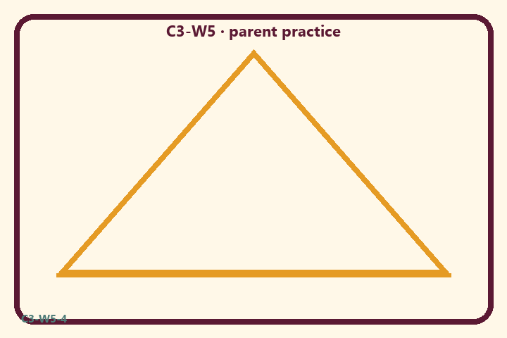
Which process fits our season of life?
Private notes:
________________________________________________________________
________________________________________________________________
________________________________________________________________
________________________________________________________________
Habit to watch this week:
________________________________________________________________
________________________________________________________________
________________________________________________________________
________________________________________________________________

P02 — Choose-one card sort
Sort REALISTIC / OVERLOAD / RANKING.
HELPFUL | MISTAKEN

L1  One small śravaṇa slot | L2  Do all nine perfectly
L3  Offer to Viṣṇu | L4  Generic kindness only
L5  Rank families | L6  Minimum version counts
TEACHER NOTE | Ranking processes/families; generic virtue without Viṣṇu as object; citing 7.5.23 without 7.5.24.

P03 — Substantial family case
Parents compete over which process is “higher.”
SAFETY & PRIVACY | Fictional case. No compelled confession of real events.

Parents argue which of the nine processes is “higher” and push children to announce a competitive choice for status.
Tempting mistaken conclusion:
________________________________________________________________
________________________________________________________________
________________________________________________________________
Principle from primary:
________________________________________________________________
________________________________________________________________
________________________________________________________________
Compassionate response:
________________________________________________________________
________________________________________________________________
________________________________________________________________
One seven-day household action:
________________________________________________________________
________________________________________________________________
________________________________________________________________
What we should not say:
________________________________________________________________
________________________________________________________________
________________________________________________________________
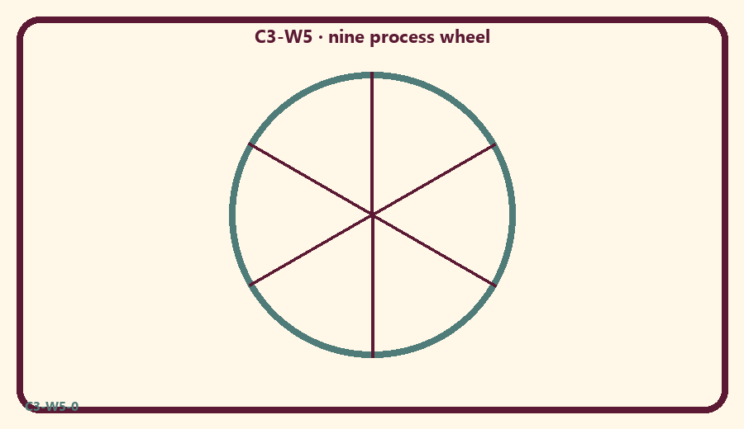

P04 — Household operating application
One chosen process for seven days.
SAFETY & PRIVACY | No ranking and no public reading required.

One household action for seven days:
________________________________________________________________
________________________________________________________________
________________________________________________________________
Trigger (when/where):
________________________________________________________________
________________________________________________________________
________________________________________________________________
Who starts if others are tired:
________________________________________________________________
________________________________________________________________
________________________________________________________________
Minimum version on a hard day:
________________________________________________________________
________________________________________________________________
________________________________________________________________

Memory phrase
Nine ways to love Viṣṇu.

P05 — Private next-step saṅkalpa
Chosen process + minimum version.
KEY IDEA | specific action + frequency + trigger + minimum version

Specific action:
________________________________________________________________
________________________________________________________________
Frequency:
________________________________________________________________
________________________________________________________________
Trigger (when and where):
________________________________________________________________
________________________________________________________________
Minimum version for a hard day:
________________________________________________________________
________________________________________________________________
Where we will place the reminder:
________________________________________________________________
________________________________________________________________
No ranking. The minimum version counts as success.
RIGHTS NOTE | KUTUMBA-original framing; cited third-party material retains its own rights. Human/temple review remains EXTERNAL_OPEN.

