KUTUMBA

C3-W5 — Younger Teacher Pack
  - K–2 run sheet and activities
C3-W5 • The Nine Processes of Bhakti
V13 • Families Growing in Krishna Consciousness
Program Director: Swapnil Patil
Internal founding-cohort teaching material — human/temple review EXTERNAL_OPEN
KUTUMBA | Families Growing in Krishna Consciousness

Locked Saturday Schedule
Time | Block
1:50–2:00 | Arrival
2:00–2:10 | Opening mantras + welcome
2:10–2:30 | All-family launch/orientation
2:30–3:10 | Parallel tracks
3:10–3:30 | Reunification + bhakti laboratory
3:30–3:40 | Snack + water
3:40–3:55 | Saṅkalpa + project + home practice
3:55–4:00 | Close

TIME CUE | Track handoff is at 2:30; all groups reunite at 3:10.

Primary verse: ŚB 7.5.23–24
Source URL: https://vedabase.io/en/library/sb/7/5/23-24/

Younger Teacher Run Sheet
Canonical source: 11-weekly-program-library/first-six-months/c3-w5-the-nine-processes-of-bhakti/teacher/YOUNGER-TEACHER-GUIDE-V13.md • SHA-256: 6f75f5aa1968ffcacb755bc83682223ae9342f95bd9c9581a1f6dfd3cfe041ce
KUTUMBA · Families Growing in Krishna Consciousness Program Director: Swapnil Patil Week: The Nine Processes of Bhakti · Date: 2027-02-06 Track window: Saturday 2:30–3:10 (K–2) Reunite: 3:10 for bhakti laboratory Primary: ŚB 7.5.23–24 — https://vedabase.io/en/library/sb/7/5/23-24/ Primary mechanic: Nine-process wheel Status: Internal founding-cohort teaching material — human/temple review EXTERNAL_OPEN

Essential question
How do the nine processes map family life — with Viṣṇu/Kṛṣṇa as the object, not generic virtue?

Materials (print before Saturday)
From activities/v13-younger/: Y01–Y05 Also pens/crayons; verse card; privacy reminder.

Locked Saturday context
- 1:50–2:00 Arrival · 2:00–2:10 Mantras · 2:10–2:30 All-family launch
- 2:30–3:10 This track · 3:10–3:30 Reunify · 3:30–3:40 Snack/water · 3:40–3:55 Saṅkalpa · 3:55–4:00 Close
Parents remain onsite. No public ranking. No forced disclosure.

Source layer (use mid-track)
Primary: ŚB 7.5.23–24 — https://vedabase.io/en/library/sb/7/5/23-24/
Devanāgarī: श्रीप्रह्राद उवाच श्रवणं कीर्तनं विष्णो: स्मरणं पादसेवनम् । अर्चनं वन्दनं दास्यं सख्यमात्मनिवेदनम् ॥ २३ ॥ इति पुंसार्पिता विष्णौ भक्तिश्चेन्नवलक्षणा । क्रियेत भगवत्यद्धा तन्मन्येऽधीतमुत्तमम् ॥ २४ ॥
IAST: śravaṇaṁ kīrtanaṁ viṣṇoḥ smaraṇaṁ pāda-sevanam / arcanaṁ vandanaṁ dāsyaṁ sakhyam ātma-nivedanam // iti puṁsārpitā viṣṇau bhaktiś cen nava-lakṣaṇā / kriyeta bhagavaty addhā tan manye 'dhītam uttamam
KUTUMBA teaching meaning (not a BBT translation): Hearing, chanting, remembering, serving the Lord's feet, worship, prayer, servitude, friendship, and full surrender — nine processes of bhakti; when such bhakti is offered to Viṣṇu, that is considered the topmost learning.

Memory line
Nine ways to love Viṣṇu.

V13 printable wiring (Nine-process wheel)

V13 printable block 0–6 — Process picture wheel
Printable: activities/v13-younger/Y01-PROCESS-PICTURE-WHEEL.md (Y01-PROCESS-PICTURE-WHEEL)
Spin/point to nine simple picture slices — no ranking.
Keep primary mechanic (Nine-process wheel). Block: Ranking processes/families; generic virtue without Viṣṇu as object; citing 7.5.23 without 7.5.24.

V13 printable block 6–14 — Process matching
Printable: activities/v13-younger/Y02-PROCESS-MATCHING.md (Y02-PROCESS-MATCHING)
Match hear/chant/remember pictures.
Keep primary mechanic (Nine-process wheel). Block: Ranking processes/families; generic virtue without Viṣṇu as object; citing 7.5.23 without 7.5.24.

V13 printable block 14–24 — One-practice craft
Printable: activities/v13-younger/Y03-ONE-PRACTICE-CRAFT.md (Y03-ONE-PRACTICE-CRAFT)
Choose one slice to try at home.
Keep primary mechanic (Nine-process wheel). Block: Ranking processes/families; generic virtue without Viṣṇu as object; citing 7.5.23 without 7.5.24.

V13 printable block 24–32 — Encourage cards
Printable: activities/v13-younger/Y04-ENCOURAGE-CARDS.md (Y04-ENCOURAGE-CARDS)
Cheer others’ practices without ranking.
Keep primary mechanic (Nine-process wheel). Block: Ranking processes/families; generic virtue without Viṣṇu as object; citing 7.5.23 without 7.5.24.

V13 printable block 32–38 — Memory phrase mat
Printable: activities/v13-younger/Y05-MEMORY-PHRASE-MAT.md (Y05-MEMORY-PHRASE-MAT)
Echo: Nine ways to love Viṣṇu.
Keep primary mechanic (Nine-process wheel). Block: Ranking processes/families; generic virtue without Viṣṇu as object; citing 7.5.23 without 7.5.24.

Close of track (handoff)
Bring one sentence or artifact to reunification. Do not start next week’s topic. Care boundary: Must include both 7.5.23 and 7.5.24; no ranking; one realistic practice.

Inherited classroom depth (from V12 YOUNGER-TEACHER-GUIDE.md)
Keep story scripts, movement steps, and wonder questions below. Wire printables to the V13 codes above; do not replace this depth with “see research.”
Week: The Nine Processes of Bhakti Primary: ŚB 7.5.23–24 — https://vedabase.io/en/library/sb/7/5/23-24/ Session length: 40 minutes (parallel track ~2:30–3:10) Parents: Remain onsite; reunite at 3:10 Status: Internal founding-cohort teaching material — human/temple review EXTERNAL_OPEN

Objective
Children recognize nine picture processes, walk one door, and say nine ways to love Viṣṇu — offered to Him.

Exact memory phrase
Nine ways to love Viṣṇu.

Teacher background (2 minutes to review)
- KUTUMBA teaching meaning (adult wording): Hearing, chanting, remembering, serving the Lord's feet, worship, prayer, servitude, friendship, and full surrender — nine processes of bhakti to Viṣṇu/Kṛṣṇa; when such bhakti is offered to Viṣṇu (iti puṁsārpitā), Prahlāda considers it the topmost learning.
- Child-facing paraphrase: There are nine ways to love Viṣṇu/Kṛṣṇa. We keep our main practice and try one more way with love.
- Block misconceptions (child words):
- “We must do all nine today.”
- “Being nice is enough with no Kṛṣṇa.”
- Do not: invent deity dialogue; force confession; rank children; use scare tactics; claim temple certification stickers.

Materials
- Nine picture cards
- Door mats
- Paper hearts
- Crayons
- Soft toss
- Calm corner
- Phrase stickers

Room setup
Circle on the floor; materials table behind you; calm corner with one chair for quiet reset. Keep aisles clear for movement.

Minute-by-minute executable plan

0–5 min — Opening and recall
1. Welcome.
2. Echo: Nine ways / to love / Viṣṇu.
3. Show two pictures; say “to Kṛṣṇa.”
4. Say: “Not all nine today.”

5–13 min — Story script (paraphrase only; ~8 minutes)
Say exactly this spine (do not invent deity dialogue):
Prahlāda said the best learning is loving Viṣṇu in nine ways — hearing, chanting, remembering, serving, worshiping, praying, being a servant, being a friend, and giving ourselves to Him. We do not have to do every door today. We keep our main practice and try one more door with love for Kṛṣṇa.
Story boundaries: No scare surrender talk. No invented dialogues. No ranking.

13–16 min — Three wonder questions
1. How many ways? (Nine)
2. To whom? (Viṣṇu/Kṛṣṇa)
3. All nine today? (No)
Accept one- or two-word answers. Affirm effort.

16–24 min — Movement game: One-Door Walk (steps)
1. Nine cards around room.
2. Children walk to teacher-chosen one door; act a simple gesture.
3. Say phrase.
4. Return to circle.

24–32 min — Craft: Addressed heart (steps)
1. Paper heart.
2. Write/ helper: To Kṛṣṇa/Viṣṇu.
3. Draw one process picture.
4. Phrase on back.
Full printable steps also live in activities/YOUNGER-ACTIVITY-PACK.md (use together; this guide remains executable if the pack is missing).

32–35 min — Printable / coloring task
If time remains, color the younger line-art sheet if available. If short on time, keep the craft as the take-home.

35–38 min — Behavior redirects and quiet reset
Use calm, specific redirects:
- Feet on floor — “Feet visit the mat.”
- Kind hands — “Hands help; toys rest.”
- Loud shout — “Soft voice, please.”
- Quiet reset — “Calm corner for sixty seconds.”

38–40 min — Cleanup and parent handoff
1. Materials away; craft in hand.
2. At reunification, tell parent in one sentence:
Memory phrase: “Nine ways to love Viṣṇu..” Home cue: Continue the family's core practice and add one underused process once.
1. Do not report private behavior struggles in front of other families.

Behavior redirects (quick reference)
Signal | Teacher line | Child action
Running | Walking feet. | Walk to mat
Snatching | Kind hands. | Hands to lap
Interrupt shout | Soft voice. | Whisper retry
Shutdown | Quiet reset is okay. | Calm corner 60 sec

Backup low-prep (if craft fails or energy crashes)
Toss and name one process picture.

What success looks like
- Echoes phrase
- Points to one process
- Says not all nine today

Boundaries
- Snack/water only happens in main schedule (3:30), not as a track bribe.
- No weekly meal language.
- No fabricated approval stickers implying temple certification.
- Privacy: no forced confession.

Child House Rules
Canonical source: launch/CHILD-HOUSE-RULES.md • SHA-256: 6a525f3dd1da740db86e246622696c7b08e28c1f1475227567d639a5bd54ce47
Parents remain onsite. Facilitators guide the session. Host property rules also apply.

Shared rules (all ages)
1. Keep your body safe — feet on the floor; hands gentle.
2. Use respectful speech — no teasing, yelling, or mean labels.
3. Follow the facilitator safety cue immediately (pause / freeze / come here).
4. No jumping on furniture.
5. No indoor throwing.
6. No writing on walls, books, or furniture that are not activity materials.
7. Ask before entering private rooms.
8. Respect belongings — ask before touching what is not yours.
9. Devices away unless the lesson specifically needs them.
10. Snack only in the allowed area; water anytime with permission.
11. Help clean up before leaving.

Correction ladder (no public shame)
1. Calm reminder
2. Redirect / offer a choice
3. Brief quiet reset in a visible space
4. Parent involvement
5. Sit out a specific activity
6. Private parent/program conversation for repeated patterns
Never: public shame, yelling, sarcasm, corporal punishment, forced chanting, or comparing children.

Younger (K–2) emphasis
- Soft voices indoors
- Stay with the group
- Hands to yourself
- Ask before leaving the room

Older (Grades 4–5) emphasis
- Model respectful speech for younger children
- Devices fully away unless assigned
- Help clean-up leadership
- Honest questions welcome; speculation wait for source check
Printable versions: W1 launch-pack CHILD-RULES-YOUNGER.md and CHILD-RULES-OLDER.md.

Y01 — Process picture wheel
Spin/point to nine simple picture slices — no ranking.
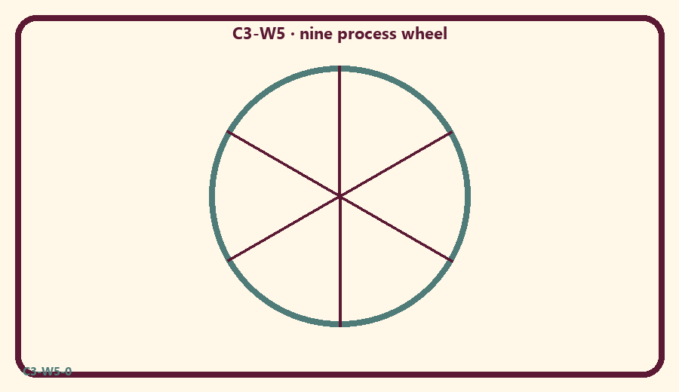
CARD 1  Hear | CARD 2  Chant
CARD 3  Remember | CARD 4  Serve
CARD 5  Rank friends | CARD 6  Encourage

Memory phrase
Nine ways to love Viṣṇu.
Cut on the dashed borders. Keep each card intact.
TEACHER NOTE | Must include both 7.5.23 and 7.5.24; no ranking; one realistic practice.

Y02 — Process matching
Match hear/chant/remember pictures.
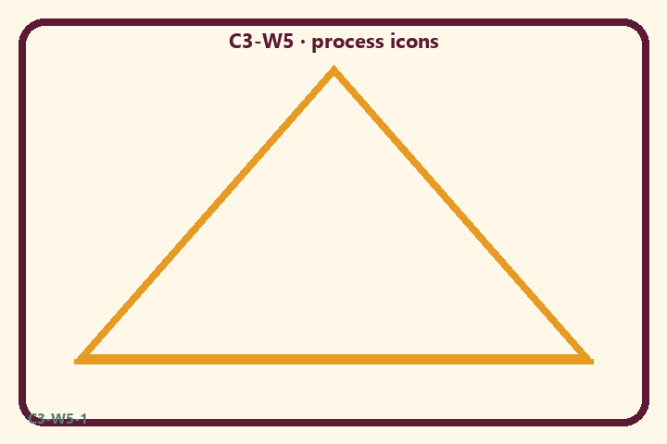
CARD 1  Hear | CARD 2  Chant
CARD 3  Remember | CARD 4  Serve
CARD 5  Rank friends | CARD 6  Encourage

Memory phrase
Nine ways to love Viṣṇu.
Cut on the dashed borders. Keep each card intact.
TEACHER NOTE | Must include both 7.5.23 and 7.5.24; no ranking; one realistic practice.

Y03 — One-practice craft
Choose one slice to try at home.
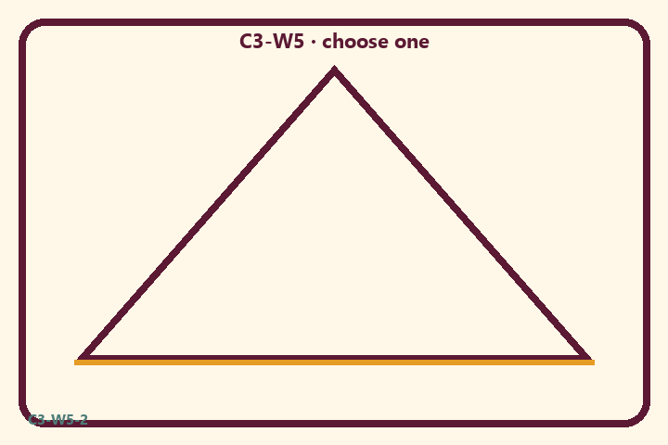
CARD 1  Hear | CARD 2  Chant
CARD 3  Remember | CARD 4  Serve
CARD 5  Rank friends | CARD 6  Encourage

Memory phrase
Nine ways to love Viṣṇu.
Cut on the dashed borders. Keep each card intact.
TEACHER NOTE | Must include both 7.5.23 and 7.5.24; no ranking; one realistic practice.

Y04 — Encourage cards
Cheer others’ practices without ranking.
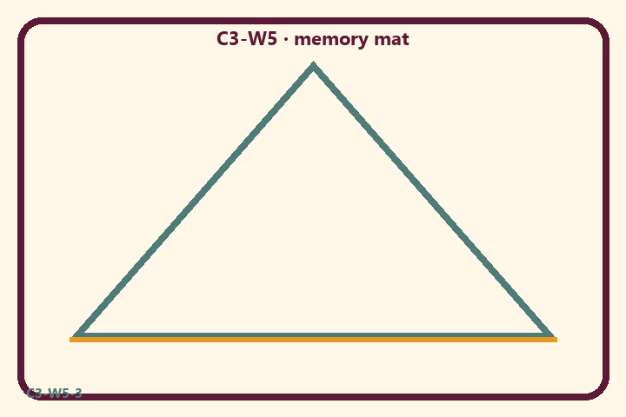
CARD 1  Hear | CARD 2  Chant
CARD 3  Remember | CARD 4  Serve
CARD 5  Rank friends | CARD 6  Encourage

Memory phrase
Nine ways to love Viṣṇu.
Cut on the dashed borders. Keep each card intact.
TEACHER NOTE | Must include both 7.5.23 and 7.5.24; no ranking; one realistic practice.

Y05 — Memory phrase mat
Echo: Nine ways to love Viṣṇu.

Memory phrase
Nine ways to love Viṣṇu.
ŚB 7.5.23–24 · family week
RIGHTS NOTE | KUTUMBA-original framing; cited third-party material retains its own rights. Human/temple review remains EXTERNAL_OPEN.

