KUTUMBA

C3-W6 — Older Teacher Pack
  - Grades 4–5 run sheet and activities
C3-W6 • Bhakti Mela: Kīrtana, Drama and Family Presentation
V13 • Families Growing in Krishna Consciousness
Program Director: Swapnil Patil
Internal founding-cohort teaching material — human/temple review EXTERNAL_OPEN
KUTUMBA | Families Growing in Krishna Consciousness

Locked Saturday Schedule
Time | Block
1:50–2:00 | Arrival
2:00–2:10 | Opening mantras + welcome
2:10–2:30 | All-family launch/orientation
2:30–3:10 | Parallel tracks
3:10–3:30 | Reunification + bhakti laboratory
3:30–3:40 | Snack + water
3:40–3:55 | Saṅkalpa + project + home practice
3:55–4:00 | Close

TIME CUE | Integration planning date 2027-02-13. Use 2:30 / 3:10 cues when parallel tracks run; local tithi remains EXTERNAL_OPEN.

Primary verse: Cycle 3 review (ŚB 7.5.23–24 center)
Source URL: https://vedabase.io/en/library/sb/7/5/23-24/

Older Teacher Run Sheet
Canonical source: 11-weekly-program-library/first-six-months/c3-w6-bhakti-mela-kīrtana-drama-and-family-presentation/teacher/OLDER-TEACHER-GUIDE-V13.md • SHA-256: d421867cfa13920093a9282f53ae038369beb5a5d07408e3cc18182576ad412d
KUTUMBA · Families Growing in Krishna Consciousness Program Director: Swapnil Patil Week: Bhakti Mela: Kīrtana, Drama and Family Presentation · Date: 2027-02-13 Track window: Saturday 2:30–3:10 (Grades 4–5) Reunite: 3:10 for bhakti laboratory Primary: Cycle 3 review (ŚB 7.5.23–24 center) — https://vedabase.io/en/library/sb/7/5/23-24/ Primary mechanic: Drama + exhibition Status: Internal founding-cohort teaching material — human/temple review EXTERNAL_OPEN

Essential question
Can our family offer Cycle 3 learning to Viṣṇu with joy — without ranking?

Materials (print before Saturday)
From activities/v13-older/: O01–O06 Also pens/crayons; verse card; privacy reminder.

Locked Saturday context
- 1:50–2:00 Arrival · 2:00–2:10 Mantras · 2:10–2:30 All-family launch
- 2:30–3:10 This track · 3:10–3:30 Reunify · 3:30–3:40 Snack/water · 3:40–3:55 Saṅkalpa · 3:55–4:00 Close
Parents remain onsite. No public ranking. No forced disclosure.

Source layer (use mid-track)
Primary: Cycle 3 review (ŚB 7.5.23–24 center) — https://vedabase.io/en/library/sb/7/5/23-24/
Devanāgarī: श्रीप्रह्राद उवाच श्रवणं कीर्तनं विष्णो: स्मरणं पादसेवनम् । अर्चनं वन्दनं दास्यं सख्यमात्मनिवेदनम् ॥ २३ ॥ इति पुंसार्पिता विष्णौ भक्तिश्चेन्नवलक्षणा । क्रियेत भगवत्यद्धा तन्मन्येऽधीतमुत्तमम् ॥ २४ ॥
IAST: śravaṇaṁ kīrtanaṁ viṣṇoḥ smaraṇaṁ pāda-sevanam / arcanaṁ vandanaṁ dāsyaṁ sakhyam ātma-nivedanam // iti puṁsārpitā viṣṇau bhaktiś cen nava-lakṣaṇā / kriyeta bhagavaty addhā tan manye 'dhītam uttamam
KUTUMBA teaching meaning (not a BBT translation): Bhakti Mela integrates Cycle 3 around offering bhakti to Viṣṇu with joy — retrieval and presentation, not new doctrine. (ŚB 7.5.23–24 center.)

Memory line
Offer it to Viṣṇu.

V13 printable wiring (Drama + exhibition)

V13 printable block 0–6 — Cycle 3 retrieval
Printable: activities/v13-older/O01-CYCLE3-RETRIEVAL.md (O01-CYCLE3-RETRIEVAL)
Retrieve five primary themes.
Keep primary mechanic (Drama + exhibition). Block: Mela as talent contest; new doctrine dump; ranking presentations.

V13 printable block 6–14 — Presentation rubric
Printable: activities/v13-older/O02-PRESENTATION-RUBRIC.md (O02-PRESENTATION-RUBRIC)
Clarity / source / kindness / time — not polish ranking.
Keep primary mechanic (Drama + exhibition). Block: Mela as talent contest; new doctrine dump; ranking presentations.

V13 printable block 14–22 — Noncompetitive sort
Printable: activities/v13-older/O03-NONCOMPETITIVE-SORT.md (O03-NONCOMPETITIVE-SORT)
Sort OFFERING / RANKING.
Keep primary mechanic (Drama + exhibition). Block: Mela as talent contest; new doctrine dump; ranking presentations.

V13 printable block 22–30 — Drama/exhibition scenarios
Printable: activities/v13-older/O04-DRAMA-EXHIBITION-SCENARIOS.md (O04-DRAMA-EXHIBITION-SCENARIOS)
Three coaching cases.
Keep primary mechanic (Drama + exhibition). Block: Mela as talent contest; new doctrine dump; ranking presentations.

V13 printable block 30–36 — Mela flow diagram
Printable: activities/v13-older/O05-MELA-FLOW-DIAGRAM.md (O05-MELA-FLOW-DIAGRAM)
Kīrtana → drama → present → reflect.
Keep primary mechanic (Drama + exhibition). Block: Mela as talent contest; new doctrine dump; ranking presentations.

V13 printable block 36–40 — Exit ticket
Printable: activities/v13-older/O06-EXIT-TICKET.md (O06-EXIT-TICKET)
One offering sentence + gratitude.
Keep primary mechanic (Drama + exhibition). Block: Mela as talent contest; new doctrine dump; ranking presentations.

Close of track (handoff)
Bring one sentence or artifact to reunification. Do not start next week’s topic. Care boundary: Integration only; noncompetitive; presentation/retrieval focus.

Inherited classroom depth (from V12 OLDER-TEACHER-GUIDE.md)
Keep story scripts, movement steps, and wonder questions below. Wire printables to the V13 codes above; do not replace this depth with “see research.”
Week: Bhakti Mela: Kīrtana, Drama and Family Presentation Primary: Cycle 3 review (BG 5.29 · BG 7.7 · BG 4.34 · CC Antya 20.12 · ŚB 7.5.23–24) — https://vedabase.io/en/library/sb/7/5/23-24/ Session length: ~40 minutes (parallel track ~2:30–3:10) Parents: Remain onsite; reunite at 3:10 Status: Internal founding-cohort teaching material — human/temple review EXTERNAL_OPEN

Objective
Students match Cycle 3 review anchors, participate in non-ranked mela offerings, and design a thirty-day smallest baseline.

Exact memory phrase
These processes become pure devotional service when offered to Viṣṇu with one’s life and intention.
Short echo: Offer it to Viṣṇu.

Teacher background
- KUTUMBA teaching meaning: Bhakti Mela integrates Cycle 3 — celebrate hearing, śrī-kṛṣṇa-saṅkīrtana, and family presentation without ranking. (Label as KUTUMBA teaching meaning — not as BBT translation.)
- Supporting frames (one sentence each): Five review verses; offering mood; baseline sizing.
- Block: Ranking family presentations or kīrtana.; New doctrine dump into the off week / skipping baseline.
- Scope: No new doctrine; no initiation; no ranking.

Materials
- Review match strips
- Presentation half-sheets
- Baseline cards
- Worksheets
- Answer key
- Station map

Minute-by-minute plan

0–5 min — Settle and hook
Trophy shelf vs offering plate — which is mela?

5–14 min — Primary text observation
Match five anchors to one-line meanings; fix any generic-only Antya label.

14–22 min — Worksheet questions
Students complete Section A of the older activity pack. Teacher circulates; use OLDER-ANSWER-KEY.md for expected directions (not for grading ranks).

22–28 min — Scenario cards (small groups)
A Ranking B Doctrine dump C Generic label
Share one insight per group (60 seconds).

28–33 min — Puzzle / game: Offer or Rank
O vs R claims.

33–37 min — Diagram / map task
Baseline calendar: smallest practice × 30.

37–40 min — Project sentence + handoff
Baseline card to parent.

Boundaries
- No ranking or public scores.
- No invented dialogue.
- Parents onsite; snack/water only at 3:30 in the main schedule.
- Defer off-scope topics: New curriculum tracks; initiation ceremonies.

O01 — Cycle 3 retrieval
Retrieve five primary themes.

VERSE CARD • Cycle 3 review (ŚB 7.5.23–24 center)
श्रीप्रह्राद उवाच श्रवणं कीर्तनं विष्णो: स्मरणं पादसेवनम् । अर्चनं वन्दनं दास्यं सख्यमात्मनिवेदनम् ॥ २३ ॥ इति पुंसार्पिता विष्णौ भक्तिश्चेन्नवलक्षणा । क्रियेत भगवत्यद्धा तन्मन्येऽधीतमुत्तमम् ॥ २४ ॥
śravaṇaṁ kīrtanaṁ viṣṇoḥ smaraṇaṁ pāda-sevanam / arcanaṁ vandanaṁ dāsyaṁ sakhyam ātma-nivedanam // iti puṁsārpitā viṣṇau bhaktiś cen nava-lakṣaṇā / kriyeta bhagavaty addhā tan manye 'dhītam uttamam
KUTUMBA teaching meaning: Bhakti Mela integrates Cycle 3 around offering bhakti to Viṣṇu with joy — retrieval and presentation, not new doctrine. (ŚB 7.5.23–24 center.)
Source: https://vedabase.io/en/library/sb/7/5/23-24/
Rights/status: Scripture display/source: VedaBase; teaching meaning: KUTUMBA-original (not labeled as BBT translation).

What does the verse teach in my words?
________________________________________________________________
________________________________________________________________
What misconception does this week block?
________________________________________________________________
________________________________________________________________
One question for the facilitator:
________________________________________________________________
________________________________________________________________

O02 — Presentation rubric
Clarity / source / kindness / time — not polish ranking.
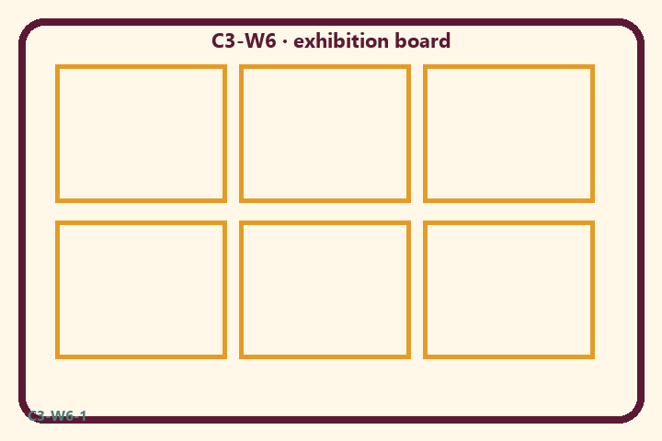
Prompt | My notes
Presentation rubric | ________________
Limit / care | ________________

Application:
________________________________________________________________
________________________________________________________________
What not to say:
________________________________________________________________
________________________________________________________________
KEY IDEA | Review BG 5.29 · 7.7 · 4.34 · CC Antya 20.12 · ŚB 7.5.23–24 through kīrtana, drama, and presentation — no new doctrine.

O03 — Noncompetitive sort
Sort OFFERING / RANKING.
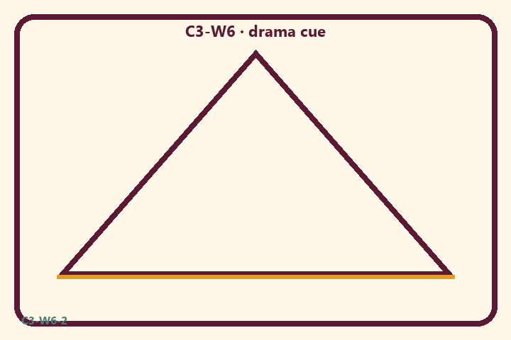
Prompt | My notes
Noncompetitive sort | ________________
Limit / care | ________________

Application:
________________________________________________________________
________________________________________________________________
What not to say:
________________________________________________________________
________________________________________________________________
KEY IDEA | Review BG 5.29 · 7.7 · 4.34 · CC Antya 20.12 · ŚB 7.5.23–24 through kīrtana, drama, and presentation — no new doctrine.

O04 — Drama/exhibition scenarios
Three coaching cases.
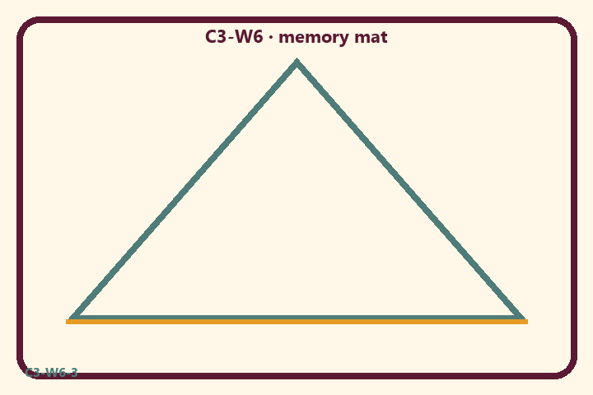
Prompt | My notes
Drama/exhibition scenarios | ________________
Limit / care | ________________

Application:
________________________________________________________________
________________________________________________________________
What not to say:
________________________________________________________________
________________________________________________________________
KEY IDEA | Review BG 5.29 · 7.7 · 4.34 · CC Antya 20.12 · ŚB 7.5.23–24 through kīrtana, drama, and presentation — no new doctrine.

O05 — Mela flow diagram
Kīrtana → drama → present → reflect.
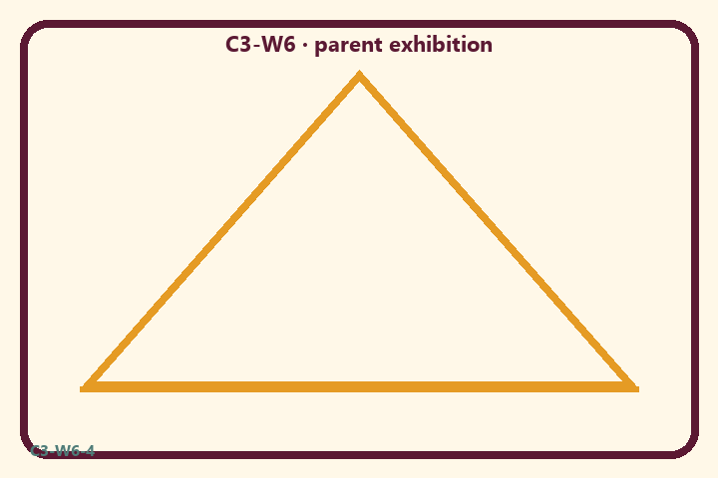
Prompt | My notes
Mela flow diagram | ________________
Limit / care | ________________

Application:
________________________________________________________________
________________________________________________________________
What not to say:
________________________________________________________________
________________________________________________________________
KEY IDEA | Review BG 5.29 · 7.7 · 4.34 · CC Antya 20.12 · ŚB 7.5.23–24 through kīrtana, drama, and presentation — no new doctrine.

O06 — Exit ticket
One offering sentence + gratitude.
Primary in one sentence:
________________________________________________________________
________________________________________________________________
One analogy or mechanic and its limit:
________________________________________________________________
________________________________________________________________
One home action:
________________________________________________________________
________________________________________________________________
One question I still have:
________________________________________________________________
________________________________________________________________
RIGHTS NOTE | KUTUMBA-original framing; cited third-party material retains its own rights. Human/temple review remains EXTERNAL_OPEN.

