KUTUMBA

C3-W6 — Parent Track
  - Facilitator guide and parent printables
C3-W6 • Bhakti Mela: Kīrtana, Drama and Family Presentation
V13 • Families Growing in Krishna Consciousness
Program Director: Swapnil Patil
Internal founding-cohort teaching material — human/temple review EXTERNAL_OPEN
KUTUMBA | Families Growing in Krishna Consciousness

Locked Saturday Schedule
Time | Block
1:50–2:00 | Arrival
2:00–2:10 | Opening mantras + welcome
2:10–2:30 | All-family launch/orientation
2:30–3:10 | Parallel tracks
3:10–3:30 | Reunification + bhakti laboratory
3:30–3:40 | Snack + water
3:40–3:55 | Saṅkalpa + project + home practice
3:55–4:00 | Close

TIME CUE | Integration planning date 2027-02-13. Use 2:30 / 3:10 cues when parallel tracks run; local tithi remains EXTERNAL_OPEN.

Primary verse: Cycle 3 review (ŚB 7.5.23–24 center)
Source URL: https://vedabase.io/en/library/sb/7/5/23-24/

Parent Facilitator Run Sheet
Canonical source: 11-weekly-program-library/first-six-months/c3-w6-bhakti-mela-kīrtana-drama-and-family-presentation/teacher/PARENT-GUIDE-V13.md • SHA-256: b6d31bb46e944ecb8b3dbd9a9a914059d6d9cf795da0562780352f30bc92211d
KUTUMBA · Families Growing in Krishna Consciousness Program Director: Swapnil Patil Week: Bhakti Mela: Kīrtana, Drama and Family Presentation · Date: 2027-02-13 Track window: Saturday 2:30–3:10 (parents) Reunite: 3:10 for bhakti laboratory Primary: Cycle 3 review (ŚB 7.5.23–24 center) — https://vedabase.io/en/library/sb/7/5/23-24/ Primary mechanic: Drama + exhibition Status: Internal founding-cohort teaching material — human/temple review EXTERNAL_OPEN

Essential question
Can our family offer Cycle 3 learning to Viṣṇu with joy — without ranking?

Materials (print before Saturday)
From activities/v13-parent/: P01–P05 Also pens/crayons; verse card; privacy reminder.

Locked Saturday context
- 1:50–2:00 Arrival · 2:00–2:10 Mantras · 2:10–2:30 All-family launch
- 2:30–3:10 This track · 3:10–3:30 Reunify · 3:30–3:40 Snack/water · 3:40–3:55 Saṅkalpa · 3:55–4:00 Close
Parents remain onsite. No public ranking. No forced disclosure.

Source layer (use mid-track)
Primary: Cycle 3 review (ŚB 7.5.23–24 center) — https://vedabase.io/en/library/sb/7/5/23-24/
Devanāgarī: श्रीप्रह्राद उवाच श्रवणं कीर्तनं विष्णो: स्मरणं पादसेवनम् । अर्चनं वन्दनं दास्यं सख्यमात्मनिवेदनम् ॥ २३ ॥ इति पुंसार्पिता विष्णौ भक्तिश्चेन्नवलक्षणा । क्रियेत भगवत्यद्धा तन्मन्येऽधीतमुत्तमम् ॥ २४ ॥
IAST: śravaṇaṁ kīrtanaṁ viṣṇoḥ smaraṇaṁ pāda-sevanam / arcanaṁ vandanaṁ dāsyaṁ sakhyam ātma-nivedanam // iti puṁsārpitā viṣṇau bhaktiś cen nava-lakṣaṇā / kriyeta bhagavaty addhā tan manye 'dhītam uttamam
KUTUMBA teaching meaning (not a BBT translation): Bhakti Mela integrates Cycle 3 around offering bhakti to Viṣṇu with joy — retrieval and presentation, not new doctrine. (ŚB 7.5.23–24 center.)

Memory line
Offer it to Viṣṇu.

V13 printable wiring (Drama + exhibition)

V13 printable block 0–5 — Private reflection — offering vs performing
Printable: activities/v13-parent/P01-PRIVATE-REFLECTION.md (P01-PRIVATE-REFLECTION)
Where do we slip into ranking?
Keep primary mechanic (Drama + exhibition). Block: Mela as talent contest; new doctrine dump; ranking presentations.

V13 printable block 5–12 — Exhibition coaching card sort
Printable: activities/v13-parent/P02-EXHIBITION-COACHING-CARD-SORT.md (P02-EXHIBITION-COACHING-CARD-SORT)
Sort COACH / RANK / NEW DOCTRINE.
Keep primary mechanic (Drama + exhibition). Block: Mela as talent contest; new doctrine dump; ranking presentations.

V13 printable block 12–22 — Substantial family case
Printable: activities/v13-parent/P03-SUBSTANTIAL-FAMILY-CASE.md (P03-SUBSTANTIAL-FAMILY-CASE)
Family wants awards for “best drama.”
Keep primary mechanic (Drama + exhibition). Block: Mela as talent contest; new doctrine dump; ranking presentations.

V13 printable block 22–32 — Household operating application
Printable: activities/v13-parent/P04-HOUSEHOLD-OPERATING-APPLICATION.md (P04-HOUSEHOLD-OPERATING-APPLICATION)
One noncompetitive cheer rule + offering line.
Keep primary mechanic (Drama + exhibition). Block: Mela as talent contest; new doctrine dump; ranking presentations.

V13 printable block 32–38 — Private next-step saṅkalpa
Printable: activities/v13-parent/P05-PRIVATE-NEXT-STEP-SANKALPA.md (P05-PRIVATE-NEXT-STEP-SANKALPA)
Mela offering practice.
Keep primary mechanic (Drama + exhibition). Block: Mela as talent contest; new doctrine dump; ranking presentations.

Close of track (handoff)
Bring one sentence or artifact to reunification. Do not start next week’s topic. Care boundary: Integration only; noncompetitive; presentation/retrieval focus.

Inherited classroom depth (from V12 parent-lesson / constructed V13 flow)
Keep story scripts, movement steps, and wonder questions below. Wire printables to the V13 codes above; do not replace this depth with “see research.”

Essential question
How do we celebrate what we learned?

Source
Cycle 3 review (ŚB 7.5.23–24 center) — teaching meaning: Bhakti Mela — celebrate hearing, chanting, and family presentation without ranking.

Discussion
One realistic household tension; no compelled confession.

Application
5–15 minute cue; minimum version counts.

Privacy
No public scoring of sādhana.

P01 — Private reflection — offering vs performing
Where do we slip into ranking?

SAFETY & PRIVACY | Write privately. Sharing is optional. Do not collect or place completed sheets in Git.

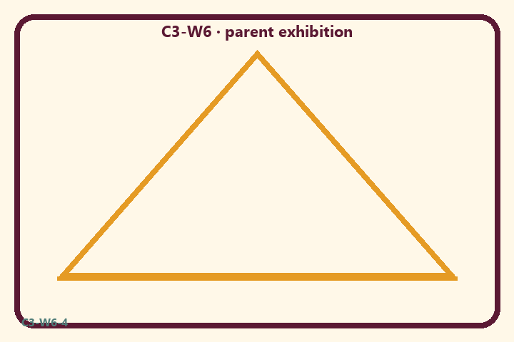
Where do we slip into ranking?
Private notes:
________________________________________________________________
________________________________________________________________
________________________________________________________________
________________________________________________________________
Habit to watch this week:
________________________________________________________________
________________________________________________________________
________________________________________________________________
________________________________________________________________

P02 — Exhibition coaching card sort
Sort COACH / RANK / NEW DOCTRINE.
HELPFUL | MISTAKEN

L1  Retrieve a verse theme | L2  Award best family
L3  Kind presentation | L4  Invent new theology
L5  Timebox share | L6  Cheer another group
TEACHER NOTE | Mela as talent contest; new doctrine dump; ranking presentations.

P03 — Substantial family case
Family wants awards for “best drama.”
SAFETY & PRIVACY | Fictional case. No compelled confession of real events.

A family lobbies for “best drama” awards and wants to introduce a brand-new doctrinal topic during Mela instead of reviewing Cycle 3.
Tempting mistaken conclusion:
________________________________________________________________
________________________________________________________________
________________________________________________________________
Principle from primary:
________________________________________________________________
________________________________________________________________
________________________________________________________________
Compassionate response:
________________________________________________________________
________________________________________________________________
________________________________________________________________
One seven-day household action:
________________________________________________________________
________________________________________________________________
________________________________________________________________
What we should not say:
________________________________________________________________
________________________________________________________________
________________________________________________________________
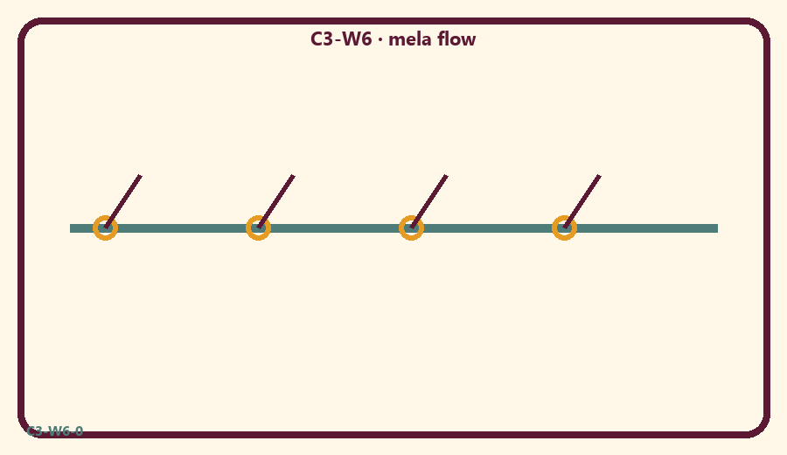

P04 — Household operating application
One noncompetitive cheer rule + offering line.
SAFETY & PRIVACY | No ranking and no public reading required.

One household action for seven days:
________________________________________________________________
________________________________________________________________
________________________________________________________________
Trigger (when/where):
________________________________________________________________
________________________________________________________________
________________________________________________________________
Who starts if others are tired:
________________________________________________________________
________________________________________________________________
________________________________________________________________
Minimum version on a hard day:
________________________________________________________________
________________________________________________________________
________________________________________________________________

Memory phrase
Offer it to Viṣṇu.

P05 — Private next-step saṅkalpa
Mela offering practice.
KEY IDEA | specific action + frequency + trigger + minimum version

Specific action:
________________________________________________________________
________________________________________________________________
Frequency:
________________________________________________________________
________________________________________________________________
Trigger (when and where):
________________________________________________________________
________________________________________________________________
Minimum version for a hard day:
________________________________________________________________
________________________________________________________________
Where we will place the reminder:
________________________________________________________________
________________________________________________________________
No ranking. The minimum version counts as success.
RIGHTS NOTE | KUTUMBA-original framing; cited third-party material retains its own rights. Human/temple review remains EXTERNAL_OPEN.

