KUTUMBA

C3-W6 — Younger Teacher Pack
  - K–2 run sheet and activities
C3-W6 • Bhakti Mela: Kīrtana, Drama and Family Presentation
V13 • Families Growing in Krishna Consciousness
Program Director: Swapnil Patil
Internal founding-cohort teaching material — human/temple review EXTERNAL_OPEN
KUTUMBA | Families Growing in Krishna Consciousness

Locked Saturday Schedule
Time | Block
1:50–2:00 | Arrival
2:00–2:10 | Opening mantras + welcome
2:10–2:30 | All-family launch/orientation
2:30–3:10 | Parallel tracks
3:10–3:30 | Reunification + bhakti laboratory
3:30–3:40 | Snack + water
3:40–3:55 | Saṅkalpa + project + home practice
3:55–4:00 | Close

TIME CUE | Integration planning date 2027-02-13. Use 2:30 / 3:10 cues when parallel tracks run; local tithi remains EXTERNAL_OPEN.

Primary verse: Cycle 3 review (ŚB 7.5.23–24 center)
Source URL: https://vedabase.io/en/library/sb/7/5/23-24/

Younger Teacher Run Sheet
Canonical source: 11-weekly-program-library/first-six-months/c3-w6-bhakti-mela-kīrtana-drama-and-family-presentation/teacher/YOUNGER-TEACHER-GUIDE-V13.md • SHA-256: 7d170167b19345078b668b4f40d6c26405413fc8e6d424a05320f03e04f38ffb
KUTUMBA · Families Growing in Krishna Consciousness Program Director: Swapnil Patil Week: Bhakti Mela: Kīrtana, Drama and Family Presentation · Date: 2027-02-13 Track window: Saturday 2:30–3:10 (K–2) Reunite: 3:10 for bhakti laboratory Primary: Cycle 3 review (ŚB 7.5.23–24 center) — https://vedabase.io/en/library/sb/7/5/23-24/ Primary mechanic: Drama + exhibition Status: Internal founding-cohort teaching material — human/temple review EXTERNAL_OPEN

Essential question
Can our family offer Cycle 3 learning to Viṣṇu with joy — without ranking?

Materials (print before Saturday)
From activities/v13-younger/: Y01–Y05 Also pens/crayons; verse card; privacy reminder.

Locked Saturday context
- 1:50–2:00 Arrival · 2:00–2:10 Mantras · 2:10–2:30 All-family launch
- 2:30–3:10 This track · 3:10–3:30 Reunify · 3:30–3:40 Snack/water · 3:40–3:55 Saṅkalpa · 3:55–4:00 Close
Parents remain onsite. No public ranking. No forced disclosure.

Source layer (use mid-track)
Primary: Cycle 3 review (ŚB 7.5.23–24 center) — https://vedabase.io/en/library/sb/7/5/23-24/
Devanāgarī: श्रीप्रह्राद उवाच श्रवणं कीर्तनं विष्णो: स्मरणं पादसेवनम् । अर्चनं वन्दनं दास्यं सख्यमात्मनिवेदनम् ॥ २३ ॥ इति पुंसार्पिता विष्णौ भक्तिश्चेन्नवलक्षणा । क्रियेत भगवत्यद्धा तन्मन्येऽधीतमुत्तमम् ॥ २४ ॥
IAST: śravaṇaṁ kīrtanaṁ viṣṇoḥ smaraṇaṁ pāda-sevanam / arcanaṁ vandanaṁ dāsyaṁ sakhyam ātma-nivedanam // iti puṁsārpitā viṣṇau bhaktiś cen nava-lakṣaṇā / kriyeta bhagavaty addhā tan manye 'dhītam uttamam
KUTUMBA teaching meaning (not a BBT translation): Bhakti Mela integrates Cycle 3 around offering bhakti to Viṣṇu with joy — retrieval and presentation, not new doctrine. (ŚB 7.5.23–24 center.)

Memory line
Offer it to Viṣṇu.

V13 printable wiring (Drama + exhibition)

V13 printable block 0–6 — Mini drama / kīrtana
Printable: activities/v13-younger/Y01-MINI-DRAMA-KIRTANA.md (Y01-MINI-DRAMA-KIRTANA)
Short joyful scene + soft kīrtana invitation.
Keep primary mechanic (Drama + exhibition). Block: Mela as talent contest; new doctrine dump; ranking presentations.

V13 printable block 6–14 — Cycle 3 icon matching
Printable: activities/v13-younger/Y02-CYCLE3-ICON-MATCHING.md (Y02-CYCLE3-ICON-MATCHING)
Match five week icons.
Keep primary mechanic (Drama + exhibition). Block: Mela as talent contest; new doctrine dump; ranking presentations.

V13 printable block 14–24 — Exhibition craft
Printable: activities/v13-younger/Y03-EXHIBITION-CRAFT.md (Y03-EXHIBITION-CRAFT)
One poster sentence: Offer it to Viṣṇu.
Keep primary mechanic (Drama + exhibition). Block: Mela as talent contest; new doctrine dump; ranking presentations.

V13 printable block 24–32 — Cheer cards
Printable: activities/v13-younger/Y04-CHEER-CARDS.md (Y04-CHEER-CARDS)
Encourage every family.
Keep primary mechanic (Drama + exhibition). Block: Mela as talent contest; new doctrine dump; ranking presentations.

V13 printable block 32–38 — Memory phrase mat
Printable: activities/v13-younger/Y05-MEMORY-PHRASE-MAT.md (Y05-MEMORY-PHRASE-MAT)
Echo: Offer it to Viṣṇu.
Keep primary mechanic (Drama + exhibition). Block: Mela as talent contest; new doctrine dump; ranking presentations.

Close of track (handoff)
Bring one sentence or artifact to reunification. Do not start next week’s topic. Care boundary: Integration only; noncompetitive; presentation/retrieval focus.

Inherited classroom depth (from V12 YOUNGER-TEACHER-GUIDE.md)
Keep story scripts, movement steps, and wonder questions below. Wire printables to the V13 codes above; do not replace this depth with “see research.”
Week: Bhakti Mela: Kīrtana, Drama and Family Presentation Primary: Cycle 3 review (BG 5.29 · BG 7.7 · BG 4.34 · CC Antya 20.12 · ŚB 7.5.23–24) — https://vedabase.io/en/library/sb/7/5/23-24/ Session length: 40 minutes (parallel track ~2:30–3:10) Parents: Remain onsite; reunite at 3:10 Status: Internal founding-cohort teaching material — human/temple review EXTERNAL_OPEN

Objective
Children celebrate soft śrī-kṛṣṇa-saṅkīrtanam, make an offering-plate craft, and pick a tiny daily baseline star — without ranking.

Exact memory phrase
Offer it to Viṣṇu.

Teacher background (2 minutes to review)
- KUTUMBA teaching meaning (adult wording): Bhakti Mela integrates Cycle 3 — celebrate hearing, śrī-kṛṣṇa-saṅkīrtana, and family presentation without ranking.
- Child-facing paraphrase: We offer our singing and learning to Viṣṇu. We practice a tiny bit every day. We do not rank friends.
- Block misconceptions (child words):
- “Who was best?”
- “Skip practice after the party.”
- Do not: invent deity dialogue; force confession; rank children; use scare tactics; claim temple certification stickers.

Materials
- Paper plates
- Five pearl stickers
- Soft kīrtana guide
- Star stickers
- Crayons
- Calm corner
- Phrase poster

Room setup
Circle on the floor; materials table behind you; calm corner with one chair for quiet reset. Keep aisles clear for movement.

Minute-by-minute executable plan

0–5 min — Opening and recall
1. Welcome.
2. Echo: Offer / it / to Viṣṇu.
3. Soft clap.
4. Say: “We don’t rank friends.”

5–13 min — Story script (paraphrase only; ~8 minutes)
Say exactly this spine (do not invent deity dialogue):
Tonight is a happy offering festival. We remember Kṛṣṇa owns and befriends, nothing is above Kṛṣṇa, we ask-serve-verify, we sing śrī-kṛṣṇa-saṅkīrtanam, and we love Viṣṇu in many ways. We put our learning on an offering plate for Viṣṇu. Then we light a tiny daily practice for thirty days. We do not give prizes for who is best.
Story boundaries: Review themes only. No invented dialogues. No ranking games.

13–16 min — Three wonder questions
1. Do we rank? (No)
2. Who do we offer to? (Viṣṇu/Kṛṣṇa)
3. Tiny daily practice? (Yes)
Accept one- or two-word answers. Affirm effort.

16–24 min — Movement game: Offering Plate Parade (steps)
1. Hold paper plates.
2. Walk gently to “offer” mat; say phrase.
3. Soft echo of a short mantra line.
4. Sit; place a star sticker for baseline.

24–32 min — Craft: Offering plate + baseline star (steps)
1. Decorate paper plate.
2. Add five pearl stickers (review cues).
3. Helper writes: Offer it to Viṣṇu.
4. Star sticker: tiny daily practice picture.
Full printable steps also live in activities/YOUNGER-ACTIVITY-PACK.md (use together; this guide remains executable if the pack is missing).

32–35 min — Printable / coloring task
If time remains, color the younger line-art sheet if available. If short on time, keep the craft as the take-home.

35–38 min — Behavior redirects and quiet reset
Use calm, specific redirects:
- Feet on floor — “Feet visit the mat.”
- Kind hands — “Hands help; toys rest.”
- Loud shout — “Soft voice, please.”
- Quiet reset — “Calm corner for sixty seconds.”

38–40 min — Cleanup and parent handoff
1. Materials away; craft in hand.
2. At reunification, tell parent in one sentence:
Memory phrase: “Offer it to Viṣṇu..” Home cue: Begin the thirty-day baseline with the smallest daily practice.
1. Do not report private behavior struggles in front of other families.

Behavior redirects (quick reference)
Signal | Teacher line | Child action
Running | Walking feet. | Walk to mat
Snatching | Kind hands. | Hands to lap
Interrupt shout | Soft voice. | Whisper retry
Shutdown | Quiet reset is okay. | Calm corner 60 sec

Backup low-prep (if craft fails or energy crashes)
Toss and say “Offer it to Viṣṇu.”

What success looks like
- Echoes phrase
- Says no ranking
- Names a tiny practice

Boundaries
- Snack/water only happens in main schedule (3:30), not as a track bribe.
- No weekly meal language.
- No fabricated approval stickers implying temple certification.
- Privacy: no forced confession.

Child House Rules
Canonical source: launch/CHILD-HOUSE-RULES.md • SHA-256: 6a525f3dd1da740db86e246622696c7b08e28c1f1475227567d639a5bd54ce47
Parents remain onsite. Facilitators guide the session. Host property rules also apply.

Shared rules (all ages)
1. Keep your body safe — feet on the floor; hands gentle.
2. Use respectful speech — no teasing, yelling, or mean labels.
3. Follow the facilitator safety cue immediately (pause / freeze / come here).
4. No jumping on furniture.
5. No indoor throwing.
6. No writing on walls, books, or furniture that are not activity materials.
7. Ask before entering private rooms.
8. Respect belongings — ask before touching what is not yours.
9. Devices away unless the lesson specifically needs them.
10. Snack only in the allowed area; water anytime with permission.
11. Help clean up before leaving.

Correction ladder (no public shame)
1. Calm reminder
2. Redirect / offer a choice
3. Brief quiet reset in a visible space
4. Parent involvement
5. Sit out a specific activity
6. Private parent/program conversation for repeated patterns
Never: public shame, yelling, sarcasm, corporal punishment, forced chanting, or comparing children.

Younger (K–2) emphasis
- Soft voices indoors
- Stay with the group
- Hands to yourself
- Ask before leaving the room

Older (Grades 4–5) emphasis
- Model respectful speech for younger children
- Devices fully away unless assigned
- Help clean-up leadership
- Honest questions welcome; speculation wait for source check
Printable versions: W1 launch-pack CHILD-RULES-YOUNGER.md and CHILD-RULES-OLDER.md.

Y01 — Mini drama / kīrtana
Short joyful scene + soft kīrtana invitation.
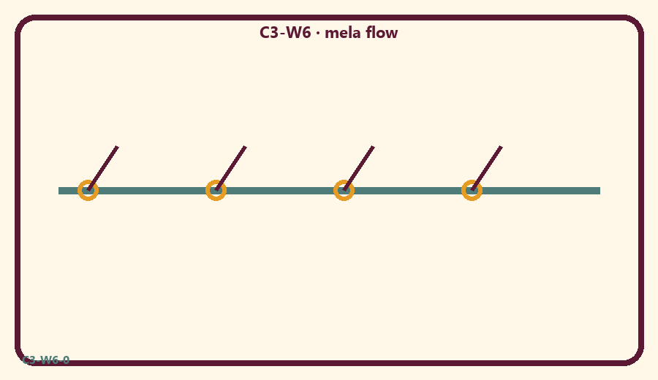
CARD 1  Kīrtana joy | CARD 2  Short drama
CARD 3  Offer to Viṣṇu | CARD 4  Trophy fight
CARD 5  Cheer friends | CARD 6  New doctrine dump

Memory phrase
Offer it to Viṣṇu.
Cut on the dashed borders. Keep each card intact.
TEACHER NOTE | Integration only; noncompetitive; presentation/retrieval focus.

Y02 — Cycle 3 icon matching
Match five week icons.
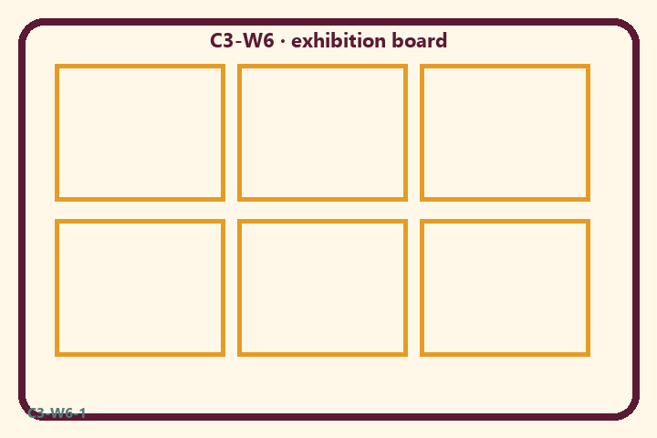
CARD 1  Kīrtana joy | CARD 2  Short drama
CARD 3  Offer to Viṣṇu | CARD 4  Trophy fight
CARD 5  Cheer friends | CARD 6  New doctrine dump

Memory phrase
Offer it to Viṣṇu.
Cut on the dashed borders. Keep each card intact.
TEACHER NOTE | Integration only; noncompetitive; presentation/retrieval focus.

Y03 — Exhibition craft
One poster sentence: Offer it to Viṣṇu.
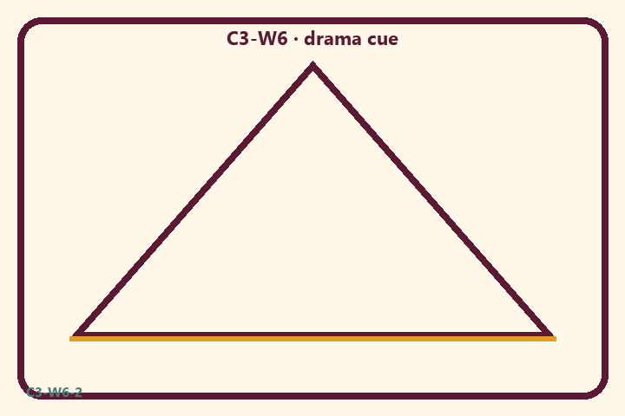
CARD 1  Kīrtana joy | CARD 2  Short drama
CARD 3  Offer to Viṣṇu | CARD 4  Trophy fight
CARD 5  Cheer friends | CARD 6  New doctrine dump

Memory phrase
Offer it to Viṣṇu.
Cut on the dashed borders. Keep each card intact.
TEACHER NOTE | Integration only; noncompetitive; presentation/retrieval focus.

Y04 — Cheer cards
Encourage every family.
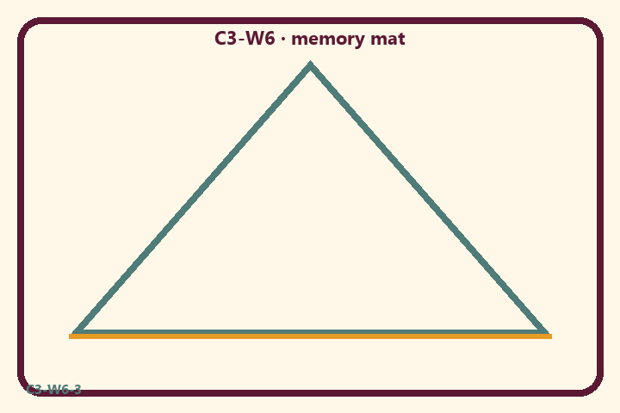
CARD 1  Kīrtana joy | CARD 2  Short drama
CARD 3  Offer to Viṣṇu | CARD 4  Trophy fight
CARD 5  Cheer friends | CARD 6  New doctrine dump

Memory phrase
Offer it to Viṣṇu.
Cut on the dashed borders. Keep each card intact.
TEACHER NOTE | Integration only; noncompetitive; presentation/retrieval focus.

Y05 — Memory phrase mat
Echo: Offer it to Viṣṇu.

Memory phrase
Offer it to Viṣṇu.
Cycle 3 review (ŚB 7.5.23–24 center) · family week
RIGHTS NOTE | KUTUMBA-original framing; cited third-party material retains its own rights. Human/temple review remains EXTERNAL_OPEN.

