KUTUMBA

MELA — Parent Track
  - Facilitator guide and parent printables
MELA • Six-Month Reflection / Family Mela
V13 • Families Growing in Krishna Consciousness
Program Director: Swapnil Patil
Internal founding-cohort teaching material — human/temple review EXTERNAL_OPEN
KUTUMBA | Families Growing in Krishna Consciousness

Locked Saturday Schedule
Time | Block
1:50–2:00 | Arrival
2:00–2:10 | Opening mantras + welcome
2:10–2:30 | All-family launch/orientation
2:30–3:10 | Parallel tracks
3:10–3:30 | Reunification + bhakti laboratory
3:30–3:40 | Snack + water
3:40–3:55 | Saṅkalpa + project + home practice
3:55–4:00 | Close

TIME CUE | Mela planning date 2027-03-06. Use 2:30 / 3:10 cues when parallel tracks run; local tithi remains EXTERNAL_OPEN.

Primary verse: First-six-month review chain
Source URL: https://vedabase.io/en/library/sb/1/2/18/

Parent Facilitator Run Sheet
Canonical source: 11-weekly-program-library/first-six-months/mela-six-month-reflection-family-mela/teacher/PARENT-GUIDE-V13.md • SHA-256: 103de54b52ab31758d7e8d1ab9a1c7102ff9a081960d1baf6e0ef2488261b0b1
Use with printable stations. Operator completeness pack.

Main Facilitator Guide — MELA
Six-Month Reflection / Family Mela · Owner-select 2027-02-27 or 2027-03-06 (not a tithi claim) Entry: V13-MELA-START-HERE.md

Primary review center
- ŚB 1.2.18 — https://vedabase.io/en/library/sb/1/2/18/ — hearing/service culture that nourishes bhakti (Cycle 1 opening chain center).
- Review first-six-month verse chain without introducing major new doctrine tonight.

10–20 minute speaking script
Welcome to our Six-Month Reflection / Family Mela.
Owner selects 2027-02-27 or 2027-03-06. This is not a religious tithi claim.
Essential question: What will our family continue, review, and strengthen — without ranking anyone?
We celebrate projects and learning. We give feedback that is kind and specific. We do not crown winners of devotion.
Analogy one — exhibition as garden walk: notice beauty; do not score flowers against each other. Analogy two — feedback as polishing cloth: gentle, specific, hopeful. Analogy three — three doors: Continue / Review / Strengthen.
Household case: A parent compares children aloud during exhibition. Redirect to one appreciative sentence per child without ranking.
Memory line: Continue · Review · Strengthen — without comparison.
Gaura Pūrṇimā (published example 2027-03-22) is lookahead only — do not distort this Mela to force-fit it.

P01 — Private Six-Month Reflection

Gift of these months:
________________________________________________________________
________________________________________________________________
________________________________________________________________
Hard stretch:
________________________________________________________________
________________________________________________________________
________________________________________________________________
Grace noticed:
________________________________________________________________
________________________________________________________________
________________________________________________________________
SAFETY & PRIVACY | Private. Optional share. No ranking.

P02 — Review-Chain Observation
ŚB 1.2.18 center

VERSE CARD • ŚB 1.2.18

KUTUMBA teaching meaning: Hearing and serving culture nourishes bhakti — review center for tonight.
Source: https://vedabase.io/en/library/sb/1/2/18/
Rights/status: Sanskrit/Bengali display + KUTUMBA teaching meaning; no full purport

What we heard well:
________________________________________________________________
________________________________________________________________
________________________________________________________________
What we want to hear better:
________________________________________________________________
________________________________________________________________
________________________________________________________________

P03 — Testimony Prep (optional)
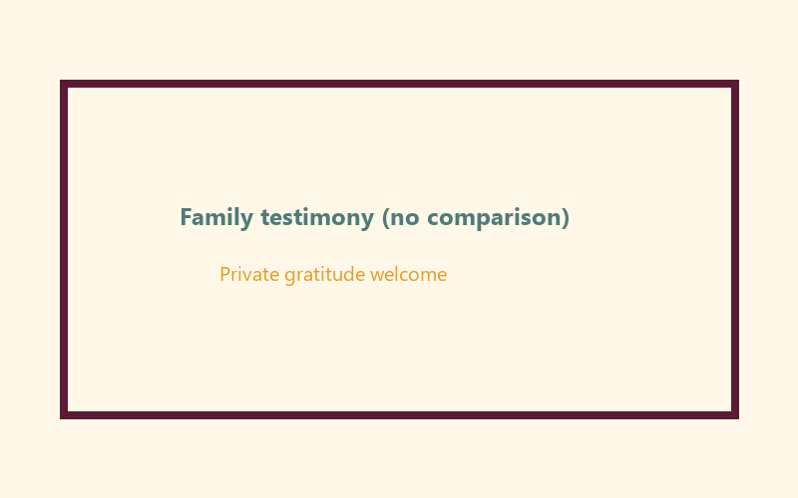
One sentence without comparison:
________________________________________________________________
________________________________________________________________
Opt-out is OK because:
________________________________________________________________
________________________________________________________________
SAFETY & PRIVACY | Invitation only.

P04 — Continue / Review / Strengthen
CONTINUE:
________________________________________________________________
________________________________________________________________
REVIEW:
________________________________________________________________
________________________________________________________________
STRENGTHEN:
________________________________________________________________
________________________________________________________________
Who supports this at home:
________________________________________________________________
________________________________________________________________
FAMILY APPLICATION | Decision without competition.

P05 — Private Next-Phase Saṅkalpa
KEY IDEA | specific action + frequency + trigger + minimum version

Specific action:
________________________________________________________________
________________________________________________________________
Frequency:
________________________________________________________________
________________________________________________________________
Trigger:
________________________________________________________________
________________________________________________________________
Minimum version:
________________________________________________________________
________________________________________________________________
RIGHTS NOTE | KUTUMBA-original framing; cited third-party material retains its own rights. Human/temple review remains EXTERNAL_OPEN.

