KUTUMBA

MELA — Saturday Print Packet
  - Complete ordered participant and teacher packet
MELA • Six-Month Reflection / Family Mela
V13 • Families Growing in Krishna Consciousness
Program Director: Swapnil Patil
Internal founding-cohort teaching material — human/temple review EXTERNAL_OPEN
KUTUMBA | Families Growing in Krishna Consciousness

Quick Schedule
Time | Block
1:50–2:00 | Arrival
2:00–2:10 | Opening mantras + welcome
2:10–2:30 | All-family launch/orientation
2:30–3:10 | Parallel tracks
3:10–3:30 | Reunification + bhakti laboratory
3:30–3:40 | Snack + water
3:40–3:55 | Saṅkalpa + project + home practice
3:55–4:00 | Close

TIME CUE | Mela planning date 2027-03-06. Use 2:30 / 3:10 cues when parallel tracks run; local tithi remains EXTERNAL_OPEN.

Primary verse: First-six-month review chain
Source URL: https://vedabase.io/en/library/sb/1/2/18/

Opening Mantras
Canonical source: launch/OPENING-MANTRAS-HANDOUT.md • SHA-256: e9487fa3eef1f08c79b8a191932fc70aae9766d2ad3b52a5c47815e3d50e6cb6
KUTUMBA · Families Growing in Krishna Consciousness Program Director: Swapnil Patil

1. Śrīla Prabhupāda Praṇāma
nama oṁ viṣṇu-pādāya kṛṣṇa-preṣṭhāya bhū-tale śrīmate bhaktivedānta-svāmin iti nāmine namas te sārasvate deve gaura-vāṇī-pracāriṇe nirviśeṣa-śūnyavādi-pāścātya-deśa-tāriṇe
Direct sources (verify chanting sheet locally):
- https://vedabase.io/en/library/transcripts/690110in-los-angeles/
- https://vedabase.io/en/library/transcripts/690413sb-new-york/
KUTUMBA plain meaning: We offer respects to Śrīla Prabhupāda, dear to Kṛṣṇa, who carries Lord Caitanya's message.

2. Pañca-tattva Mantra
(jaya) śrī-kṛṣṇa-caitanya prabhu-nityānanda śrī-advaita gadādhara śrīvāsādi-gaura-bhakta-vṛnda
Source: https://vedabase.io/en/library/cc/adi/7/4/ Also see transcript context: https://vedabase.io/en/library/transcripts/710328bg-bombay/

3. Hare Kṛṣṇa Mahā-mantra
Hare Kṛṣṇa Hare Kṛṣṇa Kṛṣṇa Kṛṣṇa Hare Hare Hare Rāma Hare Rāma Rāma Rāma Hare Hare
Direct sources (complete sixteen-word mahā-mantra stated / teaching context):
- Lecture on the Mahā-mantra: https://vedabase.io/en/library/transcripts/660909le-new-york/
- Śrī Caitanya-caritāmṛta Ādi 7.83 (nature of the mahā-mantra): https://vedabase.io/en/library/cc/adi/7/83/
Invitation only — never forced volume or punishment.
RIGHTS NOTE | do not invent extra prayers; temple sheet is exact-text control where required.

Parent Track Run Sheet
Canonical source: 11-weekly-program-library/first-six-months/mela-six-month-reflection-family-mela/teacher/PARENT-GUIDE-V13.md • SHA-256: 103de54b52ab31758d7e8d1ab9a1c7102ff9a081960d1baf6e0ef2488261b0b1
Use with printable stations. Operator completeness pack.

Main Facilitator Guide — MELA
Six-Month Reflection / Family Mela · Owner-select 2027-02-27 or 2027-03-06 (not a tithi claim) Entry: V13-MELA-START-HERE.md

Primary review center
- ŚB 1.2.18 — https://vedabase.io/en/library/sb/1/2/18/ — hearing/service culture that nourishes bhakti (Cycle 1 opening chain center).
- Review first-six-month verse chain without introducing major new doctrine tonight.

10–20 minute speaking script
Welcome to our Six-Month Reflection / Family Mela.
Owner selects 2027-02-27 or 2027-03-06. This is not a religious tithi claim.
Essential question: What will our family continue, review, and strengthen — without ranking anyone?
We celebrate projects and learning. We give feedback that is kind and specific. We do not crown winners of devotion.
Analogy one — exhibition as garden walk: notice beauty; do not score flowers against each other. Analogy two — feedback as polishing cloth: gentle, specific, hopeful. Analogy three — three doors: Continue / Review / Strengthen.
Household case: A parent compares children aloud during exhibition. Redirect to one appreciative sentence per child without ranking.
Memory line: Continue · Review · Strengthen — without comparison.
Gaura Pūrṇimā (published example 2027-03-22) is lookahead only — do not distort this Mela to force-fit it.

P01 — Private Six-Month Reflection

Gift of these months:
________________________________________________________________
________________________________________________________________
________________________________________________________________
Hard stretch:
________________________________________________________________
________________________________________________________________
________________________________________________________________
Grace noticed:
________________________________________________________________
________________________________________________________________
________________________________________________________________
SAFETY & PRIVACY | Private. Optional share. No ranking.

P02 — Review-Chain Observation
ŚB 1.2.18 center

VERSE CARD • ŚB 1.2.18

KUTUMBA teaching meaning: Hearing and serving culture nourishes bhakti — review center for tonight.
Source: https://vedabase.io/en/library/sb/1/2/18/
Rights/status: Sanskrit/Bengali display + KUTUMBA teaching meaning; no full purport

What we heard well:
________________________________________________________________
________________________________________________________________
________________________________________________________________
What we want to hear better:
________________________________________________________________
________________________________________________________________
________________________________________________________________

P03 — Testimony Prep (optional)
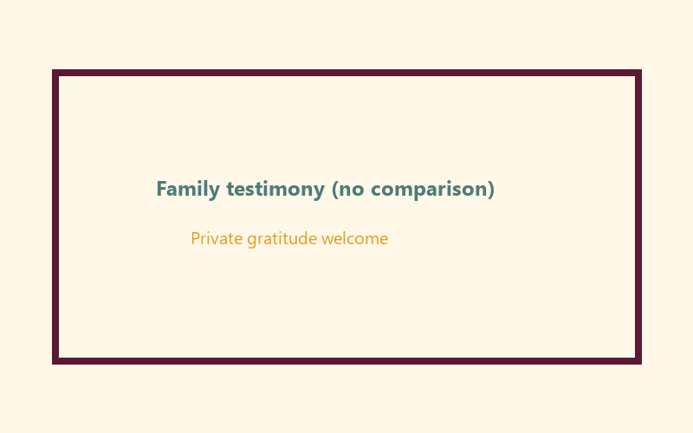
One sentence without comparison:
________________________________________________________________
________________________________________________________________
Opt-out is OK because:
________________________________________________________________
________________________________________________________________
SAFETY & PRIVACY | Invitation only.

P04 — Continue / Review / Strengthen
CONTINUE:
________________________________________________________________
________________________________________________________________
REVIEW:
________________________________________________________________
________________________________________________________________
STRENGTHEN:
________________________________________________________________
________________________________________________________________
Who supports this at home:
________________________________________________________________
________________________________________________________________
FAMILY APPLICATION | Decision without competition.

P05 — Private Next-Phase Saṅkalpa
KEY IDEA | specific action + frequency + trigger + minimum version

Specific action:
________________________________________________________________
________________________________________________________________
Frequency:
________________________________________________________________
________________________________________________________________
Trigger:
________________________________________________________________
________________________________________________________________
Minimum version:
________________________________________________________________
________________________________________________________________

Younger Child Rules
Canonical source: launch/CHILD-HOUSE-RULES.md • SHA-256: 6a525f3dd1da740db86e246622696c7b08e28c1f1475227567d639a5bd54ce47
Parents remain onsite. Facilitators guide the session. Host property rules also apply.

Shared rules (all ages)
1. Keep your body safe — feet on the floor; hands gentle.
2. Use respectful speech — no teasing, yelling, or mean labels.
3. Follow the facilitator safety cue immediately (pause / freeze / come here).
4. No jumping on furniture.
5. No indoor throwing.
6. No writing on walls, books, or furniture that are not activity materials.
7. Ask before entering private rooms.
8. Respect belongings — ask before touching what is not yours.
9. Devices away unless the lesson specifically needs them.
10. Snack only in the allowed area; water anytime with permission.
11. Help clean up before leaving.

Correction ladder (no public shame)
1. Calm reminder
2. Redirect / offer a choice
3. Brief quiet reset in a visible space
4. Parent involvement
5. Sit out a specific activity
6. Private parent/program conversation for repeated patterns
Never: public shame, yelling, sarcasm, corporal punishment, forced chanting, or comparing children.

Younger (K–2) emphasis
- Soft voices indoors
- Stay with the group
- Hands to yourself
- Ask before leaving the room

Older (Grades 4–5) emphasis
- Model respectful speech for younger children
- Devices fully away unless assigned
- Help clean-up leadership
- Honest questions welcome; speculation wait for source check
Printable versions: W1 launch-pack CHILD-RULES-YOUNGER.md and CHILD-RULES-OLDER.md.

Y01 — Exhibition Walk
See · say one kind word
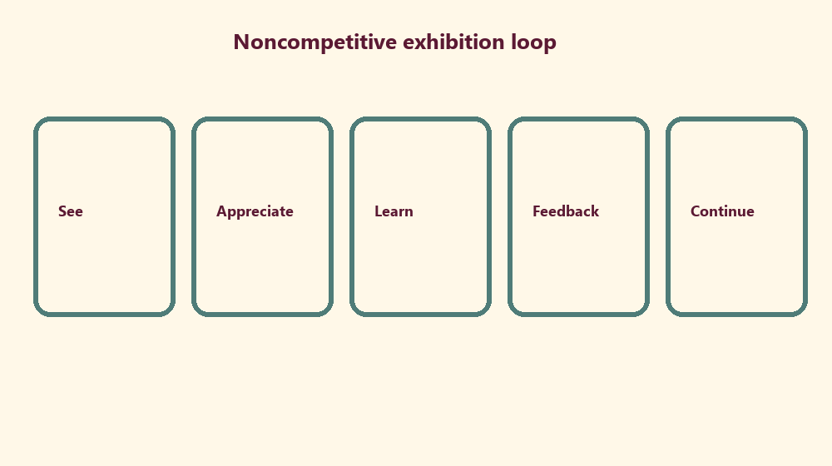

Memory phrase
Continue · Review · Strengthen — without comparison.

Y02 — Appreciation Cards
No ranking winners
CARD 1  I noticed... | CARD 2  I learned...
CARD 3  Thank you for... | CARD 4  This helped me...
CHILD ACTIVITY | Appreciation only — no scoreboard.

Y03 — Favorite Memory Craft
My favorite learning memory:
________________________________________________________________
________________________________________________________________
________________________________________________________________
One person who helped me:
________________________________________________________________
________________________________________________________________
________________________________________________________________

Y04 — Feedback Smile Cards
Kind · specific · hopeful
Kind:
________________________________________________________________
________________________________________________________________
Specific:
________________________________________________________________
________________________________________________________________
Hopeful:
________________________________________________________________
________________________________________________________________

Y05 — Memory Phrase Mat
Continue · Review · Strengthen — without comparison.

Memory phrase
Continue · Review · Strengthen — without comparison.

Older Child Rules
Canonical source: launch/CHILD-HOUSE-RULES.md • SHA-256: 6a525f3dd1da740db86e246622696c7b08e28c1f1475227567d639a5bd54ce47
Parents remain onsite. Facilitators guide the session. Host property rules also apply.

Shared rules (all ages)
1. Keep your body safe — feet on the floor; hands gentle.
2. Use respectful speech — no teasing, yelling, or mean labels.
3. Follow the facilitator safety cue immediately (pause / freeze / come here).
4. No jumping on furniture.
5. No indoor throwing.
6. No writing on walls, books, or furniture that are not activity materials.
7. Ask before entering private rooms.
8. Respect belongings — ask before touching what is not yours.
9. Devices away unless the lesson specifically needs them.
10. Snack only in the allowed area; water anytime with permission.
11. Help clean up before leaving.

Correction ladder (no public shame)
1. Calm reminder
2. Redirect / offer a choice
3. Brief quiet reset in a visible space
4. Parent involvement
5. Sit out a specific activity
6. Private parent/program conversation for repeated patterns
Never: public shame, yelling, sarcasm, corporal punishment, forced chanting, or comparing children.

Younger (K–2) emphasis
- Soft voices indoors
- Stay with the group
- Hands to yourself
- Ask before leaving the room

Older (Grades 4–5) emphasis
- Model respectful speech for younger children
- Devices fully away unless assigned
- Help clean-up leadership
- Honest questions welcome; speculation wait for source check
Printable versions: W1 launch-pack CHILD-RULES-YOUNGER.md and CHILD-RULES-OLDER.md.

O01 — Gentle Verse-Chain Quiz
Not a tournament
One verse I remember:
________________________________________________________________
________________________________________________________________
One week theme I remember:
________________________________________________________________
________________________________________________________________
One family practice I remember:
________________________________________________________________
________________________________________________________________
TEACHER NOTE | Celebrate recall; do not rank scores publicly.

O02 — Exhibition Host Sheet
Welcome line:
________________________________________________________________
________________________________________________________________
One-sentence explain:
________________________________________________________________
________________________________________________________________
Thank-you line:
________________________________________________________________
________________________________________________________________

O03 — Feedback That Helps
Comparative line to avoid:
________________________________________________________________
________________________________________________________________
________________________________________________________________
Helpful rewrite:
________________________________________________________________
________________________________________________________________
________________________________________________________________

O04 — Continue / Review / Strengthen
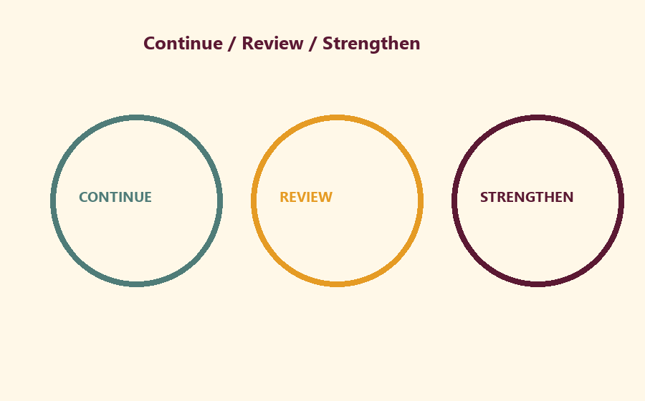
CONTINUE:
________________________________________________________________
________________________________________________________________
REVIEW:
________________________________________________________________
________________________________________________________________
STRENGTHEN:
________________________________________________________________
________________________________________________________________

O05 — Next-Phase Preview
High-level only
One curiosity for next phase:
________________________________________________________________
________________________________________________________________
One support we need:
________________________________________________________________
________________________________________________________________

O06 — Exit Ticket
Continue:
________________________________________________________________
________________________________________________________________
Review:
________________________________________________________________
________________________________________________________________
Strengthen:
________________________________________________________________
________________________________________________________________

Module Project
Canonical source: 11-weekly-program-library/first-six-months/mela-six-month-reflection-family-mela/project/V13-MODULE-PROJECT-BRIEF.md • SHA-256: 7a6ab78f89a51323945b5ff5beccb4e8f0eee82483570cf5410c50710d603623
All prior cycle artifacts may be exhibited. Feedback cards collected for owner learning — strip private names before any repo notes.

Week Home Practice
Memory: Continue · Review · Strengthen — without comparison. Write three private lines: Continue / Review / Strengthen. Optional look at Gaura Pūrṇimā lookahead file — no forced attendance claim.

TEACHER-ONLY
Remove teacher-only pages before distributing participant copies.

Younger Teacher Run Sheet
Canonical source: 11-weekly-program-library/first-six-months/mela-six-month-reflection-family-mela/teacher/YOUNGER-TEACHER-GUIDE-V13.md • SHA-256: d23a4cf880d2d64532174bfaafd7345c7613be1eb398f420aa85123334b3c06f
Use with printable stations. Operator completeness pack.

Main Facilitator Guide — MELA
Six-Month Reflection / Family Mela · Owner-select 2027-02-27 or 2027-03-06 (not a tithi claim) Entry: V13-MELA-START-HERE.md

Primary review center
- ŚB 1.2.18 — https://vedabase.io/en/library/sb/1/2/18/ — hearing/service culture that nourishes bhakti (Cycle 1 opening chain center).
- Review first-six-month verse chain without introducing major new doctrine tonight.

10–20 minute speaking script
Welcome to our Six-Month Reflection / Family Mela.
Owner selects 2027-02-27 or 2027-03-06. This is not a religious tithi claim.
Essential question: What will our family continue, review, and strengthen — without ranking anyone?
We celebrate projects and learning. We give feedback that is kind and specific. We do not crown winners of devotion.
Analogy one — exhibition as garden walk: notice beauty; do not score flowers against each other. Analogy two — feedback as polishing cloth: gentle, specific, hopeful. Analogy three — three doors: Continue / Review / Strengthen.
Household case: A parent compares children aloud during exhibition. Redirect to one appreciative sentence per child without ranking.
Memory line: Continue · Review · Strengthen — without comparison.
Gaura Pūrṇimā (published example 2027-03-22) is lookahead only — do not distort this Mela to force-fit it.

Older Teacher Run Sheet
Canonical source: 11-weekly-program-library/first-six-months/mela-six-month-reflection-family-mela/teacher/OLDER-TEACHER-GUIDE-V13.md • SHA-256: b30e7ba628138b1d0318073675510c65fe9e48e09890c399b8968a47930b32dd
Use with printable stations. Operator completeness pack.

Main Facilitator Guide — MELA
Six-Month Reflection / Family Mela · Owner-select 2027-02-27 or 2027-03-06 (not a tithi claim) Entry: V13-MELA-START-HERE.md

Primary review center
- ŚB 1.2.18 — https://vedabase.io/en/library/sb/1/2/18/ — hearing/service culture that nourishes bhakti (Cycle 1 opening chain center).
- Review first-six-month verse chain without introducing major new doctrine tonight.

10–20 minute speaking script
Welcome to our Six-Month Reflection / Family Mela.
Owner selects 2027-02-27 or 2027-03-06. This is not a religious tithi claim.
Essential question: What will our family continue, review, and strengthen — without ranking anyone?
We celebrate projects and learning. We give feedback that is kind and specific. We do not crown winners of devotion.
Analogy one — exhibition as garden walk: notice beauty; do not score flowers against each other. Analogy two — feedback as polishing cloth: gentle, specific, hopeful. Analogy three — three doors: Continue / Review / Strengthen.
Household case: A parent compares children aloud during exhibition. Redirect to one appreciative sentence per child without ranking.
Memory line: Continue · Review · Strengthen — without comparison.
Gaura Pūrṇimā (published example 2027-03-22) is lookahead only — do not distort this Mela to force-fit it.

Main Facilitator Speaking Map
Canonical source: 11-weekly-program-library/first-six-months/mela-six-month-reflection-family-mela/teacher/MAIN-FACILITATOR-GUIDE-V13.md • SHA-256: aeda86244d5910133e5a47a50dc05ce2a18b12842d6664b6fdfcd6a5e0a5180a
Six-Month Reflection / Family Mela · Owner-select 2027-02-27 or 2027-03-06 (not a tithi claim) Entry: V13-MELA-START-HERE.md

Primary review center
- ŚB 1.2.18 — https://vedabase.io/en/library/sb/1/2/18/ — hearing/service culture that nourishes bhakti (Cycle 1 opening chain center).
- Review first-six-month verse chain without introducing major new doctrine tonight.

10–20 minute speaking script
Welcome to our Six-Month Reflection / Family Mela.
Owner selects 2027-02-27 or 2027-03-06. This is not a religious tithi claim.
Essential question: What will our family continue, review, and strengthen — without ranking anyone?
We celebrate projects and learning. We give feedback that is kind and specific. We do not crown winners of devotion.
Analogy one — exhibition as garden walk: notice beauty; do not score flowers against each other. Analogy two — feedback as polishing cloth: gentle, specific, hopeful. Analogy three — three doors: Continue / Review / Strengthen.
Household case: A parent compares children aloud during exhibition. Redirect to one appreciative sentence per child without ranking.
Memory line: Continue · Review · Strengthen — without comparison.
Gaura Pūrṇimā (published example 2027-03-22) is lookahead only — do not distort this Mela to force-fit it.

Room / Material / Snack / Cleanup Checklist
Done | Area | Check
☐ | Room | Parent circle, younger floor zone, older table zone, clear aisles
☐ | Materials | Labeled track folders, pencils, crayons, tape, timer
☐ | Privacy | Completed forms remain private and never enter Git
☐ | Snack | Snack and water staged for 3:30; allergy plan confirmed
☐ | Safety | Calm corner visible; private rooms closed; exits clear
☐ | Cleanup | Tables wiped and host home reset assigned

RIGHTS NOTE | KUTUMBA-original framing; cited third-party material retains its own rights. Human/temple review remains EXTERNAL_OPEN.

