KUTUMBA

MELA — Younger Teacher Pack
  - K–2 run sheet and activities
MELA • Six-Month Reflection / Family Mela
V13 • Families Growing in Krishna Consciousness
Program Director: Swapnil Patil
Internal founding-cohort teaching material — human/temple review EXTERNAL_OPEN
KUTUMBA | Families Growing in Krishna Consciousness

Locked Saturday Schedule
Time | Block
1:50–2:00 | Arrival
2:00–2:10 | Opening mantras + welcome
2:10–2:30 | All-family launch/orientation
2:30–3:10 | Parallel tracks
3:10–3:30 | Reunification + bhakti laboratory
3:30–3:40 | Snack + water
3:40–3:55 | Saṅkalpa + project + home practice
3:55–4:00 | Close

TIME CUE | Mela planning date 2027-03-06. Use 2:30 / 3:10 cues when parallel tracks run; local tithi remains EXTERNAL_OPEN.

Primary verse: First-six-month review chain
Source URL: https://vedabase.io/en/library/sb/1/2/18/

Younger Teacher Run Sheet
Canonical source: 11-weekly-program-library/first-six-months/mela-six-month-reflection-family-mela/teacher/YOUNGER-TEACHER-GUIDE-V13.md • SHA-256: d23a4cf880d2d64532174bfaafd7345c7613be1eb398f420aa85123334b3c06f
Use with printable stations. Operator completeness pack.

Main Facilitator Guide — MELA
Six-Month Reflection / Family Mela · Owner-select 2027-02-27 or 2027-03-06 (not a tithi claim) Entry: V13-MELA-START-HERE.md

Primary review center
- ŚB 1.2.18 — https://vedabase.io/en/library/sb/1/2/18/ — hearing/service culture that nourishes bhakti (Cycle 1 opening chain center).
- Review first-six-month verse chain without introducing major new doctrine tonight.

10–20 minute speaking script
Welcome to our Six-Month Reflection / Family Mela.
Owner selects 2027-02-27 or 2027-03-06. This is not a religious tithi claim.
Essential question: What will our family continue, review, and strengthen — without ranking anyone?
We celebrate projects and learning. We give feedback that is kind and specific. We do not crown winners of devotion.
Analogy one — exhibition as garden walk: notice beauty; do not score flowers against each other. Analogy two — feedback as polishing cloth: gentle, specific, hopeful. Analogy three — three doors: Continue / Review / Strengthen.
Household case: A parent compares children aloud during exhibition. Redirect to one appreciative sentence per child without ranking.
Memory line: Continue · Review · Strengthen — without comparison.
Gaura Pūrṇimā (published example 2027-03-22) is lookahead only — do not distort this Mela to force-fit it.

Child House Rules
Canonical source: launch/CHILD-HOUSE-RULES.md • SHA-256: 6a525f3dd1da740db86e246622696c7b08e28c1f1475227567d639a5bd54ce47
Parents remain onsite. Facilitators guide the session. Host property rules also apply.

Shared rules (all ages)
1. Keep your body safe — feet on the floor; hands gentle.
2. Use respectful speech — no teasing, yelling, or mean labels.
3. Follow the facilitator safety cue immediately (pause / freeze / come here).
4. No jumping on furniture.
5. No indoor throwing.
6. No writing on walls, books, or furniture that are not activity materials.
7. Ask before entering private rooms.
8. Respect belongings — ask before touching what is not yours.
9. Devices away unless the lesson specifically needs them.
10. Snack only in the allowed area; water anytime with permission.
11. Help clean up before leaving.

Correction ladder (no public shame)
1. Calm reminder
2. Redirect / offer a choice
3. Brief quiet reset in a visible space
4. Parent involvement
5. Sit out a specific activity
6. Private parent/program conversation for repeated patterns
Never: public shame, yelling, sarcasm, corporal punishment, forced chanting, or comparing children.

Younger (K–2) emphasis
- Soft voices indoors
- Stay with the group
- Hands to yourself
- Ask before leaving the room

Older (Grades 4–5) emphasis
- Model respectful speech for younger children
- Devices fully away unless assigned
- Help clean-up leadership
- Honest questions welcome; speculation wait for source check
Printable versions: W1 launch-pack CHILD-RULES-YOUNGER.md and CHILD-RULES-OLDER.md.

Y01 — Exhibition Walk
See · say one kind word
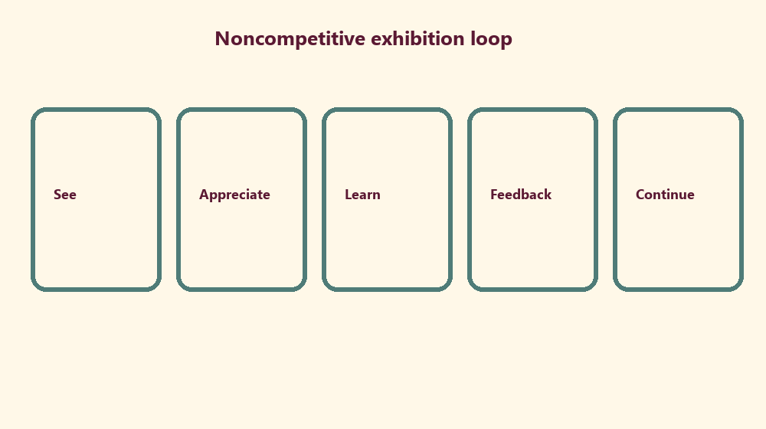

Memory phrase
Continue · Review · Strengthen — without comparison.

Y02 — Appreciation Cards
No ranking winners
CARD 1  I noticed... | CARD 2  I learned...
CARD 3  Thank you for... | CARD 4  This helped me...
CHILD ACTIVITY | Appreciation only — no scoreboard.

Y03 — Favorite Memory Craft
My favorite learning memory:
________________________________________________________________
________________________________________________________________
________________________________________________________________
One person who helped me:
________________________________________________________________
________________________________________________________________
________________________________________________________________

Y04 — Feedback Smile Cards
Kind · specific · hopeful
Kind:
________________________________________________________________
________________________________________________________________
Specific:
________________________________________________________________
________________________________________________________________
Hopeful:
________________________________________________________________
________________________________________________________________

Y05 — Memory Phrase Mat
Continue · Review · Strengthen — without comparison.

Memory phrase
Continue · Review · Strengthen — without comparison.
RIGHTS NOTE | KUTUMBA-original framing; cited third-party material retains its own rights. Human/temple review remains EXTERNAL_OPEN.

