KUTUMBA

C1-W1 OLDER TEACHER GUIDE
  - Families Growing in Krishna Consciousness
C1-W1
V12 • Families Growing in Krishna Consciousness
Program Director: Swapnil Patil
Internal founding-cohort teaching material — human/temple review EXTERNAL_OPEN
KUTUMBA | Families Growing in Krishna Consciousness

Week: What Is KUTUMBA and Why Are We Here? Primary: ŚB 1.2.18 — https://vedabase.io/en/library/sb/1/2/18/ Session length: ~40 minutes (parallel track ~2:30–3:10) Parents: Remain onsite; reunite at 3:10 Status: Internal founding-cohort teaching material — human/temple review EXTERNAL_OPEN
◆ ◆ ◆

Objective
Students observe ŚB 1.2.18, explain that protected weekly hearing plus home practice create a path for family growth, map a Hear → Practice → Steadier devotion diagram, and contribute one project sentence answering: Why are we committing as a family?

Exact memory phrase
Regular hearing and service to Śrīmad-Bhāgavatam steadies our family's devotion.
Short echo: Hear + Practice steadies us.

Teacher background
- KUTUMBA teaching meaning: When we regularly hear and serve the Bhāgavata (book and devotee association), troubles in the heart are cleared and steady devotion to the Lord becomes established. (Label as KUTUMBA teaching meaning — not as BBT translation.)
- Supporting frames (one sentence each): ŚB 1.2.17 — the Lord in the heart cleanses the faithful hearer; ŚB 1.2.19 — passion and ignorance can recede as hearing nourishes goodness; ŚB 1.1.4 — sages assemble to inquire about duty (pattern of protected hearing).
- Block: “Attendance alone equals growth” and “Alone is always holier than association.”
- Scope: Do not teach soul ontology (W2–W3) or rarity scare (W4) tonight.

Materials
- Printed verse strip: Devanāgarī + IAST + KUTUMBA teaching meaning
- Worksheet copies from activities/OLDER-ACTIVITY-PACK.md
- Scenario cards (Saturday-only family; home-only / avoid association; ranking siblings — fictional)
- Hear–Practice–Steady diagram sheet
- Pencils; timer; answer key activities/OLDER-ANSWER-KEY.md for teacher only
- Project contribution half-sheets
- Matching term cards (optional cut set)
◆ ◆ ◆

Minute-by-minute plan

0–5 min — Settle and hook
- Welcome; feet on floor.
- Hook: “Which is more true — ‘Coming on Saturday is enough’ or ‘Staying home alone is always safer’?” Let two volunteers answer; hold both as incomplete.
- State essential question: Why are we committing as a family?

5–14 min — Primary text observation (ŚB 1.2.18)
- Display verse; read IAST aloud together once; teacher reads Devanāgarī slowly or plays authorized audio if available.
- Students underline three idea-words in the teaching meaning: regularly, hear/serve, steady devotion.
- Observation prompts (write short answers):
- What kind of service does the verse point to? (Bhāgavata — book and devotee association)
- What happens as troubles in the heart are cleared? (steady devotion becomes established)
- What does this verse not say? (that one Saturday replaces home practice; that science proves bhakti)
- Add one-sentence bridges:
- ŚB 1.2.17 — hearing with faith invites cleansing in the heart.
- ŚB 1.1.4 — protected inquiry in association is a model pattern, not a claim that our room equals that forest.
- Paraphrase only; no invented dialogue.

14–22 min — Worksheet questions
Students complete Section A of the older activity pack:
- Restate KUTUMBA teaching meaning in their own words (one sentence).
- Name two halves of family growth (weekly hearing + home practice).
- Why is “attendance alone” incomplete?
- Why is “alone is always holier” incomplete?
- Write one 5–15 minute if-then home cue for this week.
Teacher circulates; use OLDER-ANSWER-KEY.md for expected directions (not for grading ranks).

22–28 min — Scenario cards (small groups)
Each group gets one fictional card:
Card A — Saturday-only: Never miss 2:00–4:00; zero weekday cue. Mistaken line: “Attendance equals growth.” Card B — Home-only avoiders: Chant at home; avoid association because awkward. Mistaken line: “Alone is always safer.” Card C — Ranking hallway: Parent compares children’s seriousness aloud. Mistaken line: “Ranking produces devotion.”
For each card, group writes:
- What is the mistaken conclusion?
- What compassionate response keeps dignity?
- What is one better family action (no shame, no ranking)?
Share one insight per group (60 seconds).

28–33 min — Puzzle / game: Hear–Practice Match
- Place four term cards face down: Hearing · Saṅkalpa · Charter · Association.
- Place four meaning cards: Regular Bhāgavata reception · Specific practice intention · KUTUMBA purposes/boundaries · Learning with devotees.
- Teams race (quietly) to match all four; then one student explains why Hearing and Association both matter for ŚB 1.2.18.
- Keep energy respectful; no mocking wrong matches.

33–37 min — Diagram task
On the Hear–Practice–Steady sheet, students fill:
Protected Saturday hearing → Tiny home practice → Steadier family devotion
Draw one arrow labeled ŚB 1.2.18 into the Steady box. Write the short echo inside it.

37–40 min — Project contribution + reflection + handoff
- Complete project half-sheet: “We are committing as a family because _______________.”
- Reflection (one sentence): Where might I confuse a garden analogy with the verse itself?
- Cleanup; bring sheets to reunification.
- Parent handoff line: Home practice is After dinner dishes → say memory phrase once (5 minutes counts).

Extension (if group finishes early)
Compare ŚB 1.2.19 (passion/ignorance receding through hearing) with the garden image: roots grow before flowers. Still no soul ontology dump.

Answer key pointer
Teacher-facing expected answers: activities/OLDER-ANSWER-KEY.md. Do not distribute the key to students during the first attempt.

Behavior and privacy
- Redirect side talk: “Return to your diagram — Steady box only.”
- No forced confession of real family attendance gaps.
- No ranking scores aloud.
- Parents onsite; snack/water belongs to main schedule, not track rewards framed as a meal.

Instructional visuals
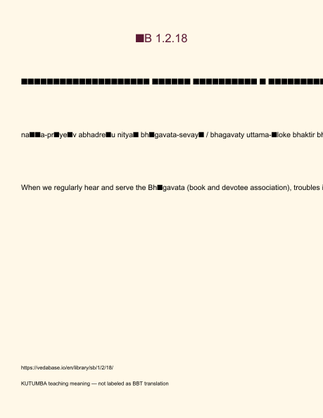
Original KUTUMBA visual: verse-card.png
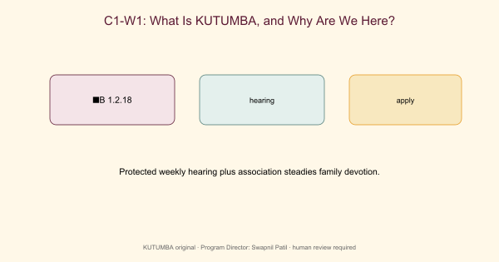
Original KUTUMBA visual: concept-diagram.png
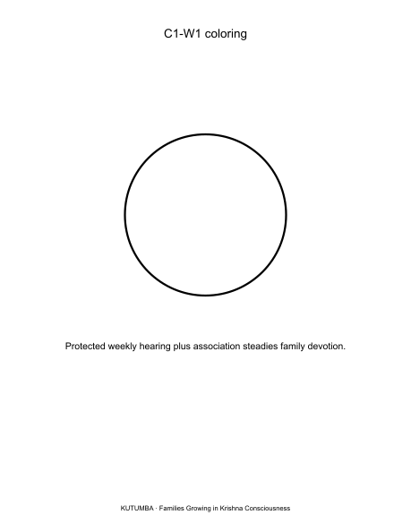
Original KUTUMBA visual: line-art-younger.png
RIGHTS NOTE | Original KUTUMBA program material. Scripture/BBT/ISKCON/third-party rights remain with their holders.

