KUTUMBA

C1-W1 YOUNGER TEACHER GUIDE
  - Families Growing in Krishna Consciousness
C1-W1
V12 • Families Growing in Krishna Consciousness
Program Director: Swapnil Patil
Internal founding-cohort teaching material — human/temple review EXTERNAL_OPEN
KUTUMBA | Families Growing in Krishna Consciousness

Week: What Is KUTUMBA and Why Are We Here? Primary: ŚB 1.2.18 — https://vedabase.io/en/library/sb/1/2/18/ Session length: 40 minutes (parallel track ~2:30–3:10) Parents: Remain onsite; reunite at 3:10 Status: Internal founding-cohort teaching material — human/temple review EXTERNAL_OPEN
◆ ◆ ◆

Objective
Children experience that regular hearing and a tiny home practice belong together. They plant a “Hear → Practice” seed card and take home one watering cue for the week.

Exact memory phrase
Regular hearing and service to Śrīmad-Bhāgavatam steadies our family's devotion.

Teacher background (2 minutes to review)
- KUTUMBA teaching meaning (adult wording): When we regularly hear and serve the Bhāgavata (book and devotee association), troubles in the heart are cleared and steady devotion to the Lord becomes established.
- Child-facing paraphrase: When our family hears about Kṛṣṇa again and again, and does one kind practice at home, our hearts can grow steady — like a garden that is watered every week.
- Block misconceptions (child words):
- “Coming on Saturday is enough; we can skip home.”
- “Only big kids / only temple people hear.”
- Do not: invent sage dialogue; use fear; rank who “hears better”; claim science proves devotion.

Materials
- Small clear cup or pot with a paper “seed” labeled Hear → Practice (demo object)
- Card stock for garden watering cards (one per child)
- Blue crayon / marker for “water drops”
- Soft toss object (backup game)
- Printed visuals/V12/line-art-younger.svg if available (US Letter)
- Crayons; tape; name stickers
- Calm-corner chair visible to room

Room setup
Circle on the floor; materials table behind you; garden demo cup at center. Keep aisles clear for Freeze-and-Remember walking.
◆ ◆ ◆

Minute-by-minute executable plan

0–5 min — Opening and recall
- Welcome by name; feet on floor; hands in lap.
- Show the seed cup: “Hear” on one side of the seed, “Practice” on the other.
- Echo memory phrase twice, clap rhythm: Regular hearing / and service / steadies our devotion.
- Ask: “Who heard a Kṛṣṇa story this week?” Accept nods; no forced stories.

5–13 min — Story script (paraphrase only; ~8 minutes)
Say exactly this spine (do not invent deity dialogue):
Long ago, wise people gathered in a peaceful place to hear about the Lord and ask how to live well. They did not come only once and forget. They came ready to listen carefully. We are not those forest sages — but we can borrow their habit: set a protected time, hear together, and take one small practice home. Śrīmad-Bhāgavatam teaches that when we regularly hear and serve — the book and the friendship of devotees — the heart can become steadier in devotion to the Lord. A garden grows when someone waters it again and again. One splash and then forgetting is not enough. Saturday hearing and a tiny home practice belong together.
Story boundaries: Paraphrase from ŚB 1.1–1.2 assembly pattern and ŚB 1.2.18 themes only. No invented quotes. No fear. No claiming our room equals Naimiṣāraṇya.

13–16 min — Three wonder questions
- What do we do on Saturday that helps our hearts? (Hear together)
- What tiny thing can we do at home so the garden keeps growing? (Practice)
- Who can we serve with kindness this week? (name one person)
Accept one- or two-word answers. Affirm effort.

16–24 min — Movement game: Freeze and Water (steps)
- Children walk gently in a circle (or march in place).
- Teacher says Freeze! — everyone stops.
- Teacher says the first half: “Regular hearing and service…” — children finish: “…steadies our family's devotion.”
- Teacher says Water! — children pretend to pour two gentle drops (tap one finger twice) toward the center cup.
- Play three rounds. On round three, after Freeze, show two picture cards: (A) only Saturday, then empty week; (B) Saturday + tiny home practice. Children point to B.
- End seated; echo memory phrase once.

24–32 min — Craft: Garden watering card (steps)
- Give each child a folded card-stock “garden card.”
- Outside: draw a small plant or sprout (model once).
- Inside, teacher or helper writes: Regular hearing and service to Śrīmad-Bhāgavatam steadies our family's devotion. (Or sticker the short line if literacy is limited: Hear + Practice steadies us.)
- Draw five blank water-drop circles on the back.
- Practice once: child “waters” drop 1 by tracing blue while whispering the memory phrase.
- Tell them: each home practice this week, color one drop.
Full printable steps also live in activities/YOUNGER-ACTIVITY-PACK.md (use together; this guide remains executable if the pack is missing).

32–35 min — Printable / coloring task
If time remains, color the younger line-art sheet (visuals/V12/line-art-younger.svg). If short on time, skip coloring and keep the garden card as the take-home.

35–38 min — Behavior redirects and quiet reset
Use calm, specific redirects:
- Feet on floor — “Feet visit the mat.”
- Kind words — “Garden voices are soft.”
- Toy rests — “Toy takes a nap on the shelf.”
- Quiet reset — one minute in calm corner holding the seed cup picture; rejoin on next Freeze.

38–40 min — Cleanup and parent handoff
- Crayons in bin; cards stacked; demo cup away.
- Each child holds garden watering card.
- At reunification, tell parent in one sentence:
Memory phrase: “Regular hearing and service to Śrīmad-Bhāgavatam steadies our family's devotion.” Home cue: After dinner dishes, say the phrase once and color one water drop.
- Do not report private behavior struggles in front of other families.
◆ ◆ ◆

Behavior redirects (quick reference)
Signal | Teacher line | Child action
Running | “Freeze bodies — garden walk.” | Freeze, then walk
Snatching | “Kind hands water the garden.” | Hands to lap
Loud shout | “Soft garden voice.” | Soft repeat
Shutdown | “Quiet reset is okay.” | Calm corner 60 sec

Backup low-prep (if craft fails or energy crashes)
- Sit in a circle with soft toss object.
- Child catches, says one word: “hear,” “practice,” “kind,” or “Kṛṣṇa,” then tosses to next.
- End with three echoes of the memory phrase.
- Optional: pass the seed cup; each child “waters” it once with a finger tap.

What success looks like
- Child can point to Hear and Practice on the seed.
- Child can echo (or finish) the memory phrase.
- Child can name one home watering moment.

Boundaries
- Snack/water only happens in main schedule (3:30), not as a track bribe.
- No weekly meal language.
- No fabricated approval stickers implying temple certification.
- Privacy: no forced confession of “we never practice at home.”

Instructional visuals

Original KUTUMBA visual: verse-card.png
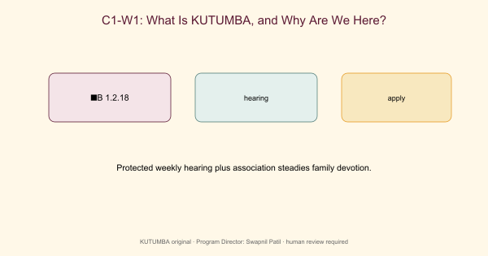
Original KUTUMBA visual: concept-diagram.png
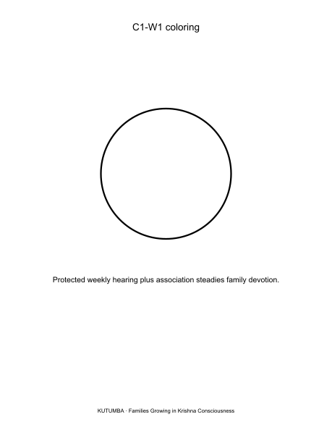
Original KUTUMBA visual: line-art-younger.png
RIGHTS NOTE | Original KUTUMBA program material. Scripture/BBT/ISKCON/third-party rights remain with their holders.

