KUTUMBA

C1-W2 MAIN FACILITATOR GUIDE
  - Families Growing in Krishna Consciousness
C1-W2
V12 • Families Growing in Krishna Consciousness
Program Director: Swapnil Patil
Internal founding-cohort teaching material — human/temple review EXTERNAL_OPEN
KUTUMBA | Families Growing in Krishna Consciousness

KUTUMBA • Families Growing in Krishna Consciousness Program Director: Swapnil Patil Status: Internal founding-cohort teaching material — human/temple review EXTERNAL_OPEN Controlling guide: This V12 file is authoritative for Saturday delivery. Core teaching is inlined below.

Two-minute summary
Body changes; conscious self continues — care for the body without mistaking it for the self. Primary: BG 2.13 (https://vedabase.io/en/library/bg/2/13/). Essential question: How should knowing I am not only this body change how we speak about bodies?

Essential question
How should knowing I am not only this body change how we speak about bodies?

15-minute night-before prep
- Open https://vedabase.io/en/library/bg/2/13/ and reread Devanāgarī, IAST, and KUTUMBA teaching meaning below.
- Rehearse the speaking script section aloud once (aim for clear 10–15 minute delivery with pauses).
- Pack younger + older materials and memory cards.
- Review misconception to block: Psychology or photos prove the soul.
- Confirm snack/water only (no weekly meal); parents onsite; privacy reminder card visible.
- For C1-W4: verify Mṛgāri source cards say CC Madhya 24.229–282 (not SB 6.x / SB 4.8).

60-minute deep prep
- Read the inlined analogies, examples, and three cases in this guide until you can teach them without notes.
- Mark which discovery / understanding / application questions you will actually ask.
- Choose one analogy and one case as your "must teach" pair; keep the others ready for Q&A.
- Walk the room: parent circle, younger zone, older zone, reunification seats.
- Pre-write the home-practice minimum version on a card (5 minutes counts).
- Review deferral line: laboratory methods measure bodies/behavior; ātman/bhakti claims rest on śāstra — no false science proof.
- Skim project/CYCLE-CONTRIBUTION.md for this week's artifact layer.
- Optional enrichment only (not a substitute for this guide): research folder files.

Exact primary and supporting readings

Primary (locked)
- Reference: BG 2.13
- URL: https://vedabase.io/en/library/bg/2/13/
- Devanāgarī: देहिनोऽस्मिन् यथा देहे कौमारं यौवनं जरा । तथा देहान्तरप्राप्तिर्धीरस्तत्र न मुह्यति ॥ १३ ॥
- IAST: dehino ’smin yathā dehe kaumāraṁ yauvanaṁ jarā / tathā dehāntara-prāptir dhīras tatra na muhyati
- KUTUMBA teaching meaning: Just as the embodied self passes through childhood, youth, and old age in one body, the sober person is not bewildered when the self passes to another body.
- Rights: Sanskrit verse text from VedaBase display; KUTUMBA teaching meaning original; no full purport.

Supporting readings
- BG 2.22 — https://vedabase.io/en/library/bg/2/22/ — As one puts on new garments, the soul accepts new bodies — analogy with limits; full ontology reserved for W3.
- BG 2.20 — https://vedabase.io/en/library/bg/2/20/ — Supporting: the soul is not slain when the body is slain — preview only; deep teaching next week.

Teaching map with exact Saturday 2:00–4:00 time cues
Time | Block | Facilitator focus
1:50–2:00 | Arrival | Welcome; privacy; parents onsite; materials check
2:00–2:10 | Opening mantras | Keep simple; invitation not volume contest
2:10–2:30 | Shared opening / Prem-kī-Kathā + verse | Deliver opening of speaking script; state memory line
2:30–3:10 | Parallel tracks | Parent circle / younger / older — see track transition
3:10–3:30 | Reunification / bhakti lab | Family synthesis sentence; no ranking
3:30–3:40 | Snack + water only | No weekly meal service
3:40–3:55 | Saṅkalpa / project / Q&A | Home cue + project artifact + likely questions
3:55–4:00 | Closing | Next-week title only; no early ontology

10–20 minute speaking script (deliverable prose)
Facilitation note: Speak naturally. Pause for the 20-second pair share where indicated. Do not replace this with "see research."
Welcome back. Tonight's title is simple and easy to misuse: I Am Not This Body.
Essential question: How should knowing I am not only this body change how we speak about bodies?
Primary reading: BG 2.13 — https://vedabase.io/en/library/bg/2/13/
KUTUMBA teaching meaning: "Just as the embodied self passes through childhood, youth, and old age in one body, the sober person is not bewildered when the self passes to another body."
Conclusion: Body changes; conscious self continues — care for the body without mistaking it for the self.
If you remember only one boundary, remember this: psychology insights and family photos can help us teach respectfully. They do not prove the soul. Our doctrine rests on śāstra.
Walk through the verse with me in plain language. In one body we all recognize childhood, youth, and later age. The sober person is not bewildered when the embodied self continues beyond one body's stage — including, the verse indicates, the passage to another body. We will not dump cosmology on K–2 tonight. We will teach dignity: the body changes; the conscious person continues; speech about bodies should be kind.
Analogy one — changing garments (supported by BG 2.22): clothes change, wearer continues. Limit: clothes are chosen; bodies are not costumes for mockery; bodies deserve care.
Analogy two — life-stage photos: same name across pictures. Limit: photos are pedagogy, not proof.
Analogy three — driver and vehicle: operator is not the metal. Limit: refuse harsh dualism. Maintain the vehicle for service.
Scriptural frame: Arjuna's opening grief is tangled with bodily relationships (https://vedabase.io/en/library/bg/1/). Kṛṣṇa's teaching begins by clarifying the embodied self. Paraphrase only.
Household case: sibling appearance teasing at snack. Mistaken conclusion: "just a joke." Principle: respectful speech. Action: repair language and make a seven-day pledge.
We are not teaching body neglect. Sleep, food, medicine, and hygiene remain acts of responsibility. We are teaching identity clarity.
Supporting readings:
- BG 2.22 — https://vedabase.io/en/library/bg/2/22/ — As one puts on new garments, the soul accepts new bodies — analogy with limits; full ontology reserved for W3.
- BG 2.20 — https://vedabase.io/en/library/bg/2/20/ — Supporting: the soul is not slain when the body is slain — preview only; deep teaching next week.
Tracks next. Memory line: My body changes; I continue as the conscious self.
I am going to teach the analogies slowly, with limits in the same breath, because an analogy without a limit becomes a new false doctrine.
First: Changing garments. Clothes change; the wearer continues. Helps children grasp body vs self. Limit: Clothes are chosen; bodies are not fashion accessories. Do not teach contempt for the body.
Second: Life-stage photos. Same person across childhood, youth, elder photos — continuity of the 'I'. Limit: Photos are not ontology proof; memory and personality also change in expression.
Third: Driver and vehicle. The operator uses the vehicle; the operator is not the metal. Limit: Avoid harsh dualism ('body is trash'). Care for the vehicle for service.
Hold those as teaching tools, not as replacements for BG 2.13.
Now two sourced examples, paraphrased only.
Example A — Arjuna's grief at Kurukṣetra opening (BG Ch. 1–2 narrative). Arjuna's distress is tied to bodily relationships. Kṛṣṇa's teaching begins by clarifying the embodied self — paraphrase only; no invented dialogue. Link: https://vedabase.io/en/library/bg/1/
Example B — Garment analogy support (BG 2.22). Scriptural analogy for changing bodies; keep limits explicit in class. Link: https://vedabase.io/en/library/bg/2/22/
Next I will walk all three household cases out loud so you can copy the pattern at home. Please listen for seven fields every time: situation, mistaken conclusion, principle, source, compassionate response, action, and what not to say.
Case 1. Situation: A sibling teases another about appearance during snack. Mistaken conclusion: Body comments are harmless jokes. Principle and source: BG 2.13 — respectful speech about changing bodies; dignity of every person. (https://vedabase.io/en/library/bg/2/13/) Compassionate response: Stop the tease gently. Affirm both children's dignity. Repair with a kind sentence. Family action: Family speech pledge: no appearance jokes at home this week. What not to say: Toughen up. It's just a joke. Spiritual people ignore feelings.
Case 2. Situation: A teen builds identity almost entirely around fitness metrics. Mistaken conclusion: The body project is the self. Principle and source: Care for body as vehicle; self continues beyond stages (BG 2.13). (https://vedabase.io/en/library/bg/2/13/) Compassionate response: Affirm health goals. Separate 'I care for this body' from 'I am only this body.' Family action: Keep healthy routine; add one non-body identity practice (memory line / service). What not to say: Fitness is māyā — stop exercising. Your body doesn't matter.
Case 3. Situation: A relative asks a child's weight publicly at a gathering. Mistaken conclusion: Public body talk is normal and fine. Principle and source: Privacy + respect; body is not public property. (Program privacy practice + BG 2.13 dignity) Compassionate response: Change the subject warmly; protect the child without shaming the relative in front of others if possible. Family action: Parents agree on a redirect line beforehand. What not to say: Announce the child's stats. Lecture the relative with anger in front of the child.
I will now ask the room three discovery questions. You may answer in a whisper to a partner:
- What changes about your body that you can notice without shame?
- Where have body jokes hurt someone at home or school?
- What would respectful body-speech sound like this week?
Understanding check — please be ready to say in one sentence: Body changes; conscious self continues — care for the body without mistaking it for the self.. Name the primary: BG 2.13. Name what we are not teaching tonight: ranking, speculation, and the misconception “Psychology or photos prove the soul.”.
Application — before you leave the shared opening, decide silently: time + place for home practice; who starts if others are tired; and the minimum version if the week is hard. Five minutes counts. Memory line plus one kind action counts.
Let me demonstrate a minimum home practice out loud so nobody leaves confused. Tonight after dinner, or at the same chair each evening, someone says the memory line once: “My body changes; I continue as the conscious self..” Then one family member paraphrases BG 2.13 in a single sentence. Then one gratitude or service act — thanking someone, offering water, putting shoes away as kindness, or a short prayer. If the house is chaotic, keep only the memory line and one kind action. That still honors tonight’s conclusion: Body changes; conscious self continues — care for the body without mistaking it for the self.
When we reunite at 3:10, I will not score families. I will ask for one sentence: “This week we will…” Drawings count. Whispered parent sentences count. Loud brilliance is not holier than quiet sincerity.
Likely questions you may hear from adults — rehearse these answers with me:
If someone asks, “Do photos prove the soul?” — answer: No. Photos help pedagogy about continuity. Ontology rests on śāstra (BG 2.13+), not albums.
If someone asks, “Should we ignore the body?” — answer: No. Care for health, rest, and hygiene. Refuse identity = body, not refuse care.
If someone asks, “Is this teaching reincarnation details?” — answer: This week introduces continuity of the self through stages and points to transmigration modestly. Deep soul ontology is W3.
If someone asks, “What about disability or illness?” — answer: Every body deserves dignity and care. Never imply someone is 'less' because of bodily condition.
If someone asks, “Can psychology replace this lesson?” — answer: Psychology may help speech and body-image habits. It does not prove ātman.
A short word on boundaries. We do not invent quotations. We do not dump full purports into Git or into the room. We do not diagnose families medically or spiritually in public. We do not guarantee initiation, advancement, or certification. We do not claim human, temple, CPO, or publication approval. Science may help habits; it does not prove ātman or replace śāstra.
Operational covenant aloud: Saturday 2:00–4:00; snack and water only; parents onsite; private struggles stay private; no false approval labels.
Recite with me before tracks:
- Essential question: How should knowing I am not only this body change how we speak about bodies?
- Conclusion: Body changes; conscious self continues — care for the body without mistaking it for the self.
- Memory line: My body changes; I continue as the conscious self.
- Misconception to block: Psychology or photos prove the soul.
- Primary: BG 2.13 — https://vedabase.io/en/library/bg/2/13/
Parents: your job in the parent circle is not to perform brilliance. It is to leave with a cue, a minimum version, and a kinder sentence than the one you might have used last week. Younger and older teachers will deepen practice in age bands. We reunite at 3:10 for one family sentence: “This week we will…”
That is the heart of tonight's teaching. Let us practice it, not merely admire it.

Analogies with limits (inline — teach from here)

1. Changing garments
- Teaches: Clothes change; the wearer continues. Helps children grasp body vs self.
- Limit (say out loud): Clothes are chosen; bodies are not fashion accessories. Do not teach contempt for the body.

2. Life-stage photos
- Teaches: Same person across childhood, youth, elder photos — continuity of the 'I'.
- Limit (say out loud): Photos are not ontology proof; memory and personality also change in expression.

3. Driver and vehicle
- Teaches: The operator uses the vehicle; the operator is not the metal.
- Limit (say out loud): Avoid harsh dualism ('body is trash'). Care for the vehicle for service.

Scriptural and devotional examples (inline paraphrase)

1. Arjuna's grief at Kurukṣetra opening
- Provenance: BG Ch. 1–2 narrative
- URL: https://vedabase.io/en/library/bg/1/
- Classroom paraphrase use: Arjuna's distress is tied to bodily relationships. Kṛṣṇa's teaching begins by clarifying the embodied self — paraphrase only; no invented dialogue.

2. Garment analogy support
- Provenance: BG 2.22
- URL: https://vedabase.io/en/library/bg/2/22/
- Classroom paraphrase use: Scriptural analogy for changing bodies; keep limits explicit in class.

Three constructed household cases (inline)

Constructed case 1
Field | Content
Situation | A sibling teases another about appearance during snack.
Mistaken conclusion | Body comments are harmless jokes.
Principle | BG 2.13 — respectful speech about changing bodies; dignity of every person.
Source | https://vedabase.io/en/library/bg/2/13/
Compassionate response | Stop the tease gently. Affirm both children's dignity. Repair with a kind sentence.
Family action | Family speech pledge: no appearance jokes at home this week.
What not to say | Toughen up. It's just a joke. Spiritual people ignore feelings.

Constructed case 2
Field | Content
Situation | A teen builds identity almost entirely around fitness metrics.
Mistaken conclusion | The body project *is* the self.
Principle | Care for body as vehicle; self continues beyond stages (BG 2.13).
Source | https://vedabase.io/en/library/bg/2/13/
Compassionate response | Affirm health goals. Separate 'I care for this body' from 'I am only this body.'
Family action | Keep healthy routine; add one non-body identity practice (memory line / service).
What not to say | Fitness is māyā — stop exercising. Your body doesn't matter.

Constructed case 3
Field | Content
Situation | A relative asks a child's weight publicly at a gathering.
Mistaken conclusion | Public body talk is normal and fine.
Principle | Privacy + respect; body is not public property.
Source | Program privacy practice + BG 2.13 dignity
Compassionate response | Change the subject warmly; protect the child without shaming the relative in front of others if possible.
Family action | Parents agree on a redirect line beforehand.
What not to say | Announce the child's stats. Lecture the relative with anger in front of the child.

Discovery questions
- What changes about your body that you can notice without shame?
- Where have body jokes hurt someone at home or school?
- What would respectful body-speech sound like this week?

Understanding questions
- State BG 2.13's teaching meaning in one sentence.
- Name one analogy and its limit.
- What does this week not claim about science or photos?

Application questions
- What family speech rule will we keep for seven days?
- How will we care for the body as service this week?
- What is our minimum respectful redirect when teasing starts?

Five likely Q&A
Question | Source-based direction
Do photos prove the soul? | No. Photos help pedagogy about continuity. Ontology rests on śāstra (BG 2.13+), not albums.
Should we ignore the body? | No. Care for health, rest, and hygiene. Refuse identity = body, not refuse care.
Is this teaching reincarnation details? | This week introduces continuity of the self through stages and points to transmigration modestly. Deep soul ontology is W3.
What about disability or illness? | Every body deserves dignity and care. Never imply someone is 'less' because of bodily condition.
Can psychology replace this lesson? | Psychology may help speech and body-image habits. It does not prove ātman.

Misconceptions to block
- Psychology or photos prove the soul.
- Confusing analogy with scripture quotation
- Importing next week's full ontology early
- Ranking families or children
- Claiming science proves or disproves ātman / bhakti metaphysics
- False human, temple, CPO, or publication approval labels

What not to speculate about
- Invented quotations, purport dumps, or unverified lecture lines
- Private medical or spiritual diagnoses of families
- Guarantees of advancement, initiation, or certification
- Graphic retellings (especially Mṛgāri) or fear-based death pressure on children
- For W4: any claim that Mṛgāri is located in SB 6.x or SB 4.8

Track transition (say at ~2:28)
Parents remain in the parent circle. Younger friends go with [younger teacher]. Older students go with [older teacher]. We reunite at 3:10. We do not rank groups.

Family reunification synthesis (3:10–3:30)
Invite one sentence per family tied to the essential question:
"This week we will…"
Accept drawings or whispered parent sentences for shy children. No scoreboard.

Project contribution
Advance the cumulative project Who Am I, and How Should Our Family Live? using project/CYCLE-CONTRIBUTION.md. This week layer must connect to BG 2.13 and tonight's conclusion. Store artifacts for Week 6. Non-competitive.

Home practice (5–15 minutes)
- Say the memory line once: My body changes; I continue as the conscious self.
- Paraphrase BG 2.13 in one family sentence.
- Do one gratitude or service act.
- Minimum version if exhausted: memory line + one kind action only.

Next-week preview
Name only: C1-W3 — The Nature of the Soul. Do not teach next week's ontology in depth tonight.

Do not claim
Human/temple/CPO approval; publication readiness; BBT ownership of KUTUMBA teaching meanings; science proving ātman; ranking results; guaranteed spiritual outcomes.

Misconceptions and no-speculation boundaries
- Do not invent dialogue for scriptural persons.
- Do not diagnose private karma or modes as insults in the room.
- Do not claim temple/BBT/human approval that has not been given.
- Defer off-scope questions with the standard deferral line.

Instructional visuals
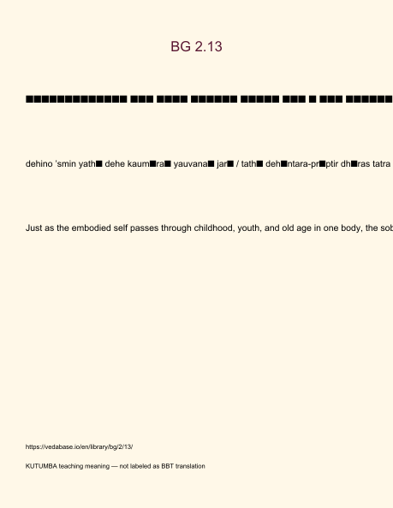
Original KUTUMBA visual: verse-card.png
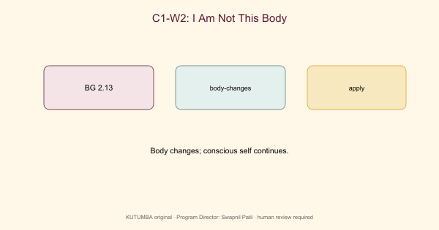
Original KUTUMBA visual: concept-diagram.png
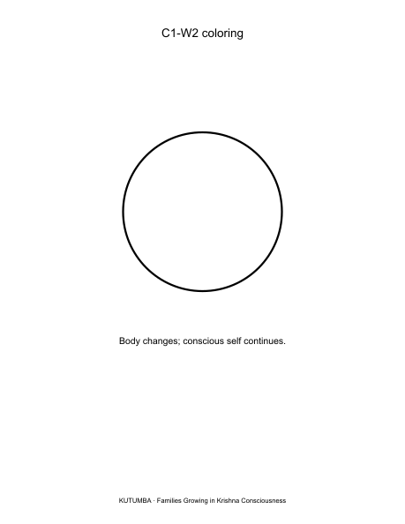
Original KUTUMBA visual: line-art-younger.png
RIGHTS NOTE | Original KUTUMBA program material. Scripture/BBT/ISKCON/third-party rights remain with their holders.

