KUTUMBA

C1-W2 OLDER TEACHER GUIDE
  - Families Growing in Krishna Consciousness
C1-W2
V12 • Families Growing in Krishna Consciousness
Program Director: Swapnil Patil
Internal founding-cohort teaching material — human/temple review EXTERNAL_OPEN
KUTUMBA | Families Growing in Krishna Consciousness

Week: I Am Not This Body Primary: BG 2.13 — https://vedabase.io/en/library/bg/2/13/ Session length: ~40 minutes (parallel track ~2:30–3:10) Parents: Remain onsite; reunite at 3:10 Status: Internal founding-cohort teaching material — human/temple review EXTERNAL_OPEN
◆ ◆ ◆

Objective
Students observe BG 2.13, explain that the body changes while the conscious self continues, map Care-without-confusion, practice respectful body speech, and contribute one project sentence answering: How should knowing I am not only this body change how we speak about bodies?

Exact memory phrase
My body changes; I continue as the conscious self.
Short echo: Care for the body; don’t confuse it with the self.

Teacher background
- KUTUMBA teaching meaning: Just as the embodied self passes through childhood, youth, and old age in one body, the sober person is not bewildered when the self passes to another body. (Label as KUTUMBA teaching meaning — not as BBT translation.)
- Supporting frames (one sentence each): BG 2.22 — garments analogy with limits (clothes chosen; bodies not costumes for mockery); BG 2.20 — preview only (deep teaching next week).
- Block: “Psychology or photos prove the soul” and “Body neglect is spiritual” and “Appearance jokes are harmless.”
- Scope: No full jīva ontology dump (W3); no rarity scare (W4).

Materials
- Printed verse strip: Devanāgarī + IAST + KUTUMBA teaching meaning
- Worksheet copies from activities/OLDER-ACTIVITY-PACK.md
- Scenario cards (sibling appearance tease; fitness-as-self; public weight question — fictional)
- Care–Self / driver–vehicle diagram sheet
- Pencils; timer; answer key activities/OLDER-ANSWER-KEY.md for teacher only
- Project contribution half-sheets
- R / M fork cards (Respectful / Mistaken)
◆ ◆ ◆

Minute-by-minute plan

0–5 min — Settle and hook
- Welcome; feet on floor.
- Hook: “Which is worse as a teaching error — treating the body as the whole self, or treating the body as trash?” Let two volunteers answer; hold both as incomplete extremes.
- State essential question: How should knowing I am not only this body change how we speak about bodies?

5–14 min — Primary text observation (BG 2.13)
- Display verse; read IAST aloud together once; teacher reads Devanāgarī slowly or plays authorized audio if available.
- Students underline three idea-clusters in the teaching meaning: childhood–youth–old age, embodied self, not bewildered.
- Observation prompts (write short answers):
- What changes inside one body according to the verse?
- Who is not bewildered when passage continues?
- What does this verse not authorize? (mockery; body contempt; lab proof of ātman)
- Add one-sentence bridges:
- BG 2.22 — garments support continuity teaching; limits: bodies deserve care; not fashion props for jokes.
- BG 2.20 — preview only: soul not slain when body is — deep teaching next week.
- Paraphrase only; no invented Kṛṣṇa–Arjuna dialogue; no gore.

14–22 min — Worksheet questions
Students complete Section A of the older activity pack:
- Restate KUTUMBA teaching meaning in their own words (one sentence).
- Name two body changes everyone recognizes.
- Name one way to care for the body as service readiness (not identity).
- Why don’t photos prove the soul?
- Why is “bodies don’t matter” not this week’s teaching?
- Rewrite “It’s just a joke” into a repair sentence after appearance teasing.
Teacher circulates; use OLDER-ANSWER-KEY.md for expected directions (not for grading ranks).

22–28 min — Scenario cards (small groups)
Each group gets one fictional card:
Card A — Sibling appearance tease at snack: Mistaken line: “Just a joke.” Card B — Teen identity = fitness metrics: Mistaken line: “The body project is the self.” Card C — Relative asks weight publicly: Mistaken line: “Public body talk is fine.”
For each card, group writes:
- Mistaken conclusion
- Principle from BG 2.13 (one sentence)
- Compassionate response
- Better family action
- One sentence they should not say (shame, ranking, or public exposure)
Share one insight per group (60 seconds).

28–33 min — Puzzle / game: Respectful Fork
- Teacher reads a short fork aloud (two endings about body speech or care).
- Teams hold up R (respectful / aligned) or M (mistaken).
- Three rounds, then students explain one “R” choice using the words care or self continues.
- Keep energy respectful; no mocking wrong holds.
Sample forks (paraphrase freely):
- Tease vs repair after a height comment
- Skip sleep “because spiritual” vs rest as service readiness
- Announce someone’s stats vs change the subject warmly

33–37 min — Diagram task
On the Care–Self sheet, students fill:
Body stages (child→youth→elder) → Conscious self continues → Kind speech + responsible care
Circle the Kind speech box and write the short echo inside it. Use a low-risk example (shoes too small, lost pencil joke) — not forced trauma disclosure.

37–40 min — Project contribution + reflection + handoff
- Complete project half-sheet: “This week our family will speak about bodies by _______________.”
- Reflection (one sentence): How does BG 2.13 challenge both body-as-self and body-contempt?
- Cleanup; bring sheets to reunification.
- Parent handoff line: Home practice is once daily — notice one body change or repair one speech habit; say the memory phrase.

Extension (if group finishes early)
Compare garment analogy limits with driver–vehicle: maintain the vehicle for service; refuse harsh dualism. Still no W3 “I am God” deep dive beyond a one-line preview if asked.

Answer key pointer
Teacher-facing expected answers: activities/OLDER-ANSWER-KEY.md. Do not distribute the key to students during the first attempt.

Behavior and privacy
- Redirect side talk: “Return to your Care–Self map — kind speech box.”
- No forced confession of real teasing incidents.
- No ranking scores aloud.
- Parents onsite; snack/water belongs to main schedule, not track rewards framed as a meal.

Instructional visuals
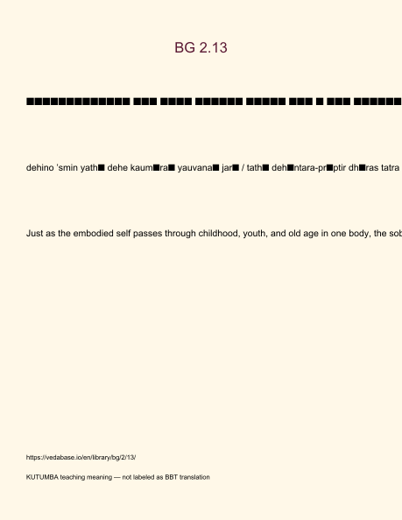
Original KUTUMBA visual: verse-card.png
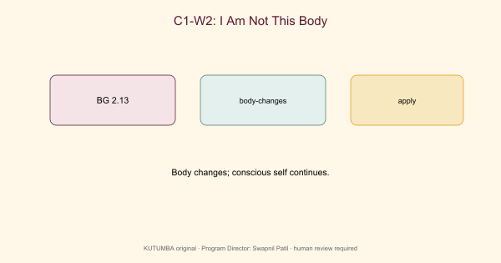
Original KUTUMBA visual: concept-diagram.png
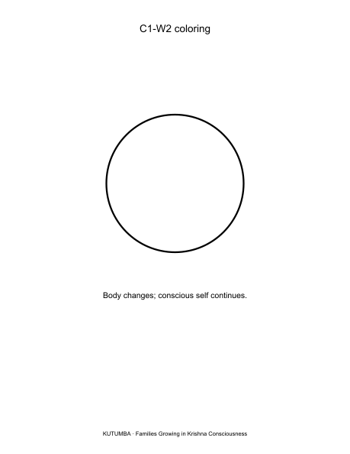
Original KUTUMBA visual: line-art-younger.png
RIGHTS NOTE | Original KUTUMBA program material. Scripture/BBT/ISKCON/third-party rights remain with their holders.

