KUTUMBA

C1-W2 YOUNGER TEACHER GUIDE
  - Families Growing in Krishna Consciousness
C1-W2
V12 • Families Growing in Krishna Consciousness
Program Director: Swapnil Patil
Internal founding-cohort teaching material — human/temple review EXTERNAL_OPEN
KUTUMBA | Families Growing in Krishna Consciousness

Week: I Am Not This Body Primary: BG 2.13 — https://vedabase.io/en/library/bg/2/13/ Session length: 40 minutes (parallel track ~2:30–3:10) Parents: Remain onsite; reunite at 3:10 Status: Internal founding-cohort teaching material — human/temple review EXTERNAL_OPEN
◆ ◆ ◆

Objective
Children experience that the body changes while the conscious “I” continues. They practice kind body-speech and take home a “care without confusing” cue card.

Exact memory phrase
My body changes; I continue as the conscious self.

Teacher background (2 minutes to review)
- KUTUMBA teaching meaning (adult wording): Just as the embodied self passes through childhood, youth, and old age in one body, the sober person is not bewildered when the self passes to another body.
- Child-facing paraphrase: Your body grows and changes, like clothes that get bigger. You are still you — the person who can love Kṛṣṇa. We care for our bodies; we do not tease bodies.
- Block misconceptions (child words):
- “Photos / science prove the soul.”
- “Bodies don’t matter — skip care.”
- “Appearance jokes are fine.”
- Do not: invent Kṛṣṇa–Arjuna dialogue; use death scare; dump full reincarnation ontology (preview only); force body-shame stories.

Materials
- Three life-stage picture cards (child / youth / elder — respectful drawings, not real family photos of students)
- Soft scarf or fabric square for “changing garments” demo
- Card stock for Care / Self cue cards
- Crayons / markers
- Printed visuals/V12/line-art-younger.svg if available
- Soft toss object for backup
- Calm-corner chair

Room setup
Circle on the floor; picture cards in order on a low stand; aisles clear for Grow-and-Freeze movement.
◆ ◆ ◆

Minute-by-minute executable plan

0–5 min — Opening and recall
- Welcome by name; feet on floor; hands in lap.
- Show child → youth → elder cards quickly: “Bodies change.”
- Echo memory phrase three times: My body changes; / I continue / as the conscious self.
- Ask: “Did anyone’s shoes get too small this year?” Laugh gently; connect to change.

5–13 min — Story script (paraphrase only; ~8 minutes)
Say exactly this spine (do not invent deity dialogue):
Long ago, Arjuna felt heavy sadness about people he loved. His feelings were tangled with bodies and relationships. He asked Kṛṣṇa to teach him what was true. Kṛṣṇa taught that just as we pass through childhood, youth, and older age in one body, the sober person is not confused when the conscious self continues beyond one body’s stage. Clothes change; the person who wears them continues. Photos of a baby and a grown child show change — and still one “I.” We care for our bodies like a driver cares for a car. We do not call bodies trash. We do not tease how someone looks. My body changes; I continue as the conscious self.
Story boundaries: Paraphrase BG 2.13 and gentle BG 2.22 garment support only. No invented quotes. No gore. No “your body is garbage.” Full ontology waits for W3.

13–16 min — Three wonder questions
- What changes as we grow? (Body / shoes / height)
- Who continues — the person who can love and choose kind words? (I / conscious self)
- What is one kind thing to say (or not say) about someone’s body?
Accept short answers. Affirm effort.

16–24 min — Movement game: Grow and Freeze (steps)
- Spread children in a safe open space.
- Teacher calls Grow! — children stretch tall slowly (body changing).
- Teacher calls Freeze! — freeze; whisper memory phrase.
- Teacher calls Kind hands! — hands on heart; smile at a neighbor (no touching without consent — wave is fine).
- Play three rounds. On round three, show two cards: (A) tease about looks; (B) kind words. On Freeze, children point to B.
- End seated; echo memory phrase once.

24–32 min — Craft: Care / Self cue card (steps)
- Give each child a folded card stock.
- Outside left: draw a small body outline; label Care.
- Outside right: draw a simple heart or “I”; label Self.
- Inside, teacher/helper writes: My body changes; I continue as the conscious self.
- On the back, child draws one kind body action (sleep, water, brush teeth) OR one kind speech bubble (“You’re a friend”).
- Practice once: touch Care → touch Self while saying the phrase.
Full printable steps also live in activities/YOUNGER-ACTIVITY-PACK.md.

32–35 min — Printable / coloring task
Color line-art if time; otherwise keep cue card as take-home.

35–38 min — Behavior redirects and quiet reset
- Feet on floor — “Feet visit the mat.”
- Kind words — “Use Care words.”
- Toy rests — “Toy naps on the shelf.”
- Quiet reset — calm corner with Care card; rejoin on Kind hands.

38–40 min — Cleanup and parent handoff
- Materials away; each child holds cue card.
- Parent line:
Memory: “My body changes; I continue as the conscious self.” Home cue: once daily — notice one body change or one kind body-speech; say the phrase.
- No private teasing reports in the hallway.
◆ ◆ ◆

Behavior redirects (quick reference)
Signal | Teacher line | Child action
Appearance tease | “Care words only.” | Repair sentence
Running | “Freeze bodies.” | Freeze, walk
Loud shout | “Soft self voice.” | Soft repeat
Shutdown | “Quiet reset okay.” | Calm corner 60 sec

Backup low-prep
- Circle with soft toss object.
- Catch → say “change” or “continue” or “kind.”
- Three echoes of memory phrase.
- Optional: wrap/unwrap scarf once as garment demo.

What success looks like
- Child can show Care vs Self on the card.
- Child can echo the memory phrase.
- Child can name one kind body-speech or care act.

Boundaries
- Snack/water only at main schedule (3:30).
- No weekly meal language.
- Psychology/photos are pedagogy — never “proof of the soul.”
- No forced confession of home teasing.

Instructional visuals
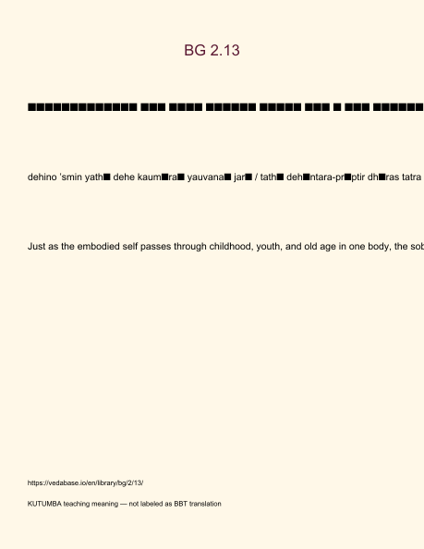
Original KUTUMBA visual: verse-card.png
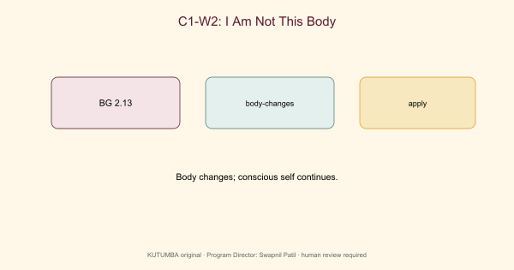
Original KUTUMBA visual: concept-diagram.png
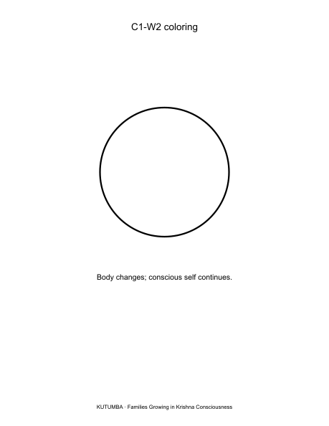
Original KUTUMBA visual: line-art-younger.png
RIGHTS NOTE | Original KUTUMBA program material. Scripture/BBT/ISKCON/third-party rights remain with their holders.

