KUTUMBA

C1-W3 OLDER TEACHER GUIDE
  - Families Growing in Krishna Consciousness
C1-W3
V12 • Families Growing in Krishna Consciousness
Program Director: Swapnil Patil
Internal founding-cohort teaching material — human/temple review EXTERNAL_OPEN
KUTUMBA | Families Growing in Krishna Consciousness

Week: The Nature of the Soul Primary: BG 2.20 — https://vedabase.io/en/library/bg/2/20/ Session length: ~40 minutes (parallel track ~2:30–3:10) Parents: Remain onsite; reunite at 3:10 Status: Internal founding-cohort teaching material — human/temple review EXTERNAL_OPEN
◆ ◆ ◆

Objective
Students observe BG 2.20, map jīva is/is-not (eternal, conscious, individual, minute, related in service — not God Himself), complete a sun-ray diagram, practice a science deferral line, and answer: If I am a soul, how should I live?

Exact memory phrase
I am an eternal soul — conscious, individual, and meant for Kṛṣṇa's service.
Short echo: Spark who serves — not the sun.

Teacher background
- KUTUMBA teaching meaning: The soul is never born and never dies; unborn, eternal, and everlasting — not destroyed when the body is destroyed. (KUTUMBA teaching meaning — not BBT translation.)
- Supporting frames: BG 15.7 — eternal fragmental parts (qualitative likeness, quantitative difference); BG 2.17 — that which pervades the body is indestructible; ŚB 5.10 Jaḍa Bharata context — bodily labels do not define the soul (gentle paraphrase only).
- Block: “All souls are God / we are the Supreme”; “science disproved the soul”; “body contempt is spiritual.”
- Science stance: N/A — no empirical claim is needed for this week's doctrinal conclusion about ātman. Labs measure bodies/behavior; doctrine rests on śāstra.

Materials
- Printed verse strip: Devanāgarī + IAST + KUTUMBA teaching meaning
- Worksheet copies from activities/OLDER-ACTIVITY-PACK.md
- Scenario cards (‘I am God’ boast; anti-science dismissal; hygiene neglect — fictional)
- Is/Is-not + sun-ray diagram sheet
- Pencils; timer; activities/OLDER-ANSWER-KEY.md (teacher only)
- Project contribution half-sheets
- T / F cards for Soul Map game
◆ ◆ ◆

Minute-by-minute plan

0–5 min — Settle and hook
- Welcome; feet on floor.
- Hook: “If a child proudly says ‘I am God,’ what gentle correction fits — and what would shame look like?” Collect two answers; hold for verse.
- Essential question: If I am a soul, how should I live?

5–14 min — Primary text observation (BG 2.20)
- Display verse; read IAST together once; Devanāgarī slowly or authorized audio.
- Students underline: never born / never dies / not destroyed when the body is destroyed.
- Observation prompts (write short answers):
- What continues when the body is destroyed?
- What is not claimed (that jīva = the Supreme)?
- What domain does laboratory science measure?
- Add bridges:
- BG 15.7 — fragmental part; spark ≠ sun.
- Science deferral line aloud once as a class.
- Paraphrase only; no invented dialogue; Jaḍa Bharata only if gentle and nonviolent.

14–22 min — Worksheet questions
Students complete Section A:
- Restate teaching meaning in one sentence.
- Fill: eternal _______________ parts (fragmental).
- Mark IS / IS NOT for body, Supreme, conscious individual, service.
- Write a gentle correction for “I am God.”
- Write science deferral in own words.
- Name one body-care act as service readiness.
Circulate with answer key for directions, not ranks.

22–28 min — Scenario cards (small groups)
Card A — Child: ‘I am God.’ Mistaken: Soul equals the Supreme. Card B — Adult: ‘Science disproved the soul.’ Mistaken: Empiricism settled ātman. Card C — Family neglects hygiene ‘because we are soul.’ Mistaken: Body contempt is spiritual.
Each group writes mistaken conclusion / principle / compassionate response / better action / what not to say. Share 60 seconds.

28–33 min — Puzzle / game: Soul Map True/False
- Teacher reads statements (examples below).
- Teams hold T or F, then one sentence why.
- Four to five rounds; respectful energy; no mocking.
Sample statements:
- The soul is never born. (T)
- The jīva is God Himself. (F)
- Labs prove the soul exists. (F)
- Caring for the body can support service. (T)
- Bodily job labels fully define the person. (F)

33–37 min — Diagram task
Complete is/is-not table and sun ← ray sketch. Circle service relationship. Write short echo inside. Low-risk examples only.

37–40 min — Project contribution + reflection + handoff
- Project: “Because I am a soul, this week I will live by _______________.”
- Reflection: How do BG 2.20 and BG 15.7 together block both nihilism and “I am God”?
- Cleanup; reunification sheets ready.
- Parent handoff: daily phrase + one care act as service readiness; keep science deferral ready.

Extension (if group finishes early)
One gentle Jaḍa Bharata status-label point (ŚB 5.10) — nonviolent, no invented dialogue — connecting bodily labels ≠ soul identity.

Answer key pointer
Teacher-facing expected answers: activities/OLDER-ANSWER-KEY.md. Do not distribute during first attempt.

Behavior and privacy
- Redirect “I am God” boasts without public shame: “Dear spark who serves.”
- No ranking; no forced metaphysical debates with visitors.
- Snack/water on main schedule only — not track bribes.

Instructional visuals
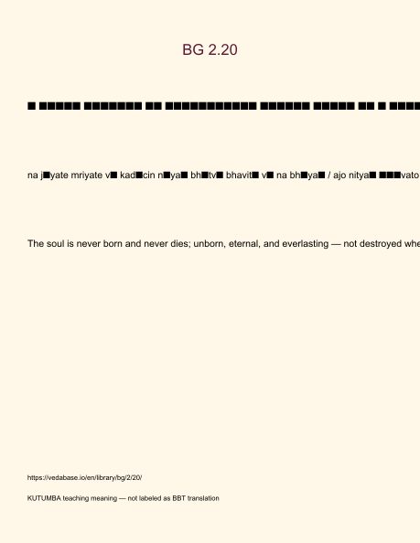
Original KUTUMBA visual: verse-card.png
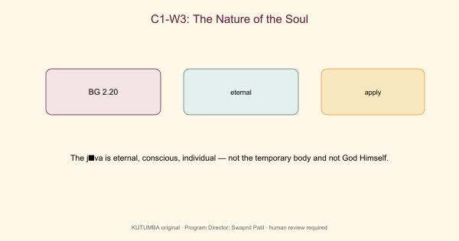
Original KUTUMBA visual: concept-diagram.png
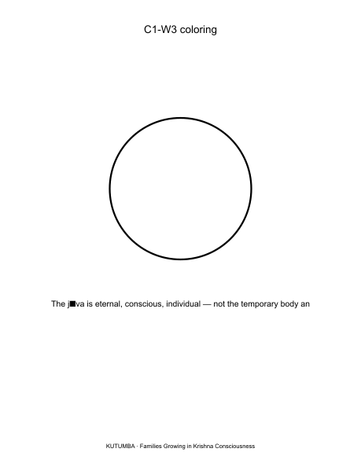
Original KUTUMBA visual: line-art-younger.png
RIGHTS NOTE | Original KUTUMBA program material. Scripture/BBT/ISKCON/third-party rights remain with their holders.

