KUTUMBA

C1-W4 MAIN FACILITATOR GUIDE
  - Families Growing in Krishna Consciousness
C1-W4
V12 • Families Growing in Krishna Consciousness
Program Director: Swapnil Patil
Internal founding-cohort teaching material — human/temple review EXTERNAL_OPEN
KUTUMBA | Families Growing in Krishna Consciousness

KUTUMBA • Families Growing in Krishna Consciousness Program Director: Swapnil Patil Status: Internal founding-cohort teaching material — human/temple review EXTERNAL_OPEN Controlling guide: This V12 file is authoritative for Saturday delivery. Core teaching is inlined below.

Two-minute summary
Human life gives a rare opportunity for deliberate self-realization — protect inquiry and practice time. Primary: ŚB 11.9.29 (https://vedabase.io/en/library/sb/11/9/29/). Essential question: What deserves protected family time?

Essential question
What deserves protected family time?

15-minute night-before prep
- Open https://vedabase.io/en/library/sb/11/9/29/ and reread Devanāgarī, IAST, and KUTUMBA teaching meaning below.
- Rehearse the speaking script section aloud once (aim for clear 10–15 minute delivery with pauses).
- Pack younger + older materials and memory cards.
- Review misconception to block: Use fear or death-pressure to motivate children.
- Confirm snack/water only (no weekly meal); parents onsite; privacy reminder card visible.
- For C1-W4: verify Mṛgāri source cards say CC Madhya 24.229–282 (not SB 6.x / SB 4.8).

60-minute deep prep
- Read the inlined analogies, examples, and three cases in this guide until you can teach them without notes.
- Mark which discovery / understanding / application questions you will actually ask.
- Choose one analogy and one case as your "must teach" pair; keep the others ready for Q&A.
- Walk the room: parent circle, younger zone, older zone, reunification seats.
- Pre-write the home-practice minimum version on a card (5 minutes counts).
- Review deferral line: laboratory methods measure bodies/behavior; ātman/bhakti claims rest on śāstra — no false science proof.
- Skim project/CYCLE-CONTRIBUTION.md for this week's artifact layer.
- Optional enrichment only (not a substitute for this guide): research folder files.

Exact primary and supporting readings

Primary (locked)
- Reference: ŚB 11.9.29
- URL: https://vedabase.io/en/library/sb/11/9/29/
- Devanāgarī: लब्ध्वा सुदुर्लभमिदं बहुसम्भवान्ते मानुष्यमर्थदमनित्यमपीह धीर: । तूर्णं यतेत न पतेदनुमृत्यु यावन्नि:श्रेयसाय विषय: खलु सर्वत: स्यात् ॥ २९ ॥
- IAST: labdhvā su-durlabham idaṁ bahu-sambhavānte mānuṣyam artha-dam anityam apīha dhīraḥ / tūrṇaṁ yateta na pated anu-mṛtyu yāvan niḥśreyasāya viṣayaḥ khalu sarvataḥ syāt
- KUTUMBA teaching meaning: After many births one obtains the rare human form — temporary yet able to give the highest purpose. A sober person should quickly endeavor for the ultimate good while this body lasts.
- Rights: Sanskrit verse text from VedaBase display; KUTUMBA teaching meaning original; no full purport.

Supporting readings
- BG 2.40 — https://vedabase.io/en/library/bg/2/40/ — No loss or diminution in this endeavor; a little progress protects from fear.
- CC Madhya 24.229–282 (Nārada–Mṛgāri) — https://vedabase.io/en/library/cc/madhya/24/ — Mercy and authorized instruction transform harmful conduct — not SB 6.x / SB 4.8.

Teaching map with exact Saturday 2:00–4:00 time cues
Time | Block | Facilitator focus
1:50–2:00 | Arrival | Welcome; privacy; parents onsite; materials check
2:00–2:10 | Opening mantras | Keep simple; invitation not volume contest
2:10–2:30 | Shared opening / Prem-kī-Kathā + verse | Deliver opening of speaking script; state memory line
2:30–3:10 | Parallel tracks | Parent circle / younger / older — see track transition
3:10–3:30 | Reunification / bhakti lab | Family synthesis sentence; no ranking
3:30–3:40 | Snack + water only | No weekly meal service
3:40–3:55 | Saṅkalpa / project / Q&A | Home cue + project artifact + likely questions
3:55–4:00 | Closing | Next-week title only; no early ontology

10–20 minute speaking script (deliverable prose)
Facilitation note: Speak naturally. Pause for the 20-second pair share where indicated. Do not replace this with "see research."
Essential question: What deserves protected family time?
Primary locked verse: ŚB 11.9.29 — https://vedabase.io/en/library/sb/11/9/29/
Teaching meaning: "After many births one obtains the rare human form — temporary yet able to give the highest purpose. A sober person should quickly endeavor for the ultimate good while this body lasts."
Conclusion: Human life gives a rare opportunity for deliberate self-realization — protect inquiry and practice time.
This week can slide into fear if we are careless. We will not scare children with death pressure. We will speak of rare opportunity, mercy, and protected time.
Supporting narrative — correct source discipline: Nārada and Mṛgāri is Caitanya-caritāmṛta Madhya 24.229–282 (https://vedabase.io/en/library/cc/madhya/24/229/). It is not ŚB 6.x and not ŚB 4.8. Useful anchors: intro 24.229, name 24.242, bow 24.255–256, careful steps 24.270–272, conclusion 24.278–282. Paraphrase only; no gore.
The hunter's turn toward careful life illustrates mercy transforming human opportunity — it does not authorize terror tactics at home.
Analogies: rare ticket, crossroads, seed season — each teaches urgency-without-panic. Limits: no species contempt; no guaranteed timetable; no shaming.
BG 2.40 support: a little sincere progress is not lost — this helps families who only have five minutes.
Case: screens consume the only quiet block. Action: one Must jar slot before Optional screens.
Case: parent uses death scare. Stop it. Rewrite the ask as invitation.
Supporting readings:
- BG 2.40 — https://vedabase.io/en/library/bg/2/40/ — No loss or diminution in this endeavor; a little progress protects from fear.
- CC Madhya 24.229–282 (Nārada–Mṛgāri) — https://vedabase.io/en/library/cc/madhya/24/ — Mercy and authorized instruction transform harmful conduct — not SB 6.x / SB 4.8.
Memory: Human life is a rare chance to ask who I am and serve Kṛṣṇa.
I am going to teach the analogies slowly, with limits in the same breath, because an analogy without a limit becomes a new false doctrine.
First: Rare ticket. A hard-to-get ticket is meant to be used, not forgotten in a drawer. Limit: Not a scare tactic; opportunity language, not threat language.
Second: Crossroads sign. Choice of path matters when the road splits. Limit: No species contempt; no mocking other forms of life.
Third: Seed season. Plant while the season is open. Limit: No guaranteed harvest timing; avoid pressuring children with panic.
Hold those as teaching tools, not as replacements for ŚB 11.9.29.
Now two sourced examples, paraphrased only.
Example A — Nārada and the hunter Mṛgāri (CC Madhya 24.229–282). Nārada meets a hunter, teaches him, and the hunter's life turns toward care and devotion (bow broken; careful steps even toward ants — paraphrase gently). Source is Madhya 24 — not SB 6.x or SB 4.8. Link: https://vedabase.io/en/library/cc/madhya/24/229/
Example B — Rare human form teaching (ŚB 11.9.29). Primary: after many births, human form is rare and purpose-capable — use it for the highest good. Link: https://vedabase.io/en/library/sb/11/9/29/
Next I will walk all three household cases out loud so you can copy the pattern at home. Please listen for seven fields every time: situation, mistaken conclusion, principle, source, compassionate response, action, and what not to say.
Case 1. Situation: Screens eat the family's only quiet evening block every night. Mistaken conclusion: Entertainment first is always fine. Principle and source: ŚB 11.9.29 — protect opportunity for inquiry and practice. (https://vedabase.io/en/library/sb/11/9/29/) Compassionate response: No shame spiral. Name one protected 10-minute block as 'Must.' Family action: Move one optional screen slot after the spiritual cue. What not to say: You're wasting your human life forever. Terrify the kids.
Case 2. Situation: A parent uses death scare to make a child chant. Mistaken conclusion: Fear creates lasting urgency. Principle and source: Compassion and opportunity — not terror. BG 2.40 supports steady endeavor without fear-panic. (https://vedabase.io/en/library/bg/2/40/) Compassionate response: Stop fear tactics. Replace with invitation and short joyful practice. Family action: Rewrite the family ask: 'We get to practice' not 'or else.' What not to say: If you don't chant you'll be punished / die badly.
Case 3. Situation: Calendar is full; no inquiry time remains. Mistaken conclusion: Busy equals successful human life. Principle and source: Human form is for realization — trade one optional for hearing. (https://vedabase.io/en/library/sb/11/9/29/) Compassionate response: Audit optional activities with kindness; keep duties; protect one inquiry slot. Family action: Time-jar: Must / Should / Optional — move one item. What not to say: Quit school/work to prove spirituality.
I will now ask the room three discovery questions. You may answer in a whisper to a partner:
- What currently wins your family's evening time?
- Where have you heard fear used as a spiritual motivator?
- What would a protected 'Must' block look like?
Understanding check — please be ready to say in one sentence: Human life gives a rare opportunity for deliberate self-realization — protect inquiry and practice time.. Name the primary: ŚB 11.9.29. Name what we are not teaching tonight: ranking, speculation, and the misconception “Use fear or death-pressure to motivate children.”.
Application — before you leave the shared opening, decide silently: time + place for home practice; who starts if others are tired; and the minimum version if the week is hard. Five minutes counts. Memory line plus one kind action counts.
Let me demonstrate a minimum home practice out loud so nobody leaves confused. Tonight after dinner, or at the same chair each evening, someone says the memory line once: “Human life is a rare chance to ask who I am and serve Kṛṣṇa..” Then one family member paraphrases ŚB 11.9.29 in a single sentence. Then one gratitude or service act — thanking someone, offering water, putting shoes away as kindness, or a short prayer. If the house is chaotic, keep only the memory line and one kind action. That still honors tonight’s conclusion: Human life gives a rare opportunity for deliberate self-realization — protect inquiry and practice time.
When we reunite at 3:10, I will not score families. I will ask for one sentence: “This week we will…” Drawings count. Whispered parent sentences count. Loud brilliance is not holier than quiet sincerity.
Likely questions you may hear from adults — rehearse these answers with me:
If someone asks, “Should we scare kids so they take life seriously?” — answer: No. Teach opportunity and mercy. Fear tactics are out of bounds.
If someone asks, “Where is the Mṛgāri story from?” — answer: Caitanya-caritāmṛta Madhya 24.229–282 — not ŚB 6.x or ŚB 4.8.
If someone asks, “Does valuing human life mean disrespecting animals?” — answer: No. No species contempt. Care and compassion remain.
If someone asks, “What if we only have five minutes?” — answer: Five protected minutes of hearing/inquiry still honor the opportunity (aligns with BG 2.40 little progress).
If someone asks, “Is this week about leaving family life?” — answer: No. It is about protecting inquiry inside family life.
A short word on boundaries. We do not invent quotations. We do not dump full purports into Git or into the room. We do not diagnose families medically or spiritually in public. We do not guarantee initiation, advancement, or certification. We do not claim human, temple, CPO, or publication approval. Science may help habits; it does not prove ātman or replace śāstra.
Operational covenant aloud: Saturday 2:00–4:00; snack and water only; parents onsite; private struggles stay private; no false approval labels.
Recite with me before tracks:
- Essential question: What deserves protected family time?
- Conclusion: Human life gives a rare opportunity for deliberate self-realization — protect inquiry and practice time.
- Memory line: Human life is a rare chance to ask who I am and serve Kṛṣṇa.
- Misconception to block: Use fear or death-pressure to motivate children.
- Primary: ŚB 11.9.29 — https://vedabase.io/en/library/sb/11/9/29/
Parents: your job in the parent circle is not to perform brilliance. It is to leave with a cue, a minimum version, and a kinder sentence than the one you might have used last week. Younger and older teachers will deepen practice in age bands. We reunite at 3:10 for one family sentence: “This week we will…”
That is the heart of tonight's teaching. Let us practice it, not merely admire it.

Analogies with limits (inline — teach from here)

1. Rare ticket
- Teaches: A hard-to-get ticket is meant to be used, not forgotten in a drawer.
- Limit (say out loud): Not a scare tactic; opportunity language, not threat language.

2. Crossroads sign
- Teaches: Choice of path matters when the road splits.
- Limit (say out loud): No species contempt; no mocking other forms of life.

3. Seed season
- Teaches: Plant while the season is open.
- Limit (say out loud): No guaranteed harvest timing; avoid pressuring children with panic.

Scriptural and devotional examples (inline paraphrase)

1. Nārada and the hunter Mṛgāri
- Provenance: CC Madhya 24.229–282
- URL: https://vedabase.io/en/library/cc/madhya/24/229/
- Classroom paraphrase use: Nārada meets a hunter, teaches him, and the hunter's life turns toward care and devotion (bow broken; careful steps even toward ants — paraphrase gently). Source is Madhya 24 — not SB 6.x or SB 4.8.

2. Rare human form teaching
- Provenance: ŚB 11.9.29
- URL: https://vedabase.io/en/library/sb/11/9/29/
- Classroom paraphrase use: Primary: after many births, human form is rare and purpose-capable — use it for the highest good.

Three constructed household cases (inline)

Constructed case 1
Field | Content
Situation | Screens eat the family's only quiet evening block every night.
Mistaken conclusion | Entertainment first is always fine.
Principle | ŚB 11.9.29 — protect opportunity for inquiry and practice.
Source | https://vedabase.io/en/library/sb/11/9/29/
Compassionate response | No shame spiral. Name one protected 10-minute block as 'Must.'
Family action | Move one optional screen slot after the spiritual cue.
What not to say | You're wasting your human life forever. Terrify the kids.

Constructed case 2
Field | Content
Situation | A parent uses death scare to make a child chant.
Mistaken conclusion | Fear creates lasting urgency.
Principle | Compassion and opportunity — not terror. BG 2.40 supports steady endeavor without fear-panic.
Source | https://vedabase.io/en/library/bg/2/40/
Compassionate response | Stop fear tactics. Replace with invitation and short joyful practice.
Family action | Rewrite the family ask: 'We get to practice' not 'or else.'
What not to say | If you don't chant you'll be punished / die badly.

Constructed case 3
Field | Content
Situation | Calendar is full; no inquiry time remains.
Mistaken conclusion | Busy equals successful human life.
Principle | Human form is for realization — trade one optional for hearing.
Source | https://vedabase.io/en/library/sb/11/9/29/
Compassionate response | Audit optional activities with kindness; keep duties; protect one inquiry slot.
Family action | Time-jar: Must / Should / Optional — move one item.
What not to say | Quit school/work to prove spirituality.

Discovery questions
- What currently wins your family's evening time?
- Where have you heard fear used as a spiritual motivator?
- What would a protected 'Must' block look like?

Understanding questions
- Paraphrase ŚB 11.9.29's teaching meaning.
- Name the correct Mṛgāri source range.
- What motivation style is forbidden this week?

Application questions
- Which Optional activity can move this week?
- What is our protected inquiry cue?
- How will we tell the Mṛgāri story without gore or fear?

Five likely Q&A
Question | Source-based direction
Should we scare kids so they take life seriously? | No. Teach opportunity and mercy. Fear tactics are out of bounds.
Where is the Mṛgāri story from? | Caitanya-caritāmṛta Madhya 24.229–282 — not ŚB 6.x or ŚB 4.8.
Does valuing human life mean disrespecting animals? | No. No species contempt. Care and compassion remain.
What if we only have five minutes? | Five protected minutes of hearing/inquiry still honor the opportunity (aligns with BG 2.40 little progress).
Is this week about leaving family life? | No. It is about protecting inquiry inside family life.

Misconceptions to block
- Use fear or death-pressure to motivate children.
- Confusing analogy with scripture quotation
- Importing next week's full ontology early
- Ranking families or children
- Claiming science proves or disproves ātman / bhakti metaphysics
- False human, temple, CPO, or publication approval labels

What not to speculate about
- Invented quotations, purport dumps, or unverified lecture lines
- Private medical or spiritual diagnoses of families
- Guarantees of advancement, initiation, or certification
- Graphic retellings (especially Mṛgāri) or fear-based death pressure on children
- For W4: any claim that Mṛgāri is located in SB 6.x or SB 4.8

Track transition (say at ~2:28)
Parents remain in the parent circle. Younger friends go with [younger teacher]. Older students go with [older teacher]. We reunite at 3:10. We do not rank groups.

Family reunification synthesis (3:10–3:30)
Invite one sentence per family tied to the essential question:
"This week we will…"
Accept drawings or whispered parent sentences for shy children. No scoreboard.

Project contribution
Advance the cumulative project Who Am I, and How Should Our Family Live? using project/CYCLE-CONTRIBUTION.md. This week layer must connect to ŚB 11.9.29 and tonight's conclusion. Store artifacts for Week 6. Non-competitive.

Home practice (5–15 minutes)
- Say the memory line once: Human life is a rare chance to ask who I am and serve Kṛṣṇa.
- Paraphrase ŚB 11.9.29 in one family sentence.
- Do one gratitude or service act.
- Minimum version if exhausted: memory line + one kind action only.

Next-week preview
Name only: C1-W5 — The Temporary World and the Search for Permanent Happiness. Do not teach next week's ontology in depth tonight.

Do not claim
Human/temple/CPO approval; publication readiness; BBT ownership of KUTUMBA teaching meanings; science proving ātman; ranking results; guaranteed spiritual outcomes.

Misconceptions and no-speculation boundaries
- Do not invent dialogue for scriptural persons.
- Do not diagnose private karma or modes as insults in the room.
- Do not claim temple/BBT/human approval that has not been given.
- Defer off-scope questions with the standard deferral line.

Instructional visuals
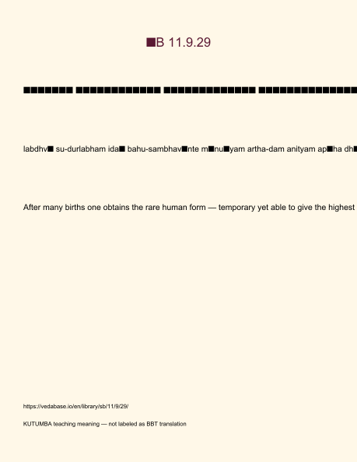
Original KUTUMBA visual: verse-card.png
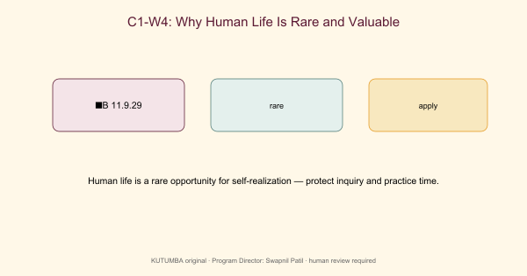
Original KUTUMBA visual: concept-diagram.png
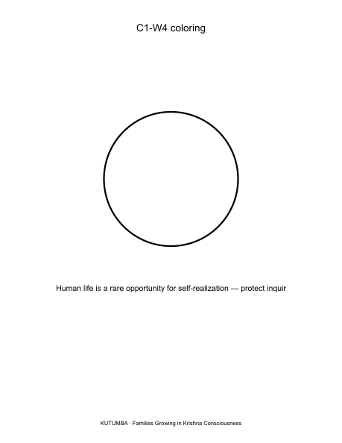
Original KUTUMBA visual: line-art-younger.png
RIGHTS NOTE | Original KUTUMBA program material. Scripture/BBT/ISKCON/third-party rights remain with their holders.

