KUTUMBA

C1-W4 OLDER TEACHER GUIDE
  - Families Growing in Krishna Consciousness
C1-W4
V12 • Families Growing in Krishna Consciousness
Program Director: Swapnil Patil
Internal founding-cohort teaching material — human/temple review EXTERNAL_OPEN
KUTUMBA | Families Growing in Krishna Consciousness

Week: Why Human Life Is Rare and Valuable Primary: ŚB 11.9.29 — https://vedabase.io/en/library/sb/11/9/29/ Session length: ~40 minutes (parallel track ~2:30–3:10) Parents: Remain onsite; reunite at 3:10 Status: Internal founding-cohort teaching material — human/temple review EXTERNAL_OPEN
◆ ◆ ◆

Objective
Students observe ŚB 11.9.29, protect inquiry and practice time without fear tactics, correctly source Nārada–Mṛgāri to CC Madhya 24.229–282, complete a Must/Should/Optional time-jar, and answer: What deserves protected family time?

Exact memory phrase
Human life is a rare chance to ask who I am and serve Kṛṣṇa.
Short echo: Rare chance — protect practice time.

Teacher background
- KUTUMBA teaching meaning: After many births one obtains the rare human form — temporary yet able to give the highest purpose. A sober person should quickly endeavor for the ultimate good while this body lasts. (KUTUMBA teaching meaning — not BBT translation.)
- Supporting frames: BG 2.40 — little progress not lost (helps five-minute families); CC Madhya 24.229–282 — mercy and authorized instruction transform harmful conduct.
- Hard source lock: Mṛgāri is not SB 6.x and not SB 4.8. Useful Madhya anchors if needed: intro 24.229, name 24.242, bow 24.255–256, careful steps 24.270–272, conclusion 24.278–282 — paraphrase only; no gore.
- Block: Fear/death-pressure motivation; entertainment-first as default; busy = successful human life; species contempt.

Materials
- Printed verse strip: Devanāgarī + IAST + KUTUMBA teaching meaning
- Worksheet copies from activities/OLDER-ACTIVITY-PACK.md
- Scenario cards (screens eat quiet block; death-scare parent; full calendar — fictional)
- Must / Should / Optional time-jar diagram sheet
- Pencils; timer; activities/OLDER-ANSWER-KEY.md (teacher only)
- Project contribution half-sheets
- Source-check cards: M24 vs WRONG; priority-sort slips
◆ ◆ ◆

Minute-by-minute plan

0–5 min — Settle and hook
- Welcome; feet on floor.
- Hook: “Does urgency have to mean fear?” Collect yes/no with one reason each; hold both for the verse.
- Essential question: What deserves protected family time?

5–14 min — Primary text observation (ŚB 11.9.29)
- Display verse; read IAST aloud together once; Devanāgarī slowly or authorized audio.
- Students underline: rare / temporary / highest purpose / endeavor.
- Observation prompts (write short answers):
- What is rare, and what can it give?
- What should a sober person do while the body lasts?
- What classroom language do we refuse (terror / death pressure)?
- Bridges:
- BG 2.40 — a little sincere endeavor is not lost.
- Source drill: write CC Madhya 24.229–282 as the only Mṛgāri source; mark SB 6.x / SB 4.8 as wrong.
- Paraphrase Madhya mercy arc in one gentle sentence if used — no invented dialogue, no gore.

14–22 min — Worksheet questions
Students complete Section A:
- Restate teaching meaning in opportunity language (one sentence).
- Rewrite a fear-based ask into an invitation ask.
- Circle rare / purpose / endeavor; cross out terror ranking.
- Select correct Mṛgāri source.
- Explain how BG 2.40 helps a five-minute family.
- Name one Must slot to protect this week.
Circulate with answer key for directions, not ranks.

22–28 min — Scenario cards (small groups)
Card A — Screens eat the only quiet evening block. Mistaken: Entertainment first is always fine. Card B — Parent uses death scare to force chanting. Mistaken: Fear creates lasting urgency. Card C — Calendar full; no inquiry time. Mistaken: Busy equals successful human life.
Each group writes mistaken conclusion / principle / compassionate response / better action / what not to say. Share 60 seconds.

28–33 min — Puzzle / game: Source Check + Priority Sort
- Round 1 — Source Check: Teacher reads citations for Mṛgāri. Teams hold M24 or WRONG.
- Round 2 — Priority Sort: Quietly sort activity slips into Must / Should / Optional.
- One student explains one Must using “rare chance” language (not scare language).
- Keep energy respectful; no mocking wrong holds.

33–37 min — Diagram task
Fill Must / Should / Optional jars. Move one Optional below a Must spiritual cue. Write the short echo inside Must. Low-risk schedule examples only — no forced disclosure of home screen battles.

37–40 min — Project contribution + reflection + handoff
- Project: “This week we protect _______________ before Optional screens.”
- Reflection: How does ŚB 11.9.29 invite urgency without panic?
- Cleanup; reunification sheets ready.
- Parent handoff: Must slot first; invitation language; Mṛgāri = Madhya 24 if discussed.

Extension (if group finishes early)
Map Madhya 24 mercy arc in three words only: meet → teach → careful life. Still no gore; still no SB mis-citation.

Answer key pointer
Teacher-facing expected answers: activities/OLDER-ANSWER-KEY.md. Do not distribute during first attempt.

Behavior and privacy
- Redirect scare language: “Chance words only.”
- No public shame about screens or busy calendars.
- No ranking families by how “urgent” they sound.
- Snack/water on main schedule only.

Instructional visuals
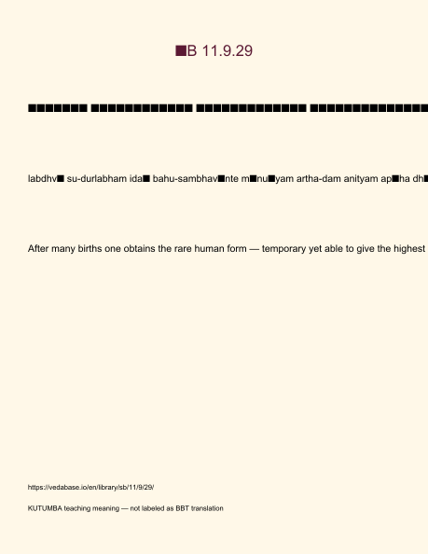
Original KUTUMBA visual: verse-card.png
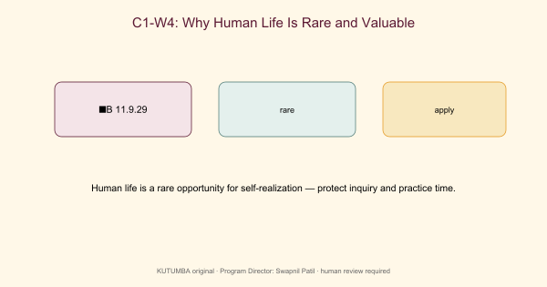
Original KUTUMBA visual: concept-diagram.png
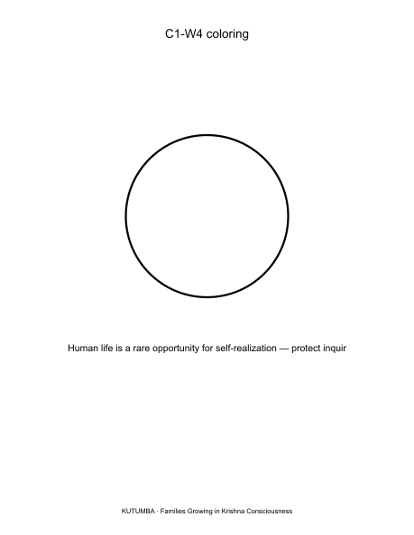
Original KUTUMBA visual: line-art-younger.png
RIGHTS NOTE | Original KUTUMBA program material. Scripture/BBT/ISKCON/third-party rights remain with their holders.

