KUTUMBA

C1-W4 YOUNGER TEACHER GUIDE
  - Families Growing in Krishna Consciousness
C1-W4
V12 • Families Growing in Krishna Consciousness
Program Director: Swapnil Patil
Internal founding-cohort teaching material — human/temple review EXTERNAL_OPEN
KUTUMBA | Families Growing in Krishna Consciousness

Week: Why Human Life Is Rare and Valuable Primary: ŚB 11.9.29 — https://vedabase.io/en/library/sb/11/9/29/ Session length: 40 minutes (parallel track ~2:30–3:10) Parents: Remain onsite; reunite at 3:10 Status: Internal founding-cohort teaching material — human/temple review EXTERNAL_OPEN
◆ ◆ ◆

Objective
Children experience human life as a rare chance to ask who we are and serve Kṛṣṇa — with opportunity language, not fear. They make a Must / Optional ticket card and protect one tiny practice slot.

Exact memory phrase
Human life is a rare chance to ask who I am and serve Kṛṣṇa.

Teacher background (2 minutes to review)
- KUTUMBA teaching meaning (adult wording): After many births one obtains the rare human form — temporary yet able to give the highest purpose. A sober person should quickly endeavor for the ultimate good while this body lasts.
- Child-facing paraphrase: Getting a human life is like a special ticket — meant to be used for asking “Who am I?” and serving Kṛṣṇa. We speak of chance and kindness, never scary death pressure.
- Block misconceptions (child words):
- “Scare kids so they chant.”
- “Screens always come first.”
- “Busy means successful.”
- Do not: invent Nārada–Mṛgāri dialogue; show gore; cite Mṛgāri from SB 6.x or SB 4.8 (source is CC Madhya 24.229–282 only); mock other life forms.

Materials
- Paper “rare ticket” props (one demo + one per child later)
- Must jar / Optional jar labels (two small boxes or jars)
- Card stock for Must-ticket cards
- Soft toss object; crayons; line-art if available
- Picture cards: screen-first vs practice-first (gentle, not shaming)

Room setup
Circle; jars visible; open space for Ticket Walk game.
◆ ◆ ◆

Minute-by-minute executable plan

0–5 min — Opening and recall
- Welcome; feet on floor.
- Hold up rare ticket: “Hard to get — meant to be used, not forgotten in a drawer.”
- Echo memory phrase three times.
- Ask: “What is one special thing humans can do with words?” (ask questions / say Kṛṣṇa’s names — accept short answers)

5–13 min — Story script (paraphrase only; ~8 minutes)
Say exactly this spine (do not invent deity dialogue):
Śrīmad-Bhāgavatam teaches that after many births, the human form is rare. It does not last forever, but it can help us reach the highest purpose. A sober person uses this chance carefully for the ultimate good. Think of a rare ticket to something wonderful. You would not throw it away. You would use it wisely — without panic, without shouting at friends. In Caitanya-caritāmṛta Madhya chapter 24, Nārada meets a hunter named Mṛgāri. With mercy and teaching, the hunter’s life turns toward care and devotion — even careful steps so tiny creatures are not harmed. We tell this gently, without scary details. The source is Madhya 24 — not other books. At home we protect a little time to ask who we are and serve Kṛṣṇa. Screens can wait for Optional. We never scare children with death talk to make them practice.
Story boundaries: ŚB 11.9.29 + CC Madhya 24.229–282 paraphrase only. No gore. Opportunity language only. BG 2.40 may be whispered as “a little sincere practice is not lost” if a child fears missing out.

13–16 min — Three wonder questions
- Is human life a rare chance or a scare story? (Chance)
- What belongs in the Must jar first — practice or endless screens? (Practice / asking who I am)
- How did mercy help Mṛgāri’s life change — fear or kind teaching? (Kind teaching / mercy)

16–24 min — Movement game: Ticket Walk (steps)
- Children walk in a circle holding imaginary tickets.
- Teacher calls Must! — freeze; whisper memory phrase; take one step toward Must jar.
- Teacher calls Optional! — soft sit; count to three; then stand (Optional waits).
- Teacher calls Kind chance! — hand on heart; smile (no fear faces).
- Three rounds. Round three: point to practice-first card, not screen-first.
- End seated; echo phrase once.

24–32 min — Craft: Must-ticket card (steps)
- Give ticket-shaped card stock.
- Front: decorate “RARE TICKET” / draw a small path or lamp.
- Inside: write memory phrase (helper may write) or short: Rare chance — ask & serve.
- Back: two boxes — Must (draw hearing / memory phrase) and Optional (draw a toy/screen).
- Child places a sticker or star in Must.
- Practice: “Must first, then Optional.”
Full steps in activities/YOUNGER-ACTIVITY-PACK.md.

32–35 min — Printable / coloring task
Line-art if time; else keep ticket.

35–38 min — Behavior redirects and quiet reset
- Fear talk from peer — “We use chance words, not scare words.”
- Running — “Ticket walk.”
- Snatching — “Kind hands.”
- Quiet reset — calm corner with ticket; rejoin on Must.

38–40 min — Cleanup and parent handoff
Memory: “Human life is a rare chance to ask who I am and serve Kṛṣṇa.” Home cue: one Must slot before Optional screens. No death scare. Mṛgāri source if asked: CC Madhya 24.
◆ ◆ ◆

Behavior redirects (quick reference)
Signal | Teacher line | Child action
Scare language | “Chance words only.” | Soft rewrite
Screen demand | “Must first.” | Point to Must
Running | “Ticket walk.” | Walk
Shutdown | “Quiet reset okay.” | Calm corner 60 sec

Backup low-prep
Soft toss: catch → say “chance,” “ask,” “serve,” or “Must.” Three phrase echoes. Optional: sort picture cards into Must vs Optional jars.

What success looks like
- Child can say rare chance (not scare).
- Child can echo memory phrase.
- Child can point Must before Optional.

Boundaries
- Snack/water at 3:30; no weekly meal.
- Mṛgāri = CC Madhya 24 only.
- No species contempt; no panic harvest language.

Instructional visuals
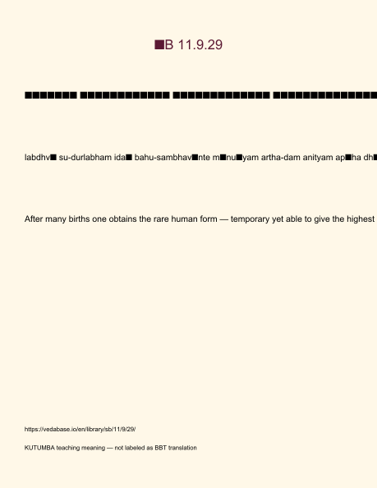
Original KUTUMBA visual: verse-card.png
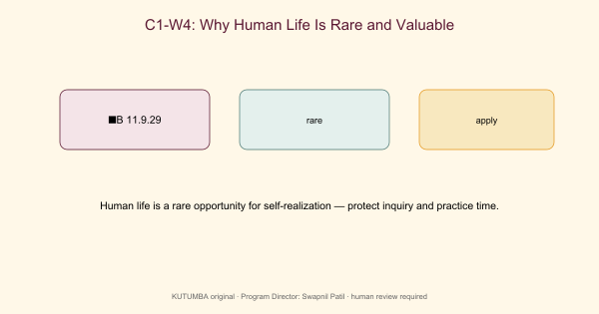
Original KUTUMBA visual: concept-diagram.png
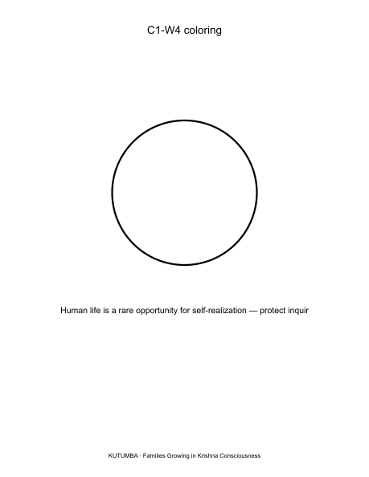
Original KUTUMBA visual: line-art-younger.png
RIGHTS NOTE | Original KUTUMBA program material. Scripture/BBT/ISKCON/third-party rights remain with their holders.

