KUTUMBA

C1-W5 MAIN FACILITATOR GUIDE
  - Families Growing in Krishna Consciousness
C1-W5
V12 • Families Growing in Krishna Consciousness
Program Director: Swapnil Patil
Internal founding-cohort teaching material — human/temple review EXTERNAL_OPEN
KUTUMBA | Families Growing in Krishna Consciousness

KUTUMBA • Families Growing in Krishna Consciousness Program Director: Swapnil Patil Status: Internal founding-cohort teaching material — human/temple review EXTERNAL_OPEN Controlling guide: This V12 file is authoritative for Saturday delivery. Core teaching is inlined below.

Two-minute summary
Temporary things can be used well but cannot provide permanent fulfillment. Primary: BG 8.15 (https://vedabase.io/en/library/bg/8/15/). Essential question: How can enjoyment become gratitude and service?

Essential question
How can enjoyment become gratitude and service?

15-minute night-before prep
- Open https://vedabase.io/en/library/bg/8/15/ and reread Devanāgarī, IAST, and KUTUMBA teaching meaning below.
- Rehearse the speaking script section aloud once (aim for clear 10–15 minute delivery with pauses).
- Pack younger + older materials and memory cards.
- Review misconception to block: Material things and family affection are worthless.
- Confirm snack/water only (no weekly meal); parents onsite; privacy reminder card visible.
- For C1-W4: verify Mṛgāri source cards say CC Madhya 24.229–282 (not SB 6.x / SB 4.8).

60-minute deep prep
- Read the inlined analogies, examples, and three cases in this guide until you can teach them without notes.
- Mark which discovery / understanding / application questions you will actually ask.
- Choose one analogy and one case as your "must teach" pair; keep the others ready for Q&A.
- Walk the room: parent circle, younger zone, older zone, reunification seats.
- Pre-write the home-practice minimum version on a card (5 minutes counts).
- Review deferral line: laboratory methods measure bodies/behavior; ātman/bhakti claims rest on śāstra — no false science proof.
- Skim project/CYCLE-CONTRIBUTION.md for this week's artifact layer.
- Optional enrichment only (not a substitute for this guide): research folder files.

Exact primary and supporting readings

Primary (locked)
- Reference: BG 8.15
- URL: https://vedabase.io/en/library/bg/8/15/
- Devanāgarī: मामुपेत्य पुनर्जन्म दु:खालयमशाश्वतम् । नाप्नुवन्ति महात्मान: संसिद्धिं परमां गता: ॥ १५ ॥
- IAST: mām upetya punar janma duḥkhālayam aśāśvatam / nāpnuvanti mahātmānaḥ saṁsiddhiṁ paramāṁ gatāḥ
- KUTUMBA teaching meaning: Having attained the Lord, great souls do not return again to this temporary world of misery; they have reached the highest perfection.
- Rights: Sanskrit verse text from VedaBase display; KUTUMBA teaching meaning original; no full purport.

Supporting readings
- BG 5.22 — https://vedabase.io/en/library/bg/5/22/ — Pleasures born of sense contact are temporary — supporting application, not the locked primary.
- BG 9.27 — https://vedabase.io/en/library/bg/9/27/ — Whatever you do, eat, offer, give — do as offering unto Me.

Teaching map with exact Saturday 2:00–4:00 time cues
Time | Block | Facilitator focus
1:50–2:00 | Arrival | Welcome; privacy; parents onsite; materials check
2:00–2:10 | Opening mantras | Keep simple; invitation not volume contest
2:10–2:30 | Shared opening / Prem-kī-Kathā + verse | Deliver opening of speaking script; state memory line
2:30–3:10 | Parallel tracks | Parent circle / younger / older — see track transition
3:10–3:30 | Reunification / bhakti lab | Family synthesis sentence; no ranking
3:30–3:40 | Snack + water only | No weekly meal service
3:40–3:55 | Saṅkalpa / project / Q&A | Home cue + project artifact + likely questions
3:55–4:00 | Closing | Next-week title only; no early ontology

10–20 minute speaking script (deliverable prose)
Facilitation note: Speak naturally. Pause for the 20-second pair share where indicated. Do not replace this with "see research."
Essential question: How can enjoyment become gratitude and service?
Primary (locked): BG 8.15 — https://vedabase.io/en/library/bg/8/15/
Teaching meaning: "Having attained the Lord, great souls do not return again to this temporary world of misery; they have reached the highest perfection."
Conclusion: Temporary things can be used well but cannot provide permanent fulfillment.
Pause with me on the phrase “temporary world of misery” in the teaching meaning. We are not training children to despise birthdays, toys, or parents’ hugs. We are training families to stop asking temporary things to do a permanent job. That distinction keeps tonight compassionate and honest.
Hold two truths at once. First: temporary contact joys fade and cannot be final shelter. Second: family affection, lawful fun, and beautiful objects are not worthless. Shame is not renunciation.
BG 5.22 supports the temporary nature of sense-contact pleasure. BG 9.27 shows how ordinary acts can turn toward offering. Neither replaces BG 8.15 as primary.
Sparkler vs lamp: enjoy the sparkler; remember the lamp. Saltwater image: hankering can increase with acquisition — pedagogical, not medical. Offering plate: thank You, Kṛṣṇa.
Devotional example: Dhruva's arc shows mixed motives can be purified toward the Lord (https://vedabase.io/en/library/sb/4/8/) — do not promise identical results.
Case: purchase chase. Add gratitude pause. Case: shaming a child's toy. Allow joy; add thanks. Case: work forever defeats prayer. Protect one cue without quitting livelihood theatrics.
If someone cites "science proves detachment," correct: gratitude research may support well-being habits; it does not prove Kṛṣṇa or the metaphysics of BG 8.15.
Supporting readings:
- BG 5.22 — https://vedabase.io/en/library/bg/5/22/ — Pleasures born of sense contact are temporary — supporting application, not the locked primary.
- BG 9.27 — https://vedabase.io/en/library/bg/9/27/ — Whatever you do, eat, offer, give — do as offering unto Me.
Memory: Temporary joys can be used with gratitude; lasting fulfillment is in Kṛṣṇa.
I am going to teach the analogies slowly, with limits in the same breath, because an analogy without a limit becomes a new false doctrine.
First: Sparkler vs lamp. Brief flash vs lasting light. Limit: Lawful joy is not condemned; sparklers can be enjoyed with gratitude.
Second: Saltwater drink. Increases thirst rather than finishing it. Limit: Not a medical claim; pedagogical image for endless hankering.
Third: Offering plate. Enjoyment becomes service when offered. Limit: Not empty ritualism — mood and remembrance matter.
Hold those as teaching tools, not as replacements for BG 8.15.
Now two sourced examples, paraphrased only.
Example A — Great souls do not return to temporary misery (BG 8.15). Primary: lasting shelter in the Lord ends the cycle of return to temporary misery — paraphrase carefully. Link: https://vedabase.io/en/library/bg/8/15/
Example B — Dhruva — mixed motive purified (ŚB 4.8–4.9). Temporary ambition can be redirected toward the Lord; do not promise identical results to children. Link: https://vedabase.io/en/library/sb/4/8/
Next I will walk all three household cases out loud so you can copy the pattern at home. Please listen for seven fields every time: situation, mistaken conclusion, principle, source, compassionate response, action, and what not to say.
Case 1. Situation: After each weekend, the family chases the next purchase for a happiness spike. Mistaken conclusion: The next thing will finally satisfy. Principle and source: BG 8.15 lasting shelter; BG 5.22 temporary contact pleasure. (https://vedabase.io/en/library/bg/8/15/) Compassionate response: Pause with gratitude before buying; name what already blesses the home. Family action: One gratitude sentence before any non-essential purchase this week. What not to say: You're materialistic garbage. Never enjoy anything.
Case 2. Situation: A parent shames a child's joy in a toy. Mistaken conclusion: Material joy is sinful; affection is worthless. Principle and source: Affection is not worthless; temporary joys can be received with thanks and offering mood (BG 9.27). (https://vedabase.io/en/library/bg/9/27/) Compassionate response: Allow lawful joy; add a simple offering/thank-you to Kṛṣṇa. Family action: Toy joy + one sentence: 'Thank You, Kṛṣṇa.' What not to say: Throw it away to prove detachment.
Case 3. Situation: Work always defeats prayer time in family conflicts. Mistaken conclusion: Career alone is permanent security. Principle and source: Temporary world framing — protect one non-negotiable spiritual cue. (https://vedabase.io/en/library/bg/8/15/) Compassionate response: Honor livelihood duties; still protect one small lasting-shelter practice. Family action: Calendar a non-negotiable 5–10 minute cue. What not to say: Quit your job tonight or you're not devoted.
I will now ask the room three discovery questions. You may answer in a whisper to a partner:
- What temporary joy faded faster than you expected?
- Where does our family already say thank you?
- What lasting shelter practice is smallest but real?
Understanding check — please be ready to say in one sentence: Temporary things can be used well but cannot provide permanent fulfillment.. Name the primary: BG 8.15. Name what we are not teaching tonight: ranking, speculation, and the misconception “Material things and family affection are worthless.”.
Application — before you leave the shared opening, decide silently: time + place for home practice; who starts if others are tired; and the minimum version if the week is hard. Five minutes counts. Memory line plus one kind action counts.
Let me demonstrate a minimum home practice out loud so nobody leaves confused. Tonight after dinner, or at the same chair each evening, someone says the memory line once: “Temporary joys can be used with gratitude; lasting fulfillment is in Kṛṣṇa..” Then one family member paraphrases BG 8.15 in a single sentence. Then one gratitude or service act — thanking someone, offering water, putting shoes away as kindness, or a short prayer. If the house is chaotic, keep only the memory line and one kind action. That still honors tonight’s conclusion: Temporary things can be used well but cannot provide permanent fulfillment.
When we reunite at 3:10, I will not score families. I will ask for one sentence: “This week we will…” Drawings count. Whispered parent sentences count. Loud brilliance is not holier than quiet sincerity.
Likely questions you may hear from adults — rehearse these answers with me:
If someone asks, “Are toys and family hugs bad?” — answer: No. Lawful affection and joy can be received with gratitude; they are temporary, not worthless.
If someone asks, “What is the primary verse this week?” — answer: BG 8.15 — lasting shelter in the Lord; BG 5.22 is support only.
If someone asks, “Does hedonic adaptation prove Kṛṣṇa?” — answer: No. Psychology may illustrate fading contact pleasure; doctrine rests on śāstra.
If someone asks, “How do we offer ordinary acts?” — answer: BG 9.27 mood: remember Kṛṣṇa in doing, eating, giving — start with one act.
If someone asks, “Is renunciation required for kids?” — answer: No. Teach gratitude and offering inside family life.
A short word on boundaries. We do not invent quotations. We do not dump full purports into Git or into the room. We do not diagnose families medically or spiritually in public. We do not guarantee initiation, advancement, or certification. We do not claim human, temple, CPO, or publication approval. Science may help habits; it does not prove ātman or replace śāstra.
Operational covenant aloud: Saturday 2:00–4:00; snack and water only; parents onsite; private struggles stay private; no false approval labels.
Recite with me before tracks:
- Essential question: How can enjoyment become gratitude and service?
- Conclusion: Temporary things can be used well but cannot provide permanent fulfillment.
- Memory line: Temporary joys can be used with gratitude; lasting fulfillment is in Kṛṣṇa.
- Misconception to block: Material things and family affection are worthless.
- Primary: BG 8.15 — https://vedabase.io/en/library/bg/8/15/
Parents: your job in the parent circle is not to perform brilliance. It is to leave with a cue, a minimum version, and a kinder sentence than the one you might have used last week. Younger and older teachers will deepen practice in age bands. We reunite at 3:10 for one family sentence: “This week we will…”
That is the heart of tonight's teaching. Let us practice it, not merely admire it.

Analogies with limits (inline — teach from here)

1. Sparkler vs lamp
- Teaches: Brief flash vs lasting light.
- Limit (say out loud): Lawful joy is not condemned; sparklers can be enjoyed with gratitude.

2. Saltwater drink
- Teaches: Increases thirst rather than finishing it.
- Limit (say out loud): Not a medical claim; pedagogical image for endless hankering.

3. Offering plate
- Teaches: Enjoyment becomes service when offered.
- Limit (say out loud): Not empty ritualism — mood and remembrance matter.

Scriptural and devotional examples (inline paraphrase)

1. Great souls do not return to temporary misery
- Provenance: BG 8.15
- URL: https://vedabase.io/en/library/bg/8/15/
- Classroom paraphrase use: Primary: lasting shelter in the Lord ends the cycle of return to temporary misery — paraphrase carefully.

2. Dhruva — mixed motive purified
- Provenance: ŚB 4.8–4.9
- URL: https://vedabase.io/en/library/sb/4/8/
- Classroom paraphrase use: Temporary ambition can be redirected toward the Lord; do not promise identical results to children.

Three constructed household cases (inline)

Constructed case 1
Field | Content
Situation | After each weekend, the family chases the next purchase for a happiness spike.
Mistaken conclusion | The next thing will finally satisfy.
Principle | BG 8.15 lasting shelter; BG 5.22 temporary contact pleasure.
Source | https://vedabase.io/en/library/bg/8/15/
Compassionate response | Pause with gratitude before buying; name what already blesses the home.
Family action | One gratitude sentence before any non-essential purchase this week.
What not to say | You're materialistic garbage. Never enjoy anything.

Constructed case 2
Field | Content
Situation | A parent shames a child's joy in a toy.
Mistaken conclusion | Material joy is sinful; affection is worthless.
Principle | Affection is not worthless; temporary joys can be received with thanks and offering mood (BG 9.27).
Source | https://vedabase.io/en/library/bg/9/27/
Compassionate response | Allow lawful joy; add a simple offering/thank-you to Kṛṣṇa.
Family action | Toy joy + one sentence: 'Thank You, Kṛṣṇa.'
What not to say | Throw it away to prove detachment.

Constructed case 3
Field | Content
Situation | Work always defeats prayer time in family conflicts.
Mistaken conclusion | Career alone is permanent security.
Principle | Temporary world framing — protect one non-negotiable spiritual cue.
Source | https://vedabase.io/en/library/bg/8/15/
Compassionate response | Honor livelihood duties; still protect one small lasting-shelter practice.
Family action | Calendar a non-negotiable 5–10 minute cue.
What not to say | Quit your job tonight or you're not devoted.

Discovery questions
- What temporary joy faded faster than you expected?
- Where does our family already say thank you?
- What lasting shelter practice is smallest but real?

Understanding questions
- Contrast temporary contact joy vs lasting shelter in one sentence each.
- Name primary vs supporting verses for this week.
- What misconception must we refuse about affection?

Application questions
- What will we offer (food/act/word) this week?
- Where will we pause for gratitude before a purchase or treat?
- What is our non-negotiable spiritual cue?

Five likely Q&A
Question | Source-based direction
Are toys and family hugs bad? | No. Lawful affection and joy can be received with gratitude; they are temporary, not worthless.
What is the primary verse this week? | BG 8.15 — lasting shelter in the Lord; BG 5.22 is support only.
Does hedonic adaptation prove Kṛṣṇa? | No. Psychology may illustrate fading contact pleasure; doctrine rests on śāstra.
How do we offer ordinary acts? | BG 9.27 mood: remember Kṛṣṇa in doing, eating, giving — start with one act.
Is renunciation required for kids? | No. Teach gratitude and offering inside family life.

Misconceptions to block
- Material things and family affection are worthless.
- Confusing analogy with scripture quotation
- Importing next week's full ontology early
- Ranking families or children
- Claiming science proves or disproves ātman / bhakti metaphysics
- False human, temple, CPO, or publication approval labels

What not to speculate about
- Invented quotations, purport dumps, or unverified lecture lines
- Private medical or spiritual diagnoses of families
- Guarantees of advancement, initiation, or certification
- Graphic retellings (especially Mṛgāri) or fear-based death pressure on children
- For W4: any claim that Mṛgāri is located in SB 6.x or SB 4.8

Track transition (say at ~2:28)
Parents remain in the parent circle. Younger friends go with [younger teacher]. Older students go with [older teacher]. We reunite at 3:10. We do not rank groups.

Family reunification synthesis (3:10–3:30)
Invite one sentence per family tied to the essential question:
"This week we will…"
Accept drawings or whispered parent sentences for shy children. No scoreboard.

Project contribution
Advance the cumulative project Who Am I, and How Should Our Family Live? using project/CYCLE-CONTRIBUTION.md. This week layer must connect to BG 8.15 and tonight's conclusion. Store artifacts for Week 6. Non-competitive.

Home practice (5–15 minutes)
- Say the memory line once: Temporary joys can be used with gratitude; lasting fulfillment is in Kṛṣṇa.
- Paraphrase BG 8.15 in one family sentence.
- Do one gratitude or service act.
- Minimum version if exhausted: memory line + one kind action only.

Next-week preview
Name only: C1-W6 — Integration Night: Who Am I, and How Should Our Family Live?. Do not teach next week's ontology in depth tonight.

Do not claim
Human/temple/CPO approval; publication readiness; BBT ownership of KUTUMBA teaching meanings; science proving ātman; ranking results; guaranteed spiritual outcomes.

Misconceptions and no-speculation boundaries
- Do not invent dialogue for scriptural persons.
- Do not diagnose private karma or modes as insults in the room.
- Do not claim temple/BBT/human approval that has not been given.
- Defer off-scope questions with the standard deferral line.

Instructional visuals
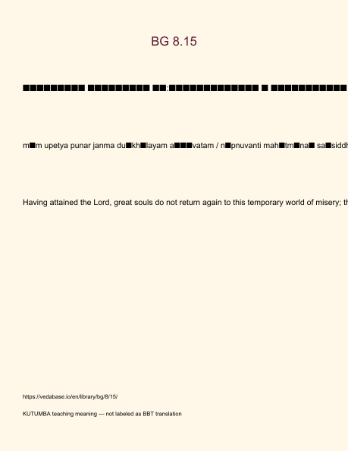
Original KUTUMBA visual: verse-card.png
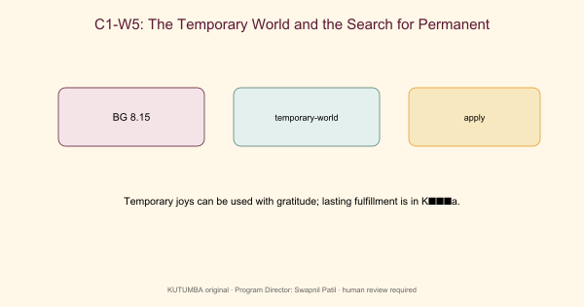
Original KUTUMBA visual: concept-diagram.png
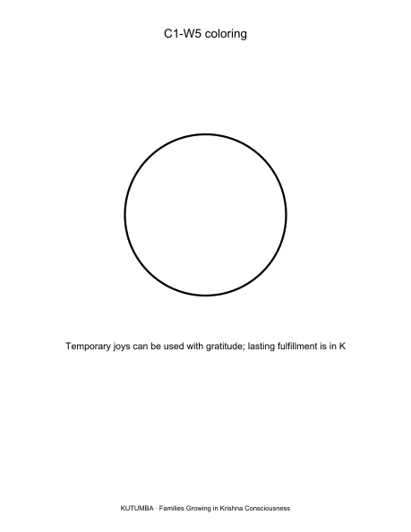
Original KUTUMBA visual: line-art-younger.png
RIGHTS NOTE | Original KUTUMBA program material. Scripture/BBT/ISKCON/third-party rights remain with their holders.

