KUTUMBA

C1-W5 OLDER TEACHER GUIDE
  - Families Growing in Krishna Consciousness
C1-W5
V12 • Families Growing in Krishna Consciousness
Program Director: Swapnil Patil
Internal founding-cohort teaching material — human/temple review EXTERNAL_OPEN
KUTUMBA | Families Growing in Krishna Consciousness

Week: The Temporary World and the Search for Permanent Happiness Primary: BG 8.15 — https://vedabase.io/en/library/bg/8/15/ Session length: ~40 minutes (parallel track ~2:30–3:10) Parents: Remain onsite; reunite at 3:10 Status: Internal founding-cohort teaching material — human/temple review EXTERNAL_OPEN
◆ ◆ ◆

Objective
Students observe BG 8.15, distinguish temporary contact pleasure from lasting shelter in the Lord, refuse “affection is worthless,” complete a sparkler→lamp / offering diagram, and answer: How can enjoyment become gratitude and service?

Exact memory phrase
Temporary joys can be used with gratitude; lasting fulfillment is in Kṛṣṇa.
Short echo: Enjoy with thanks; shelter in Kṛṣṇa.

Teacher background
- KUTUMBA teaching meaning: Having attained the Lord, great souls do not return again to this temporary world of misery; they have reached the highest perfection.
- Supporting: BG 5.22 — sense-contact pleasures temporary; BG 9.27 — offer acts unto the Lord. Neither replaces BG 8.15 as primary.
- Block: “Material things and family affection are worthless”; “next purchase finally satisfies”; “science proves detachment/Kṛṣṇa.”

Materials
- Verse strip; worksheets; scenario cards (purchase chase; shaming toy joy; work defeats prayer — fictional)
- Temporary→Lasting diagram; pencils; OLDER-ANSWER-KEY.md; project half-sheets
- G/S cards (Gratitude-path / Seize-or-Shame mistaken) for fork game
◆ ◆ ◆

Minute-by-minute plan

0–5 min — Settle and hook
- Welcome.
- Hook: “Can something be enjoyable and still not be final shelter?”
- Essential question: How can enjoyment become gratitude and service?

5–14 min — Primary text observation (BG 8.15)
- Read IAST; Devanāgarī slowly or authorized audio.
- Underline: attained the Lord / temporary world of misery / highest perfection.
- Prompts: What is lasting? What must we not conclude about hugs/toys? What is BG 5.22’s support role?
- Bridge BG 9.27: ordinary acts can turn toward offering.
- Paraphrase only; no invented dialogue; no Dhruva result guarantees.

14–22 min — Worksheet questions
Section A: restate meaning; temporary vs lasting; rewrite shame line; gratitude pause before purchase; science limitation; confirm locked primary is BG 8.15.

22–28 min — Scenario cards
Card A — Weekend purchase chase for happiness spike. Card B — Parent shames child’s toy joy. Card C — Work always defeats prayer cue.
Mistaken / principle / response / action / what not to say. Share 60 sec.

28–33 min — Puzzle / game: Gratitude Fork
- Teacher reads forks (two endings).
- Hold G (gratitude/service path) or S (seize forever / shame joy).
- Three rounds; explain one G using BG 8.15 or 9.27 language.

33–37 min — Diagram task
Temporary joy → Gratitude / offering → Lasting shelter in Kṛṣṇa (BG 8.15)
Circle lasting shelter; write short echo inside. Low-risk examples only.

37–40 min — Project + reflection + handoff
- Project: “Before _______________ we will say Thank You, Kṛṣṇa / offer mood.”
- Reflection: How does BG 8.15 challenge both endless acquisition and contempt for affection?
- Parent handoff: gratitude pause; do not shame toys; gratitude studies ≠ ontology proof.

Extension
One sentence on Dhruva: mixed motive can turn toward the Lord — no promised identical outcomes.

Answer key pointer
activities/OLDER-ANSWER-KEY.md

Behavior and privacy
No ranking purchases; no forced disclosure of family spending; snack/water on main schedule.

Instructional visuals
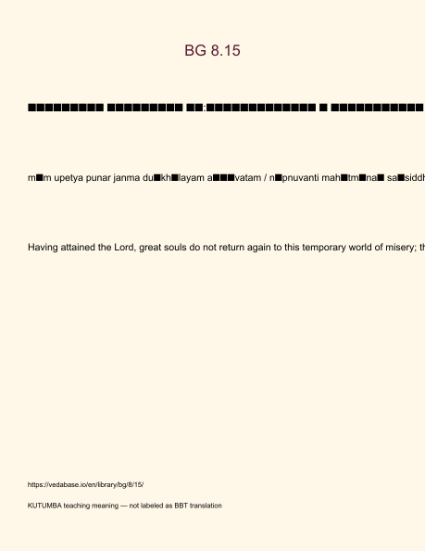
Original KUTUMBA visual: verse-card.png
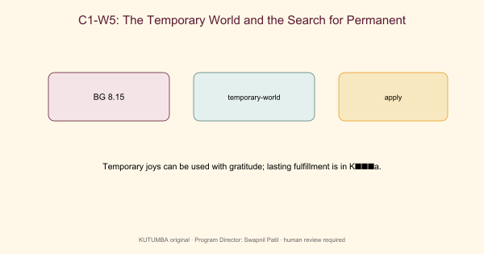
Original KUTUMBA visual: concept-diagram.png
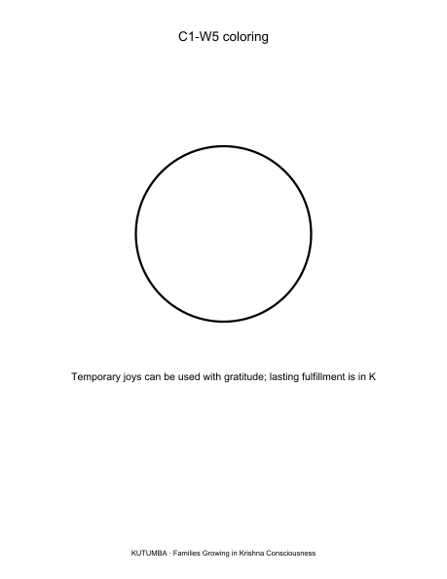
Original KUTUMBA visual: line-art-younger.png
RIGHTS NOTE | Original KUTUMBA program material. Scripture/BBT/ISKCON/third-party rights remain with their holders.

