KUTUMBA

C1-W5 YOUNGER TEACHER GUIDE
  - Families Growing in Krishna Consciousness
C1-W5
V12 • Families Growing in Krishna Consciousness
Program Director: Swapnil Patil
Internal founding-cohort teaching material — human/temple review EXTERNAL_OPEN
KUTUMBA | Families Growing in Krishna Consciousness

Week: The Temporary World and the Search for Permanent Happiness Primary: BG 8.15 — https://vedabase.io/en/library/bg/8/15/ Session length: 40 minutes (parallel track ~2:30–3:10) Parents: Remain onsite; reunite at 3:10 Status: Internal founding-cohort teaching material — human/temple review EXTERNAL_OPEN
◆ ◆ ◆

Objective
Children experience that temporary joys can be received with gratitude, while lasting fulfillment is in Kṛṣṇa. They make a sparkler/lamp thank-you card — without shaming toys or hugs.

Exact memory phrase
Temporary joys can be used with gratitude; lasting fulfillment is in Kṛṣṇa.

Teacher background (2 minutes to review)
- KUTUMBA teaching meaning (adult wording): Having attained the Lord, great souls do not return again to this temporary world of misery; they have reached the highest perfection.
- Child-facing paraphrase: Toys and parties are like sparklers — bright and short. Kṛṣṇa is like a steady lamp. We say thank you for sparklers; we look for lasting light in Kṛṣṇa. Hugs and fun are not “bad.”
- Block misconceptions (child words):
- “Toys and family love are worthless.”
- “The next buy will finally make me happy forever.”
- “Science proves detachment / proves Kṛṣṇa.”
- Do not: invent deity dialogue; shame a child’s joy; promise identical Dhruva results; treat BG 5.22 as the locked primary (support only).

Materials
- Sparkler picture + lamp picture (safe drawings — no real sparklers indoors)
- Small offering-plate prop or paper plate
- Card stock for Thank-You / Lamp cards
- Crayons; soft toss object; line-art if available
- Calm-corner chair

Room setup
Circle; sparkler vs lamp cards visible; space for Sparkle-and-Still movement.
◆ ◆ ◆

Minute-by-minute executable plan

0–5 min — Opening and recall
- Welcome; feet on floor.
- Show sparkler card then lamp card: “Brief flash / lasting light.”
- Echo memory phrase twice (two halves): Temporary joys with gratitude; / lasting fulfillment in Kṛṣṇa.
- Ask: “What is one fun thing you enjoyed this week?” Affirm; add “Thank You, Kṛṣṇa” together once.

5–13 min — Story script (paraphrase only; ~8 minutes)
Say exactly this spine (do not invent deity dialogue):
Kṛṣṇa teaches that great souls who attain the Lord do not return again to this temporary world of misery — they reach the highest perfection. “Temporary world of misery” does not mean birthdays are bad or parents’ hugs are worthless. It means temporary things cannot be our final forever home. A sparkler is fun — then it fades. A lamp keeps shining. We can enjoy a sparkler and still remember the lamp. Sometimes people think the next toy will finally finish wanting. Wanting can keep growing — like drinking salty water in a story picture (not a doctor claim). Better: enjoy, say thank you, and remember Kṛṣṇa. Dhruva’s story shows mixed wishes can turn toward the Lord — we do not promise the same results to every child. Tonight we practice: gratitude for temporary joys; lasting fulfillment in Kṛṣṇa.
Story boundaries: BG 8.15 primary; BG 5.22 / 9.27 support only; Dhruva paraphrase without result guarantees. No shame. No invented quotes.

13–16 min — Three wonder questions
- Are hugs and toys worthless? (No — receive with thanks)
- Can a sparkler be our forever home? (No)
- Whom do we remember for lasting fulfillment? (Kṛṣṇa)

16–24 min — Movement game: Sparkle and Still (steps)
- Children stand in open space.
- Teacher calls Sparkle! — gentle finger wiggles for three seconds (temporary joy).
- Teacher calls Thank You! — hands together; whisper “Thank You, Kṛṣṇa.”
- Teacher calls Still lamp! — freeze tall; whisper second half of memory phrase.
- Three rounds. Round three: show two endings — (A) grab next toy with angry want; (B) enjoy + thanks. Point to B on Still lamp.
- End seated; full phrase once.

24–32 min — Craft: Thank-You / Lamp card (steps)
- Fold card stock.
- Outside left: draw a sparkler or favorite toy; label Thanks.
- Outside right: draw a simple lamp; label Kṛṣṇa.
- Inside: write memory phrase (helper may write) or short: Thanks for sparklers; lamp is Kṛṣṇa.
- Back: child draws one temporary joy + one offering/thanks moment (plate, prayer hands).
- Practice: touch Thanks → Lamp while saying the phrase.
Full steps in activities/YOUNGER-ACTIVITY-PACK.md.

32–35 min — Printable / coloring task
Line-art if time; else keep card.

35–38 min — Behavior redirects and quiet reset
- Toy shame from peer — “Joy with thanks is okay.”
- Grabby want — “Sparkle, then Thank You.”
- Running — “Still lamp bodies.”
- Quiet reset — calm corner with lamp card.

38–40 min — Cleanup and parent handoff
Memory: “Temporary joys can be used with gratitude; lasting fulfillment is in Kṛṣṇa.” Home cue: before one fun thing, say “Thank You, Kṛṣṇa.” Do not shame toys. Gratitude research ≠ proof of Kṛṣṇa.
◆ ◆ ◆

Behavior redirects (quick reference)
Signal | Teacher line | Child action
Shaming joy | “Thanks is allowed.” | Soft rewrite
Grabby spiral | “Sparkle → Thank You.” | Pause + thanks
Running | “Still lamp.” | Freeze
Shutdown | “Quiet reset okay.” | Calm corner 60 sec

Backup low-prep
Soft toss: catch → say “thanks,” “lamp,” or “Kṛṣṇa.” Three phrase echoes. Optional: pass paper plate; each child “offers” a word of thanks.

What success looks like
- Child can show Thanks vs Lamp.
- Child can echo memory phrase (or halves).
- Child does not treat affection as sinful.

Boundaries
- Snack/water at 3:30; no weekly meal.
- Primary locked: BG 8.15 (not BG 5.22).
- No ranking; no forced confession of purchase habits.

Instructional visuals
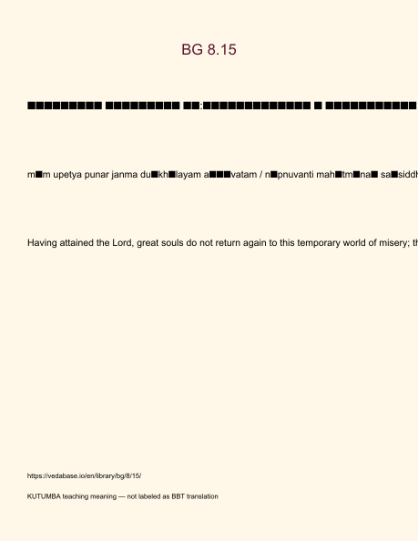
Original KUTUMBA visual: verse-card.png
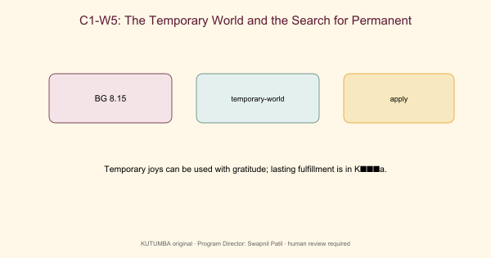
Original KUTUMBA visual: concept-diagram.png
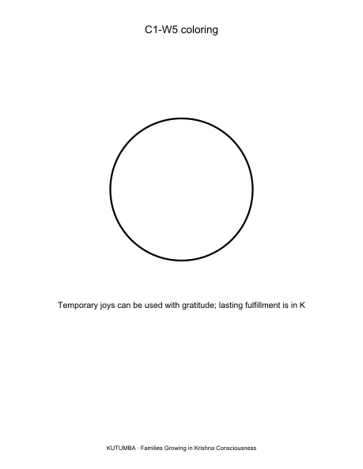
Original KUTUMBA visual: line-art-younger.png
RIGHTS NOTE | Original KUTUMBA program material. Scripture/BBT/ISKCON/third-party rights remain with their holders.

