KUTUMBA

C1-W6 MAIN FACILITATOR GUIDE
  - Families Growing in Krishna Consciousness
C1-W6
V12 • Families Growing in Krishna Consciousness
Program Director: Swapnil Patil
Internal founding-cohort teaching material — human/temple review EXTERNAL_OPEN
KUTUMBA | Families Growing in Krishna Consciousness

KUTUMBA • Families Growing in Krishna Consciousness Program Director: Swapnil Patil Status: Internal founding-cohort teaching material — human/temple review EXTERNAL_OPEN Controlling guide: This V12 file is authoritative for Saturday delivery. Core teaching is inlined below.

Two-minute summary
Identity, purpose, and practice must form one coherent family life. Primary: Cycle 1 review chain (https://vedabase.io/en/library/sb/1/2/18/). Essential question: Can our family explain and apply what we learned?

Essential question
Can our family explain and apply what we learned?

15-minute night-before prep
- Open https://vedabase.io/en/library/sb/1/2/18/ and reread Devanāgarī, IAST, and KUTUMBA teaching meaning below.
- Rehearse the speaking script section aloud once (aim for clear 10–15 minute delivery with pauses).
- Pack younger + older materials and memory cards.
- Review misconception to block: Competition or ranking of families.
- Confirm snack/water only (no weekly meal); parents onsite; privacy reminder card visible.
- For C1-W4: verify Mṛgāri source cards say CC Madhya 24.229–282 (not SB 6.x / SB 4.8).

60-minute deep prep
- Read the inlined analogies, examples, and three cases in this guide until you can teach them without notes.
- Mark which discovery / understanding / application questions you will actually ask.
- Choose one analogy and one case as your "must teach" pair; keep the others ready for Q&A.
- Walk the room: parent circle, younger zone, older zone, reunification seats.
- Pre-write the home-practice minimum version on a card (5 minutes counts).
- Review deferral line: laboratory methods measure bodies/behavior; ātman/bhakti claims rest on śāstra — no false science proof.
- Skim project/CYCLE-CONTRIBUTION.md for this week's artifact layer.
- Optional enrichment only (not a substitute for this guide): research folder files.

Exact primary and supporting readings

Primary (locked)
- Reference: Cycle 1 review chain
- URL: https://vedabase.io/en/library/sb/1/2/18/
- Devanāgarī: (review W1–W5 primary verses)
- IAST: ŚB 1.2.18 · BG 2.13 · BG 2.20 · ŚB 11.9.29 · BG 8.15
- KUTUMBA teaching meaning: Identity, purpose, and practice must form one coherent family life — reviewing the Cycle 1 chain with W5 as BG 8.15.
- Rights: Review of prior week Sanskrit layers; KUTUMBA synthesis original.

Supporting readings
- ŚB 1.2.18 — https://vedabase.io/en/library/sb/1/2/18/ — W1 — hearing and service steady devotion.
- BG 2.13 — https://vedabase.io/en/library/bg/2/13/ — W2 — body changes; self continues.
- BG 2.20 — https://vedabase.io/en/library/bg/2/20/ — W3 — eternal soul.
- ŚB 11.9.29 — https://vedabase.io/en/library/sb/11/9/29/ — W4 — rare human opportunity.
- BG 8.15 — https://vedabase.io/en/library/bg/8/15/ — W5 — lasting shelter (locked as W5 primary for review).

Teaching map with exact Saturday 2:00–4:00 time cues
Time | Block | Facilitator focus
1:50–2:00 | Arrival | Welcome; privacy; parents onsite; materials check
2:00–2:10 | Opening mantras | Keep simple; invitation not volume contest
2:10–2:30 | Shared opening / Prem-kī-Kathā + verse | Deliver opening of speaking script; state memory line
2:30–3:10 | Parallel tracks | Parent circle / younger / older — see track transition
3:10–3:30 | Reunification / bhakti lab | Family synthesis sentence; no ranking
3:30–3:40 | Snack + water only | No weekly meal service
3:40–3:55 | Saṅkalpa / project / Q&A | Home cue + project artifact + likely questions
3:55–4:00 | Closing | Next-week title only; no early ontology

10–20 minute speaking script (deliverable prose)
Facilitation note: Speak naturally. Pause for the 20-second pair share where indicated. Do not replace this with "see research."
Tonight is integration night — not a new ontology dump and not a contest.
Essential question: Can our family explain and apply what we learned?
Primary frame: Cycle 1 review chain, with W5 locked as BG 8.15. Review links: ŚB 1.2.18 · BG 2.13 · BG 2.20 · ŚB 11.9.29 · BG 8.15 Teaching meaning: "Identity, purpose, and practice must form one coherent family life — reviewing the Cycle 1 chain with W5 as BG 8.15."
Conclusion: Identity, purpose, and practice must form one coherent family life.
If your family missed a week, you are still welcome. Retrieval is mercy, not a quiz show. We will refill gaps without announcing who is “behind.” The goal is one coherent family life: hearing, identity clarity, soul nature, protected human opportunity, and lasting shelter in the Lord.
We will walk five stations or five beads:
- Hearing steadies devotion (ŚB 1.2.18).
- Body changes; self continues (BG 2.13).
- Eternal individual soul — not God Himself (BG 2.20 / BG 15.7).
- Human life is rare opportunity — mercy, not fear; Mṛgāri from Madhya 24 (ŚB 11.9.29).
- Lasting shelter in the Lord (BG 8.15).
Analogies: necklace, recipe card, station map — all refuse ranking and exam culture.
Shares tonight are invitational. Drawing-only is success. One sentence is success. Rubric lenses are understanding, application, teamwork, and source accuracy — never placement.
If a family is still confused on identity weeks, recommend extending C1 review privately. Speed is not progress.
Supporting review set:
- ŚB 1.2.18 — https://vedabase.io/en/library/sb/1/2/18/ — W1 — hearing and service steady devotion.
- BG 2.13 — https://vedabase.io/en/library/bg/2/13/ — W2 — body changes; self continues.
- BG 2.20 — https://vedabase.io/en/library/bg/2/20/ — W3 — eternal soul.
- ŚB 11.9.29 — https://vedabase.io/en/library/sb/11/9/29/ — W4 — rare human opportunity.
- BG 8.15 — https://vedabase.io/en/library/bg/8/15/ — W5 — lasting shelter (locked as W5 primary for review).
Memory: We remember who we are and how our family chooses to live.
I am going to teach the analogies slowly, with limits in the same breath, because an analogy without a limit becomes a new false doctrine.
First: Necklace of beads. Weeks link as one life, not isolated events. Limit: No ranking beads; every family's strand is private.
Second: Family recipe card. Ingredients must combine: hearing, identity, opportunity, shelter, practice. Limit: Not culinary perfectionism.
Third: Station map. Retrieval practice strengthens memory of the chain. Limit: Not exam culture or scoring families.
Hold those as teaching tools, not as replacements for Cycle 1 review chain.
Now two sourced examples, paraphrased only.
Example A — Cycle 1 chain review (W1–W5 primaries). Integration retrieves prior examples — Naimiṣāraṇya pattern, garment/stages, jīva nature, Mṛgāri mercy (Madhya 24), lasting shelter — without new unproven stories. Link: https://vedabase.io/en/library/bg/8/15/
Example B — W5 locked as BG 8.15 (BG 8.15). When reviewing temporary vs lasting, keep BG 8.15 as the W5 primary (not BG 5.22 as primary). Link: https://vedabase.io/en/library/bg/8/15/
Next I will walk all three household cases out loud so you can copy the pattern at home. Please listen for seven fields every time: situation, mistaken conclusion, principle, source, compassionate response, action, and what not to say.
Case 1. Situation: A family fears presenting because they think it is a contest. Mistaken conclusion: Presentation equals ranking. Principle and source: Non-competitive rubric: understanding, application, teamwork, source accuracy — no ranking. (Program project rubric / charter) Compassionate response: Offer drawing-only or one-sentence options; celebrate presence. Family action: Choose share format tonight that feels safe. What not to say: Score families aloud. Compare presentations.
Case 2. Situation: One child dominates every share. Mistaken conclusion: Loudest equals wisest. Principle and source: Team roles — greeting / drawing / sentence. (Pedagogy) Compassionate response: Assign roles; invite quieter voices first. Family action: Rotate who speaks the reunification sentence. What not to say: Only the talented child may speak.
Case 3. Situation: Parents want Cycle 2 immediately despite confusion on W2–W3. Mistaken conclusion: Speed equals progress. Principle and source: Review-before-C2; extend C1 if unclear. (Cycle architecture) Compassionate response: Private recommendation to extend review; no public labeling of 'behind.' Family action: Pick one unclear week for a home re-teach. What not to say: You're slow. Other families finished.
I will now ask the room three discovery questions. You may answer in a whisper to a partner:
- Which week bead feels strongest in your family?
- Which week still feels foggy?
- What format of share feels safe tonight?
Understanding check — please be ready to say in one sentence: Identity, purpose, and practice must form one coherent family life.. Name the primary: Cycle 1 review chain. Name what we are not teaching tonight: ranking, speculation, and the misconception “Competition or ranking of families.”.
Application — before you leave the shared opening, decide silently: time + place for home practice; who starts if others are tired; and the minimum version if the week is hard. Five minutes counts. Memory line plus one kind action counts.
Let me demonstrate a minimum home practice out loud so nobody leaves confused. Tonight after dinner, or at the same chair each evening, someone says the memory line once: “We remember who we are and how our family chooses to live..” Then one family member paraphrases Cycle 1 review chain in a single sentence. Then one gratitude or service act — thanking someone, offering water, putting shoes away as kindness, or a short prayer. If the house is chaotic, keep only the memory line and one kind action. That still honors tonight’s conclusion: Identity, purpose, and practice must form one coherent family life.
When we reunite at 3:10, I will not score families. I will ask for one sentence: “This week we will…” Drawings count. Whispered parent sentences count. Loud brilliance is not holier than quiet sincerity.
Likely questions you may hear from adults — rehearse these answers with me:
If someone asks, “Do we have to present?” — answer: A share is invited; drawing-only and short formats are honored. No forced performance.
If someone asks, “What is W5's primary in the review chain?” — answer: BG 8.15.
If someone asks, “Will families be ranked?” — answer: No. Ranking is a misconception to block.
If someone asks, “Can we start Cycle 2 next week no matter what?” — answer: Only if the family can explain and apply the chain; otherwise extend C1 review.
If someone asks, “What if we missed a week?” — answer: Retrieve what you can; no shame; use stations to refill gaps.
A short word on boundaries. We do not invent quotations. We do not dump full purports into Git or into the room. We do not diagnose families medically or spiritually in public. We do not guarantee initiation, advancement, or certification. We do not claim human, temple, CPO, or publication approval. Science may help habits; it does not prove ātman or replace śāstra.
Operational covenant aloud: Saturday 2:00–4:00; snack and water only; parents onsite; private struggles stay private; no false approval labels.
Recite with me before tracks:
- Essential question: Can our family explain and apply what we learned?
- Conclusion: Identity, purpose, and practice must form one coherent family life.
- Memory line: We remember who we are and how our family chooses to live.
- Misconception to block: Competition or ranking of families.
- Primary: Cycle 1 review chain — https://vedabase.io/en/library/sb/1/2/18/
Parents: your job in the parent circle is not to perform brilliance. It is to leave with a cue, a minimum version, and a kinder sentence than the one you might have used last week. Younger and older teachers will deepen practice in age bands. We reunite at 3:10 for one family sentence: “This week we will…”
That is the heart of tonight's teaching. Let us practice it, not merely admire it.

Analogies with limits (inline — teach from here)

1. Necklace of beads
- Teaches: Weeks link as one life, not isolated events.
- Limit (say out loud): No ranking beads; every family's strand is private.

2. Family recipe card
- Teaches: Ingredients must combine: hearing, identity, opportunity, shelter, practice.
- Limit (say out loud): Not culinary perfectionism.

3. Station map
- Teaches: Retrieval practice strengthens memory of the chain.
- Limit (say out loud): Not exam culture or scoring families.

Scriptural and devotional examples (inline paraphrase)

1. Cycle 1 chain review
- Provenance: W1–W5 primaries
- URL: https://vedabase.io/en/library/bg/8/15/
- Classroom paraphrase use: Integration retrieves prior examples — Naimiṣāraṇya pattern, garment/stages, jīva nature, Mṛgāri mercy (Madhya 24), lasting shelter — without new unproven stories.

2. W5 locked as BG 8.15
- Provenance: BG 8.15
- URL: https://vedabase.io/en/library/bg/8/15/
- Classroom paraphrase use: When reviewing temporary vs lasting, keep BG 8.15 as the W5 primary (not BG 5.22 as primary).

Three constructed household cases (inline)

Constructed case 1
Field | Content
Situation | A family fears presenting because they think it is a contest.
Mistaken conclusion | Presentation equals ranking.
Principle | Non-competitive rubric: understanding, application, teamwork, source accuracy — no ranking.
Source | Program project rubric / charter
Compassionate response | Offer drawing-only or one-sentence options; celebrate presence.
Family action | Choose share format tonight that feels safe.
What not to say | Score families aloud. Compare presentations.

Constructed case 2
Field | Content
Situation | One child dominates every share.
Mistaken conclusion | Loudest equals wisest.
Principle | Team roles — greeting / drawing / sentence.
Source | Pedagogy
Compassionate response | Assign roles; invite quieter voices first.
Family action | Rotate who speaks the reunification sentence.
What not to say | Only the talented child may speak.

Constructed case 3
Field | Content
Situation | Parents want Cycle 2 immediately despite confusion on W2–W3.
Mistaken conclusion | Speed equals progress.
Principle | Review-before-C2; extend C1 if unclear.
Source | Cycle architecture
Compassionate response | Private recommendation to extend review; no public labeling of 'behind.'
Family action | Pick one unclear week for a home re-teach.
What not to say | You're slow. Other families finished.

Discovery questions
- Which week bead feels strongest in your family?
- Which week still feels foggy?
- What format of share feels safe tonight?

Understanding questions
- List the five primary references in order.
- State the Cycle 1 conclusion in one sentence.
- What must we never do with presentations?

Application questions
- What one practice will continue for the next 30 days?
- Who holds the family recipe card at home?
- Do we extend C1 review or proceed after Utsava — decision pending calm discussion?

Five likely Q&A
Question | Source-based direction
Do we have to present? | A share is invited; drawing-only and short formats are honored. No forced performance.
What is W5's primary in the review chain? | BG 8.15.
Will families be ranked? | No. Ranking is a misconception to block.
Can we start Cycle 2 next week no matter what? | Only if the family can explain and apply the chain; otherwise extend C1 review.
What if we missed a week? | Retrieve what you can; no shame; use stations to refill gaps.

Misconceptions to block
- Competition or ranking of families.
- Confusing analogy with scripture quotation
- Importing next week's full ontology early
- Ranking families or children
- Claiming science proves or disproves ātman / bhakti metaphysics
- False human, temple, CPO, or publication approval labels

What not to speculate about
- Invented quotations, purport dumps, or unverified lecture lines
- Private medical or spiritual diagnoses of families
- Guarantees of advancement, initiation, or certification
- Graphic retellings (especially Mṛgāri) or fear-based death pressure on children
- For W4: any claim that Mṛgāri is located in SB 6.x or SB 4.8

Track transition (say at ~2:28)
Parents remain in the parent circle. Younger friends go with [younger teacher]. Older students go with [older teacher]. We reunite at 3:10. We do not rank groups.

Family reunification synthesis (3:10–3:30)
Invite one sentence per family tied to the essential question:
"This week we will…"
Accept drawings or whispered parent sentences for shy children. No scoreboard.

Project contribution
Advance the cumulative project Who Am I, and How Should Our Family Live? using project/CYCLE-CONTRIBUTION.md. This week layer must connect to Cycle 1 review chain and tonight's conclusion. Store artifacts for Week 6. Non-competitive.

Home practice (5–15 minutes)
- Say the memory line once: We remember who we are and how our family chooses to live.
- Paraphrase Cycle 1 review chain in one family sentence.
- Do one gratitude or service act.
- Minimum version if exhausted: memory line + one kind action only.

Next-week preview
Name only: Cycle Utsava / protected off week, then Cycle 2 when families are ready — do not teach C2 ontology tonight. Do not teach next week's ontology in depth tonight.

Do not claim
Human/temple/CPO approval; publication readiness; BBT ownership of KUTUMBA teaching meanings; science proving ātman; ranking results; guaranteed spiritual outcomes.

Misconceptions and no-speculation boundaries
- Do not invent dialogue for scriptural persons.
- Do not diagnose private karma or modes as insults in the room.
- Do not claim temple/BBT/human approval that has not been given.
- Defer off-scope questions with the standard deferral line.

Instructional visuals
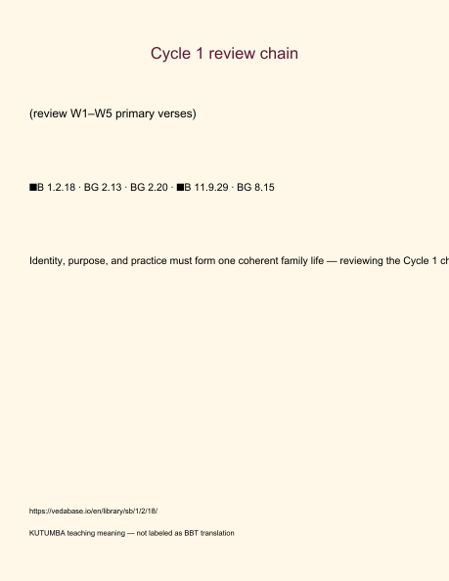
Original KUTUMBA visual: verse-card.png
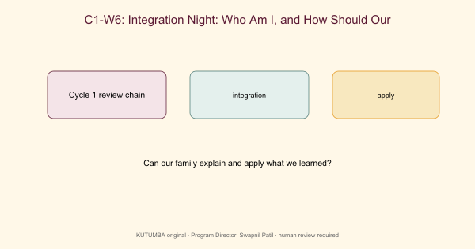
Original KUTUMBA visual: concept-diagram.png
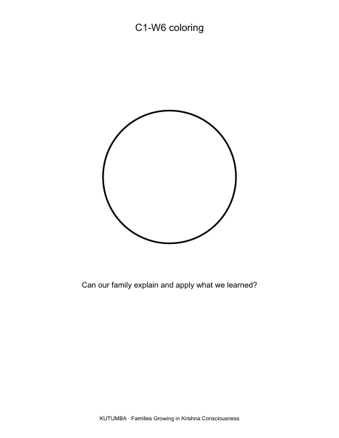
Original KUTUMBA visual: line-art-younger.png
RIGHTS NOTE | Original KUTUMBA program material. Scripture/BBT/ISKCON/third-party rights remain with their holders.

